SYSC 5104W: SYSC 4906G Modelling Discrete-Event Systems Using Cadmium (2026 Winter)

Assignment 2: Nagel–Schreckenberg Model

Gamze Atli 101391616

Carleton University

Part I

Traffic congestion is an important problem in transportation systems, especially on roads where many vehicles move in the same direction and must react to the available space ahead. Understanding how vehicles accelerate, slow down, and interact with each other is important for analyzing traffic flow efficiency and congestion.
The objective of this project is to model and simulate one-lane traffic flow using the Nagel–Schreckenberg model with the Cell-DEVS in the Cadmium simulation framework. The simulation focuses on vehicle movement along a one-dimensional road, where each vehicle follows simple update rules based on its speed and the distance to the car in front.
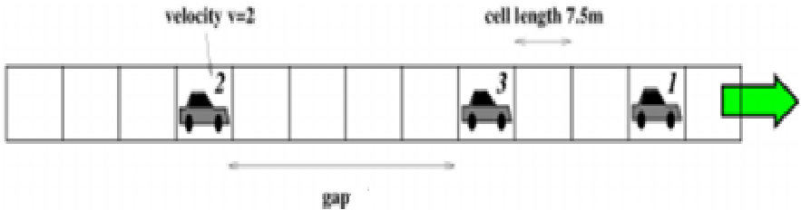
Figure1: Structure of Traffic Simulation of Hamburg
The Nagel–Schreckenberg model is a well-known cellular automata model used to simulate traffic flow on a road. In this model, the road is divided into discrete cells, and each cell can either be empty or occupied by one vehicle. Each vehicle has a discrete speed, and its behavior is updated at each simulation step using simple rules such as acceleration, checking the gap to the vehicle ahead, and movement. Although the rules are simple, the model can still represent important traffic behaviors such as smooth flow, slowing down, and congestion.

The model follows a step-by-step update process. At each step, a vehicle first checks its current speed and tries to accelerate. It then checks the gap to the vehicle ahead and reduces its speed if necessary to avoid collision. After that, it moves to its new position. Because of this simple structure, the Nagel–Schreckenberg model is a suitable choice for studying traffic flow and congestion in a one-lane traffic system.

In this project, the road is represented as a one-dimensional cell space, where each cell corresponds to one position on the road. The state of each cell shows whether a vehicle is present and stores information such as vehicle speed, vehicle type (e.g. car, truck, bus…), and the road maximum speed limit. The behavior of a cell depends on its own state and on the states of nearby cells in the neighborhoods. If a cell is occupied, the vehicle first accelerates and then checks whether braking is needed based on the neighborhood position of the vehicle ahead. If the final speed is greater than zero, the vehicle leaves its current cell. If a cell is empty, it checks whether a vehicle from a back neighborhood position can move into it, and if so, the empty cell becomes occupied by that vehicle. In this way, the model captures both vehicle departure and arrival, allowing the simulation to represent traffic movement from one road position to another.

The Cell-DEVS formalism is suitable for this study because the Nagel–Schreckenberg model is based on discrete space and local interactions between nearby positions on the road. In Cell-DEVS, the system is represented as a collection of cells, where each cell corresponds to one road position and updates its state according to local rules. This makes Cell-DEVS a strong candidate to model traffic flow and observe how the system changes over time.
Part II
Formal Specifications:
Nasch Model: TDC= < X, Y, S, θ, I, N, d, t, δint, δext, λ, D>
d: transport delay (1.)
N: ={s1​,s2​,…,sη​} where s=state
X: {hasVehicle,speed, vehicleType, maxSpeedLimit}
Y= {updated cell state}
I=⟨η,0,PX​,PY​⟩ where von Neumann range η= 5
-$P_{X}$: input ports from neighbors
-$P_{Y}$: output port of the updated state
S={(h,v,vt,mv)} where:
$h∈\{true,false\}$= hasVehicle
$v∈\{1…range n\}$= vehicle speed
$vt∈N$= vehicle type
$mv∈\{1…range n\}$ = maximum speed limit
θ: current cell state {active when there is an update}
t(s,N)= new cell state after acceleration, braking, leaving, or arrival
δint​:θ→θ
λ: S→Y

Nasch_Cell.hpp
The NaSch cell model defines the update rule for each road position in the one-lane traffic system. Each cell stores whether a vehicle is present, together with its speed, vehicle type, and the road maximum speed limit. During each simulation step, the cell uses neighborhood information to decide how its state should change. If the cell is occupied, the vehicle first accelerates and then checks the gap ahead to determine whether braking is needed. If the final speed is greater than zero, the vehicle leaves the cell. If the cell is empty, it checks whether a vehicle from a previous position can move into it. In this way, the model captures vehicle movement along the road using local interactions between neighboring cells.
Nasch_State.hpp
The Nasch state stores whether the cell currently contains a vehicle, the road-related information, and the vehicle-related information. The variable hasVehicle indicates whether the cell is occupied or empty. The roadState object stores road parameters such as the maximum speed limit and the cell length in meters. The vehicleState object stores the properties of the vehicle in that cell, such as its speed and vehicle type. In this way, naschState contains all the information needed to describe the condition of one road position during the simulation.
Part III
To study the behavior of the one-lane NaSch model, two traffic conditions were simulated: non-congested traffic and congested traffic.

In the non-congested traffic scenario, only a small number of vehicles were placed on the road. Since there was enough space between vehicles, most of them were able to accelerate and move smoothly. This resulted in stable traffic flow with little slowing.

In the congested traffic scenario, more vehicles were placed on the road, reducing the spacing between them. Because of the limited gap ahead, vehicles had to slow down more often, and traffic movement became less smooth. In some parts of the road, vehicles formed clusters, showing congestion behavior.

These two scenarios help show how traffic density affects vehicle flow in the one-lane NaSch model.
The simulation results can observe as videos under documentation folder.
Links:
1. https://programmer.ie/post/traffic/#the-map
2. chrome-extension://efaidnbmnnnibpcajpcglclefindmkaj/https://iopscience.iop.org/article/10.1088/1742-5468/aad3f9/pdf

