2

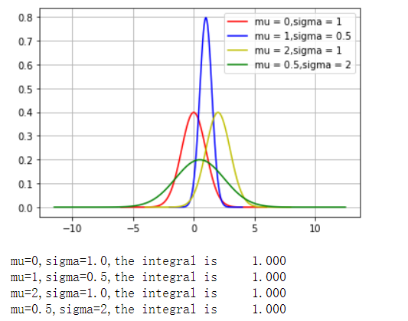

3.1

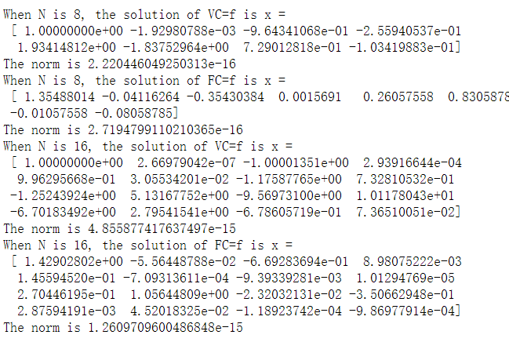

3.2

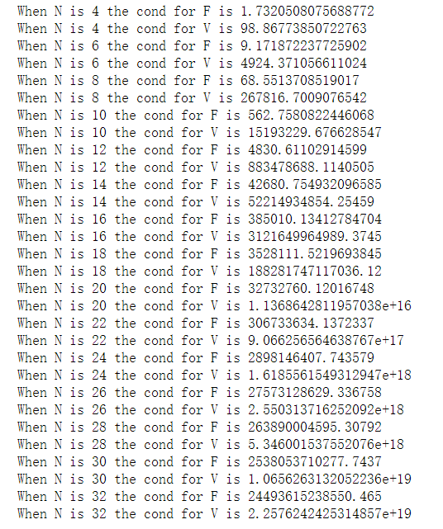

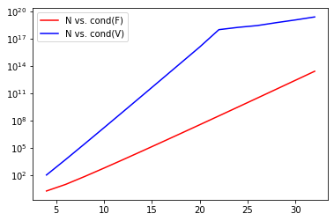

explaining the reasons for the trends：

矩阵的条件数用于界定一个矩阵是“良态的”还是“病态的”，一般来说，条件数越大，矩阵越接近一个奇异矩阵（不可逆矩阵），矩阵越“病态”。在数值计算中，矩阵的条件数越大，计算的误差越大，精度越低。当矩阵阶数增大时，它的条件数迅速增大。

（手写的范德蒙德好像会和直接调用库函数有一点出入）

3.3

|  |  |  |  |  |
| --- | --- | --- | --- | --- |
| N | Isposdef(AV) | Isposdef(AF) | Cond(V) | Cond(F) |
| 4 | True | True | 98.86773850722763 | 1.7320508075688772 |
| 6 | True | True | 4924.371056611024 | 9.171872237725902 |
| 8 | True | True | 267816.7009076542 | 68.5513708519017 |
| 10 | True | True | 15193229.676628547 | 562.7580822446068 |
| 12 | True | True | 883478688.1140505 | 4830.61102914599 |
| 14 | False | True | 52214934854.25459 | 42680.754932096585 |
| 16 | False | True | 3121649964989.3745 | 385010.13412784704 |
| 18 | False | True | 188281747117036.12 | 3528111.5219693845 |
| 20 | False | True | 1.1368642811957038e+16 | 32732760.12016748 |
| 22 | False | False | 9.066256564638767e+17 | 306733634.1372337 |
| 24 | False | True | 1.6185561549312947e+18 | 2898146407.743579 |
| 26 | False | False | 2.550313716252092e+18 | 27573128629.336758 |
| 28 | False | False | 5.346001537552076e+18 | 263890004595.30792 |
| 30 | False | False | 1.0656263132052236e+19 | 2538053710277.7437 |
| 32 | False | False | 2.2576242425314857e+19 | 24493615238550.465 |

The largest value of N where AV is positive definite is 12, and the condition number of the V is 883478688.1140505.

The largest value of N where AF is positive definite is 24, and the condition number of the F is 2898146407.743579

The condition numbers connected in someway, for positive definite matrix, the condition number is associated with its eigenvalues.

3.4

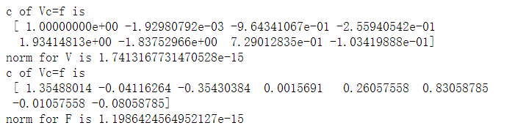

LU solve for Vc=f, the norm is 2.220446049250313e-16

LU solve for Fc=f, the norm is 2.7194799110210365e-16

Cholesky solve for Vc=f, the norm is 1.7413167731470528e-15

Cholesky solve for Fc=f, the norm is 1.1986424564952127e-15

According to the result, the norm of LU solve for the liner system is smaller than the Cholesky solve, so the error margin is smaller, LU solve is better.

4.1

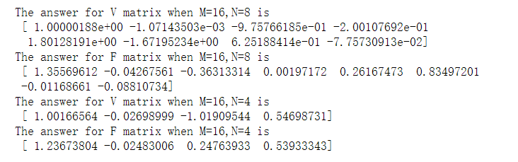

4.2

