**EMPLOYEE MANAGEMENT SYSTEM OUTPUT**

**Add Employee & Update Employee:**

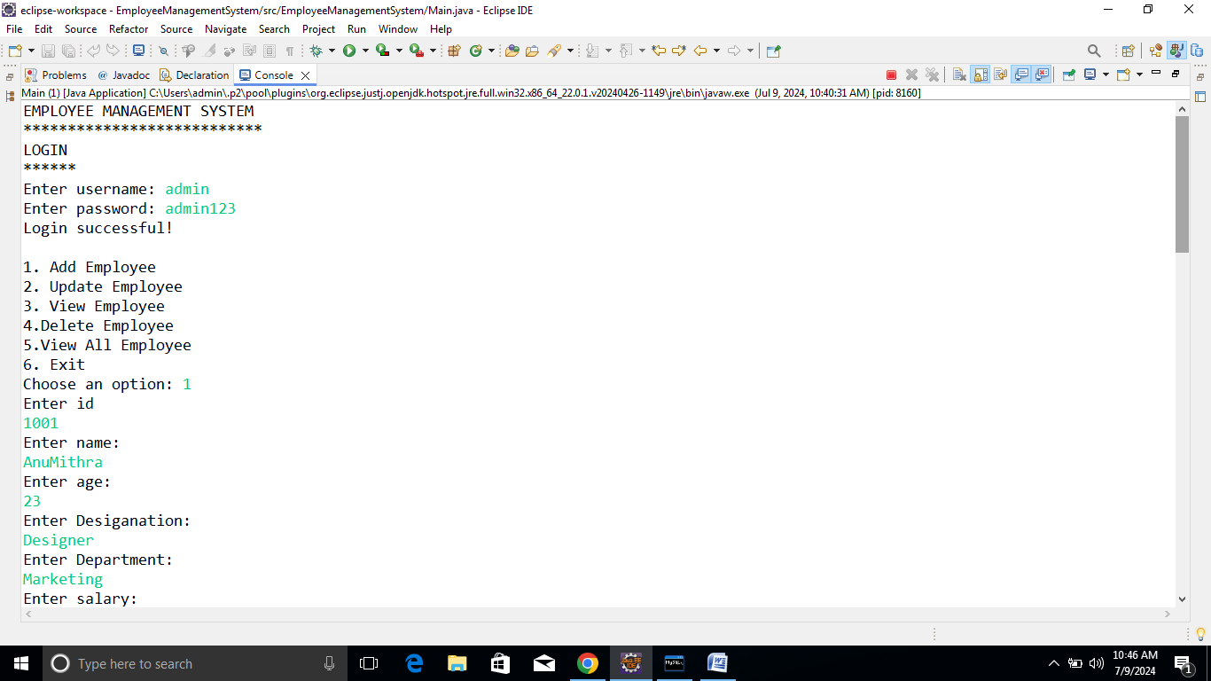

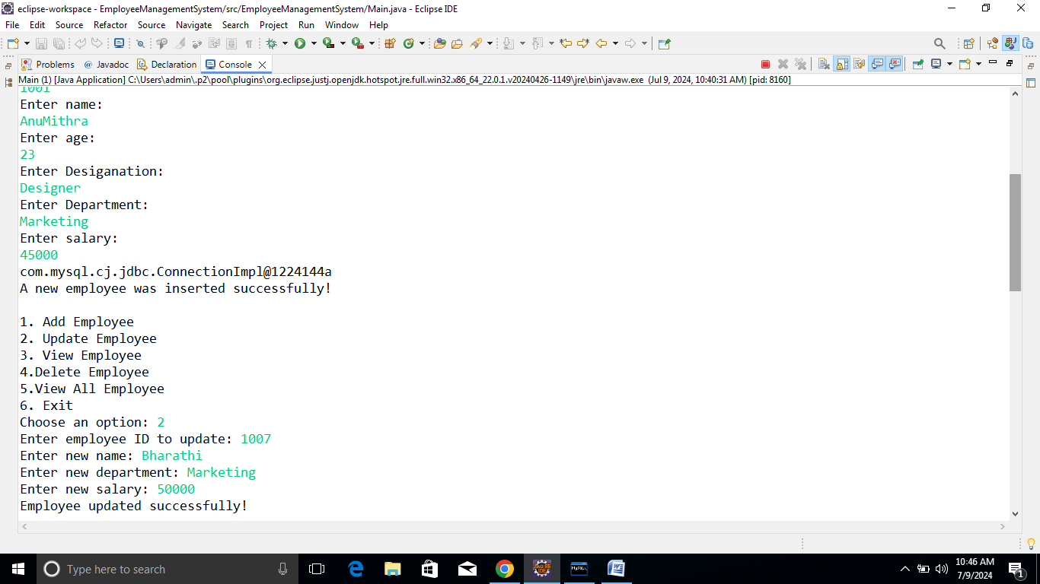

**View Employee on Get id:**

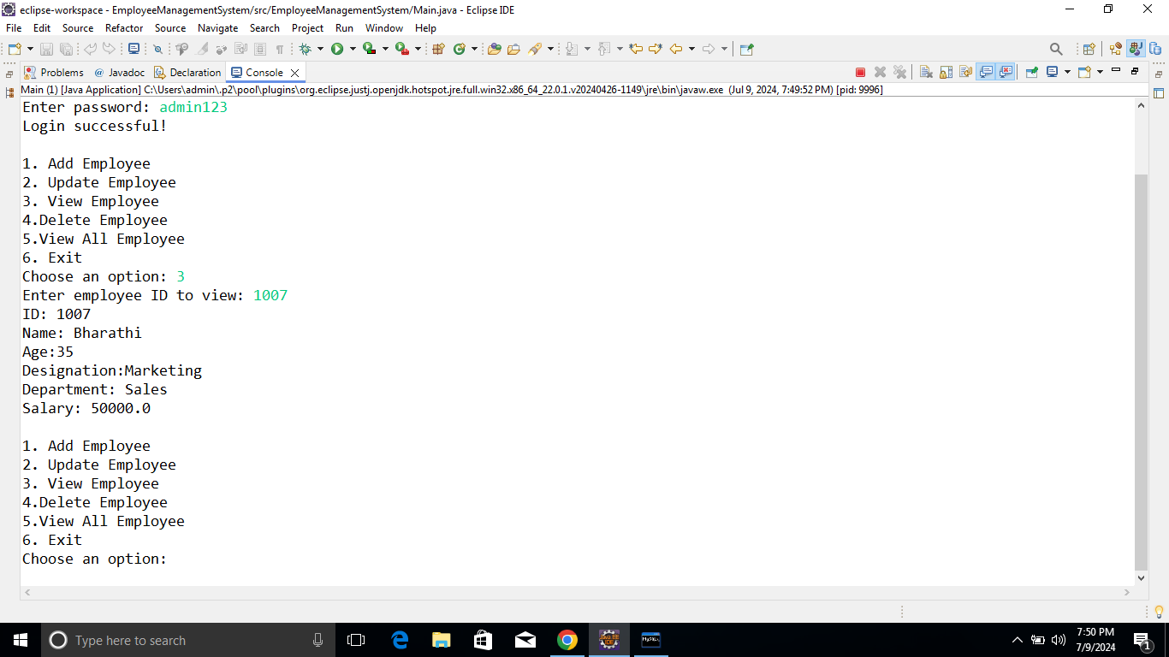

**Delete Employee For ID**

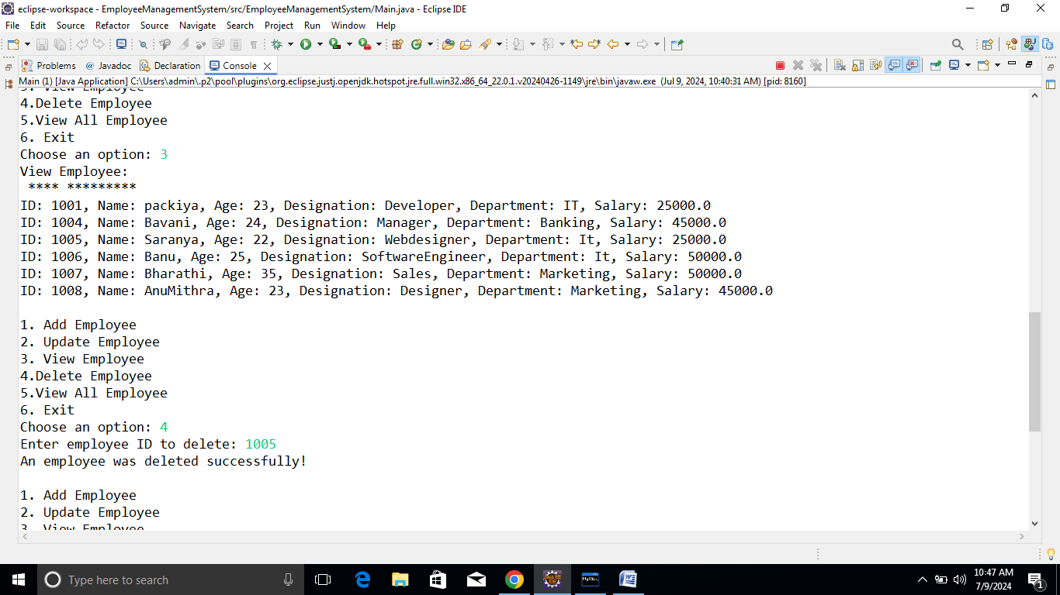

**View All Employee:**

