Data Visualization - Case Study 10

Srushti Padade

April 13, 2020

**Problem 31.1**

Jenny averaged 70 on her quizzes during the first part of the quarter and 80 on her quizzes during the second part of the quarter. When she found out that her final average for the quarter was not 75, she went to argue with her teacher. Give a possible explanation for Jenny’s misunderstanding.

**Solution:**

Average of a set of numbers is simply the sum of the numbers divided by the total number of values in the set.

Jenny averaged individual quizzes and then again averaged two of the quarters which have caused her the misunderstanding as weightage may vary quiz wise. Ideally all quiz grades are added and then divide by total number of quizzes to calculate average for the quarter.

**Problem 31.2**

Suppose the following circle graphs are used to illustrate the fact that the number of elementary teaching majors at teachers’ colleges has doubled between 1993 and 2003, while the percent of male elementary teaching majors has stayed the same. What is misleading about the way the graphs are constructed?

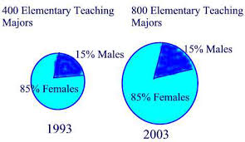

**Solution:**

As per the mathematical facts the double the radius makes the area to increase four times.

Area = π* radius^2.

The graph has exaggerated the increment in number of elementary teaching majors and hence is misleading since population in 2003 is only increase twice as 1993.

**Problem 31.3**

What is wrong with the following line graph?

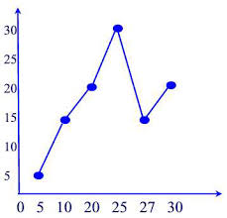

**Solution:**

Drawing any conclusion from the above graph is very difficult. We are not aware about the parameters of the graph such as title, x- axis or y-axis. Also the graph is stretched and also the spacing is unequal for x -axis.

**Problem 31.4**

Doug’s Dog Food Company wanted to impress the public with the magnitude of the company’s growth. Sales of Doug’s Dog Food had doubled from 2002 to 2003, so the company displayed the following graph, in which the radius of the base and the height of the 2003 can are double those of the 2002 can. What does the graph really show with respect to the growth of the company?

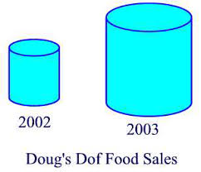

**Solution:**

Any 3D graph distorts and exaggerates the actual increase in sales. We know that,

Volume = πhr^2

The volume would increase by a factor of 8 when doubling the radius and the height of the can.

**Problem 31.5**

What’s wrong with the following graph?

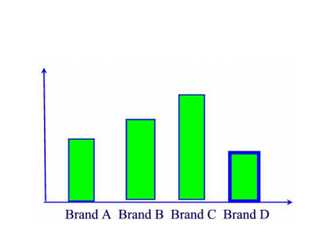

**Solution**:

The Graph represents something about the Brand A, B, C, D but we don’t have a clear picture as we are unaware of y – axis. Also the Brand B and C have their bar starting above the axis which arises a question.

**Problem 31.6**

Refer to the following pictograph:

Ms McNulty claims that on the basis of this information, we can conclude that men are worse drivers than women. Discuss whether you can reach that conclusion from the pictograph or you need more information. If more information is needed, what would you like to know?

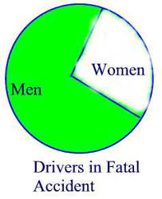

**Solution:**

Ms McNulty claim point is not supported as it is unclear if the figure displays the number of fatal accidents or the fatal accident rate. Additionally, it is unknown if the diagram takes into account the overall number of males to female drivers being tested. Also the percentage would be much clearer as it would demonstrate the amount of male to female drivers and respectively the accident rate.

**Problem 31.7**

Larry and Marc took the same courses last quarter. Each bet that he would receive the better grades. Their courses and grades are as follows:

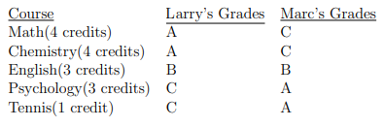

Marc claimed that the results constituted a tie, since both received 2 A’s, 1 B, and 2 C’s. Larry said that he won the bet because he had the higher GPA for the quarter. Who is correct? (Allow 4 points for A, 3 points for B, 2 points for C, 1 point for D, and 0 point for F.)

**Solution:**

Overall grade is calculated irrespective of the credits offered to each course. Since both got 2 A’s, 1B and 2 C’s they both got an overall grade of 3 GPA. Marc is correct stating that results constituted a tie.

**Problem 31.8**

Oil prices went up 20% one year and 30% the next. Is it true that over the two years, prices went up 50%?

**Solution:**

Let,

Oil price be $X,

Hence, when price went up by 20% -> $1.2X

Then, 30% next year -> 30% of $1.2 = 1.56X.

Therefore total increase is 0.56 or **56%** (not 50%).

**Problem 31.9**

True or false? My rent went down 10% last year and then rose 20% this year. Over the two years my rent went up by 10%.

**Solution:**

Let,

Rent be $X.

It goes down by 10% -> $0.9

Again rise by 20% -> $1.08.

Total rent raise after 2 years = $0.08 or 8%

Thus statement is **FALSE**.

**Problem 31.10**

Which graph could be used to indicate a greater decrease in the price of gasoline? Explain.

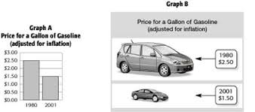

**Solution:**

* Graph A displays bar plot which is an effective way to compare between different groups and it easy to observe the trend that there is an inflation of gasoline prices from 1980 to 2001.
* Graph B uses images for communicating the main point it is easy for the reader to understand the spatial relationship between size of car and price of gasoline.

Graph B is more visually effective indicating greater decrease in the price of gasoline than Graph A.