Neural Networks Model Hypertuning

Srushti Padade

February 2, 2020

The library Keras is used fo the to load the IMDB Dataset in the workspace. The top most occuring words are considered for our deep learning model.

library(keras)  
  
imdb <- dataset_imdb(num_words = 10000)  
c(c(train_data, train_labels), c(test_data, test_labels)) %<-% imdb  
  
#The dataset is vectorized here by Create an all-zero matrix of shape (len(sequences), dimension) and Sets specific indices of results[i] to 1s.  
  
vectorize_sequences <- function(sequences, dimension = 10000) {  
 results <- matrix(0, nrow = length(sequences), ncol = dimension)  
 for (i in 1:length(sequences))  
 results[i, sequences[[i]]] <- 1  
 results  
}  
  
#Vectorized the Train and Test data.  
x_train <- vectorize_sequences(train_data)  
x_test <- vectorize_sequences(test_data)  
str(x_train[1,])

## num [1:10000] 1 1 0 1 1 1 1 1 1 0 ...

y_train <- as.numeric(train_labels)  
y_test <- as.numeric(test_labels)  
  
#From the Train data 40 % of data is allocated from Validation data.  
set.seed(123)  
val_indices <- 1:10000  
  
x_val <- x_train[val_indices,]  
partial_x_train <- x_train[-val_indices,]  
  
y_val <- y_train[val_indices]  
partial_y_train <- y_train[-val_indices]

##Layers Hypertuning

#Model 2:

Model Layers - 2

model_Layer_1 <- keras_model_sequential() %>%   
 layer_dense(units = 16, activation = "relu",input_shape = c(10000)) %>%   
 layer_dense(units = 1, activation = "sigmoid")  
  
model_Layer_1 %>% compile(  
 optimizer = "rmsprop",  
 loss = "binary_crossentropy",  
 metrics = c("accuracy")  
)  
  
history <- model_Layer_1 %>% fit(  
 partial_x_train,  
 partial_y_train,  
 epochs = 20,  
 batch_size = 512,  
 validation_data = list(x_val, y_val))  
  
plot(history)

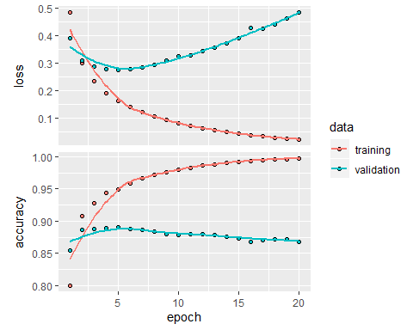

model_Layer_1 %>% fit(x_train, y_train, epochs = 5, batch_size = 512)  
Result_model_Layer_1 <- model_Layer_1 %>% evaluate(x_test, y_test)  
Result_model_Layer_1

## $loss  
## [1] 0.4526824  
##   
## $accuracy  
## [1] 0.86248

#Model 2:

Model Layers - 2

model_Layer_2 <- keras_model_sequential() %>%   
 layer_dense(units = 16, activation = "relu",input_shape = c(10000)) %>%  
 layer_dense(units = 16, activation = "relu")%>%  
 layer_dense(units = 1, activation = "sigmoid")  
  
model_Layer_2 %>% compile(  
 optimizer = "rmsprop",  
 loss = "binary_crossentropy",  
 metrics = c("accuracy")  
)  
  
history <- model_Layer_2 %>% fit(  
 partial_x_train,  
 partial_y_train,  
 epochs = 20,  
 batch_size = 512,  
 validation_data = list(x_val, y_val))  
  
plot(history)

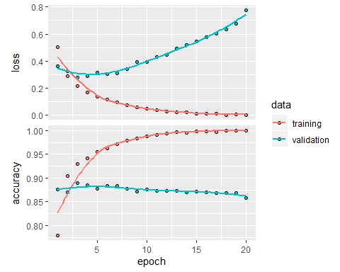

model_Layer_2 %>% fit(x_train, y_train, epochs = 5, batch_size = 512)  
Result_model_Layer_2 <- model_Layer_2 %>% evaluate(x_test, y_test)  
Result_model_Layer_2

## $loss  
## [1] 0.5512349  
##   
## $accuracy  
## [1] 0.86024

#Model 3:

Model Layers - 3

model_Layer_3 <- keras_model_sequential() %>%   
 layer_dense(units = 16, activation = "relu",input_shape = c(10000)) %>%  
 layer_dense(units = 16, activation = "relu")%>%  
 layer_dense(units = 16, activation = "relu")%>%  
 layer_dense(units = 1, activation = "sigmoid")  
  
model_Layer_3 %>% compile(  
 optimizer = "rmsprop",  
 loss = "binary_crossentropy",  
 metrics = c("accuracy")  
)  
  
history <- model_Layer_2 %>% fit(  
 partial_x_train,  
 partial_y_train,  
 epochs = 20,  
 batch_size = 512,  
 validation_data = list(x_val, y_val))  
  
plot(history)

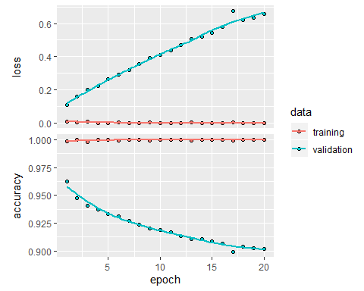

model_Layer_3 %>% fit(x_train, y_train, epochs = 1, batch_size = 512)  
Result_model_Layer_3 <- model_Layer_3 %>% evaluate(x_test, y_test)  
Result_model_Layer_3

## $loss  
## [1] 0.3431484  
##   
## $accuracy  
## [1] 0.87996

## Units Hypertuning

#Model 4:

Model Units - 4

model_unit_4 <- keras_model_sequential() %>%   
 layer_dense(units = 4, activation = "relu",input_shape = c(10000)) %>%  
 layer_dense(units = 4, activation = "relu")%>%  
 layer_dense(units = 1, activation = "sigmoid")  
  
model_unit_4 %>% compile(  
 optimizer = "rmsprop",  
 loss = "binary_crossentropy",  
 metrics = c("accuracy")  
)  
  
history <- model_unit_4 %>% fit(  
 partial_x_train,  
 partial_y_train,  
 epochs = 20,  
 batch_size = 512,  
 validation_data = list(x_val, y_val))  
  
plot(history)

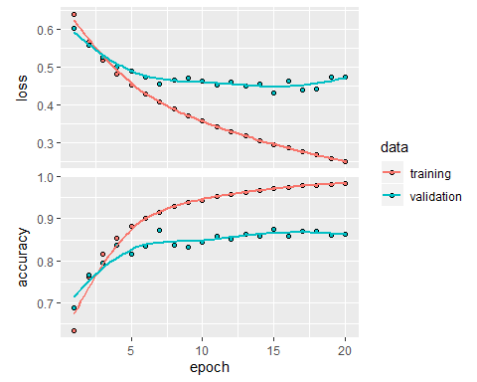

model_unit_4 %>% fit(x_train, y_train, epochs = 8, batch_size = 512)  
Result_model_unit_4 <- model_unit_4 %>% evaluate(x_test, y_test)  
Result_model_unit_4

## $loss  
## [1] 0.4651925  
##   
## $accuracy  
## [1] 0.86

#Model 5:

Model Units - 64

model_unit_64 <- keras_model_sequential() %>%   
 layer_dense(units = 64, activation = "relu",input_shape = c(10000)) %>%  
 layer_dense(units = 64, activation = "relu")%>%  
 layer_dense(units = 1, activation = "sigmoid")  
  
model_unit_64 %>% compile(  
 optimizer = "rmsprop",  
 loss = "binary_crossentropy",  
 metrics = c("accuracy")  
)  
  
history <- model_unit_64 %>% fit(  
 partial_x_train,  
 partial_y_train,  
 epochs = 20,  
 batch_size = 512,  
 validation_data = list(x_val, y_val))  
  
plot(history)

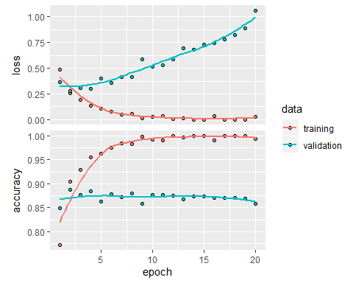

model_unit_64 %>% fit(x_train, y_train, epochs = 3, batch_size = 512)  
Result_model_unit_64 <- model_unit_64 %>% evaluate(x_test, y_test)  
Result_model_unit_64

## $loss  
## [1] 0.500592  
##   
## $accuracy  
## [1] 0.86072

#Model 6:

Model Units - 128

model_unit_128 <- keras_model_sequential() %>%   
 layer_dense(units = 128, activation = "relu",input_shape = c(10000)) %>%  
 layer_dense(units = 128, activation = "relu")%>%  
 layer_dense(units = 1, activation = "sigmoid")  
  
model_unit_128 %>% compile(  
 optimizer = "rmsprop",  
 loss = "binary_crossentropy",  
 metrics = c("accuracy")  
)  
  
history <- model_unit_128 %>% fit(  
 partial_x_train,  
 partial_y_train,  
 epochs = 20,  
 batch_size = 512,  
 validation_data = list(x_val, y_val))  
  
plot(history)

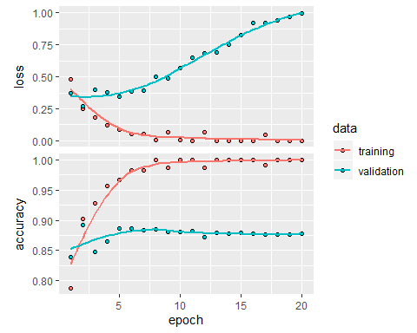

model_unit_128 %>% fit(x_train, y_train, epochs = 2, batch_size = 512)  
Result_model_unit_128 <- model_unit_128 %>% evaluate(x_test, y_test)  
Result_model_unit_128

## $loss  
## [1] 0.457048  
##   
## $accuracy  
## [1] 0.86756

## Loss Function

#Model 7:

Model Loss - MSE

model_mse <- keras_model_sequential() %>%   
 layer_dense(units = 16, activation = "relu",input_shape = c(10000)) %>%  
 layer_dense(units = 16, activation = "relu")%>%  
 layer_dense(units = 1, activation = "sigmoid")  
  
model_mse %>% compile(  
 optimizer = "rmsprop",  
 loss = "mse",  
 metrics = c("accuracy")  
)  
  
history <- model_mse %>% fit(  
 partial_x_train,  
 partial_y_train,  
 epochs = 20,  
 batch_size = 512,  
 validation_data = list(x_val, y_val))  
  
plot(history)

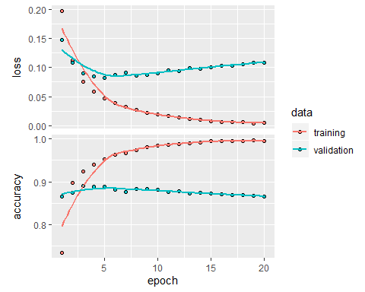

model_mse %>% fit(x_train, y_train, epochs = 4, batch_size = 512)  
Result_model_mse <- model_mse %>% evaluate(x_test, y_test)  
Result_model_mse

## $loss  
## [1] 0.1217064  
##   
## $accuracy  
## [1] 0.85388

## Activation Function

Model Activation function - tanh

model_tanh <- keras_model_sequential() %>%   
 layer_dense(units = 16, activation = "tanh",input_shape = c(10000)) %>%  
 layer_dense(units = 16, activation = "tanh")%>%  
 layer_dense(units = 1, activation = "sigmoid")  
  
model_tanh %>% compile(  
 optimizer = "rmsprop",  
 loss = "binary_crossentropy",  
 metrics = c("accuracy")  
)  
  
history <- model_tanh %>% fit(  
 partial_x_train,  
 partial_y_train,  
 epochs = 20,  
 batch_size = 512,  
 validation_data = list(x_val, y_val))  
  
plot(history)

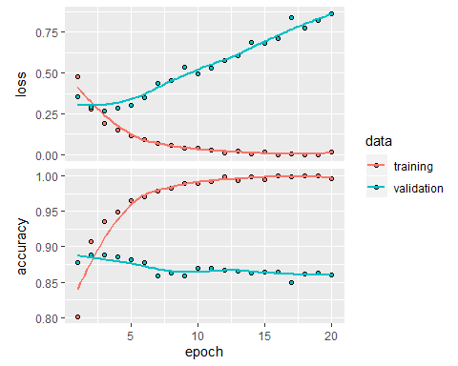

model_tanh %>% fit(x_train, y_train, epochs = 3, batch_size = 512)  
Result_model_tanh <- model_tanh %>% evaluate(x_test, y_test)  
Result_model_tanh

## $loss  
## [1] 0.4694537  
##   
## $accuracy  
## [1] 0.85816

## Regularisation

Model Regularizer - L2

model_reg_2 <- keras_model_sequential() %>%   
 layer_dense(units = 16, activation = "relu", kernel_regularizer = regularizer_l2(l = 0.001), input_shape = c(10000)) %>%  
 layer_dense(units = 16, activation = "relu", kernel_regularizer = regularizer_l2(l = 0.001))%>%  
 layer_dense(units = 1, activation = "sigmoid")  
  
model_reg_2 %>% compile(  
 optimizer = "rmsprop",  
 loss = "binary_crossentropy",  
 metrics = c("accuracy")  
)  
  
history <- model_reg_2 %>% fit(  
 partial_x_train,  
 partial_y_train,  
 epochs = 20,  
 batch_size = 512,  
 validation_data = list(x_val, y_val))  
  
plot(history)

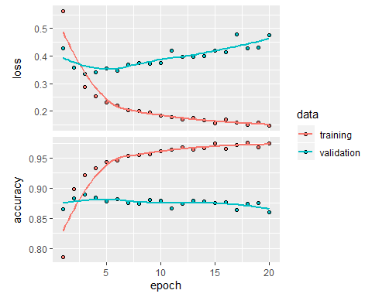

model_reg_2 %>% fit(x_train, y_train, epochs = 4, batch_size = 512)  
Result_model_reg_2 <- model_reg_2 %>% evaluate(x_test, y_test)  
Result_model_reg_2

## $loss  
## [1] 0.4608817  
##   
## $accuracy  
## [1] 0.85824

## Dropout

Model Droupout - 0.5

model_dropout <- keras_model_sequential() %>%   
 layer_dense(units = 16, activation = "relu",input_shape = c(10000)) %>%  
 layer_dropout(rate = 0.5) %>%  
 layer_dense(units = 16, activation = "relu")%>%  
 layer_dropout(rate = 0.5) %>%  
 layer_dense(units = 1, activation = "sigmoid")  
  
model_dropout %>% compile(  
 optimizer = "rmsprop",  
 loss = "binary_crossentropy",  
 metrics = c("accuracy")  
)  
  
history <- model_dropout %>% fit(  
 partial_x_train,  
 partial_y_train,  
 epochs = 20,  
 batch_size = 512,  
 validation_data = list(x_val, y_val))  
  
plot(history)

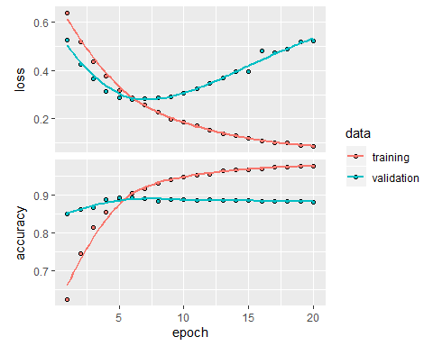

model_dropout %>% fit(x_train, y_train, epochs = 8, batch_size = 512)  
Result_model_dropout <- model_dropout %>% evaluate(x_test, y_test)  
Result_model_dropout

## $loss  
## [1] 0.4961424  
##   
## $accuracy  
## [1] 0.8704

## Final Model with Hypertunned Parameters.

model_Final <- keras_model_sequential() %>%   
 layer_dense(units = 32, activation = "relu",kernel_regularizer = regularizer_l2(l = 0.0001), input_shape = c(10000)) %>%   
 layer_dropout(rate = 0.5) %>%  
 layer_dense(units = 32, activation = "relu",kernel_regularizer = regularizer_l2(l = 0.0001)) %>%   
 layer_dropout(rate = 0.5) %>%  
 layer_dense(units = 16, activation = "relu"",kernel_regularizer = regularizer_l2(l = 0.0001)) %>%

layer_dropout(rate = 0.5) %>%  
 layer_dense(units = 1, activation = "sigmoid")  
  
model_Final %>% compile(  
 optimizer = "rmsprop",  
 loss = "mse",  
 metrics = c("accuracy")  
)  
  
history <- model_Final %>% fit(  
 partial_x_train,  
 partial_y_train,  
 epochs = 20,  
 batch_size = 512,  
 validation_data = list(x_val, y_val))  
  
plot(history)

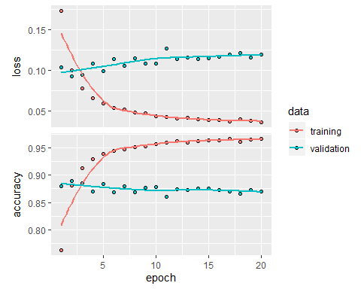

model_Final %>% fit(x_train, y_train, epochs = 3, batch_size = 512)  
Result_model_Final <- model_Final %>% evaluate(x_test, y_test)  
Result_model_Final

## $loss  
## [1] 0.08867288  
##   
## $accuracy  
## [1] 0.8814