**Assignment 4**

**Question 1:**

**Solution:**

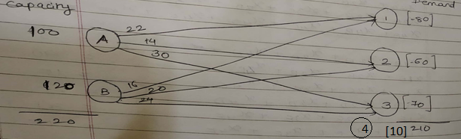

**Decision Variable:**

Let,

Xij = AED distribution from plant i to warehouse j

i = Plants; i = A, B

j = Warehouse; j = 1, 2, 3

**Objective Function:**

To minimize the transportation cost of AEDs.

Min = 22 XA1 + 14 XA2 + 30 XA3 + 16 XB1 + 20 XB2 + 24 XB3 + 600 XA1 + 600 XA2 +600 XA3 + 625 XB1 + 625 XB2 + 625 XB3 + 0 XAD + 0 XBD;

**Constraints:**

1. Supply/Capacity Constraints:

XA1 + XA2 + XA3 + XAD = 100;

XB1 + XB2 + XB3 + XBD = 120;

1. Demand Constraints:

XA1 + XB1 = 80;

XA2 + XB2 = 60;

XA3 + XB3 = 70;

1. Dummy Variable:

Production Capacity = 100 + 120 = 220

Demand = 80 + 60 + 70 = 210

Thus, create a dummy variable in demand section to equate the supply and demand.

Dummy Variable D = 10;

XAD + XBD = 10;

**Mathematical Formulation of Linear Programming Problem:**

Let,

Xij = AED distribution from plant i to warehouse j

i = Plants; i = A, B

j = Warehouse; j = 1, 2, 3

Min = 22 XA1 + 14 XA2 + 30 XA3 + 16 XB1 + 20 XB2 + 24 XB3 + 600 XA1 + 600 XA2 +600 XA3 + 625 XB1 + 625 XB2 + 625 XB3 + 0 XAD + 0 XBD;

Subject To

XA1 + XA2 + XA3 + XAD = 100;

XB1 + XB2 + XB3 + XBD = 120;

XA1 + XB1 = 80;

XA2 + XB2 = 60;

XA3 + XB3 = 70;

XAD + XBD = 10;

And

Xij >= 0;

i = A, B; j = 1, 2, 3;

**Question 2:**

**Solution:**

**Decision Variable:**

Let,

Xij = Oil flow from well i to pump j in TBH.

Xjk= Oil flow from pump j to refineries k TBH.

i = Wells; i = 1, 2, 3

j = Pumps; j = 4, 5, 6

k = Refineries; k = 7, 8, 9

**Objective Function:**

To find the minimum providing cost of oil to the refineries.

Minz = 1.52 X14 + 1.60 X15 + 1.40 X16 + 1.70 X24 + 1.63 X25 + 1.55 X26 + 1.45 X34 + 1.57 X35 + 1.30 X36 + 5.15 X47 + 5.69 X48 + 6.13 X49 + 5.63 X410 + 5.80 X411 + 5.12 X57 + 5.47 X58 + 6.05 X59 + 6.12 X510 + 5.71 X511 + 5.32 X67 + 6.16 X68 + 6.25 X69 + 6.17 X610 + 5.87 X611;

**Network Diagram for the problem:**

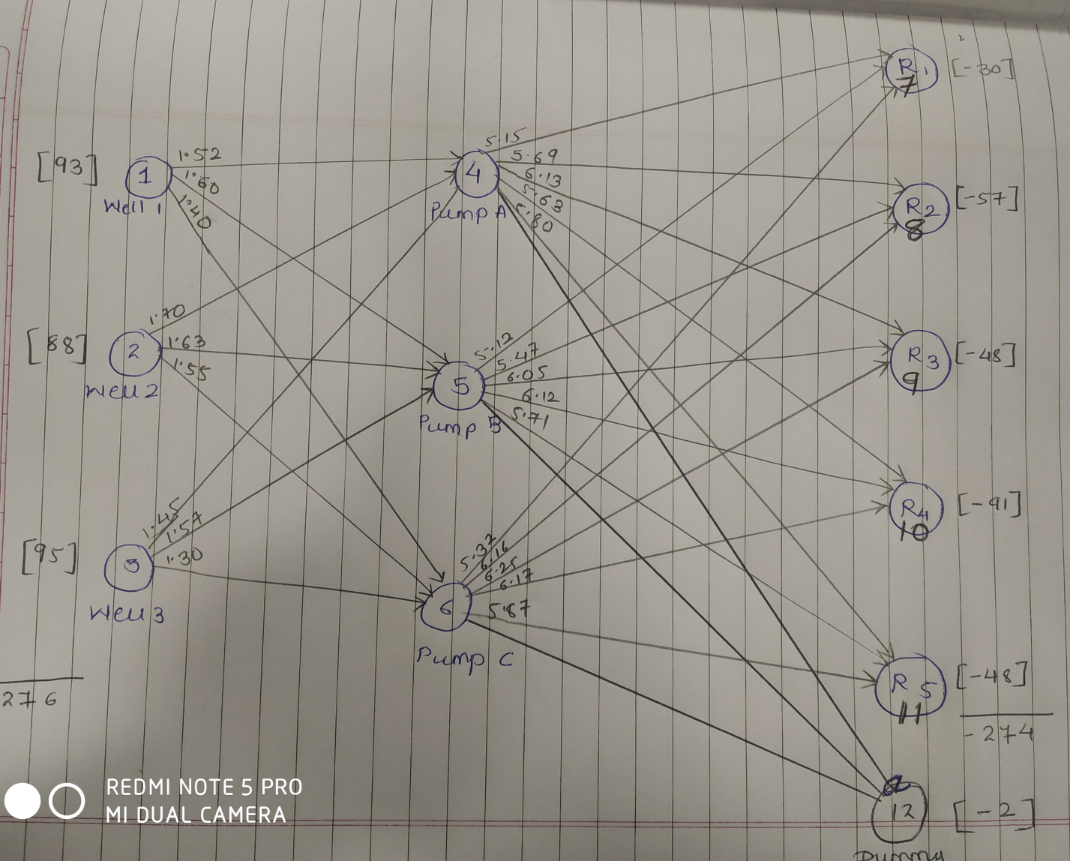

**Constraints:**

1. Oil flow from wells to the pump

X14 + X15 + X16 = 93;

X24 + X25 + X26 = 88;

X34 + X35 + X36 = 95;

1. Oil flow from pumps to the refineries

X47 + X57 + X67 = 30;

X48 + X58 + X68 = 57;

X49 + X59 + X69 = 48;

X410 + X510 + X610 = 91;

X411 + X511 + X611 = 48;

X412 + X512 + X612 = 2;

1. Dummy variable

Production Capacity = 93 + 88 + 95 = 276 TBH

Demand = 30 + 57 + 48 + 91 + 48 = 274 TBH

Thus, create a dummy variable in demand section to equate the supply and demand.

Dummy Variable D = 2;

X412 + X512 + X612 = 2;

1. Equality constraint

X14 + X24 + X34 = X47 + X48 + X49 + X410 + X411 + X412;

X15 + X25 + X35 = X57 + X58 + X59 + X510 + X511 + X512;

X16 + X26 + X36 = X67 + X68 + X69 + X610 + X611 + X612;

**Mathematical Formulation of Linear Programming Problem:**

Let,

Xij = Oil flow from well i to pump j in TBH.

Xjk= Oil flow from pump j to refineries k TBH.

i = Wells; i = 1, 2, 3

j = Pumps; j = 4, 5, 6

k = Refineries; k = 7, 8, 9

Minz = 1.52 X14 + 1.60 X15 + 1.40 X16 + 1.70 X24 + 1.63 X25 + 1.55 X26 + 1.45 X34 + 1.57 X35 + 1.30 X36 + 5.15 X47 + 5.69 X48 + 6.13 X49 + 5.63 X410 + 5.80 X411 + 5.12 X57 + 5.47 X58 + 6.05 X59 + 6.12 X510 + 5.71 X511 + 5.32 X67 + 6.16 X68 + 6.25 X69 + 6.17 X610 + 5.87 X611;

Subject To

X14 + X15 + X16 = 93;

X24 + X25 + X26 = 88;

X34 + X35 + X36 = 95;

X47 + X57 + X67 = 30;

X48 + X58 + X68 = 57;

X49 + X59 + X69 = 48;

X410 + X510 + X610 = 91;

X411 + X511 + X611 = 48;

X412 + X512 + X612 = 2;

X14 + X24 + X34 = X47 + X48 + X49 + X410 + X411 + X412;

X15 + X25 + X35 = X57 + X58 + X59 + X510 + X511 + X512;

X16 + X26 + X36 = X67 + X68 + X69 + X610 + X611 + X612;

And

Xij >= 0;

Xjk >= 0;

i = 1, 2, 3; j = 4, 5, 6; k = 7, 8, 9;

Solution Network Diagram:

