Austin Lineberry – Assignment 4
Prior Flowchart
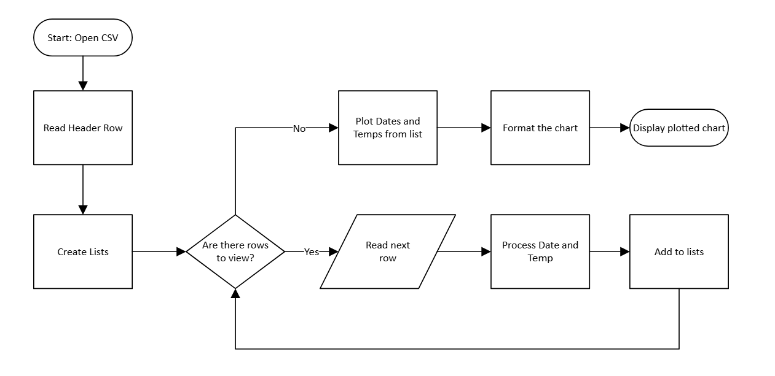

Amended Flowchart
