* [Projects](https://googlecloud.qwiklabs.com/focuses/3288" \l "projects)
* [Overview](https://googlecloud.qwiklabs.com/focuses/3288#overview)
  + [**What you will do:**](https://googlecloud.qwiklabs.com/focuses/3288#what-you-will-do)
  + [**You will learn:**](https://googlecloud.qwiklabs.com/focuses/3288#you-will-learn)
* [Create a Project](https://googlecloud.qwiklabs.com/focuses/3288#create-a-project)
* [Delete a Project](https://googlecloud.qwiklabs.com/focuses/3288#delete-a-project)
* [Select a Project](https://googlecloud.qwiklabs.com/focuses/3288#select-a-project)
  + [**Step 1: Open PROJECT-1**](https://googlecloud.qwiklabs.com/focuses/3288#step-1-open-project-1)
* [Working with Projects in Cloud Shell](https://googlecloud.qwiklabs.com/focuses/3288#working-with-projects-in-cloud-shell)
  + [**Step 1: Identify current project in Cloud Shell**](https://googlecloud.qwiklabs.com/focuses/3288#step-1-identify-current-project-in-cloud-shell)
  + [**Step 2: Switch to PROJECT-2**](https://googlecloud.qwiklabs.com/focuses/3288#step-2-switch-to-project-2)
  + [**Step 3: Cycle Cloud Shell**](https://googlecloud.qwiklabs.com/focuses/3288#step-3-cycle-cloud-shell)
  + [**Step 4: Switch to PROJECT-1**](https://googlecloud.qwiklabs.com/focuses/3288#step-4-switch-to-project-1)
  + [**Step 5: Configure current project**](https://googlecloud.qwiklabs.com/focuses/3288#step-5-configure-current-project)
* [Review of Projects](https://googlecloud.qwiklabs.com/focuses/3288#review-of-projects)

# PROJECTS

# Overview

In this lab you will learn to work with multiple projects. Projects in GCP relate resources to billing accounts. Resources can only be created and consumed within Projects. Projects also isolate related resources from one another.

## ****What you will do:****

* Create a project (walk-through)
* Delete a project (walk-through)
* Switch between projects
* Become familiar with the current project focus in Console and Cloud Shell and methods to change the current project in both interfaces

## ****You will learn:****

* Project creation, selection, and deletion in Console
* Project verification and selection in Cloud Shell

# Create a Project

The ability to create projects is not available in this lab environment. So the following steps illustrate how you would create a project.

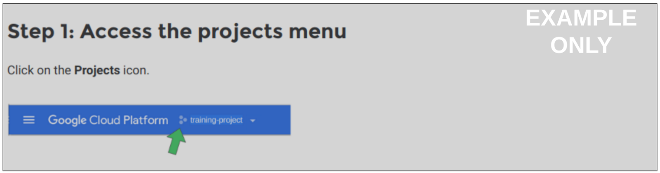

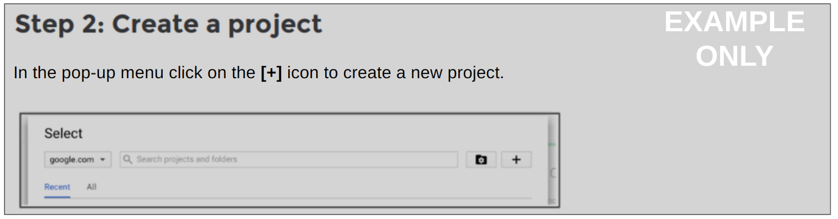

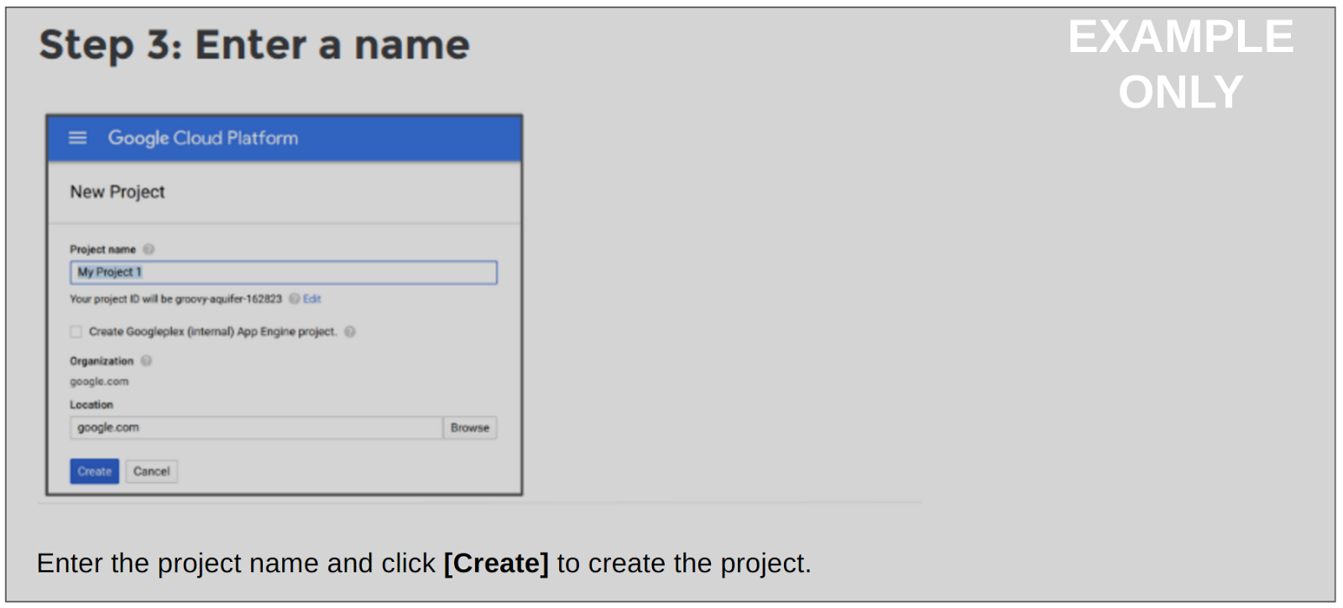

Some services are not set up initially when a new project is created. Instead, they are only initialized when you navigate to them in Console. You may see a message saying the service is being initialized, which usually clears in a few minutes.

# Delete a Project

The ability to delete projects is not available in this lab environment. So the following steps illustrate how you would delete a project.

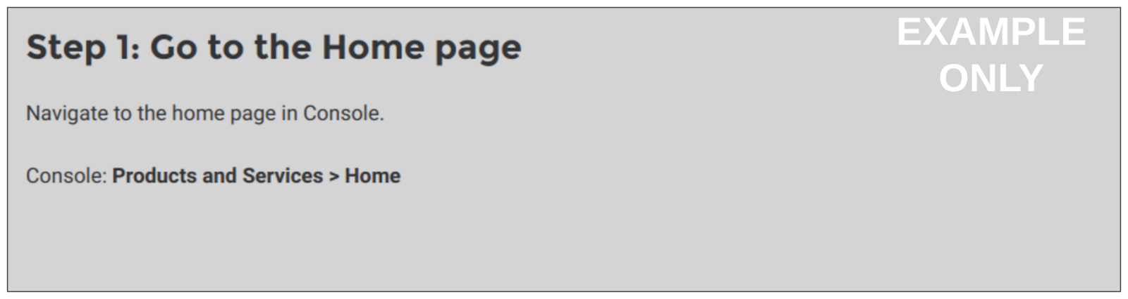

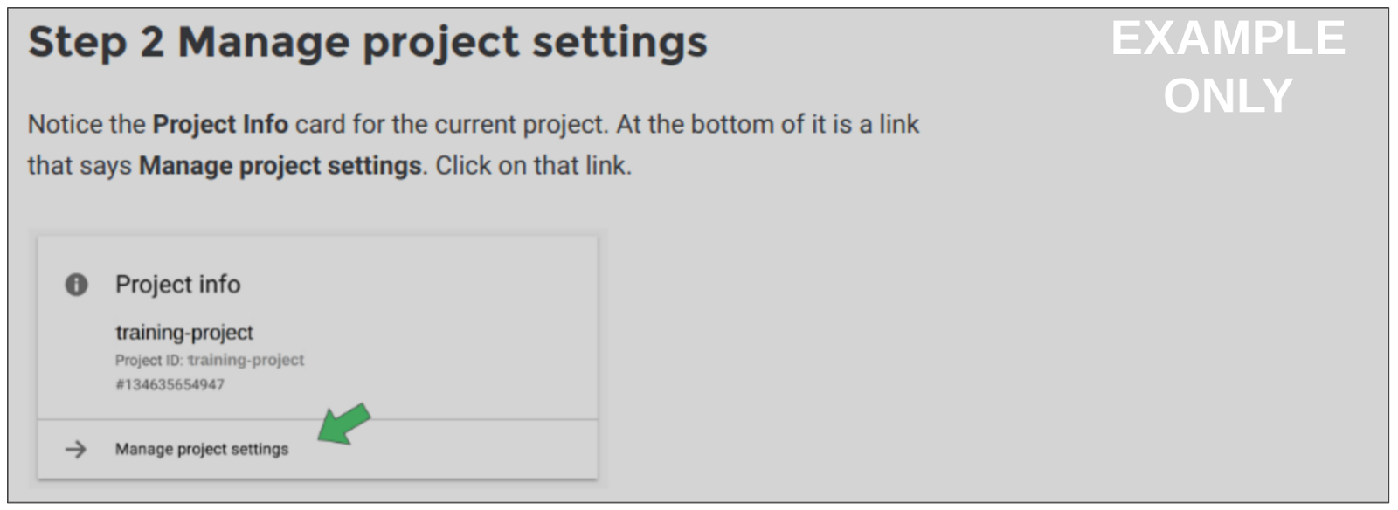

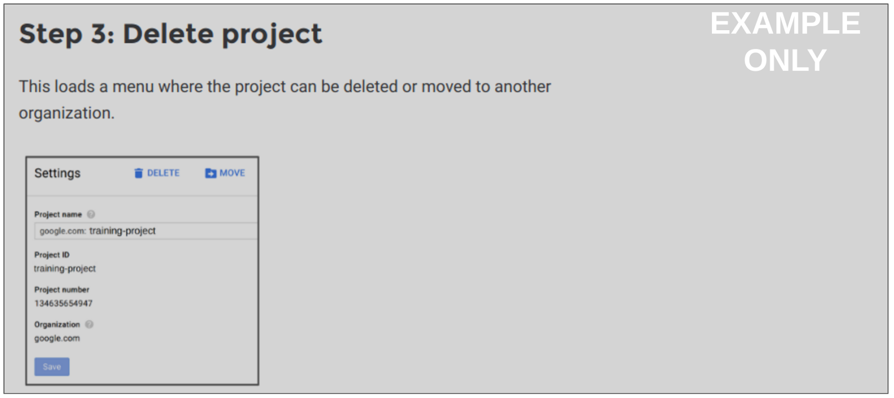

If you were to delete the project, it would be placed on a queue for deletion. The resources would be held for seven days before the project resources are actually recycled. This means that you cannot reuse the name of a project for at least seven days after it is marked for deletion.

# Select a Project

The lab environment has already established two projects for you. They will be referred to as **PROJECT-1** and **PROJECT-2** in these instructions.

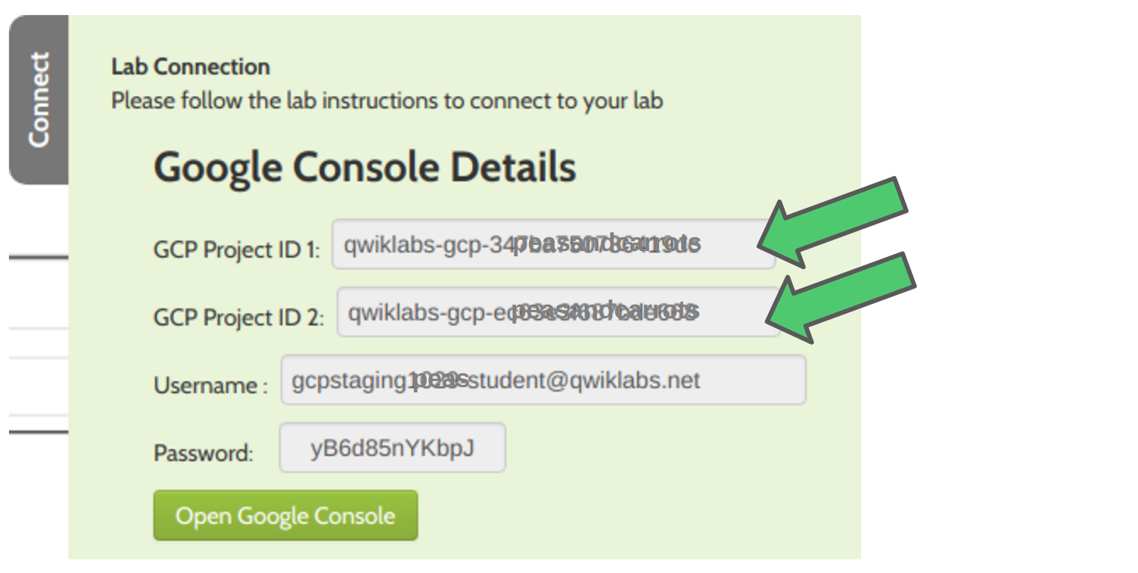

In Console, click on the **Project-1** and a menu opens:

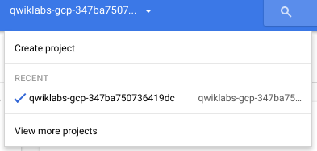

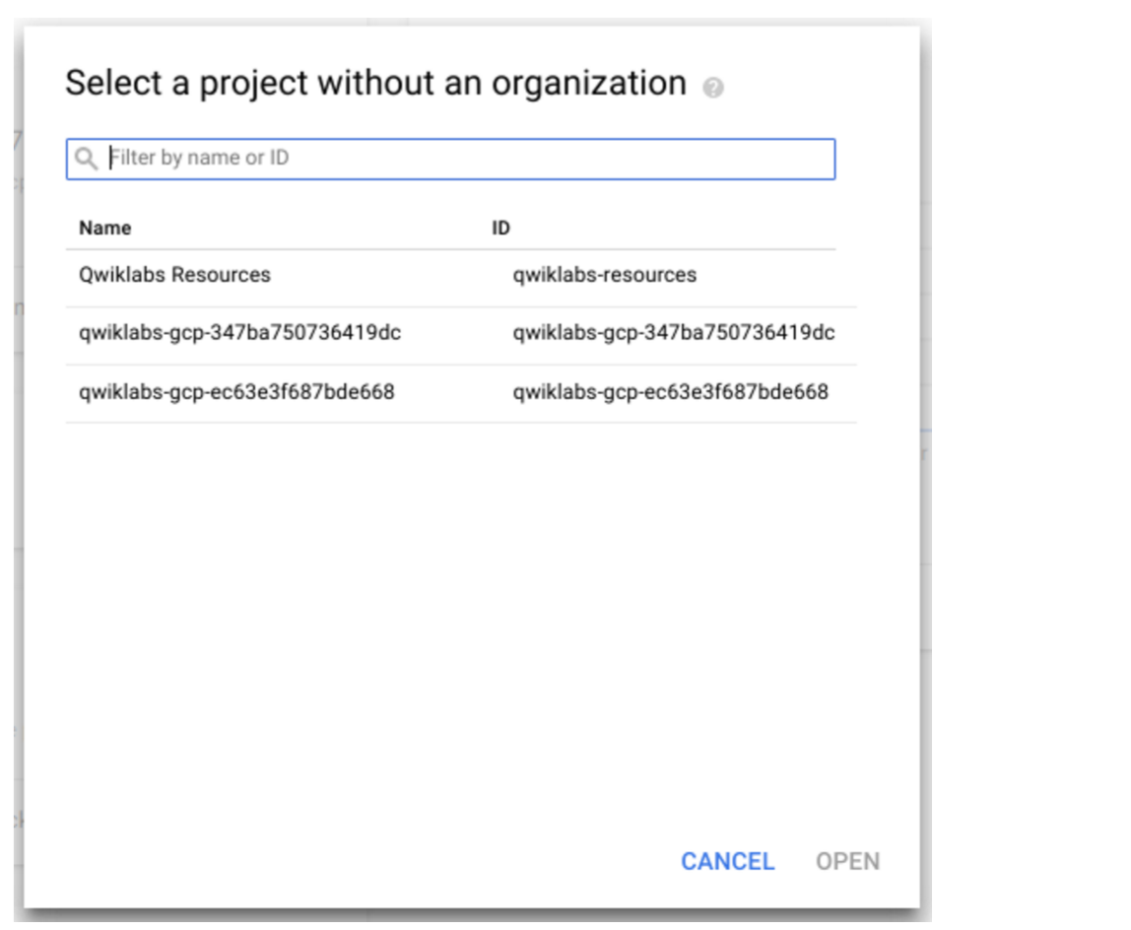

Note the names. An easy way to distinguish between them is to note the last two characters in the Project name or Project ID. In the example above, **PROJECT-1** ends in **dc** and **PROJECT-2** ends in **68**.

You will switch between PROJECT-1 and PROJECT-2 in Console so that you can see the relationship with Cloud Shell.

Notice that the illustration shows **Select a project without and organization**.

The menu looks slightly different if your account is associated with an organization.

Here is an example:

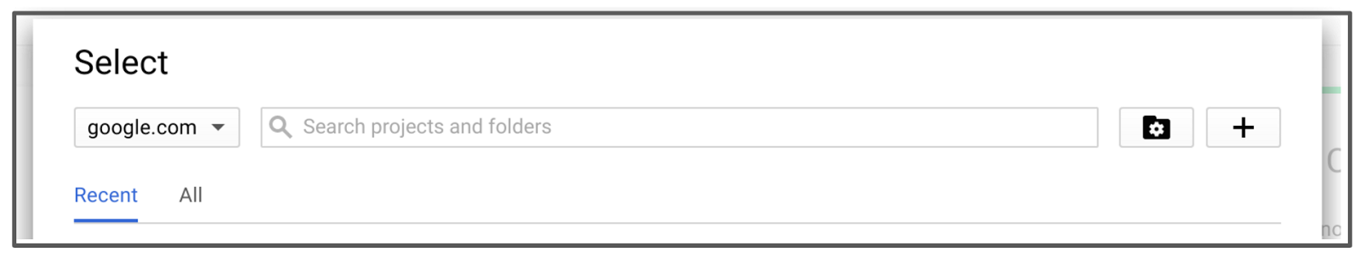

## ****Step 1: Open PROJECT-1****

In the Console status bar, click on the project selector and select the **PROJECT-1** and click **[Open]**.

# Working with Projects in Cloud Shell

## ****Step 1: Identify current project in Cloud Shell****

Open Cloud Shell and enter the following  command.

 Copy Code Block

gcloud config list

Result:

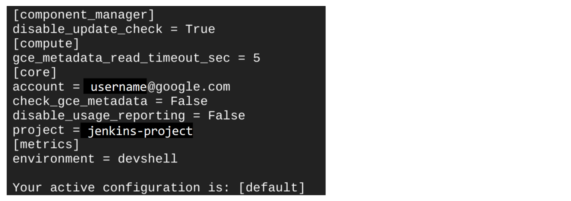

Notice the project name. The Cloud Shell session defaults to the project that Console is in when you launched Cloud Shell.

Leave Cloud Shell open.

## ****Step 2: Switch to PROJECT-2****

In Console, select the **PROJECT-2**.

Use the following command with  to more easily identify the current project.

 Copy Code Block

gcloud config list | grep project

Although the focus for Console changed to a different project, Cloud Shell remained focused on the original project. One option for getting Cloud Shell to focus on the same project that Console is showing is to close Cloud Shell and reopen it. The new session will adopt the current Console project.

## ****Step 3: Cycle Cloud Shell****

Close Cloud Shell and reopen it.

Run the command again. Verify that Cloud Shell is now aimed at the **PROJECT-2**.

 Copy Code Block

gcloud config list | grep project

## ****Step 4: Switch to PROJECT-1****

In Console, select **PROJECT-1**.

## ****Step 5: Configure current project****

This time, you can use a command to change the project setting in Cloud Shell.

 Copy Code Block

gcloud config set project [PROJECT-1]

Result (example):

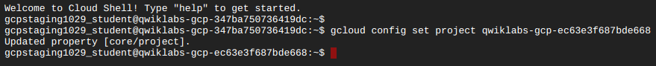

Notice that the command prompt format in Cloud Shell is:

**username@project: $**

In the example above, the original Cloud Shell prompt ended in **dc**. But after issuing the  command, the prompt changed and ends in **68**

Verify the change.

 Copy Code Block

gcloud config list | grep project

# Review of Projects

In this lab you learned how projects are created and deleted, how to switch context between projects, and how to use Cloud Shell with projects. Most importantly, the Console current project is independent from the Cloud Shell current project. You can use the Cloud Shell command prompt as an indicator. And you can issue a command to change the current project in Cloud Shell.

©Google, Inc. or its affiliates. All rights reserved. Do not distribute.

|  |
| --- |
| **Levels:**[**introductory**](https://googlecloud.qwiklabs.com/tags/introductory/level)  **Lab Description:**In this lab you will become familiar with GCP Projects, including how to create them and switch contexts between them.  **Lab Creator:** Enis Konuk  **Date Created:** April 10, 2017 19:11 |