Thursday, May 26, 2022

Exercise 3 - PARTITION

4)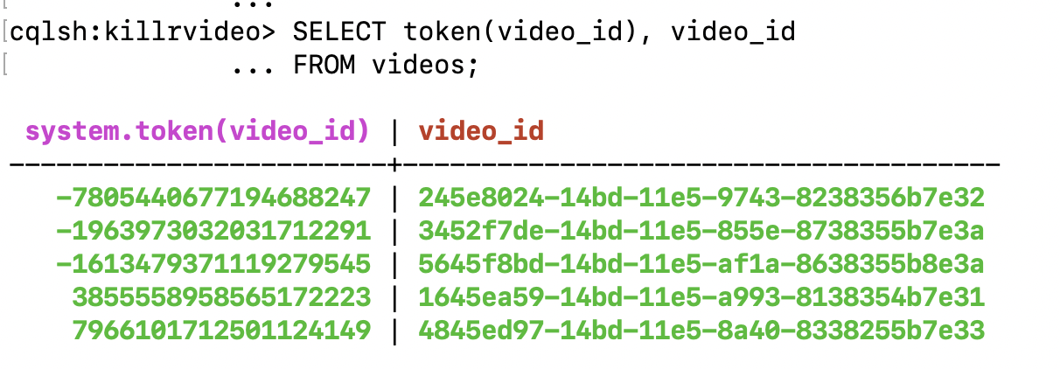

8) and 9)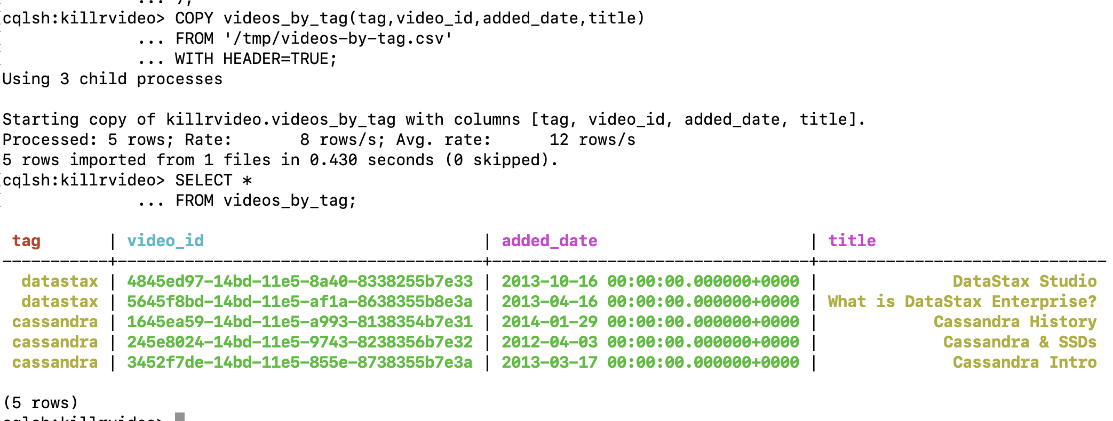

10)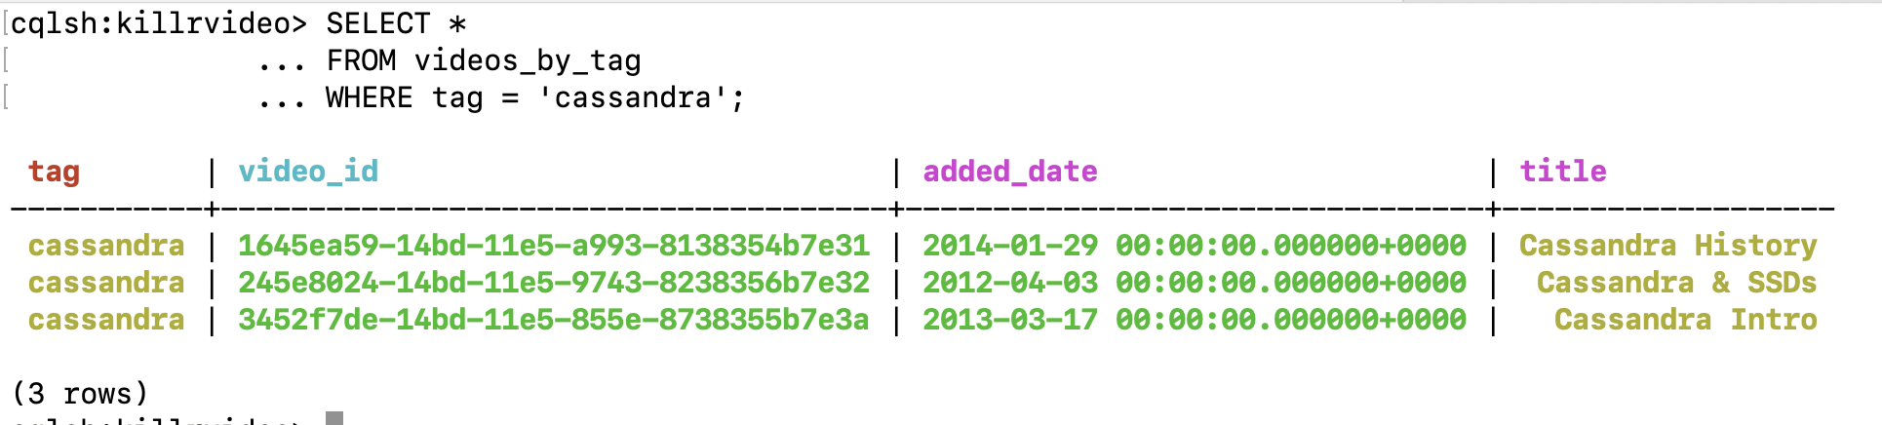

11)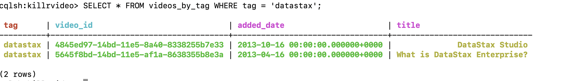

12)