Thursday, May 26, 2022

Exercise 4 - PARTITION

5)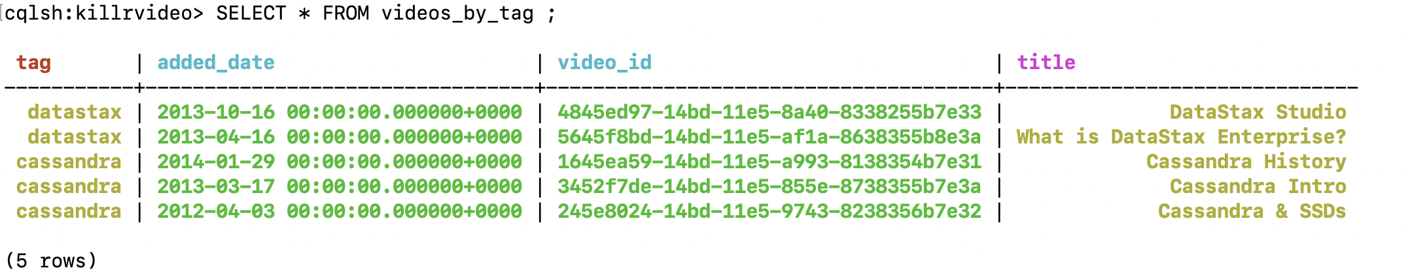

6)

7)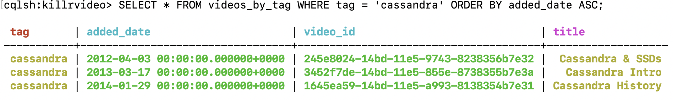

8)