Thursday, May 26, 2022

Exercise 6 - NODE

Nodetool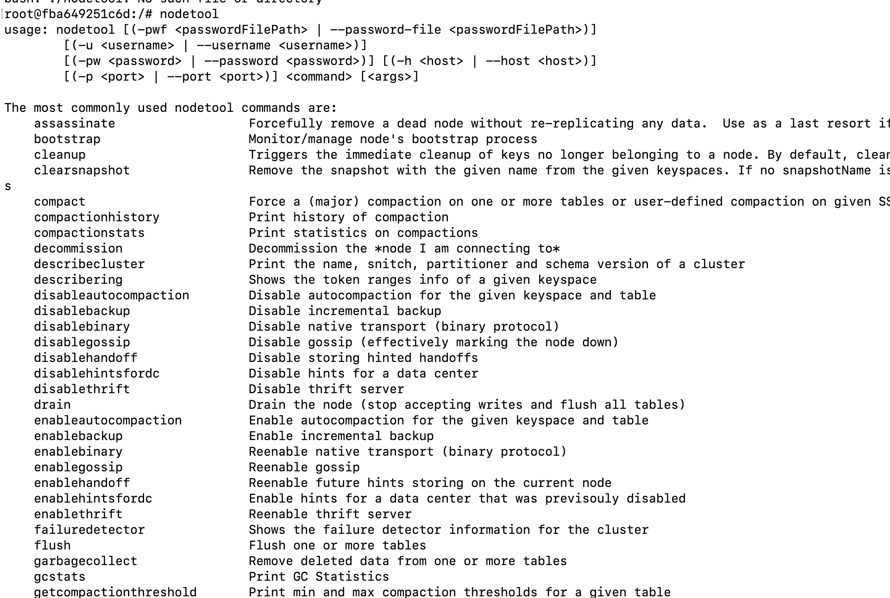

Nodetool info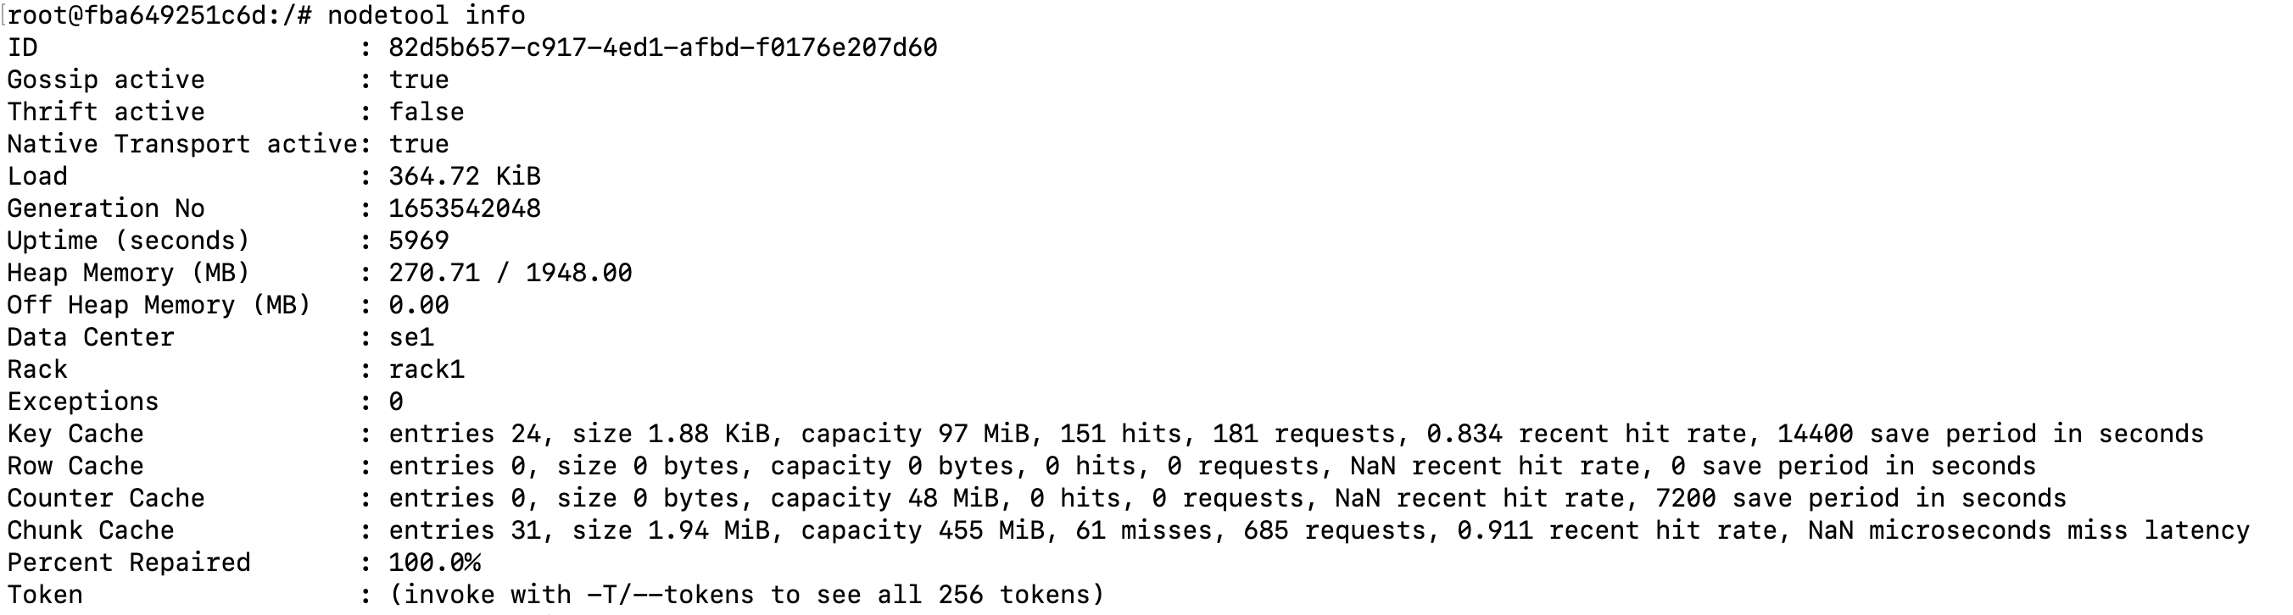

Nodetool describe cluster; getlogginglevels; setlogginglevel (TRACE); settraceprobability; drain; stop daemon