Your Title Here

Your name here  
Undergraduate Computer Science Capstone  
Capstone Advisor: Their Name Here  
SUNY Polytechnic Institute  
Fall/Spring/Summer 2021

# Introduction

What were you setting out to do?

Why is it challenging?

Why is it important?

In general, avoid:

* Colloquial language / idiom
* Contractions

# Related work

Discuss similar ideas/concepts/examples.

Cite relevant sources using IEEE format [1].

# Method

This section focuses on the project from the PROGRAMMER’S perspective.

Include things like class design, description of functionality, flow charts, and equations as relevant.

Do not forget to cite external information.

Feel free to add subsections as necessary.

Diagrams and figures are welcome, but ensure that:

1. All diagrams, figures, and tables have captions.
2. All diagrams, figures, and tables included are referred to in-text (e.g., “See Figure 1 for an example of the CycleGAN architecture”)
3. If the diagram/figure comes from another source, cite it appropriately in the caption.

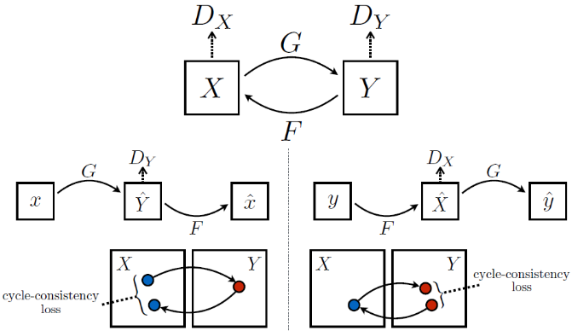

Figure : CycleGAN architecture [2]

# Results

This section focuses on the project from the USER’S perspective.

If experiment-driven, include charts and tables with results.

If application-driven, show off screenshots and demonstrate/walk-through functionality in a clear fashion; again, include captions and cite/explain in-text (“Figure 2 shows how the user can do such-and-such”).

# Discussion

This is the part that differs a bit from a typical research paper, because it should have a self-reflective part:

* What did you learn specifically (specific technology)?
* What was positive? What went right?
* What was negative? What went wrong?
* What you would do differently knowing what you know now?

# Conclusion and Future Work

Summarize what you have accomplished.

Talk about what you would do if you were to continue working on the project.

# References

This part you can handle manually OR use Word’s built-in Zotero/Mendeley support.

[1] “IEEE Overview,” *Purdue Online Writing Lab, Purdue University*. https://owl.purdue.edu/owl/research_and_citation/ieee_style/ieee_overview.html (accessed Jan. 17, 2022).

[2] J.-Y. Zhu, T. Park, P. Isola, and A. A. Efros, “Unpaired Image-to-Image Translation using Cycle-Consistent Adversarial Networks,” *ArXiv170310593 Cs*, Aug. 2020, Accessed: Jun. 01, 2021. [Online]. Available: http://arxiv.org/abs/1703.10593

# Appendix

This is effectively a README for what is necessary to install to get your project working.

Mention any software dependencies and/or libraries that must be installed.

You may cite/link to external tutorials as necessary.

Include a link to your online repository (GitHub/Bitbucket) here.