Fashion Portfolio Site Plan

Dylene Williamson

WDD 130

Overview

Purpose
Showcase my journey as an Apparel Entrepreneurship student and share my passion for fashion, design, and creating clothing. The website will highlight projects I have completed, my creative process, and future goals within the fashion industry.

Audience
Potential employers, classmates, professors, and anyone interested in fashion design, sewing, and entrepreneurship.

Branding

Website Logo

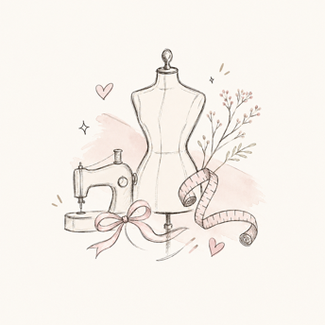

Style Guide

Color Palette
Primary | Secondary | Accent 1 | Accent 2
#22304A | #F7F4EF | #A9B7A3 | #6E6E6E

Typography

Heading Font: Comic Sans

Paragraph Font: Open Sans

Navigation
Home Projects My journey

Content

Hi! My name is Dylene, and I'm an Apparel Entrepreneurship student at BYU-Idaho. I created this website to share my passion for fashion, sewing, and creative design. Throughout my journey, I've learned how clothing can be both functional and a form of self-expression.

On this website, you'll find some of my projects, learn about my creative process, and see how my skills continue to grow. My goal is to eventually work in the fashion industry and create pieces that help people feel confident and comfortable.

Images
- About me photo
- Sewing machine/workspace photo

Projects

Some of my favorite projects have helped me build confidence in my sewing abilities. I've created pajama pants, a swimsuit, and other garments while learning important construction techniques. Every project teaches me something new and helps me become more detail-oriented.

As I continue learning, I hope to expand my skills into designing my own collections and developing products that combine creativity with practicality.

Images
Pajama pants project
swimsuit project

My journey

Choosing Apparel Entrepreneurship has allowed me to combine creativity with business skills. I've learned that building a successful brand requires more than creating clothing; it also involves marketing, communication, and understanding consumers.

In the future, I hope to continue developing my sewing, design, and entrepreneurial skills. I want to build a career where I can create products that reflect my style while also connecting with others who share similar interests.

Images
Fashion sketches or mood board
Fabric samples or workspace

Wireframes

Home

Child pages
