How to create index in Pinecone

1. Signup with google account in pine cone (<https://www.pinecone.io/> )
2. Once Sign up create index with following steps

Click on indexes and then click on create index

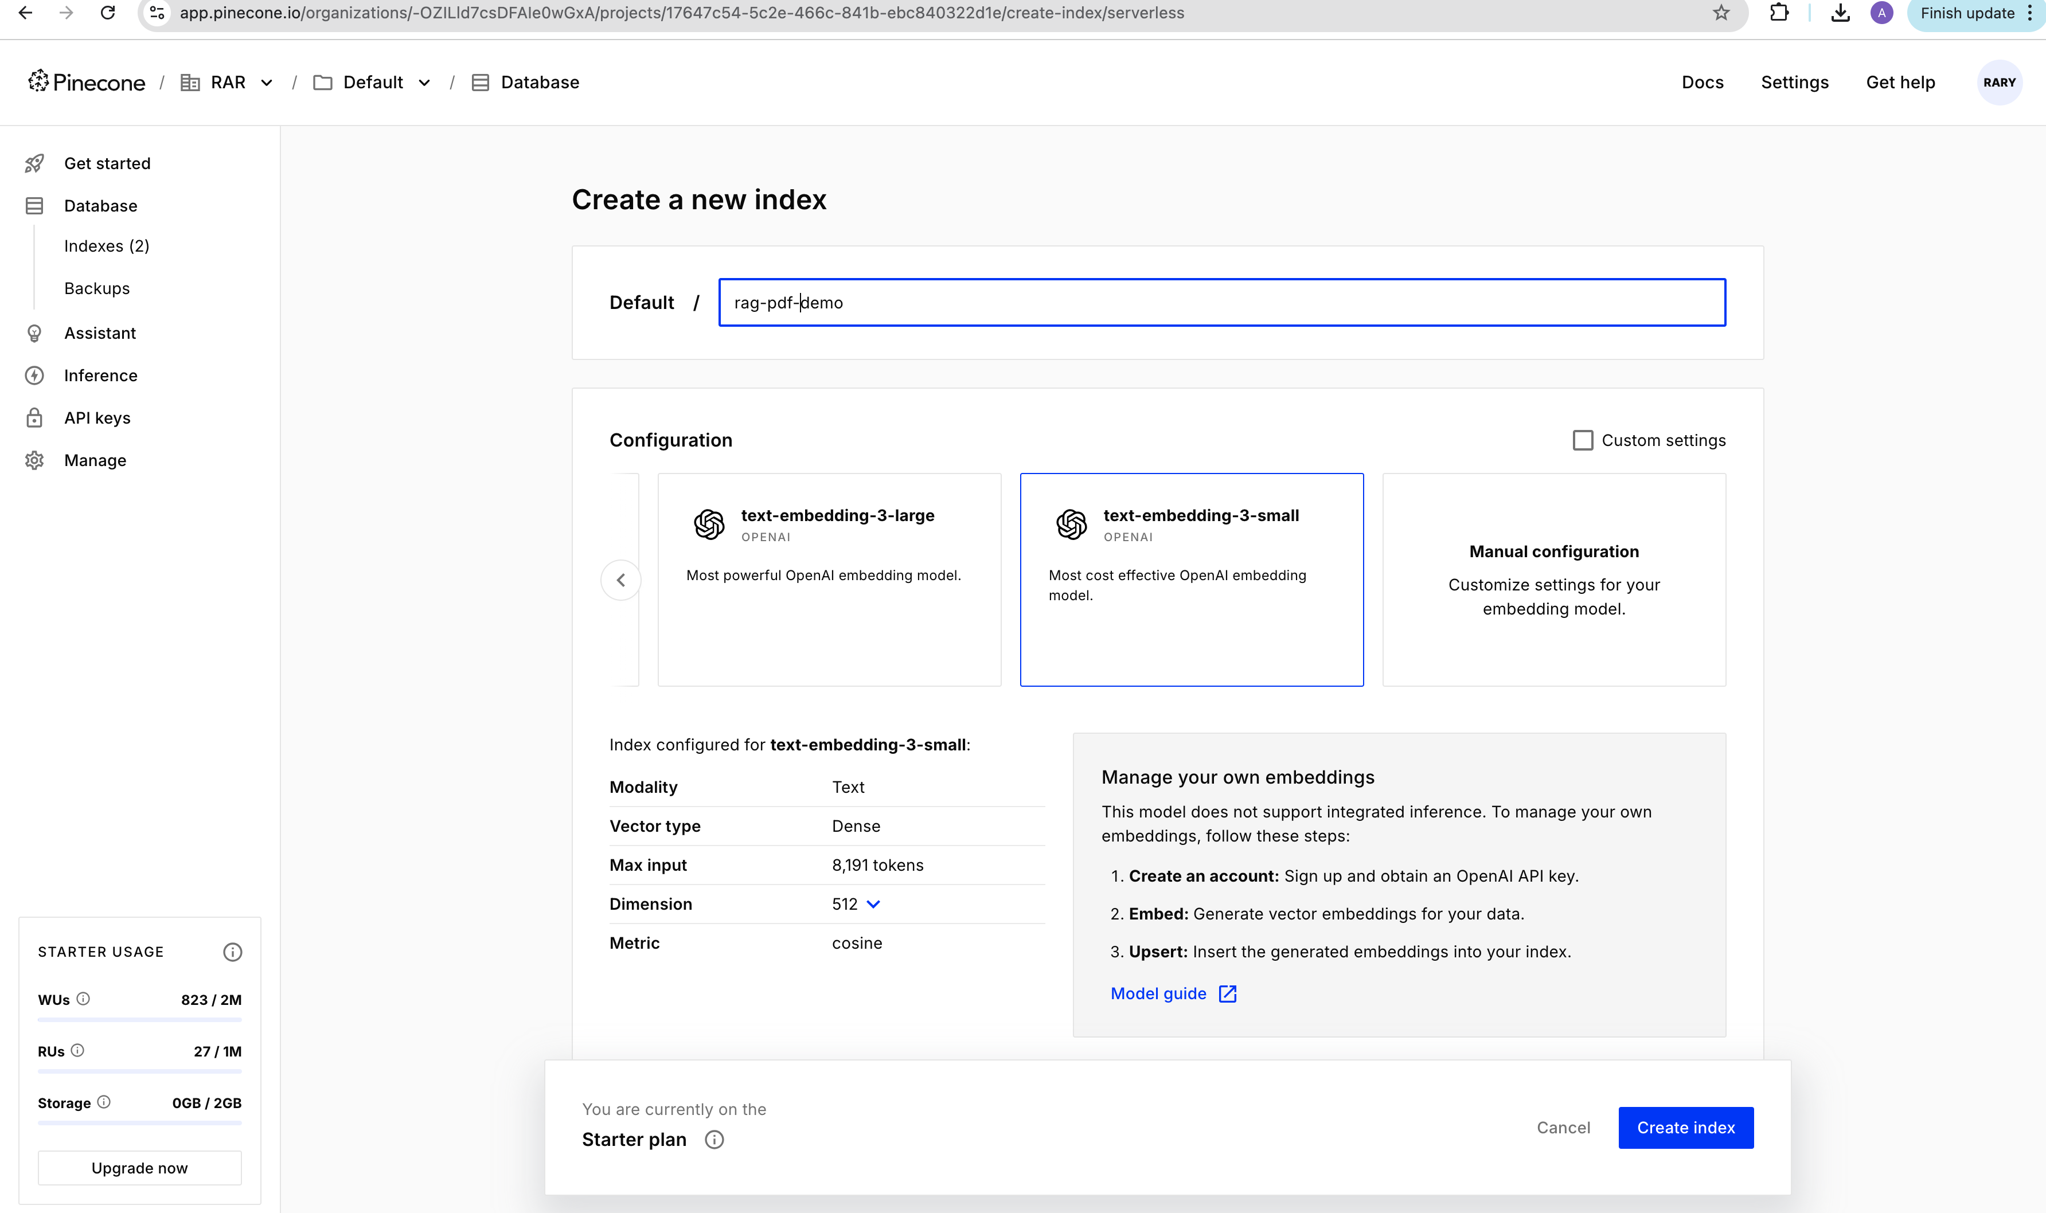

1. Based on the llm we use select the embedding model for our example we used text embedding small it is free in pine cone
2. Select server less cloud aws and region as following

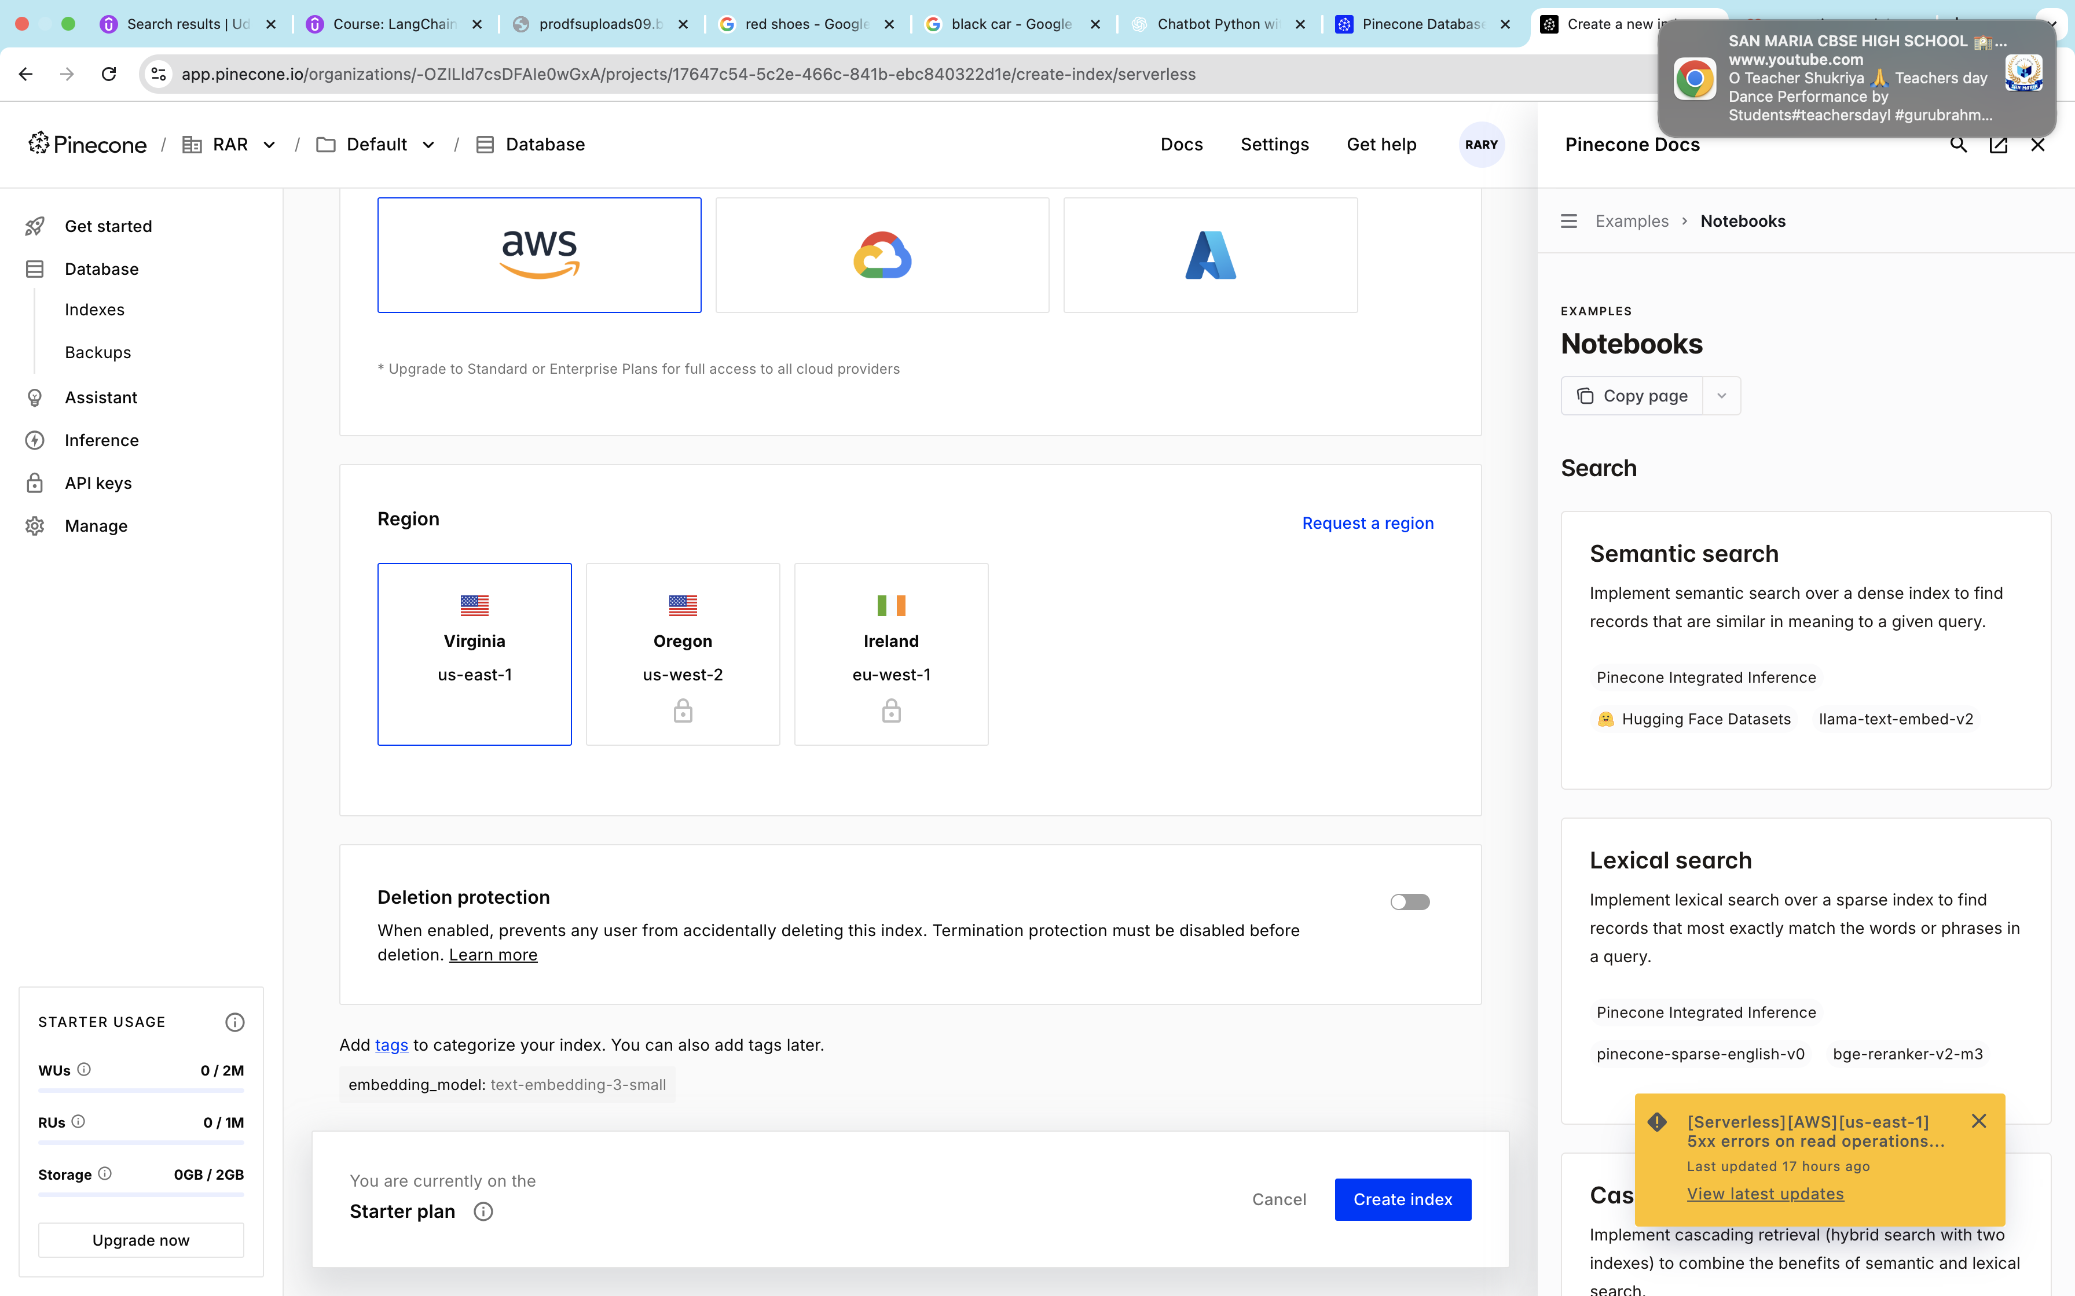

1. Once index is created it will list as following

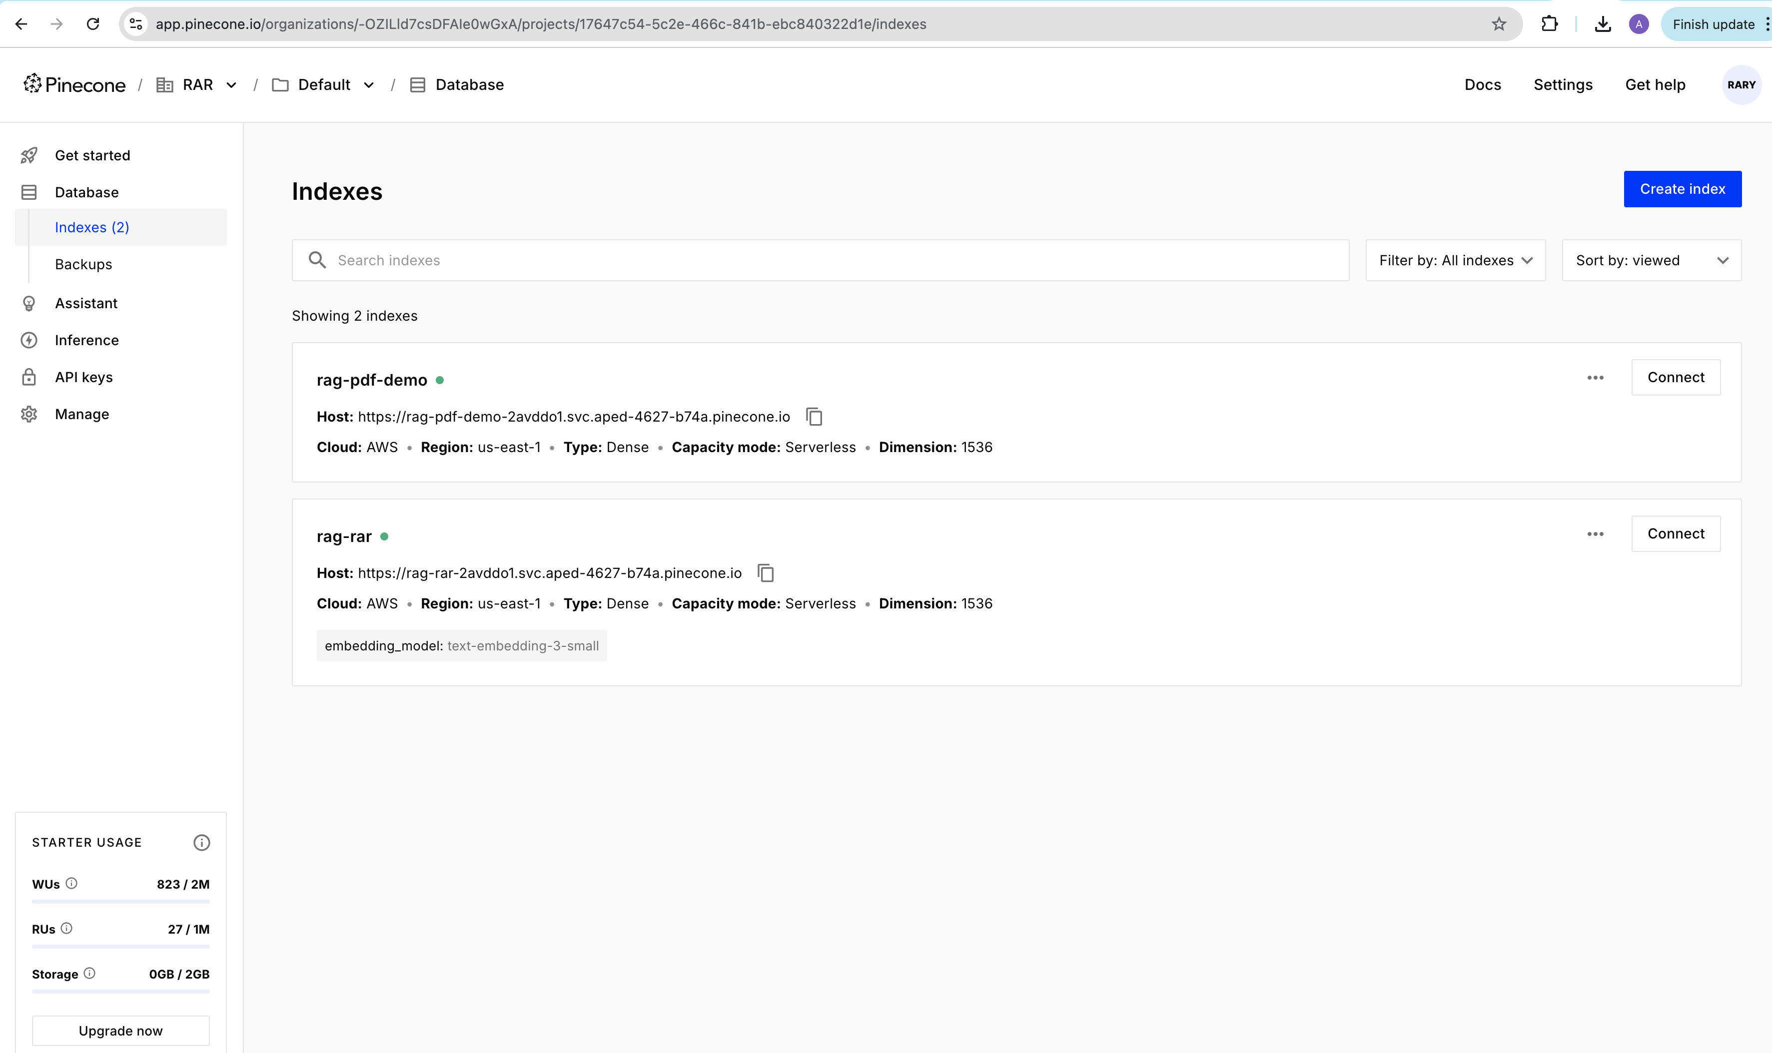

1. Now create Api keys and start storing data in to pine cone vector db

Click on Api Keys in the left , give api key name and then copy the api key immediately once generated

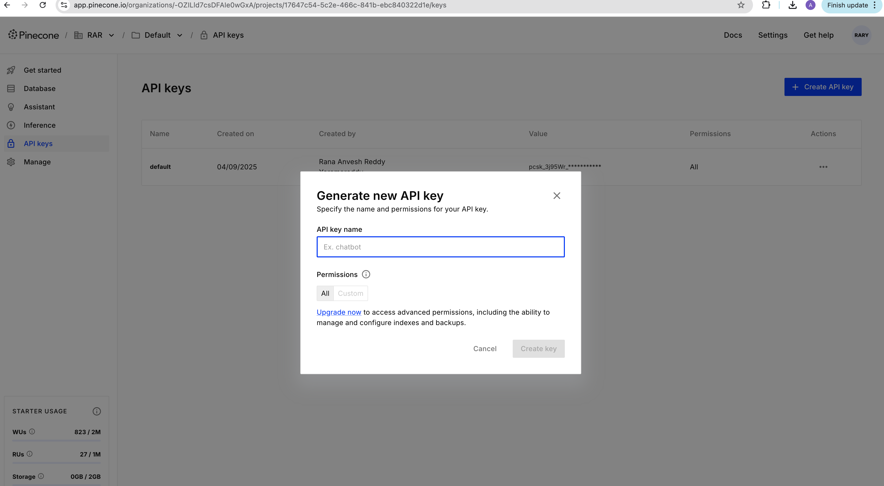

1. Now to connect from python agent to pine cone vector db in .env file mention the following things in .env file

PINECONE_API_KEY  
PINECONE_INDEX=rag-pdf-demo  
PINECONE_CLOUD=aws  
PINECONE_REGION=us-east-1  
FORCE_RECREATE_INDEX=1