CSC 120 Lab 01

This is an introductory lab. **The purpose of this lab is to understand your background and to provide guidance on how to submit assignments using Blackboard.** Questions will require you to provide screenshots as proof of your understanding. Make sure you attempt everything as there are points for attempting. Good luck!

**Motivation (**25 points)

Please provide your motivation for taking this class.

My motivation for taking this class is to expand my knowledge of computer science related topics, complete my associates degree in Science, and possibly use this as a foundation for a Computer Science degree at NC State.

**Background** (25 points)

Please provide a short summary of your computer science background. You can answer ‘None’ if you do not have any background.

* Do you have any experience with programming? If yes, which language? I previously took an Intro to Java programming course.
* Have you ever used Python? If so, in what capacity? I have never used Python.
* Do you have any experience with digital logic and binary? I have minimal experience with digital logic and binary.
* Do you have any experience with algorithm design? I do not have experience with algorithm design.

**Resources (**25 points)

* Do you have access to a laptop and internet? Yes
* Are you able to find the lectures and assignments on Blackboard? Please provide a screenshot. Yes
* 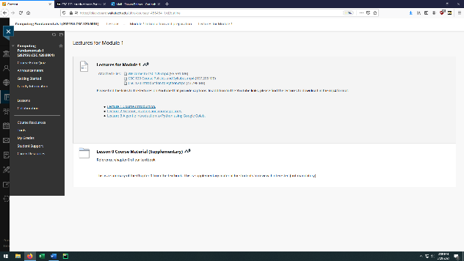
* How would you join office hours? I will join office hours through Microsoft Teams.
* Do you know where to read the announcements on Blackboard? Please provide a screenshot. Yes

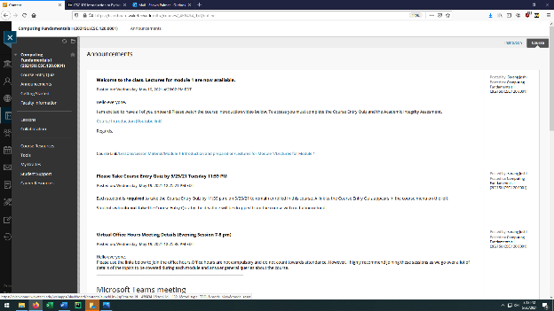

* Do you know where to find the course syllabus? Please provide a screenshot Yes

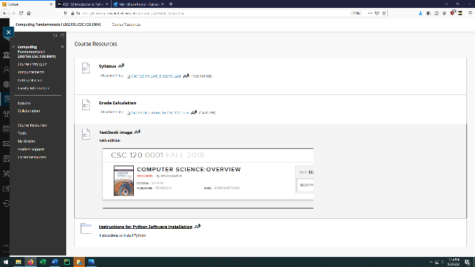

**Google Colab (**30 points)

Please create an account and a new notebook on Google Colab and provide a url to the Notebook.

For example, here is a sample url to a Notebook I have created for this class. [*https://colab.research.google.com/drive/1q8SCxYjgFxzZNcrdR1AMsG2Iys6rcD7O?usp=sharing*](https://colab.research.google.com/drive/1q8SCxYjgFxzZNcrdR1AMsG2Iys6rcD7O?usp=sharing)

https://colab.research.google.com/drive/1iSUoJX_3mrG-81aSHSrmRypFVa4siPWs?usp=sharing

**Instructions: Upload the file with the screenshot on Blackboard with your firstname_lastname.docx**