CSC 120 Lab 07

Instructions:

* Please refer to the lectures posted and the textbook in order to answer these questions.
* Provide screenshots wherever applicable.
* For programming questions, please provide a screenshot and a link to Google Colab
* You may refer to online sources for exploration but do not directly copy paste from these sources.

1. **Question 1: What is the difference between UDP and TCP protocols? Which layer of the OSI model do these protocols belong to? Provide differences in a table. (10 points)**

|  |  |
| --- | --- |
| **TCP** | **UDP** |
| Connected | Connectionless |
| Relatively slow | Relatively fast |
| Point to Point | Supports Multicast |
| Security: SSL/TLS | Security: DTLS |

These protocols belong to the transport layer.

1. **Question 2: List the layers in the OSI model and provide one service, application or example provided by each layer.**
   1. **points)**

https://www.networkworld.com/article/3239677/the-osi-model-explained-and-how-to-easily-remember-its-7-layers.html

**Application layer:** Web browsers such as Google Chrome rely on this layer.

**Presentation layer:** Encryption and decryption of data for secure transmissions happen at this layer.

**Session layer:** Involves setup, coordination, and termination between applications

**Transport layer:** Best known example is Transmission Control Protocol (TCP).

**Network layer:** Helps to connect servers efficiently, responsible for packet forwarding.

**Data link layer:** Most switches operate here. Provides note-to-note data transfer.

**Physical layer:** The plug and socket for a network cable are examples of components associated with this layer.

1. **Question 3: What is the difference between HTTP and HTTPS? What is encryption and what is its benefit ?**
   1. points)

HTTPS is HTTP with encryption. Encryption is a way of scrambling data so that only authorized parties can understand the information. The benefit is this makes HTTPS far more secure.

1. **Question 4: Write a brief definition for ports and sockets. What is the port number for email?**
   1. **points)**

<https://www.geeksforgeeks.org/difference-between-socket-and-port/>

**Port:** logical construct assigned to network processes so that they can be identified within the system.

**Socket**: combination of port and IP address

The default port number for email is port 587.

1. **Question 5: What are the risks when connecting to a public wifi network such as a coffee shop, airport, hotel wifi network. What happens if you connect to a website using http vs https over such a network (10 points)**

The risk is that unauthorized personal could gain access to your information. If you connect with http, you are more likely to be “hacked”. In other words, the website will be far less secure, and your information can be more easily accessed.

1. **Question 6: In this section, we will find the IP address, MAC address of our machines. For this section, we will open the command prompt or terminal on our laptops/PCs. (10 points)**

**Step 0:** Open command prompt on your machine. For Linux, Mac users, this is called the terminal. For Windows, it is called the command prompt.

**Step 1:** For Linux, Mac, run the command ifconfig in the terminal. For Windows, run the command ipconfig in the command prompt.

**Step 2:** Find the Wi-Fi adapter. For Windows, this should be labeled as Wireless LAN adapter Wi-Fi. For Mac, this will be labeled as en1.

**Step 3:** What is the IPv4 address of the Wi-Fi adapter you found above?

192.168.86.42

Note: Never provide your MAC address or default gateway to strangers. Hackers use this information to gain access to your computer and run malicious scripts that may delete or steal your data.

1. **Question 7: In this section, we run a ping command to an existing server. For this section, we will open the command prompt or terminal on our laptops/PCs. (10 points)**

**Step 0:** Open command prompt on your machine. For Linux, Mac users, this is called the terminal. For Windows, it is called the command prompt.

**Step 1:** For Linux, Mac and Windows, run the command ping www.google.com in the terminal.

Note: You can exit the command by pressing Ctrl+C on your keyboard.

**Step 2:** Write 2-3 lines about the ping command and what it does.

<https://www.ibm.com/docs/en/aix/7.1?topic=p-ping-command>

The **ping command** sends one datagram per second and prints one line of output for every response received. The **ping command** calculates round-trip times and packet loss statistics, and displays a brief summary on completion.

**Step 3:** Paste a screenshot of the output.

Note: Never provide your MAC address or default gateway to strangers. Hackers use this information to gain access to your computer and run malicious scripts that may delete or steal your data.

# Question 8: Connect to your router. (10 points)

We will find out more information about the router in your home. This router has an IP address which it uses to connect to devices. The objective of this question is to find the address of your router and make a note of the settings you can change from this interface.

1. Find your router IP address. Use [PCMag’s](https://www.pcmag.com/how-to/how-to-access-your-wi-fi-routers-settings) [guide](https://www.pcmag.com/how-to/how-to-access-your-wi-fi-routers-settings) to find out how to access your gateway. Note: You will need to login. Generally the default login and password for your router will be found on the internet. You can change this if you want to secure your router but make sure you remember the new password.
2. Questions:
   1. What is the frequency of your network? 5745 Mhz
   2. How many bands or channels are available for that frequency? 80 Mhz
   3. What is the bandwidth of the connection? 149
   4. Can you change your Wi-Fi password from this interface? Yes
   5. Can you change your email password from this interface? No
3. General tips:
   1. The login for default gateway is generally username: admin, password: password. Search the internet for default login instructions.

Note: Never provide your MAC address or default gateway to strangers. Hackers use this information to gain access to your computer and run malicious scripts that may delete or steal your data.

**9. Question 9: Python program to make a simple GET request.**

**(20 points)**

Definitions: An HTTP request is made by a client, to a named host, which is located on a server. The aim of the request is to access a resource on the server. An HTTP response is made by a server to a client. The aim of the response is to provide the client with the resource it requested, or to inform the client that the action it requested has been carried out, or to inform the client that an error occurred in processing its request. (Defn. from [IBM docs](https://www.ibm.com/docs/en/cics-ts/5.3?topic=concepts-http-protocol))

Run the following code and answer the questions.

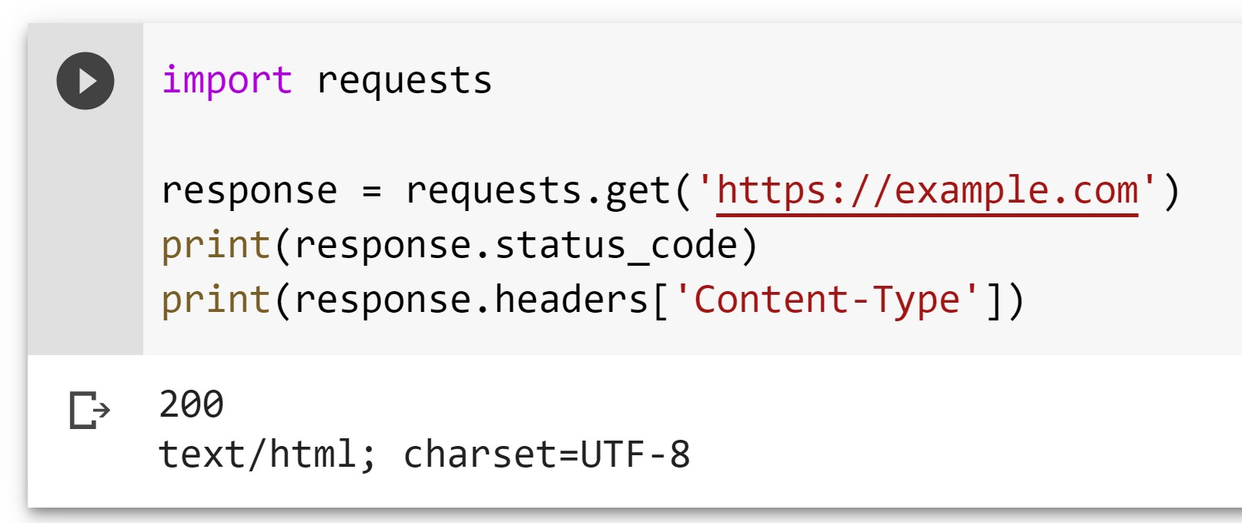

1. What is the meaning of status code 200? This means that the request has succeeded.
2. What is the meaning of status code 404? The server has not found anything matching the Request-URI.
3. Write a condition that prints “SUCCESS” if a status code is 200. If not, print “Error”. Paste the output screenshot. Use if...else..

1. Replace the URL [https://example.com](https://example.com/) with a website of your choice. Run the code again with the updated website and print out status code and headers. Website Options:

<http://www.nytimes.com>

**Additional exploration for interested students (No credit)**

1. What is Wireshark? Hint: Refer to the docs at https://www.wireshark.org/docs/wsug_html_chunked/ChapterIntroduction.html to answer the question.
2. Do a quick search and name two other packet analyzers.
3. What is latency, bandwidth and throughput for a network?
4. What is the size of an IPV4 address, What is the size of an IPV6 address.
5. How many unique addresses are available for an IPv4 address?
6. What are firewalls?
7. What is DHCP?
8. What is DNS?
9. Explain the difference between private IP vs public IP
10. Explain the difference between static IP and dynamic IP
11. Install Wireshark.
    1. Locate Wi-Fi in the list of interfaces shown on the Wireshark opening page. Click on it.

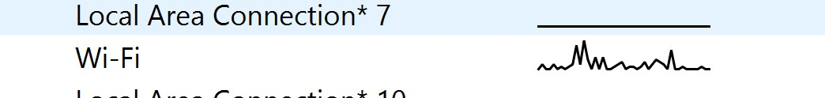

* 1. Observe the packets and click on one that says UDP in the protocol column.
  2. The information for this packet will be shown in the window below. Click on the dropdown called User Datagram Protocol.

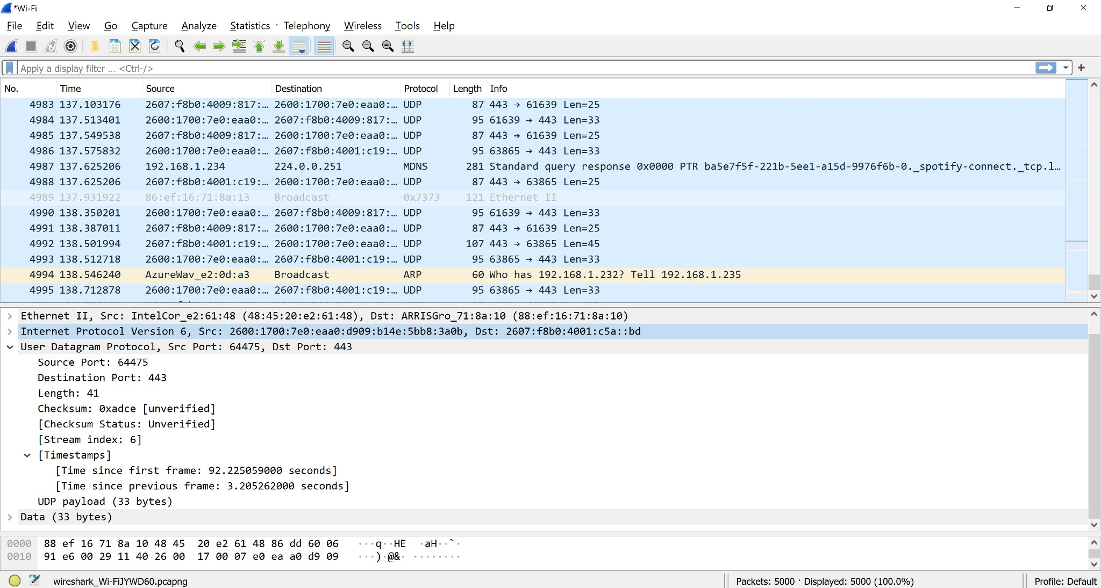

**Instructions: Upload the file with the screenshot on Blackboard with your firstname_lastname.docx**