**CS673 Software Engineering** 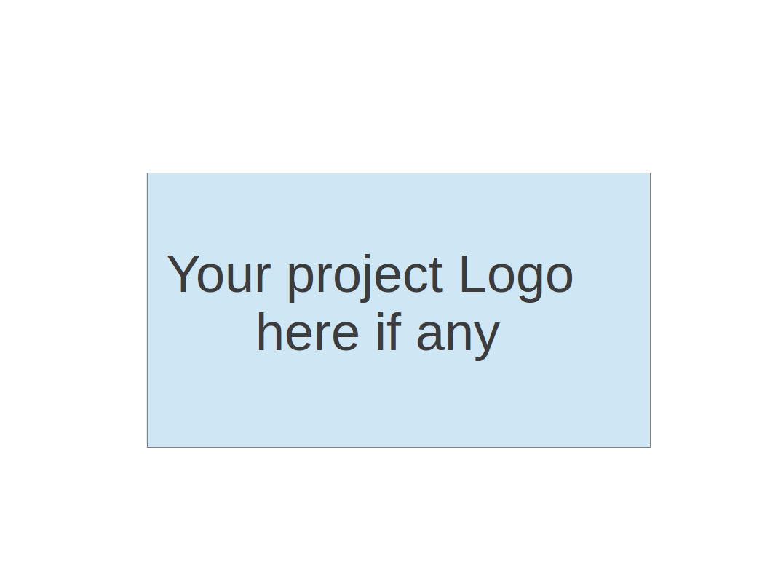

**Team 5 - Simple Health**

**Tests Report**

| Team Member | Role(s) | Signature | Date |
| --- | --- | --- | --- |
| Seema Palora | Team Leader | Seema Palora | 09/08/2021 |
| Yang Ye | Requirement Leader, Security Leader | Yang Ye | 09/08/2021 |
| Jake Stephens | Backup Team Leader, QA Leader | Jake Stephens | 09/08/2021 |
| Sherperd Liu | Configuration Leader | Sherperd Liu | 09/08/2021 |
| Sandeep Agrawal | Design and Implementation Leader | Sandeep Agrawal | 09/08/2021 |

**Revision history**

| **Version** | **Author** | **Date** | **Change** |
| --- | --- | --- | --- |
| **1.0** | **Jake Stephens** | **9/12/2021** | **Initial pass** |
|  |  |  |  |

Introduction

Test Summary

Tests Reports

Testing Metrics

References

Glossary

# Introduction

This document will list the results of the unit tests and end to end tests for each merge into the develop branch.

# Test Summary

* + Unit Tests - Testing the code line by line
  + End-to-end Tests - Testing the whole functionality of the app, including the availability of the third party applications leveraged. The end to end tests will create mock real world scenarios that will be asserted and validated that they are working correctly.

# Tests Reports

In this section, you will give a detailed description of each test case performed and the result. You shall list what are existing tests developed in the previous semester and what are new tests developed currently.

Here is a sample template that can be used for each test case. For system tests or acceptance tests, you may also include some screenshots.

* Test case ID, name
* New or old:
* Test items: (what do you test )
* Test priority (high/medium/low)
* Dependencies (to other test case/requirement if any):
* Preconditions: (if any)
* input data:
* Test steps:
* Postconditions:
* Expected output:
* Actual output:
* Pass or Fail:
* Bug id/link: (this should link to your github issue id)
* Additional notes:

(You can use an additional spreadsheet for this section as well)

# Testing Metrics

* Coverage
* Number of unit tests passed
* End to end test results

# References

# Glossary