# Develop a Django app that displays current date and time in server

**views.py**

import datetime

from django.http import HttpResponse from django.shortcuts import render

# Create your views here.

def current_date_time(request): now=datetime.datetime.now()

result="<html><body><h1>Current Date and time is %s" %(now) return HttpResponse(result)

# urls.py

from django.contrib import admin from django.urls import path

from ap1.views import current_date_time,four_hours_ahead,four_hours_before from ap2.views import showlist

urlpatterns = [

path('admin/', admin.site.urls), path('cdt/', current_date_time ),

# OUTPUT:



1. **Develop a Django app that displays date and time four hours ahead and four hours before as an offset of current date and time in server.**

*Views.py*

import datetime

from django.http import HttpResponse from django.shortcuts import render

# Create your views here.

def current_date_time(request): now=datetime.datetime.now() result="<html><body><h1>Current Date and time

is %s" %(now)

return HttpResponse(result)

def four_hours_ahead(request):

dt = datetime.datetime.now() + datetime.timedelta(hours=4)

html = "<html><body><h1>After 4hour(s), it will be %s.</h1>"% (dt,)

return HttpResponse(html)

def four_hours_before(request):

dt = datetime.datetime.now() + datetime.timedelta(hours=-4)

html = "<html><body><h1>Before 4 hour(s), it was %s.</h1>"% (dt,)

return HttpResponse(html)

*urls.py*

from django.contrib import admin from django.urls import path from ap1.views import

current_date_time,four_hours_ahead,four_hours_befor e

urlpatterns = [

path('admin/', admin.site.urls), path('cdt/', current_date_time ),y path('fhrsa/',four_hours_ahead), path('fhrsb/',four_hours_before),

]

# OUTPUT:

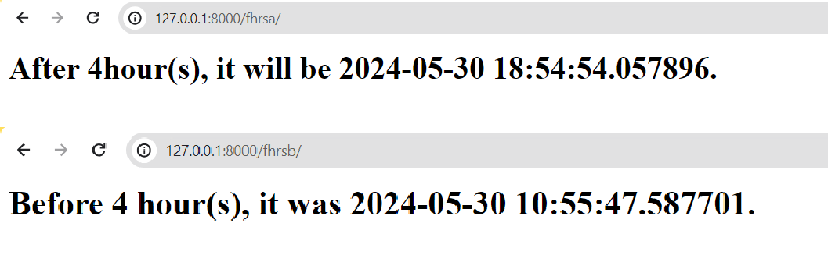

1. **Develop a simple Django app that displays an unordered list of fruits and ordered list of selected students for an event**

*Create an another ap folder:*

python manage.py startapp ap2

***Create a folder “templates” in ap2***

***Create a file “****showlist.html****” as mentioned below in***

***templates folder***

### ap2/templates/showlist.html

**<html>**

**<style type="text/css">**

**#i1 {background-color: lightgreen;color:brown;display:table} #i2 {background-color: black;color:yellow;display:table}**

**</style>**

**<body>**

**</body>**

**</html>**

### views.py

**<h1 id="i1">Unordered list of fruits</h1>**

**<ul>**

**{% for fruit in fruits %}**

**<li>{{ fruit }}</li>**

**{% endfor %}**

**</ul>**

**<h1 id="i2">Ordered list of Students</h1>**

**<ol>**

**{% for student in student_names %}**

**<li>{{ student }}</li>**

**{% endfor %}**

**</ol>**

**from django.shortcuts import render # Create your views here.**

**def showlist(request): fruits=["Mango","Apple","Banana","Jackfruits"] student_names=["Tony","Mony","Sony","Bob"] return**

**render(request,'showlist.html',{"fruits":fruits,"student_names":student_names}**

**)**

### urls.py

**from django.contrib import admin from django.urls import path**

**from ap1.views import current_date_time,four_hours_ahead,four_hours_before from ap2.views import showlist**

**urlpatterns = [**

**path('admin/', admin.site.urls), path('cdt/', current_date_time ), path('fhrsa/',four_hours_ahead), path('fhrsb/',four_hours_before), path('showlist/', showlist),**

**]**

*Lab/settings.py*

**TEMPLATES = [**

**{**

**'BACKEND': 'django.template.backends.django.DjangoTemplates', 'DIRS': [os.path.join(BASE_DIR,'ap2/templates'),],**

**'APP_DIRS': True, 'OPTIONS': {**

**'context_processors': [ 'django.template.context_processors.debug', 'django.template.context_processors.request', 'django.contrib.auth.context_processors.auth', 'django.contrib.messages.context_processors.messages',**

**],**

**},**

**},**

**]**

*OUTPUT:*

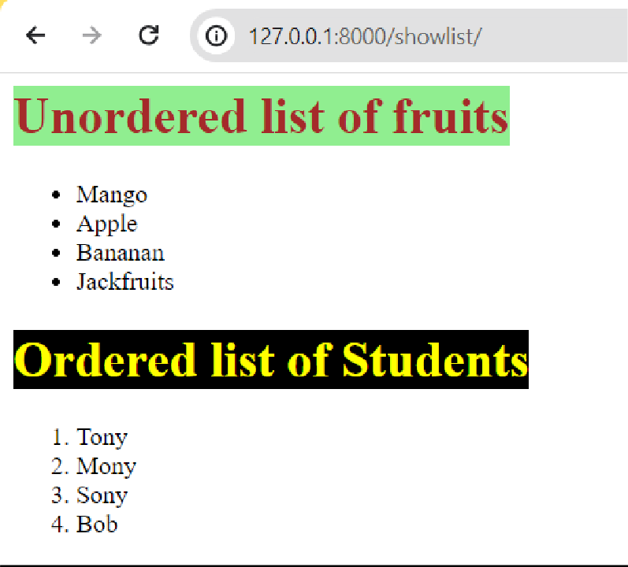

# Develop a layout.html with a suitable header (containing navigation menu) and footer with copyright and developer information. Inherit this layout.html and create 3 additional pages: contact us, About Us and Home page of any website. *views.py*

from django.shortcuts import render

def home(request):

return render(request,'home.html') def aboutus(request):

return render(request,'aboutus.html') def contactus(request):

return render(request,'contactus.html')

### urls.py

from django.urls import path

from ap2.views import aboutus,home,contactus

urlpatterns = [ path('aboutus/', aboutus), path('home/', home),

path('contactus/', contactus),

]

### Template files layout.html

<html>

<title>{% block title %} {% endblock %} </title>

<style type="text/css">

nav {background-color: lightblue;padding:10px}

</style>

<body>

<nav>

<a href="/home/">Home</a>|

<a href="/aboutus/">About Us</a>|

<a href="/contactus/">Contact Us</a>|

</nav>

<section>

{% block content %}{% endblock %}

</section>

<footer>

<hr>

&copy; Developed by Sir MVIT, Bengaluru

</footer>

</body>

</html>

### home.html

{% extends 'layout.html' %}

{% block title %} Home

{% endblock %}

{% block content %}

<h2>This is the home page</h2>

{% endblock %}

### aboutus.html

{% extends 'layout.html' %}

{% block title %} About Us

{% endblock %}

{% block content %}

<h2>We are DJango developers</h2>

{% endblock %}

### contactus.html

{% extends 'layout.html' %}

{% block title %} Contact us

{% endblock %}

{% block content %}

<h2> phone: 9900556688 <br> Address: Sir MVIT,Bengaluru</h2>

{% endblock %}

*OUTPUT:*

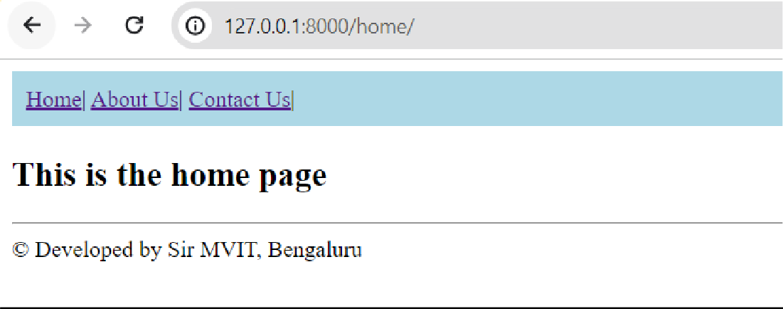

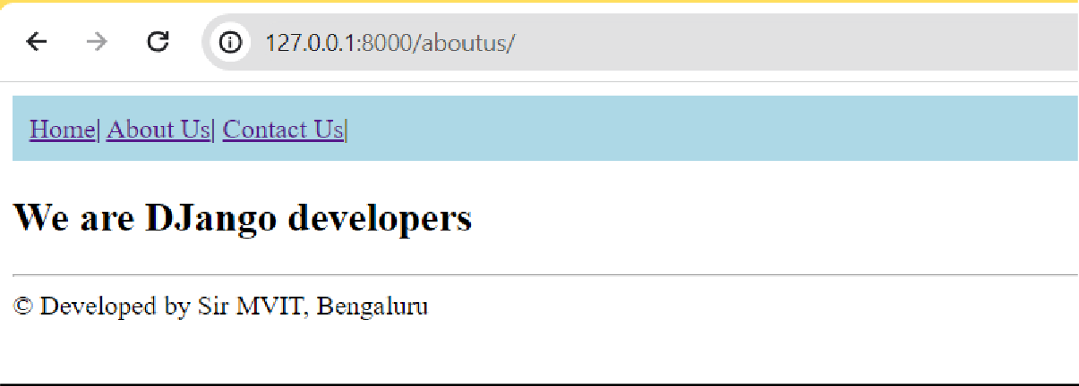

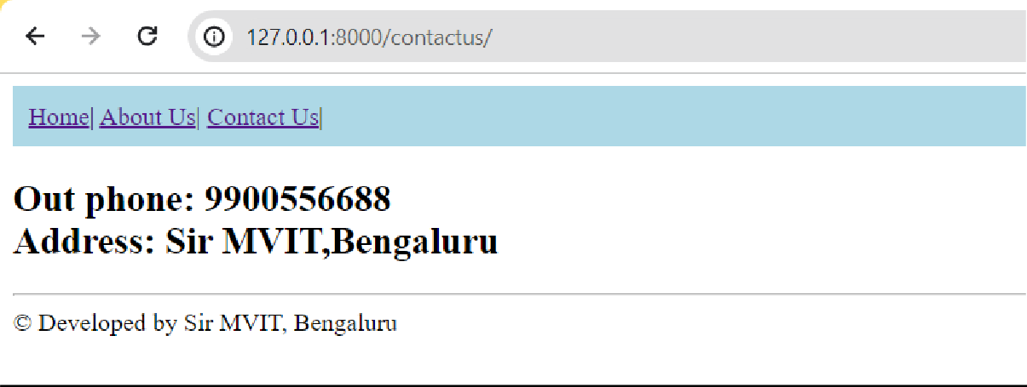

# Develop a Django app that performs student registration to a course. It should also display list of students registered for any selected course. Create students and course as models with enrolment as ManyToMany field.

## WAMP Server link

[**https://sourceforge.net/projects/wampserver/files/latest/downlo**](https://sourceforge.net/projects/wampserver/files/latest/download)[**ad**](https://sourceforge.net/projects/wampserver/files/latest/download)

During installation process, many files will be missing and system asks to install it. Hence download the files from this website:

[**https://wampserver.aviatechno.net/**](https://wampserver.aviatechno.net/)

After successful installation of WAMP server, start it and then go to

[**http://localhost/phpmyadmin**](http://localhost/phpmyadmin) **Usename: root**

# Password- empty

## Use phpMyAdmin

Create a new database “studentreg”

**PS D:\SirMVIT\MY_SUBJECTS\FullStackDevelopment> python manage.py startapp ap3**

**Install mysqlclient from VS Code terminal:**

**pip install mysqlclient**

**static and template folder creation and 3 files inside this folder**

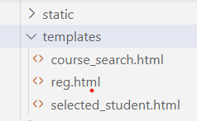

## course_search.html

<html>

<body>

<form method="POST" action=""> Courses

{% csrf_token %}

<select name="cname">

{%for course in courses %}

<option value="{{course.id}}">{{course.course_name}}</option>

{% endfor %}

</select>

<input type="submit" value="Search">

</form>

</body>

</html>

## reg.html

<html>

<body>

<form method="post" action="">

{% csrf_token %} Student Name

<select name="sname">

{%for student in students %}

<option value="{{student.id}}">{{student.student_name}}</option>

{% endfor %}

</select><br> Course Name

<select name="cname">

{%for course in courses %}

<option value="{{course.id}}">{{course.course_name}}</option>

{% endfor %}

</select><br>

<input type="submit" value="Enroll">

</form>

</body>

</html>

## selected_student.html

<html>

<body>

<table border>

<tr>

<th>Student Name</th>

<th>Student USN</th>

<th>Sem</th>

</tr>

{% for student in student_list %}

<tr>

<td>{{student.student_name}}</td>

<td>{{student.student_usn}}</td>

<td>{{student.student_sem}}</td>

</tr>

{% endfor %}

</table>

</body>

</html>

## models.py

from django.db import models

# Create your models here. class Course(models.Model):

course_code=models.CharField(max_length=40) course_name=models.CharField(max_length=100) course_credits=models.IntegerField()

class Student(models.Model): student_usn=models.CharField(max_length=20) student_name=models.CharField(max_length=100) student_sem=models.IntegerField() enrolment=models.ManyToManyField(Course)

## views.py

from django.http import HttpResponse from django.shortcuts import render

from ap3.models import Course, Student # Create your views here.

def reg(request):

if request.method == "POST": sid=request.POST.get("sname") cid=request.POST.get("cname") student=Student.objects.get(id=sid) course=Course.objects.get(id=cid) res=student.enrolment.filter(id=cid) if res:

return HttpResponse("<h1>Student already enrolled</h1>") student.enrolment.add(course)

return HttpResponse("<h1>Student enrolled successfully</h1>") else:

students=Student.objects.all() courses=Course.objects.all()

return render(request,"reg.html",{"students":students, "courses":courses})

def course_search(request):

if request.method=="POST": cid=request.POST.get("cname") s=Student.objects.all() student_list=list()

for student in s:

if student.enrolment.filter(id=cid): student_list.append(student)

if len(student_list)==0:

return HttpResponse("<h1>No Students enrolled</h1>") return

render(request,"selected_student.html",{"student_list":student_list}) else:

courses=Course.objects.all()

return render(request,"course_search.html",{"courses":courses})

## urls.py

from ap3.views import reg, course_search

urlpatterns = [

path('admin/', admin.site.urls), path('cdt/', current_date_time ), path('fhrsa/',four_hours_ahead), path('fhrsb/',four_hours_before), path('showlist/', showlist), path('aboutus/', aboutus), path('home/', home), path('contactus/', contactus), path('reg/', reg), path('course_search/',course_search),

]

## settings.py

INSTALLED_APPS = [

'django.contrib.admin', 'django.contrib.auth', 'django.contrib.contenttypes', 'django.contrib.sessions', 'django.contrib.messages', 'django.contrib.staticfiles', 'ap3'

]

TEMPLATES = [

{

'BACKEND': 'django.template.backends.django.DjangoTemplates', 'DIRS': [os.path.join(BASE_DIR,'ap3/templates'),], 'APP_DIRS': True,

'OPTIONS': {

'context_processors': [ 'django.template.context_processors.debug', 'django.template.context_processors.request', 'django.contrib.auth.context_processors.auth', 'django.contrib.messages.context_processors.messages',

],

},

},

]

DATABASES = {

'default': {

'ENGINE': 'django.db.backends.mysql',

'NAME': 'studentreg',

'USER': 'root',

'PASSWORD': '',

'HOST':'localhost',

'PORT':'3306',

}

}

STATIC_URL = 'static/' STATICFILES_DIRS=[os.path.join(BASE_DIR, 'ap3/static')]

***Perform Migrations***

# python manage.py makemigrations ap3 python manage.py migrate

**python manage.py runserver**

***Note: migration should be done every time as models.py change or any database table changes*.**

## Insert into tables in phpmyadmin

[**http://localhost/phpmyadmin**](http://localhost/phpmyadmin)

OR

[**http://localhost/phpmyadmin/index.php?route=/sql&pos=0&db=s**](http://localhost/phpmyadmin/index.php?route=/sql&pos=0&db=studentreg&table=ap3_course)[**tudentreg&table=ap3_course**](http://localhost/phpmyadmin/index.php?route=/sql&pos=0&db=studentreg&table=ap3_course)

[**http://localhost/phpmyadmin/index.php?route=/sql&pos=0&db=s**](http://localhost/phpmyadmin/index.php?route=/sql&pos=0&db=studentreg&table=ap3_student)[**tudentreg&table=ap3_student**](http://localhost/phpmyadmin/index.php?route=/sql&pos=0&db=studentreg&table=ap3_student)

# ap3_student and ap3_course

***OUTPUT***

***Run the url***

# http://127.0.0.1:8000/reg/

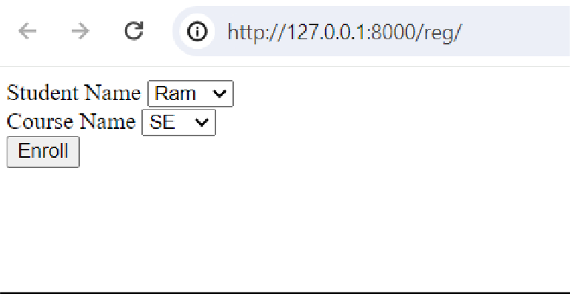

**http://127.0.0.1:8000/course_search/**

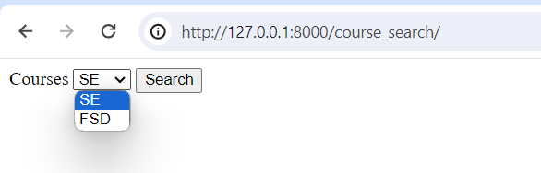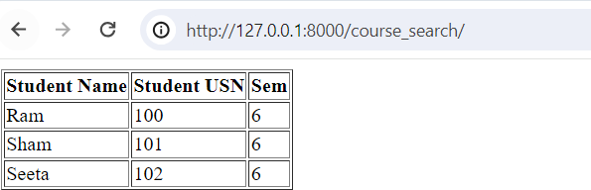

**Module 3:**

**6. For student and course models created in Lab experiment for Module2, register admin interfaces, perform migrations and illustrate data entry through admin forms.**

1)admin.py

from django.contrib import admin

from ap3.models import Course, Student # Register your models here. admin.site.register(Student) admin.site.register(Course)

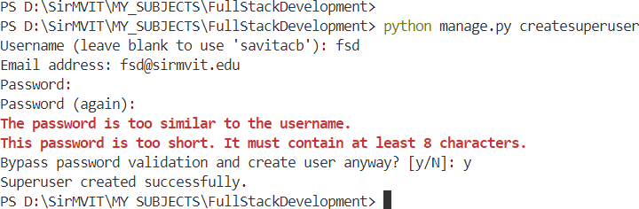

PS D:\SirMVIT\MY_SUBJECTS\FullStackDevelopment> python manage.py runserver

➔ Login with your superuser credentials

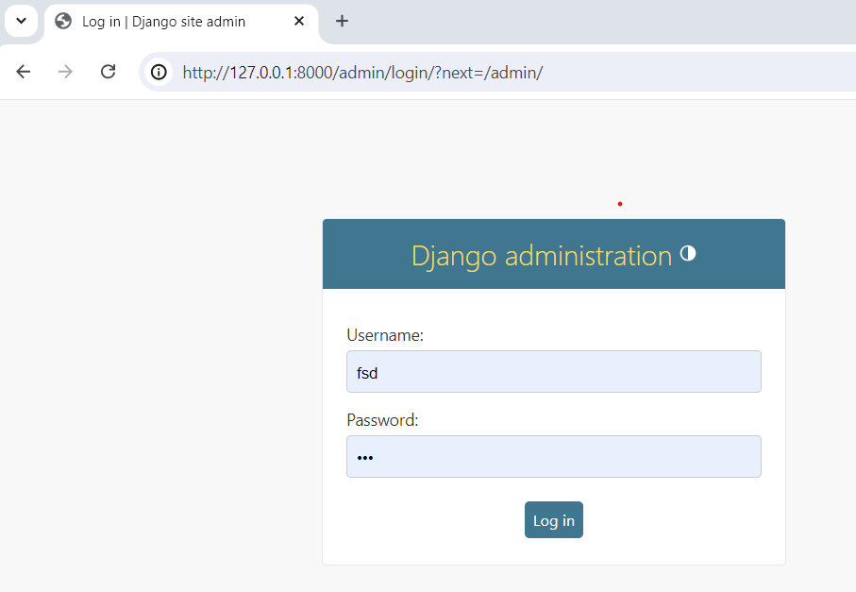

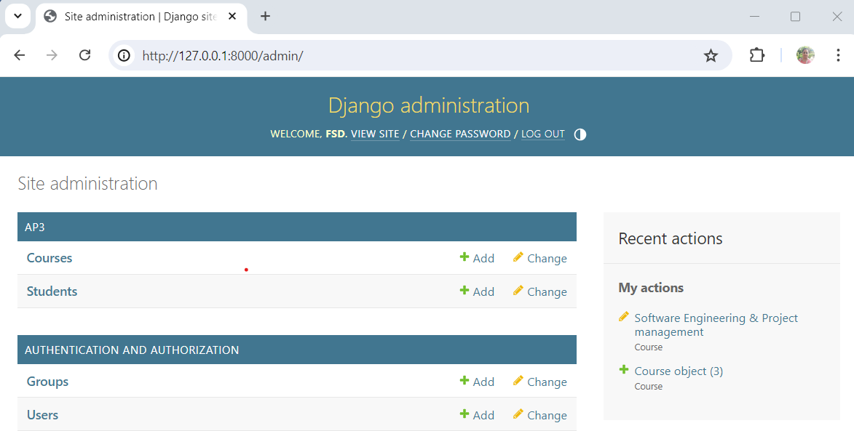➔ Index page should be visible

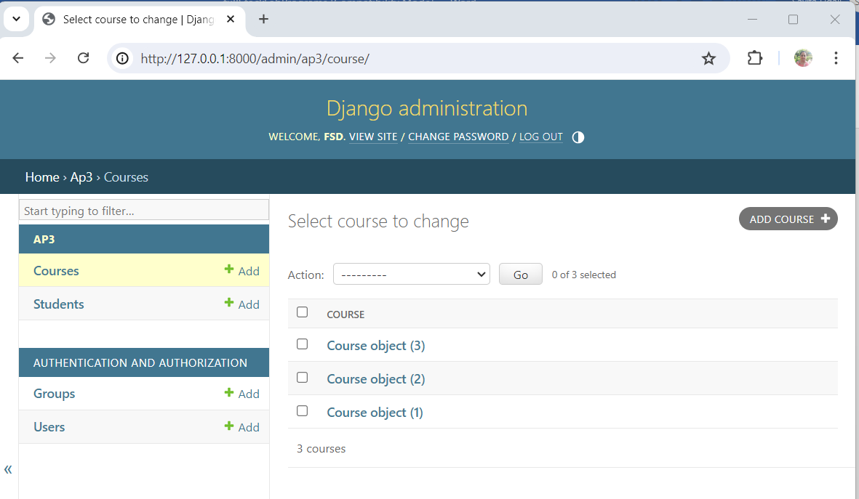➔ Go to Courses

➔ Add course

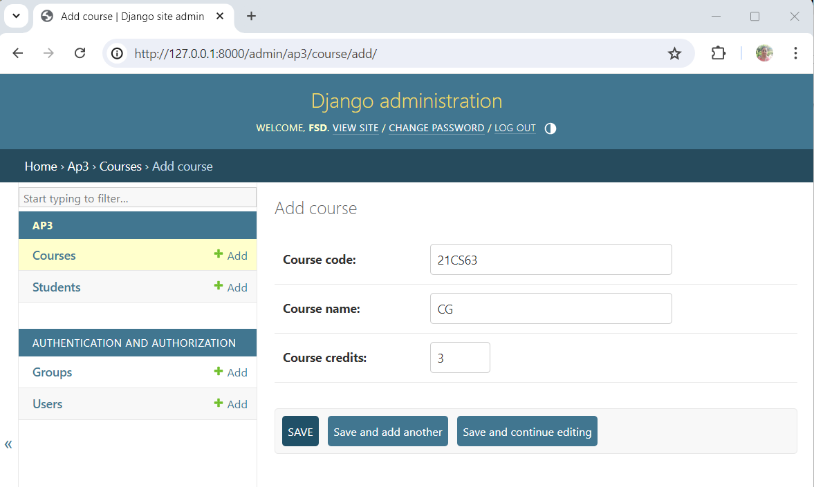

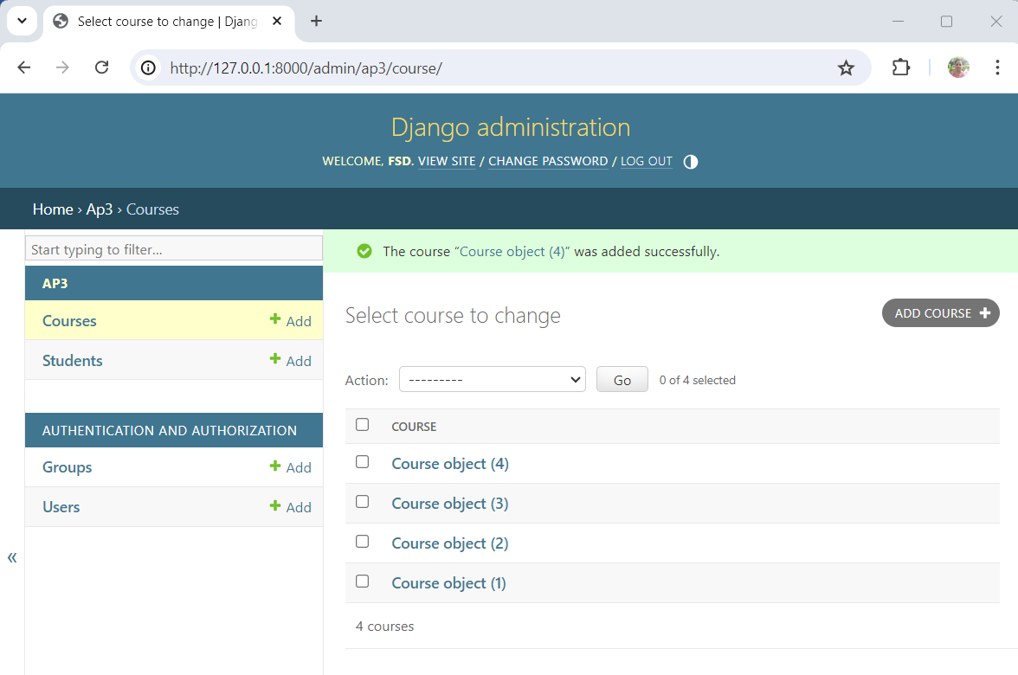

➔ We see a very vague display of objects. To fix it, make the following changes in models.py

**models.py**

from django.db import models

# Create your models here. class Course(models.Model):

course_code=models.CharField(max_length=40) course_name=models.CharField(max_length=100) course_credits=models.IntegerField()

def str (self):

return self.course_name

class Student(models.Model): student_usn=models.CharField(max_length=20) student_name=models.CharField(max_length=100) student_sem=models.IntegerField() enrolment=models.ManyToManyField(Course)

def str (self):

return self.student_name+"("+self.student_usn+")"

Run the code:

PS D:\SirMVIT\MY_SUBJECTS\FullStackDevelopment> python manage.py runserver

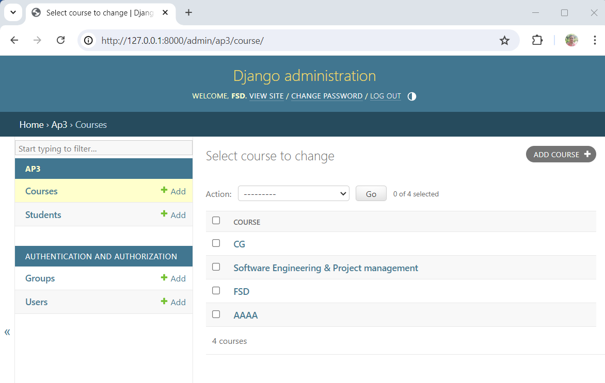

**Updating urls.py**

from ap3.views import reg, course_search

admin.site.site_header="My Site Header" admin.site.site_title="My Site Title" admin.site.index_title="My Site Index"

PS D:\SirMVIT\MY_SUBJECTS\FullStackDevelopment> python manage.py runserver

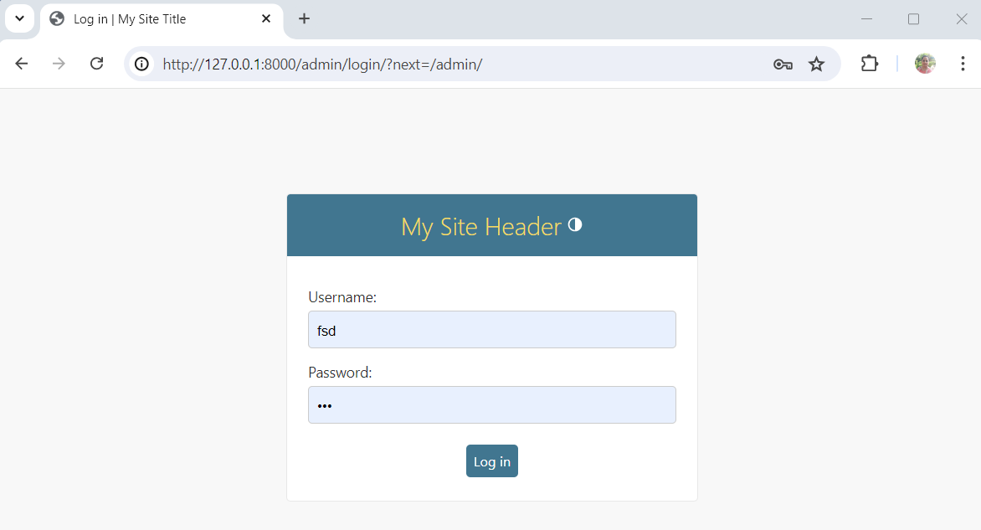

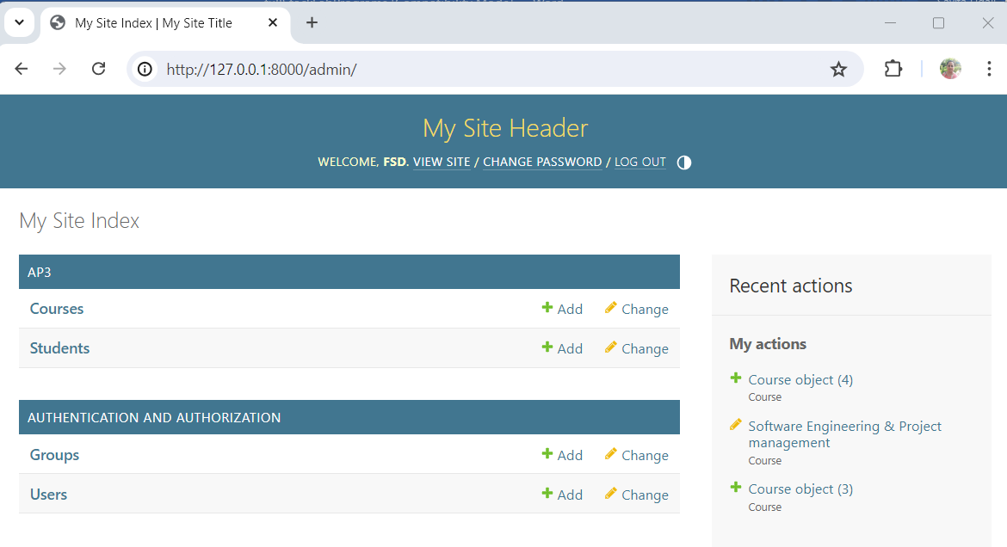

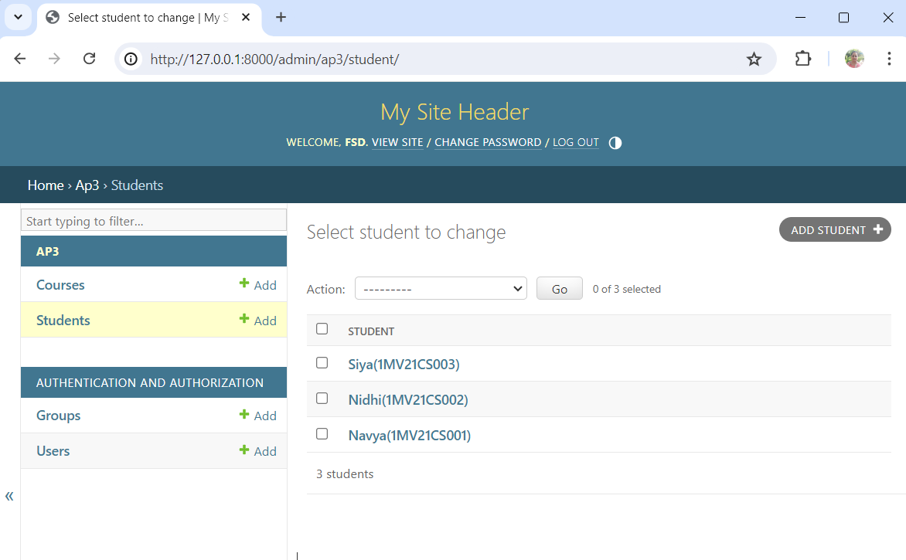

#### Updating models.py (removing compulsory field )

**In course** course_credits=models.IntegerField(blank=True, null=True) **and run the migration commands**

python manage.py makemigrations ap3 python manage.py migrate

#### customizing admin in admin.py

#admin.site.register(Student) @admin.register(Student)

class StudentAdmin(admin.ModelAdmin):

list_display = ('student_name','student_usn','student_sem')

ordering=('student_name',)

search_fields = ('student_name',)

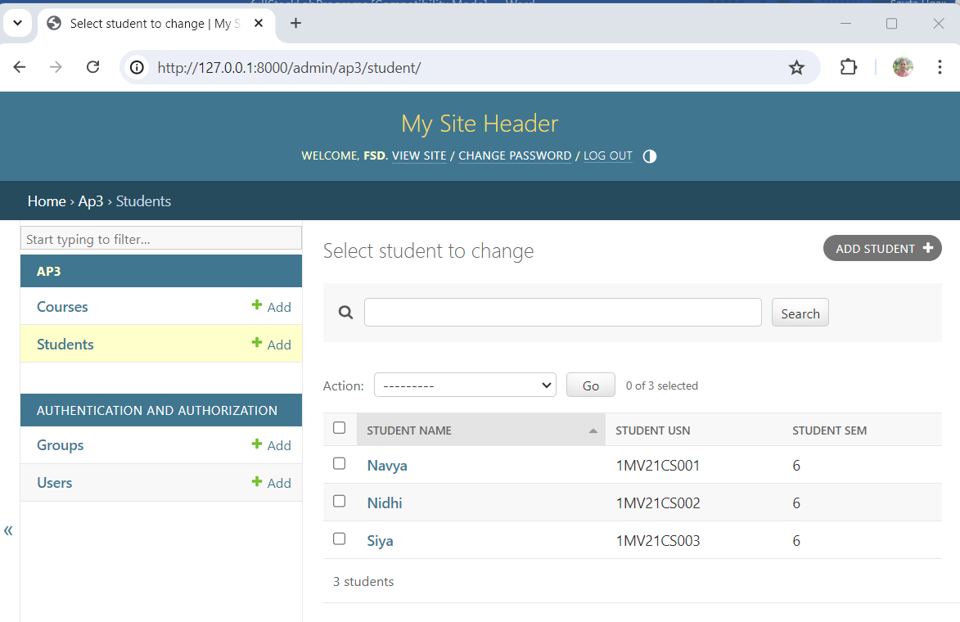

**Search Operation:**

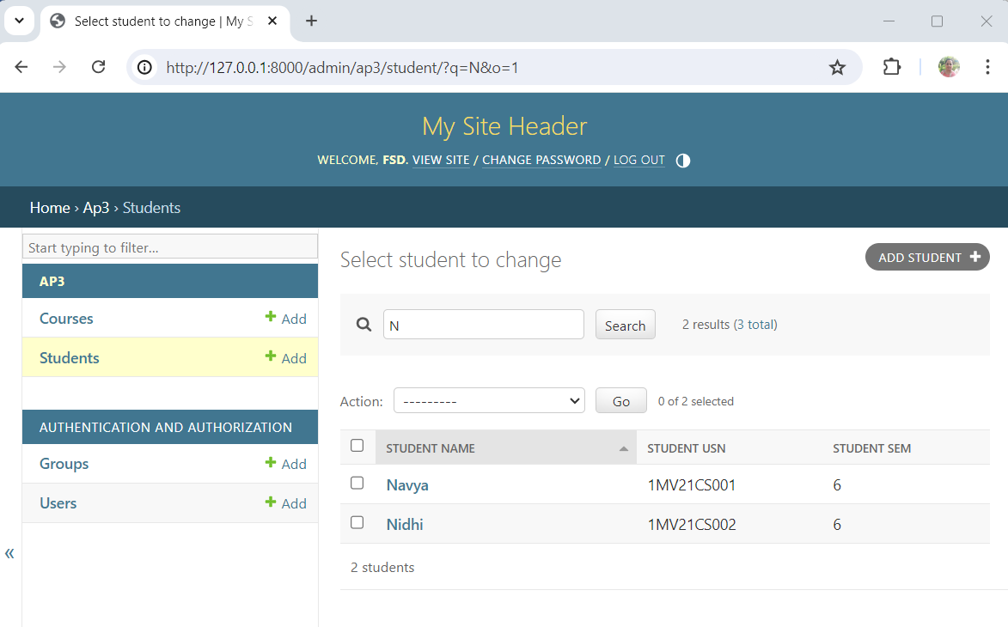

1. **Develop a Model form for student that contains his topic chosen for project, languages used and duration with a model called project.**

# models.py

from Django.db import models

from django.forms import ModelForm

class Project(models.Model): student=models.ForeignKey(Student,on_delete=models.CASCADE) ptopic=models.CharField(max_length=200) plangauges=models.CharField(max_length=200) pduration=models.IntegerField()

class ProjectReg(ModelForm): required_css_class="required" class Meta:

model=Project fields=['student','ptopic','plangauges','pduration']

# views.py

from ap3.models import Course, Student, ProjectReg

def add_project(request):

if request.method=="POST": form=ProjectReg(request.POST) if form.is_valid():

form.save()

return HttpResponse("<h1>Record inserted successfully</h1>") else:

return HttpResponse("<h1>Record not inserted</h1>")

else:

form=ProjectReg()

return render(request,"add_project.html",{"form":form})

# add_project.html (need to be created in templates folder)

<html>

<form method="post" action="">

{% csrf_token %}

<table>

{{ form.as_table}}

<tr>

<td>

<input type="submit" value="Submit">

</td>

</tr>

</table>

</form>

</html>

# urls.py

from ap3.views import reg, course_search, add_project

urlpatterns = [

path('admin/', admin.site.urls), path('cdt/', current_date_time ), path('fhrsa/',four_hours_ahead), path('fhrsb/',four_hours_before), path('showlist/', showlist), path('aboutus/', aboutus), path('home/', home), path('contactus/', contactus), path('reg/', reg), path('course_search/',course_search), path('add_project/', add_project)

]

Perform remigrations before running: python manage.py makemigrations ap3 python manage.py migrate

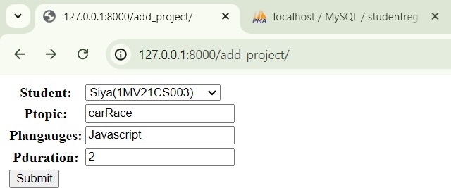python manage.py runserver OUTPUT:

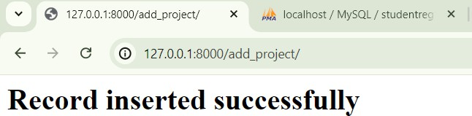

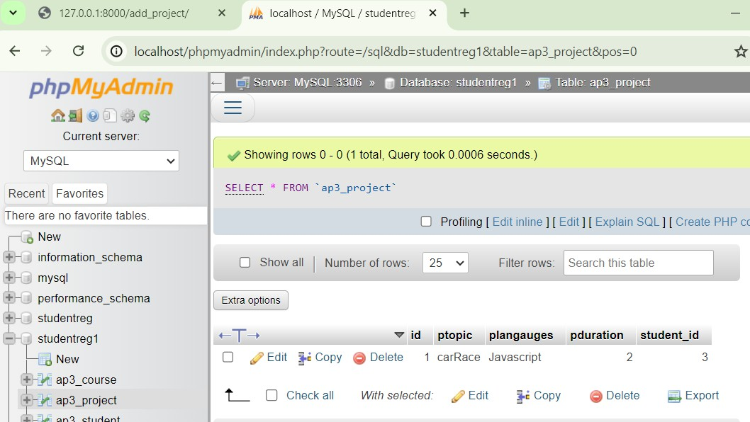

1. **For students enrolment developed in Module 2, create a generic class view which displays list of students and detailview that displays student details for any selected student in the list.**

# views.py

from django.views import generic

class StudentListView(generic.ListView): model=Student template_name="student_list.html"

class StudentDetailView(generic.DetailView): model=Student template_name="student_detail.html"

# student_list.html

<html>

<body>

{% if student_list %}

<table border>

<tr>

<th>USN</th>

<th>Courses Enrolled</th>

</tr>

{% for student in student_list %}

<tr>

<td><a href="/student_detail/{{student.pk}}">{{ student.student_usn }}</a></td>

<td>{% for course in student.enrolment.all %}

<span>{{ course.course_name }}</span>

{% endfor %}

</td>

</tr>

{% endfor %}

</table>

{% else %}

<h1>No Students Enrolled</h1>

{% endif %}

</body>

</html>

# student_detail.html

<h1>Student Name: {{ student.student_name }}</h1>

<h1>Student USN: {{ student.student_usn }}</h1>

<h1>Student Sem: {{ student.student_sem }}</h1>

# urls.py

from ap3.views import StudentListView,StudentDetailView urlpatterns = [

path('add_project/', add_project), path('student_list/', StudentListView.as_view()),

path('student_detail/<int:pk>/', StudentDetailView.as_view()),

]

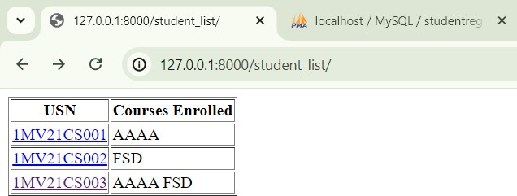

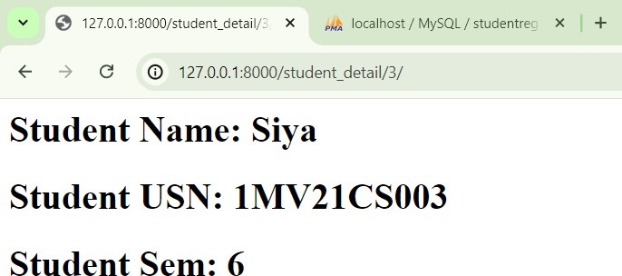

1. **Develop example Django app that performs CSV and PDF generation for any models created in previous laboratory component.**

In the terminal:

**pip install reportlab**

# views.py

def construct_csv_from_model(request): courses=Course.objects.all() response=HttpResponse(content_type="text/csv")

response['Content-Disposition'] = 'attachment;filename="courses_data.csv"' writer=csv.writer(response)

writer.writerow(["Course Name","Course Code","Credits"]) for course in courses:

writer.writerow([course.course_name,course.course_code, course.course_credits])

return response

def construct_pdf_from_model2(request): courses=Course.objects.all() response=HttpResponse(content_type="application/pdf") response['Content-Disposition'] = 'attachment;

filename="courses_data.pdf"' c=canvas.Canvas(response) c.drawString(70,720,"Course Name") c.drawString(170,720,"Course Code") c.drawString(270,720,"Credits") y=660

for course in courses: c.drawString(70,y,course.course_name) c.drawString(170,y,course.course_code) c.drawString(270,y,str(course.course_credits)) y=y-60

c.showPage()

c.save()

return response

urls.py

from ap3.views import construct_csv_from_model, construct_pdf_from_model2

urlpatterns = [

path('construct_course/', construct_csv_from_model), path('construct_pdf_from_model2/', construct_pdf_from_model2),

]

CSV file downloaded

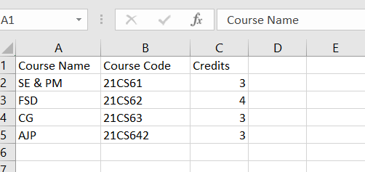

PDF file downloaded

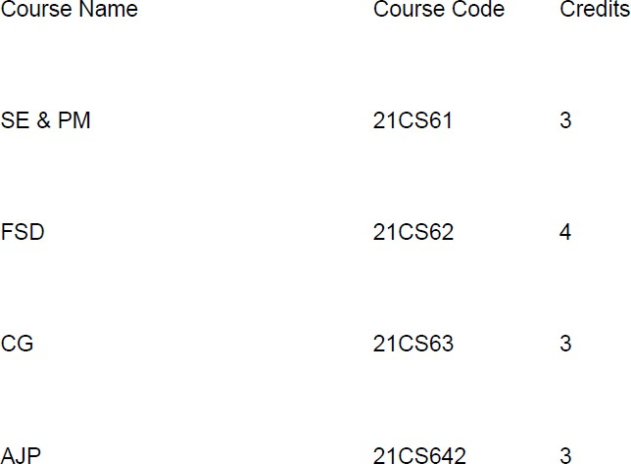

1. **Develop a registration page for student enrolment as done in Module 2 but without page refresh using AJAX.**

# views.py

def regaj(request):

if request.method == "POST": sid=request.POST.get("sname") cid=request.POST.get("cname") student=Student.objects.get(id=sid) course=Course.objects.get(id=cid)

res=student.enrolment.filter(id=cid) if res:

return HttpResponse("<h1>Student already enrolled</h1>") student.enrolment.add(course)

return HttpResponse("<h1>Student enrolled successfully</h1>") else: students=Student.objects.all()

courses=Course.objects.all()

return render(request,"regaj.html",{"students":students, "courses":courses})

**regaj.html**

{% load static %}

<html>

<body>

<form method="post" action="">

{% csrf_token %} Student Name

<select name="sname" id="sname">

{% for student in students %}

<option value="{{ student.id }}">{{ student.student_name

}}</option>

}}</option>

{% endfor %}

</select>

<br> Course Name

<select name="cname" id="cname">

{% for course in courses %}

<option value="{{ course.id }}">{{ course.course_name

{% endfor %}

</select>

<br>

<span id="ans"></span>

<input type="button" value="Enroll" id="ebtn">

</form>

<script src="{% static 'jquery.min.js' %}"></script>

<script>

$(document).ready(function(){

$("#ebtn").click(function(){

var sname = $("#sname").val(); var cname = $("#cname").val();

$.ajax({

type: "POST", url: "/regaj/", data: {

sname: sname, cname: cname,

csrfmiddlewaretoken: "{{ csrf_token }}"

},

success: function(response){

$("#ans").html(response);

});

});

}

});

</script>

</body>

</html>

**urls.py**

from ap3.views import regaj

urlpatterns = [ path('regaj/',regaj),

]

# OUTPUT

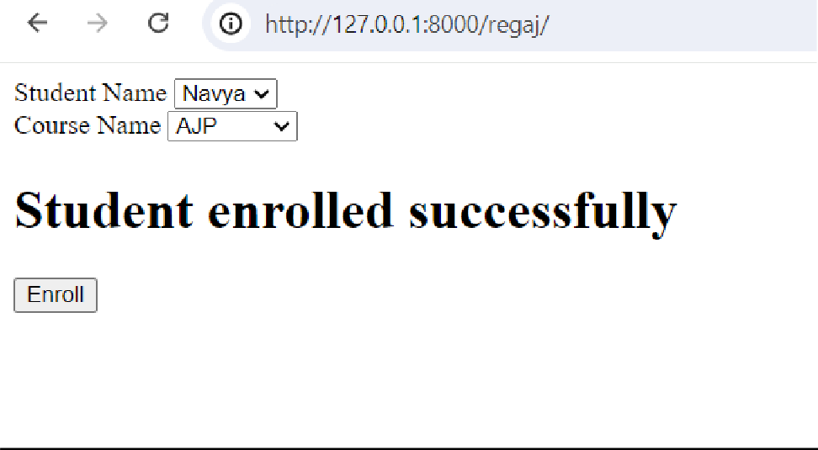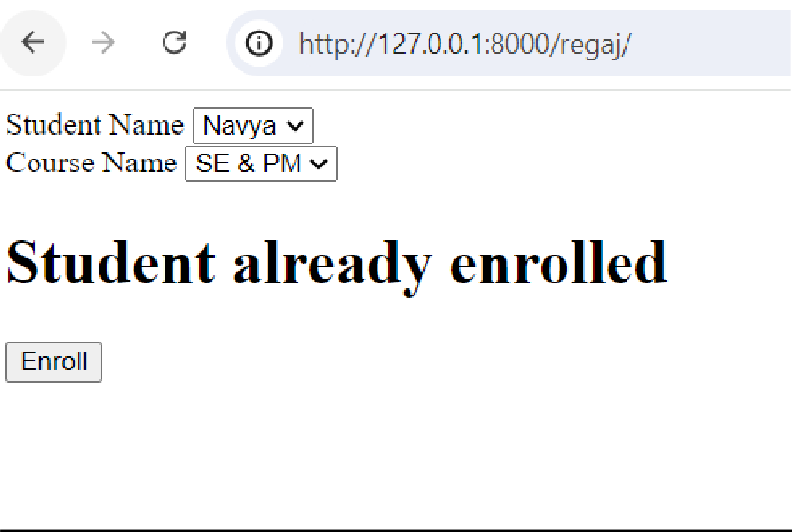

1. **Develop a search application in Django using AJAX that displays courses enrolled by a student being searched.**

# views.py

def course_search_ajax(request): if request.method=="POST":

cid=request.POST.get("cname") s=Student.objects.all() student_list=list()

for student in s:

if student.enrolment.filter(id=cid): student_list.append(student)

if len(student_list)==0:

return HttpResponse("<h1>No Students enrolled</h1>") return

render(request,"selected_students.html",{"student_list":student_list}) else:

courses=Course.objects.all()

return render(request,"course_search_aj.html",{"courses":courses})

# course_search_aj.html

{% load static %}

<html>

<body>

<form method="POST" action=""> Courses

{% csrf_token %}

<select name="cname" id="cname">

{% for course in courses %}

<option value="{{ course.id }}">{{ course.course_name

}}</option>

{% endfor %}

</select>

<input type="button" value="Search" id="serbtn">

<span id="result"></span>

</form>

</body>

<script src="{% static 'jquery.min.js' %}"></script>

<script>

$(document).ready(function(){

$("#serbtn").click(function(){

var cname = $("#cname").val();

$.ajax({

url: "/course_search/", type: "POST",

data: { cname: cname, csrfmiddlewaretoken: "{{ csrf_token

}}"},

});

success: function(response){$("#result").html(response);}

});

});

</script>

</html>

# urls.py

from ap3.views import regaj, course_search_ajax urlpatterns = [

path('course_seacrh_ajax/',course_search_ajax),

]

**OUTPUT**

