Nama: muhammad daffa aqilah

Kelas: IF3B

Npm: 2327250044  
GITHUB LINK:  
https://github.com/spammarket/UTS-IF3B-2327250044-API

<https://github.com/spammarket/UTS-IF3B-2327250044-REACT>

POSTMAN API POST

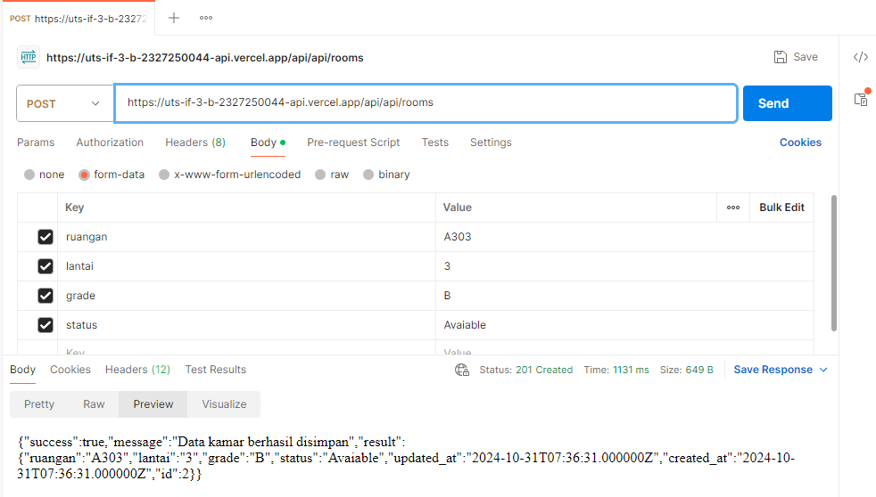

POSTMAN API GET  
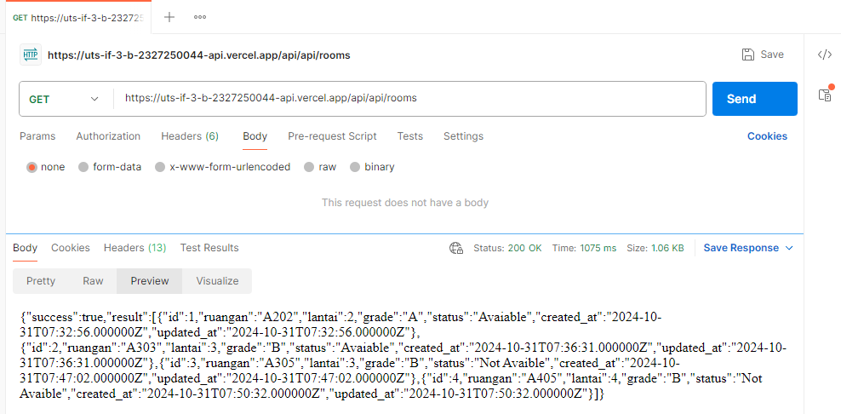

TABLE phpmyadmin clever Cloud  
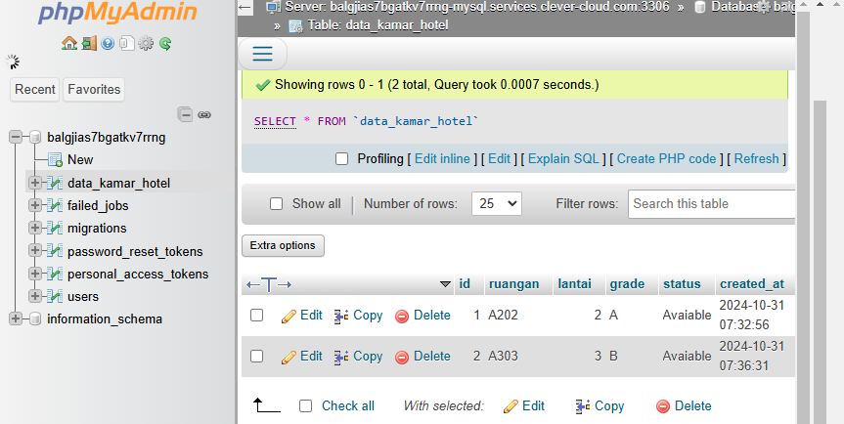

Vercel React

