Personal Trainer

This application is for aiding you on your running training. It will help you while you run as well as after your run where you can view past exercises and also help you plan your next run, use audio cues that will be played when you are exercising and even music of your choice that will be used on your run! This guide will explain the functions of this application.

(Disclaimer: as of this build, all units are in SI style, i.e. metres, kilometres etc.)

The first thing you'll see is this screen, and it's three buttons; add route, use an old route and settings. New Run will send you to a screen showing a map and your current location, ready to start a new round. The Existing Run button will take you to a list with saved runs/routes. The settings button will take you to a screen where you can fill in your desired settings.

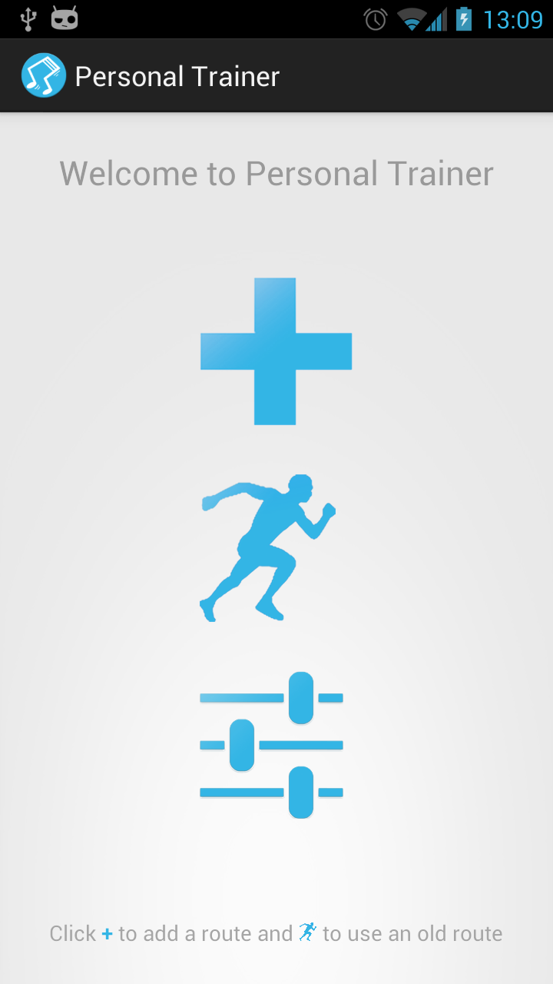
Fig 1. The Start Screen

When you press the add route button (the plus sign) you'll go to the run view. This will present you with a map, your location marked by a dot and two buttons. The Start Run button is the key button in this view. It will start the timer and thus also start the measuring of your distance, your speed at the moment and total calorie expenditure. A path will also be painted to display the path you've taken since you pressed the start button. On pressing this button, the start button will disappear to make way for a stop button instead (fig. 2).
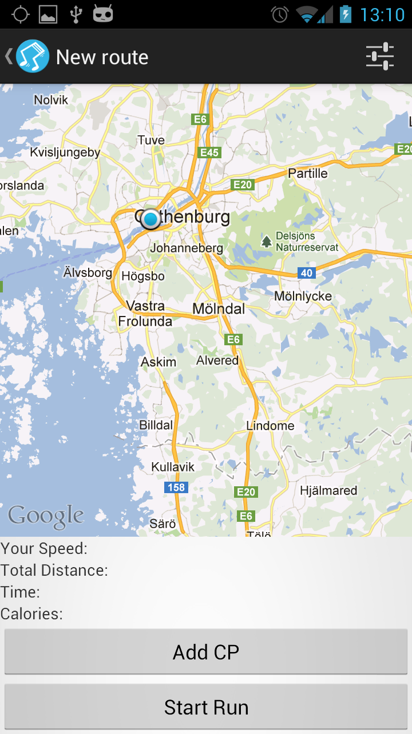
Fig 2. The Run view

Pressing the stop button will stop the run and ask you if you want to save this route, along with all saved data from this run; marked path, passed time, speed calories and checkpoints . Pressing the stop button will bring up a menu asking you if you want to save this route. If you discard this nothing gets saved and you go back to the start menu. If you do save the route it will be saved in the database and you can try it out again (fig. 3).

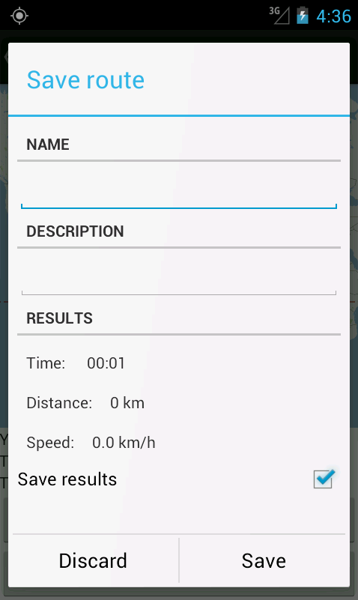
Fig. 3 Saving a route

The Checkpoint button will put a checkpoint right on your current location, this can also be done by tapping the screen once. A checkpoint is a point on the map where you want to trigger something. When you place a checkpoint in any of the two ways, you'll get a menu asking what you want to trigger; you can record your own voice that you want to hear when you reach that place on your run. You decide what you want to say. This is a great way to tell you if you're keeping the desired pace without looking at the screen while you're out running. You can also choose music from your local library that you want to play. This menu will also let you decide the radius of the checkpoint, this affects how far you need to be from the placed checkpoint in order for it to trigger (Fig. 4 Show checkpoint saving in action and fig. 5 shows placed checkpoint on map).

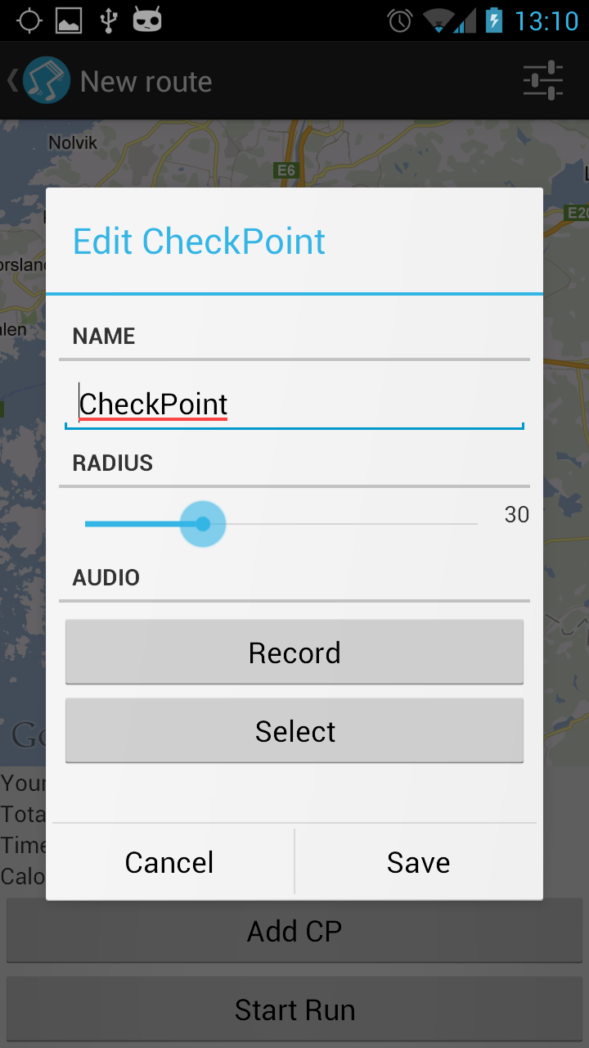
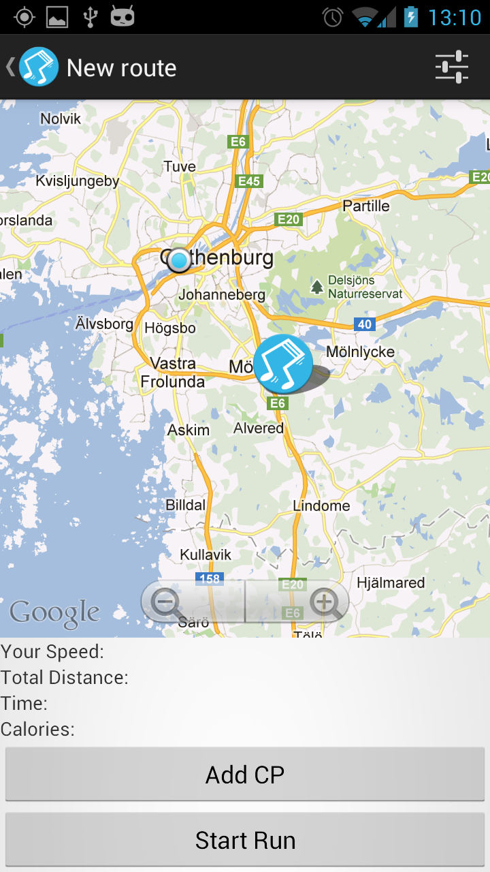
Fig 4 and fig.5 Menu when placing a checkpoint and the resulting placing of the checkpoint

Fig 6. shows the menu of all media that this app can find. That is all media found on your sd-card along with the audio cues that you may have recorded. Simply click on any item in the list and it will be bound to that checkpoint.

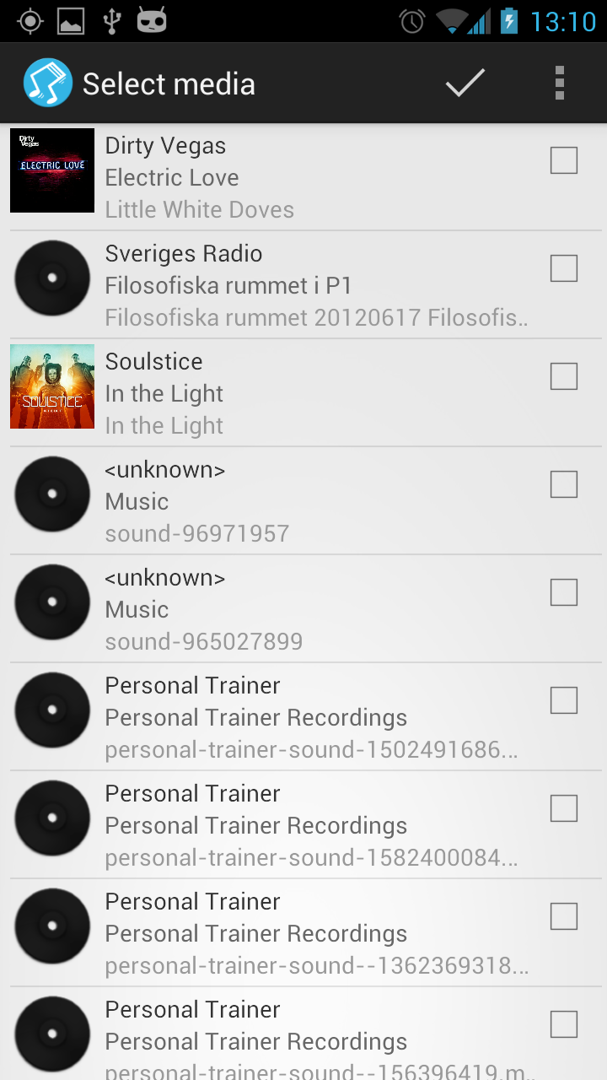

Fig. 6 List of media on the sd card

If you choose Existing route from the start menu (Fig. 1) instead you'll get a list with all the saved routes. This list displays some information about the route, like results and the name you chose for it. By clicking it you'll bring up the route saved in the database on your phone (Fig 7).

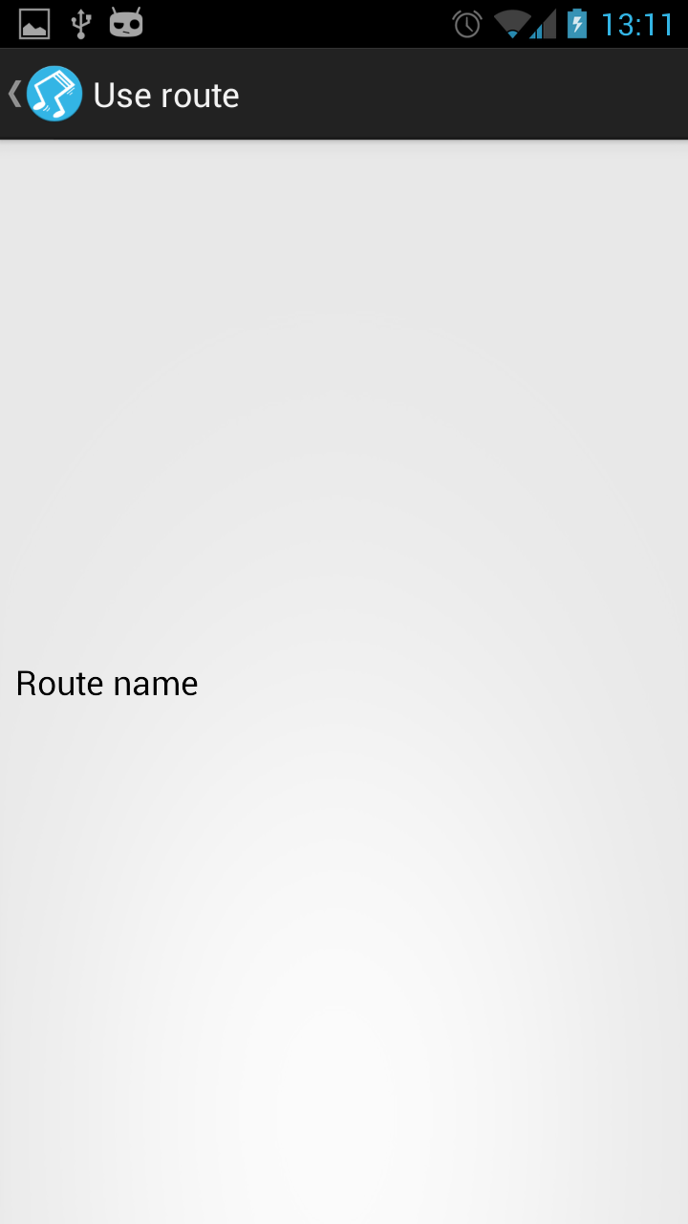

Fig 7. List of saved routes

When you choose a route you'll come to a screen that looks like the new run screen except for a couple of differences. You'll notice that a path has already been drawn. That was your path when you saved it the first time. Your new run will be shown in a different colour (Fig 8). This is great for when you want to compete against yourself. By pressing the start button you can then go again. The result button will bring up all the previous results from this route. This is a great way to see how you have improved by comparing the run time and speed.

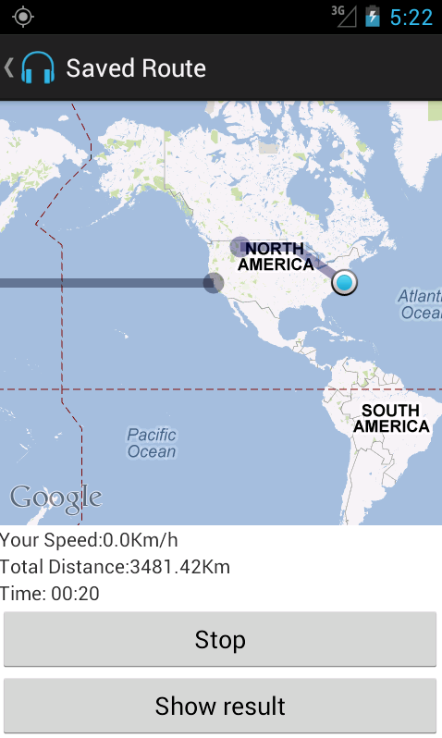

Fig. 8 See your old route along with your present one

On the screen where your old route is displayed you'll notice the button named Show result, this will bring up a list with all saved results for this route. Also in the list that holds you results you'll be presented with a graph that shows how well you did overall on that route (Fig. 9). Just click on any result and you'll see how you did on the chosen result (Fig. 10)

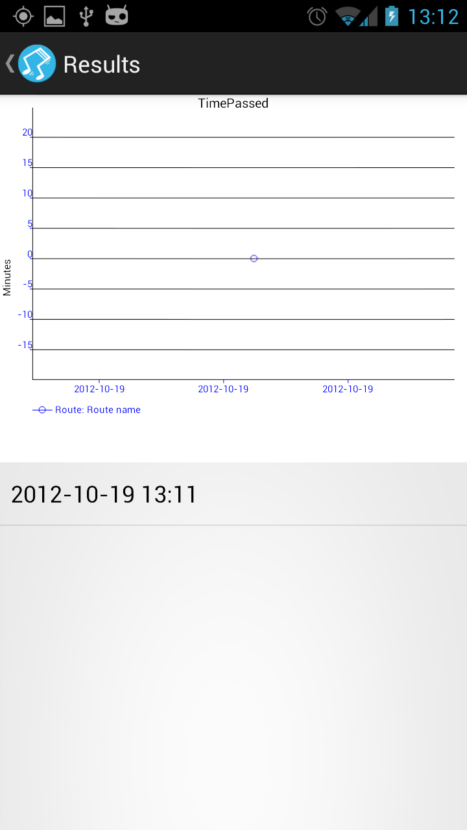
Fig 9. The result list for a route and the graph showing user progress

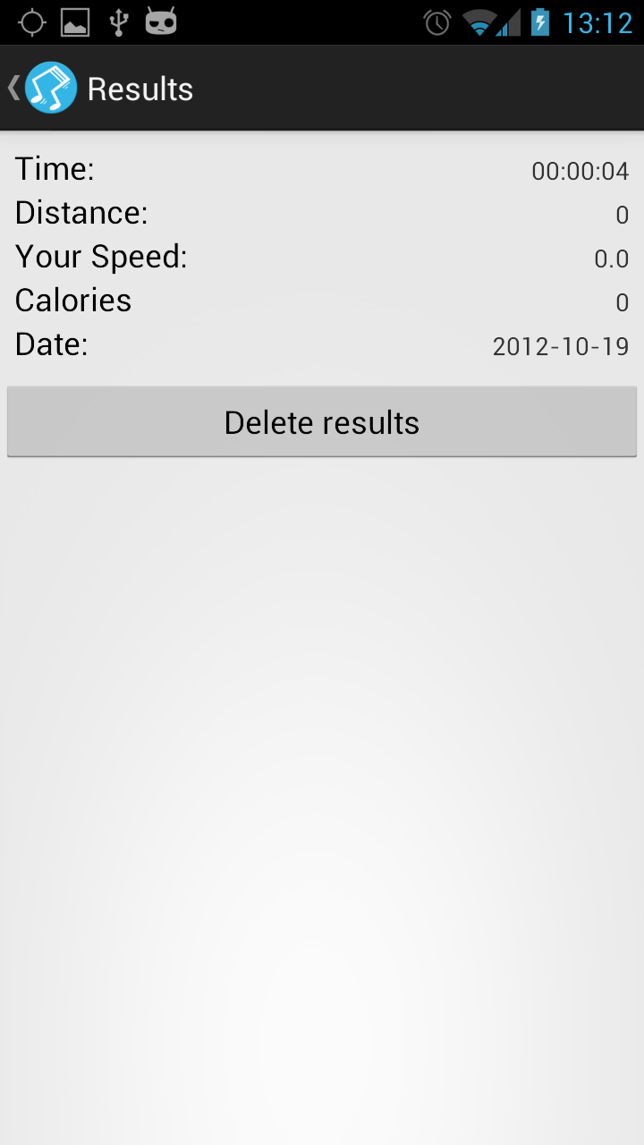

Fig 10. Details about a single result

The settings which you can reach from the start screen or the map screens shows you the user some settings you can set that will influence a couple of things (Fig. 11). The preferred activity, running or walking, and your weight influences the calculations in the calorie counter. These settings will be saved on your phone. As of this release the name is not used anywhere else but in a future release this would be implemented along with English units for distance and weight.

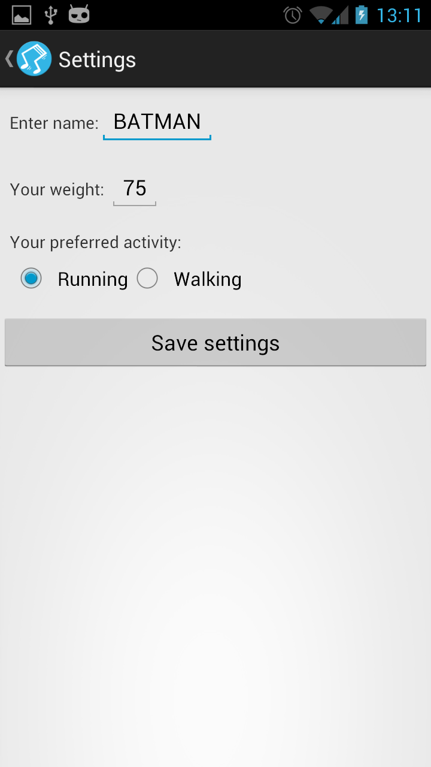
Fig. 11 The settings screen

We hope that you find this application to be of use and keep in mind that all calculations are estimates. But the main thing is that you get a healthy lifestyle.

Happy Running!

