InsuranceApi
API test evidence: every request, the reply, and what it proves
These tests were run on 11 October 2026 against the running API at https://localhost:7073, using the requests in InsuranceApi.http inside Visual Studio. The database is SQL Server (LocalDB).
Each test below shows the request, what was sent, the code we expected, the code we got, what it proves, and the screenshot. The numbers (1 to 28) are the request numbers in the .http file. Customer ids differ from run to run because the database keeps counting.
Result: 26 of 26 tests returned the expected status code.
No. | Test | Expected | Got | Result
12 | Login as agent | 200 OK | 200 OK | Pass
16 | Login as SuperUser | 200 OK | 200 OK | Pass
1 | Create a customer | 201 Created | 201 Created | Pass
2 | Get all customers | 200 OK | 200 OK | Pass
3 | Get one customer | 200 OK | 200 OK | Pass
4 | Update a customer | 200 OK | 200 OK | Pass
5 | Bad email | 400 Bad Request | 400 Bad Request | Pass
6 | Missing phone | 400 Bad Request | 400 Bad Request | Pass
7 | Duplicate email | 409 Conflict | 409 Conflict | Pass
8 | Not found | 404 Not Found | 404 Not Found | Pass
9 | Delete a customer | 204 No Content | 204 No Content | Pass
10 | No token | 401 Unauthorized | 401 Unauthorized, with "WWW-Authenticate: Bearer" | Pass
11 | Wrong password | 401 Unauthorized | 401 Unauthorized | Pass
13 | Agent creates a customer | 201 Created | 201 Created | Pass
14 | Agent reads customers | 200 OK | 200 OK | Pass
15 | Agent tries to delete | 403 Forbidden | 403 Forbidden | Pass
17 | SuperUser deletes | 204 No Content | 204 No Content | Pass
20 | Create a customer to quote for | 201 Created | 201 Created | Pass
21 | Create a quote | 201 Created | 201 Created | Pass
22 | Get that quote | 200 OK | 200 OK | Pass
23 | Get all quotes | 200 OK | 200 OK | Pass
24 | No token | 401 Unauthorized | 401 Unauthorized, with "WWW-Authenticate: Bearer" | Pass
25 | Date in the past | 400 Bad Request | 400 Bad Request | Pass
26 | Customer does not exist | 404 Not Found | 404 Not Found | Pass
27 | Unknown product | 400 Bad Request | 400 Bad Request | Pass
28 | Coverage too small | 400 Bad Request | 400 Bad Request | Pass

Part A: Login (get the tokens)

Test 12: Login as agent
Request | POST /api/auth/login
What we sent | Username "agent" with its demo password
Expected | 200 OK, returns a token
Result | 200 OK. Token returned, role "Agent"
What it proves | Login works. The server hands out a signed token and says which role it belongs to.
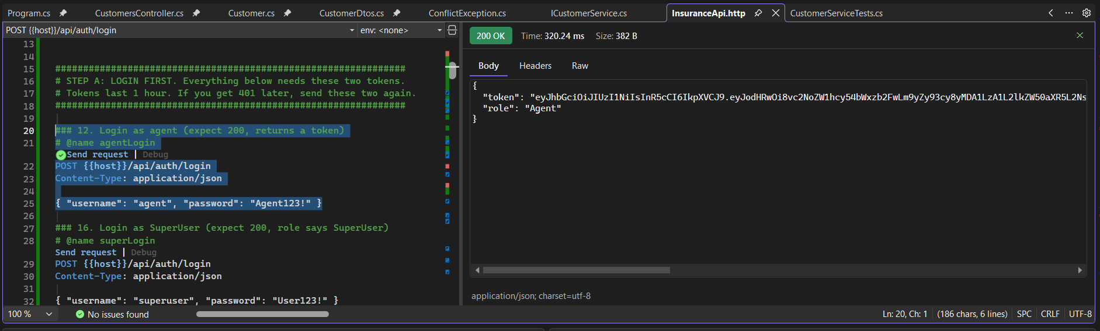

Test 16: Login as SuperUser
Request | POST /api/auth/login
What we sent | Username "superuser" with its demo password
Expected | 200 OK, role says SuperUser
Result | 200 OK. Token returned, role "SuperUser"
What it proves | The second role logs in too. This token is later used for delete.
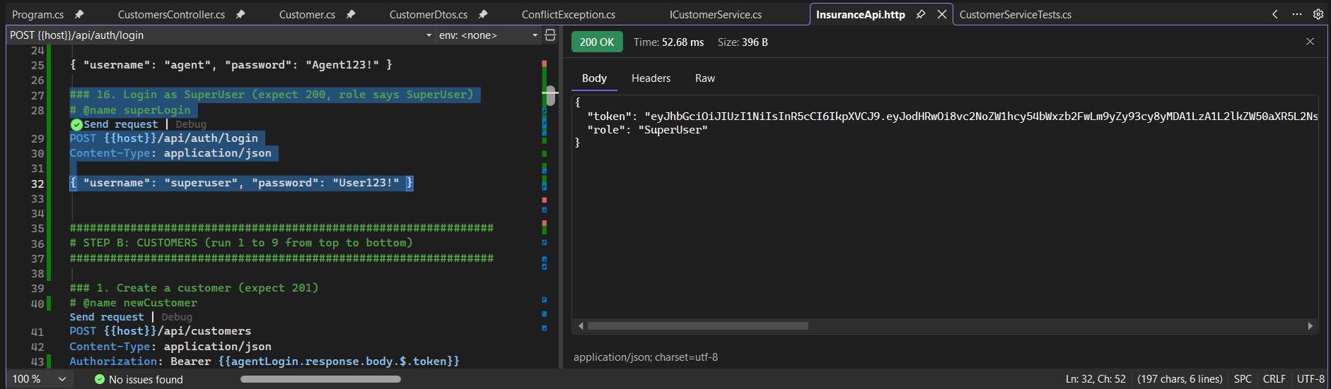

Part B: Customers

Test 1: Create a customer
Request | POST /api/customers (agent token)
What we sent | Ana Smith, ana1@test.com, 603-555-0101
Expected | 201 Created
Result | 201 Created. New customer saved with id 8
What it proves | Create works. The database gives the new customer an id. The agent token is accepted.
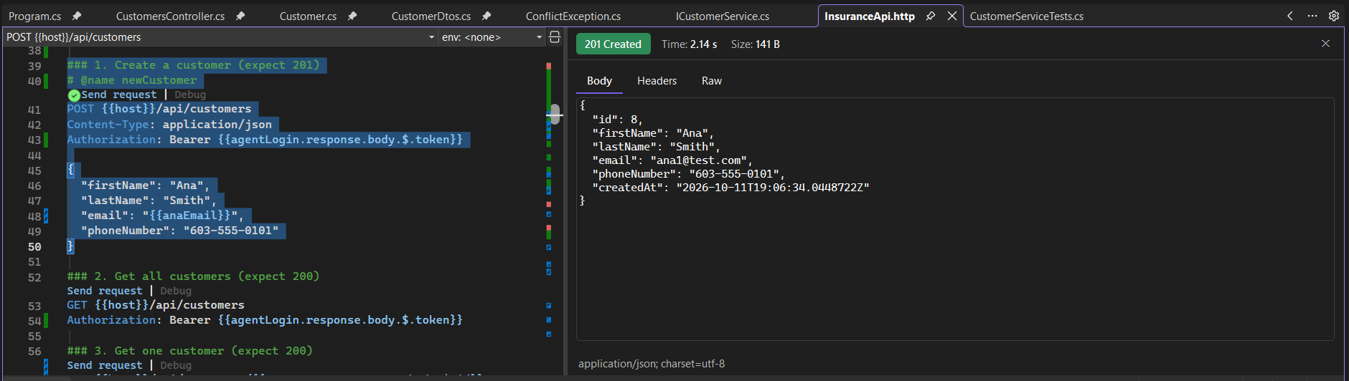

Test 2: Get all customers
Request | GET /api/customers (agent token)
What we sent | No body
Expected | 200 OK
Result | 200 OK. List containing Ana (id 8)
What it proves | Reading the full list works.
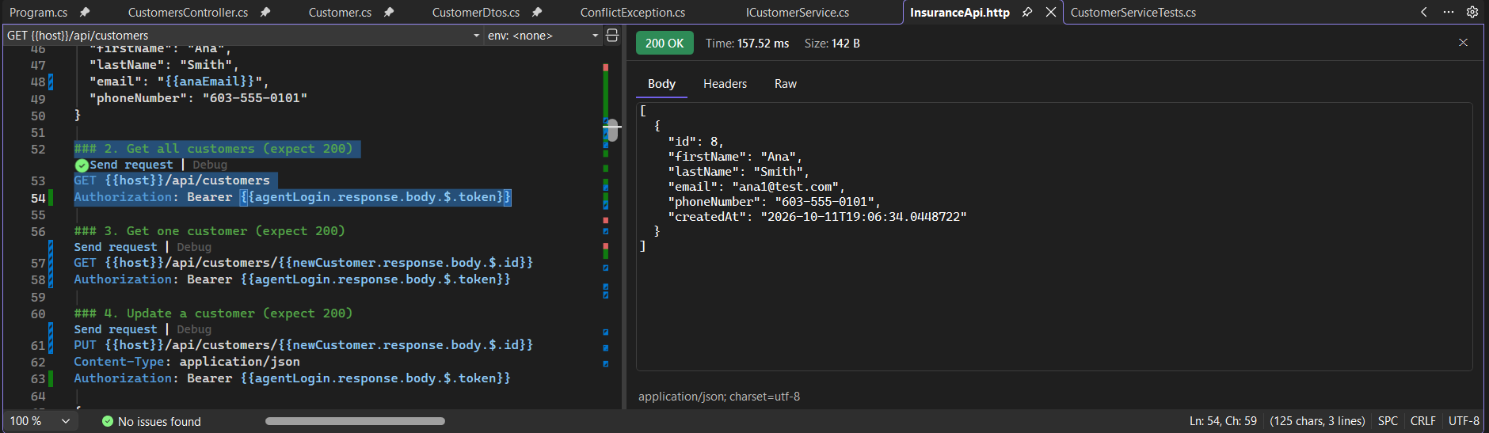

Test 3: Get one customer
Request | GET /api/customers/8 (agent token)
What we sent | The id returned by request 1
Expected | 200 OK
Result | 200 OK. Ana's record only
What it proves | Reading one customer by id works.
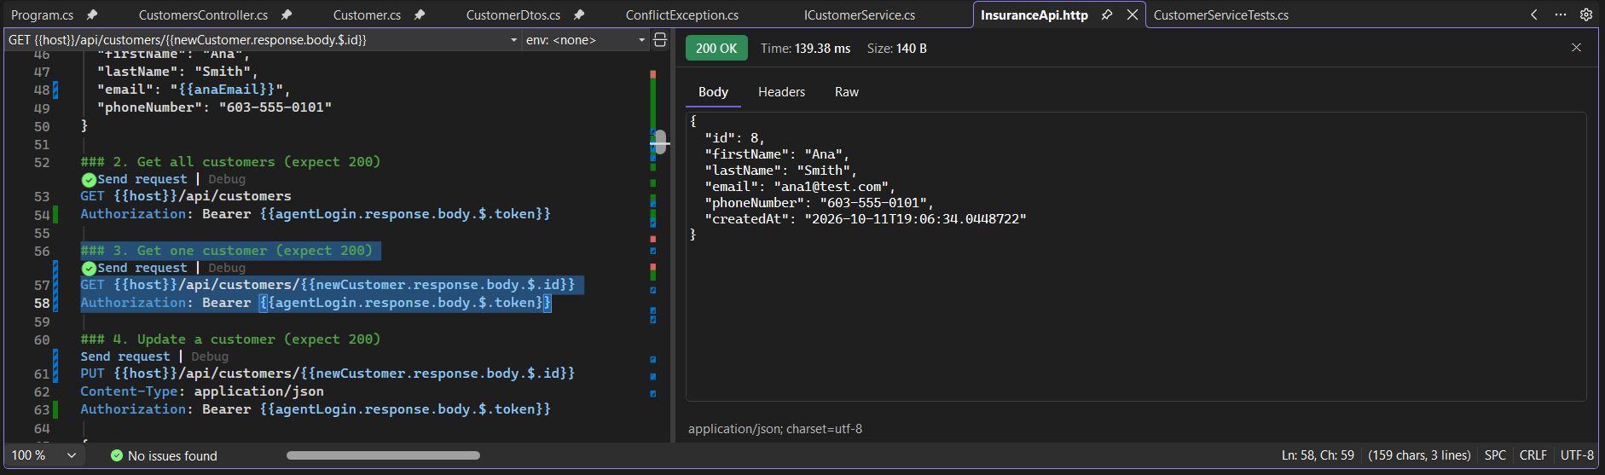

Test 4: Update a customer
Request | PUT /api/customers/8 (agent token)
What we sent | Same customer, last name changed to Johnson
Expected | 200 OK
Result | 200 OK. lastName is now "Johnson"
What it proves | Update works and the change is saved.
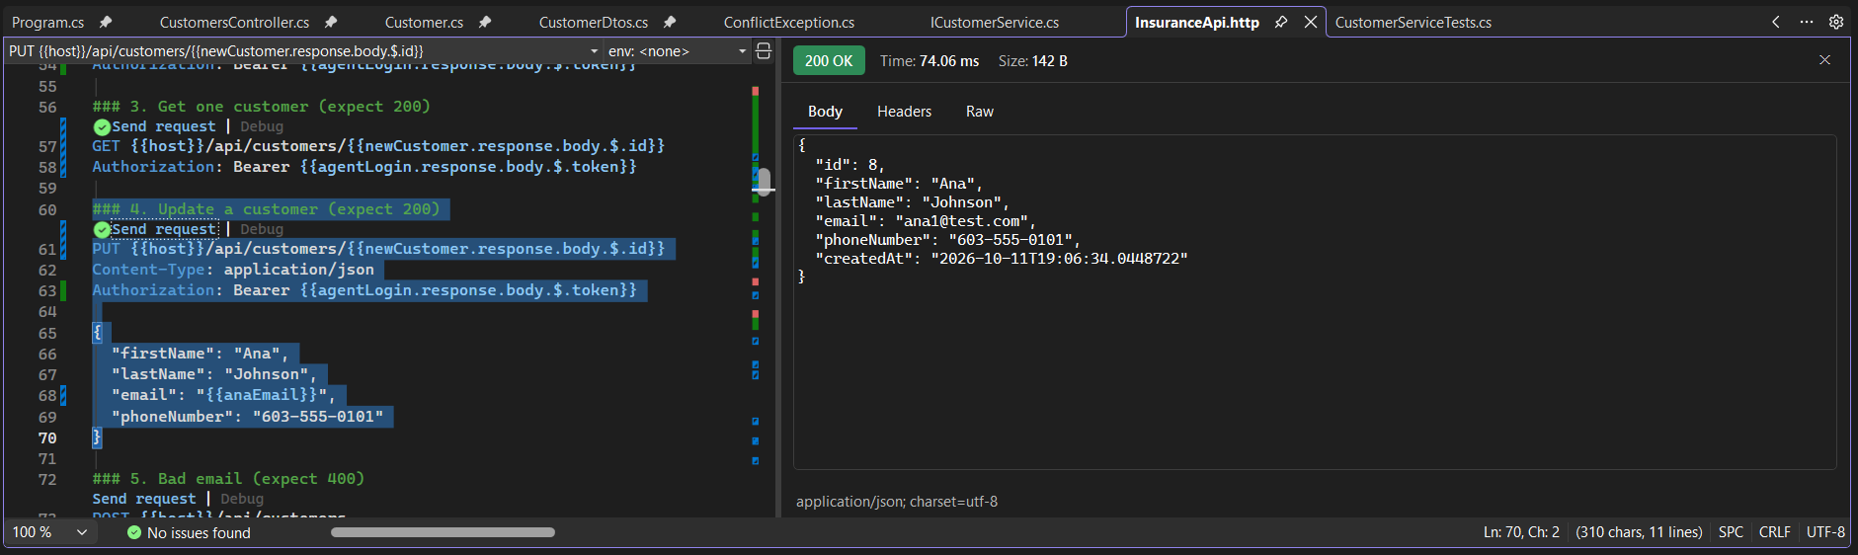

Test 5: Bad email
Request | POST /api/customers (agent token)
What we sent | Email "not-an-email"
Expected | 400 Bad Request
Result | 400 Bad Request. "The Email field is not a valid e-mail address."
What it proves | Input validation stops bad data at the door, before the business logic runs.
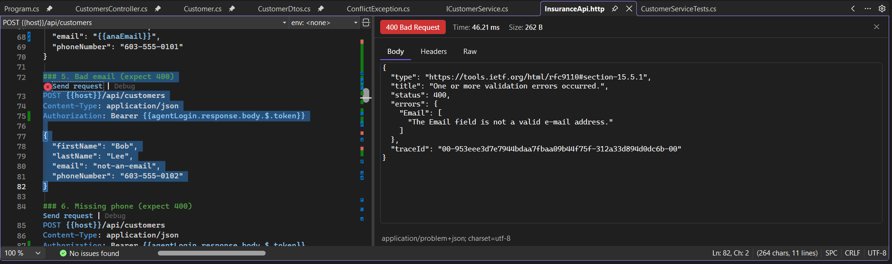

Test 6: Missing phone
Request | POST /api/customers (agent token)
What we sent | No phoneNumber field
Expected | 400 Bad Request
Result | 400 Bad Request. "The PhoneNumber field is required."
What it proves | Required fields are enforced. (The second message appears because a missing value also fails the phone format check.)
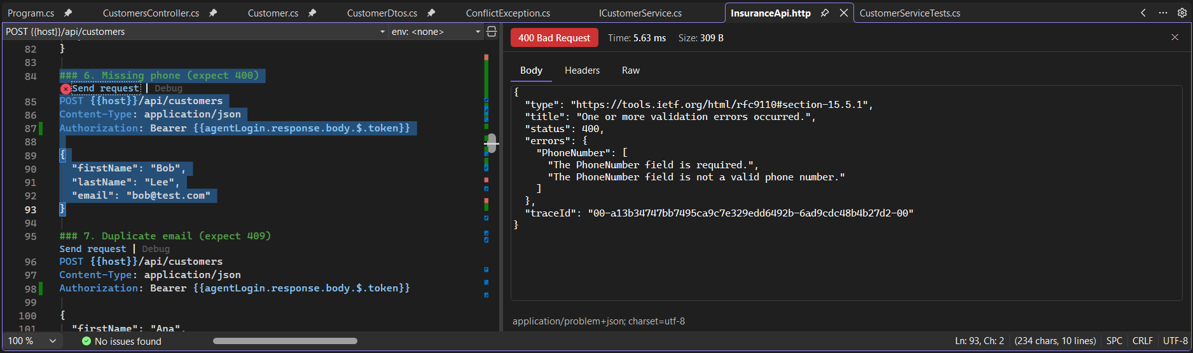

Test 7: Duplicate email
Request | POST /api/customers (agent token)
What we sent | A second customer with Ana's email
Expected | 409 Conflict
Result | 409 Conflict. "A customer with the email 'ana1@test.com' already exists."
What it proves | The no-duplicate-email rule works, and the error middleware turns it into a clean 409.
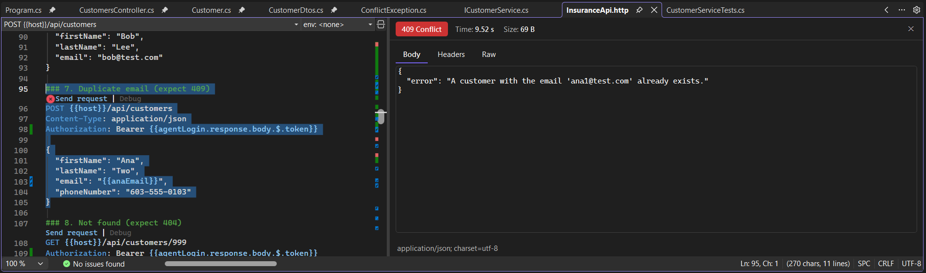

Test 8: Not found
Request | GET /api/customers/999 (agent token)
What we sent | An id that does not exist
Expected | 404 Not Found
Result | 404 Not Found
What it proves | Asking for a missing customer gives a clear 404, not a crash.
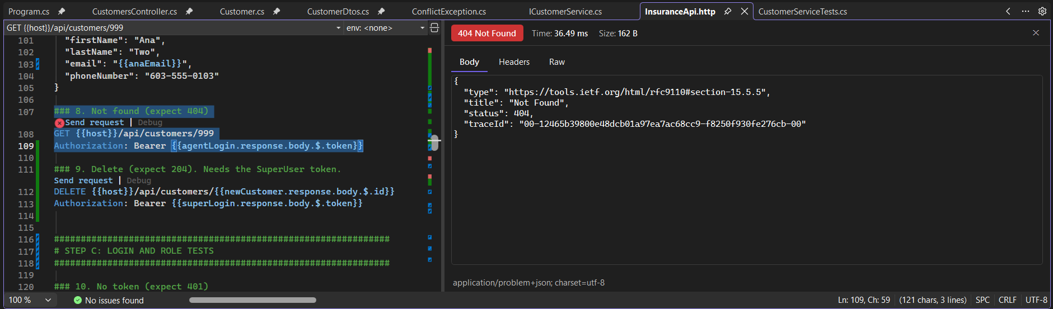

Test 9: Delete a customer
Request | DELETE /api/customers/8 (SuperUser token)
What we sent | The id returned by request 1
Expected | 204 No Content
Result | 204 No Content. Empty body
What it proves | Delete works for a SuperUser. The Raw tab shows the exact request and the reply.
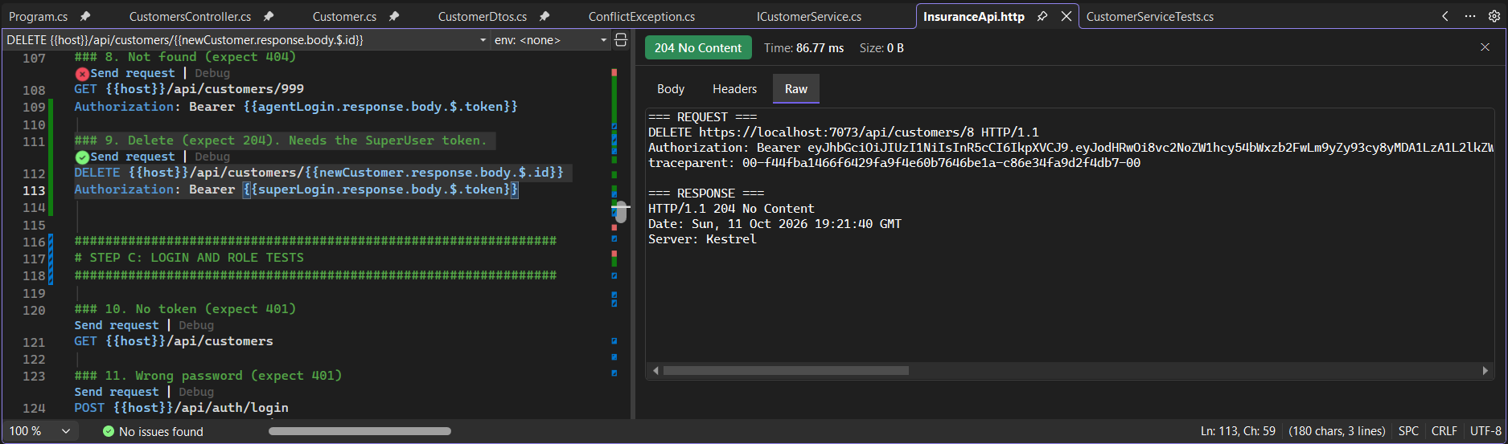

Part C: Login and role tests

Test 10: No token
Request | GET /api/customers (no Authorization header)
What we sent | No token on purpose
Expected | 401 Unauthorized
Result | 401 Unauthorized, with "WWW-Authenticate: Bearer"
What it proves | The API is locked. Nobody gets in without a token.
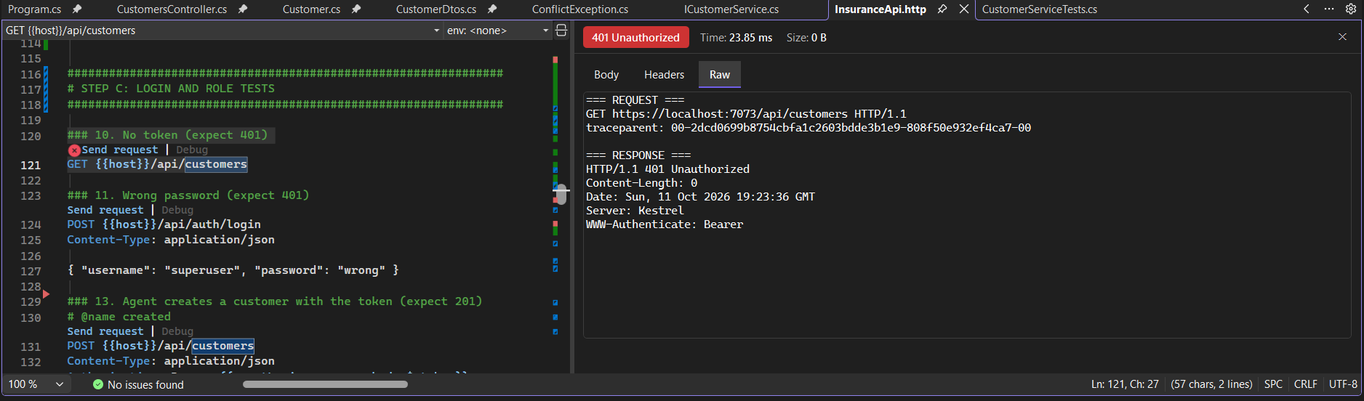

Test 11: Wrong password
Request | POST /api/auth/login
What we sent | Username "superuser" with the password "wrong"
Expected | 401 Unauthorized
Result | 401 Unauthorized. "Invalid username or password"
What it proves | Bad logins are refused.
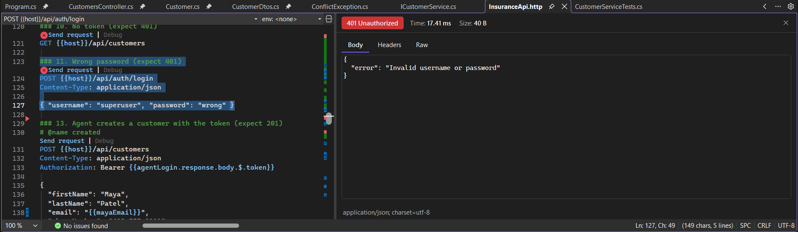

Test 13: Agent creates a customer
Request | POST /api/customers (agent token)
What we sent | Maya Patel, maya1@test.com
Expected | 201 Created
Result | 201 Created. New customer saved with id 9
What it proves | A valid token opens the door. An agent is allowed to create.
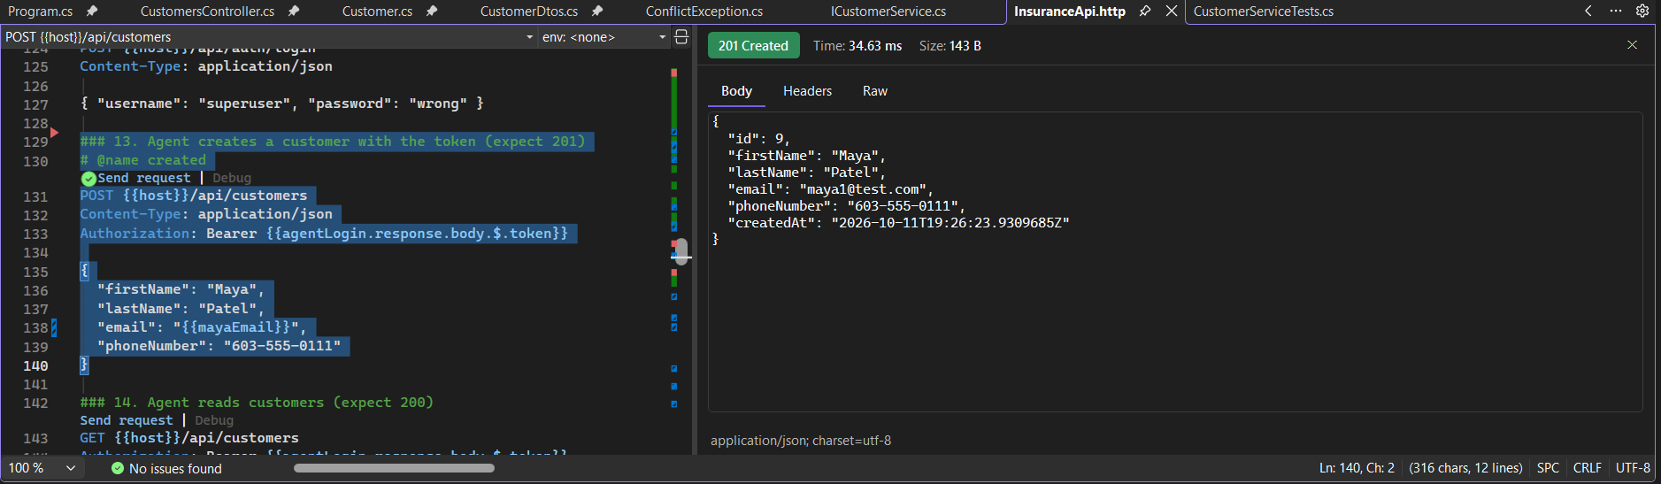

Test 14: Agent reads customers
Request | GET /api/customers (agent token)
What we sent | No body
Expected | 200 OK
Result | 200 OK. List containing Maya (id 9)
What it proves | An agent is allowed to read.
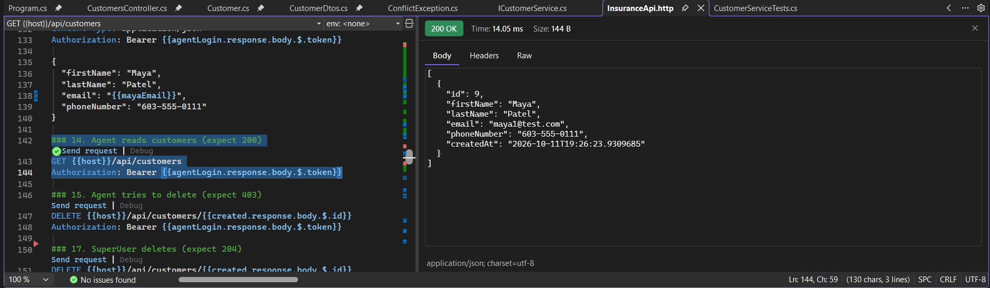

Test 15: Agent tries to delete
Request | DELETE /api/customers/9 (agent token)
What we sent | Maya's id, with the agent token
Expected | 403 Forbidden
Result | 403 Forbidden. Empty body
What it proves | Roles work. The agent is logged in but is not allowed to delete.
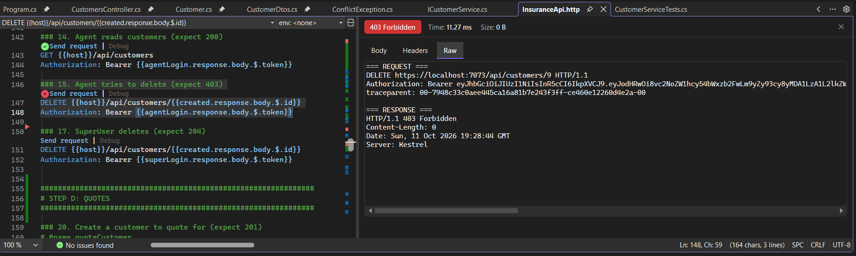

Test 17: SuperUser deletes
Request | DELETE /api/customers/9 (SuperUser token)
What we sent | The same id, with the SuperUser token
Expected | 204 No Content
Result | 204 No Content. Empty body
What it proves | The same delete that the agent was refused now works for the SuperUser.
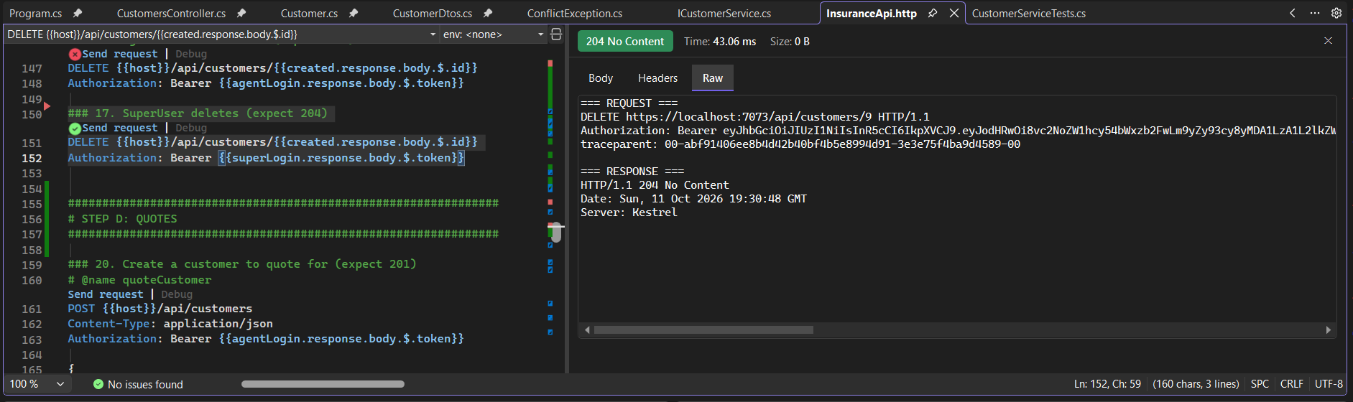

Part D: Quotes

Test 20: Create a customer to quote for
Request | POST /api/customers (agent token)
What we sent | Sam Rivera, sam1@test.com
Expected | 201 Created
Result | 201 Created. New customer saved with id 10
What it proves | Sets up the customer the quote tests use.
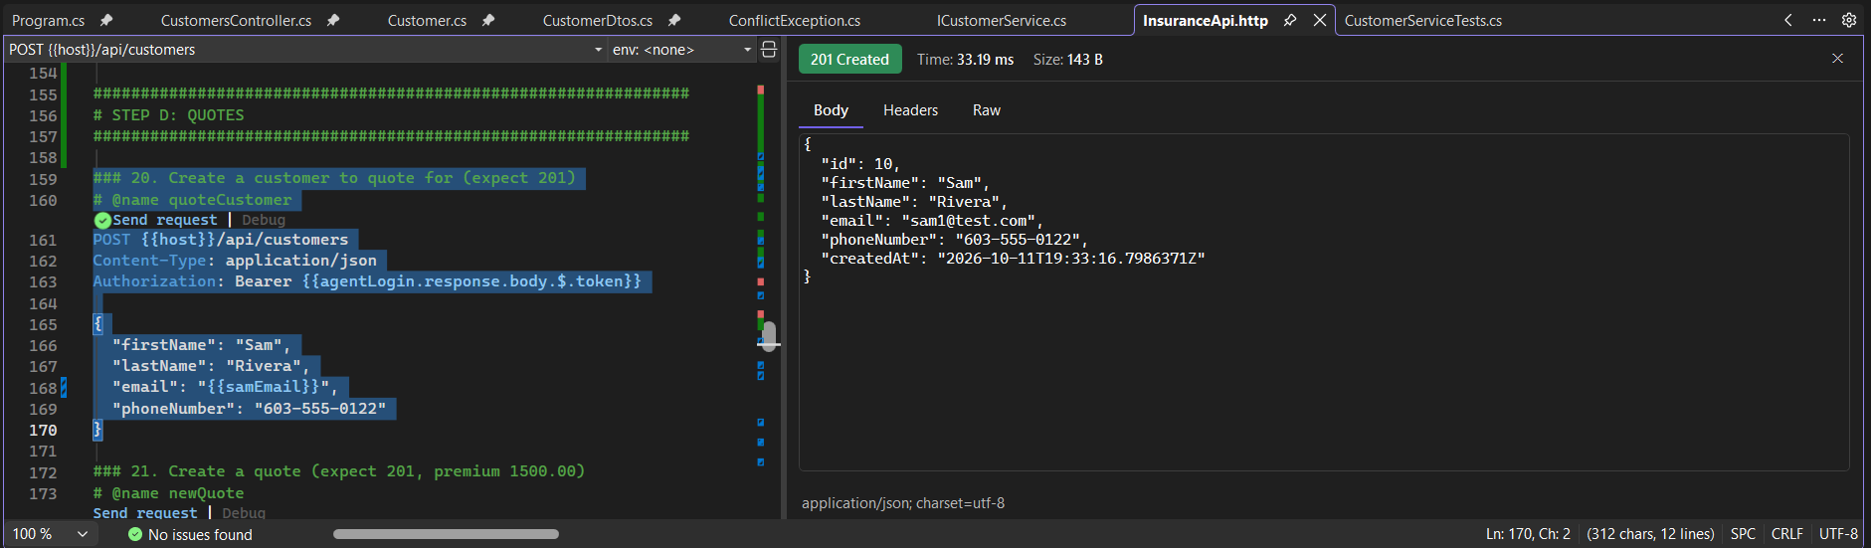

Test 21: Create a quote
Request | POST /api/quotes (agent token)
What we sent | Customer 10, Home, Medium risk, coverage 300,000, start 2027-01-01. No price sent.
Expected | 201 Created, premium 1500.00
Result | 201 Created. premium 1500.00, status "Quoted", expires 2026-11-10
What it proves | The server works out the premium itself: 300,000 x 0.005 x 1.0 = 1,500. The client never sets the price. The quote expires 30 days after it is created.
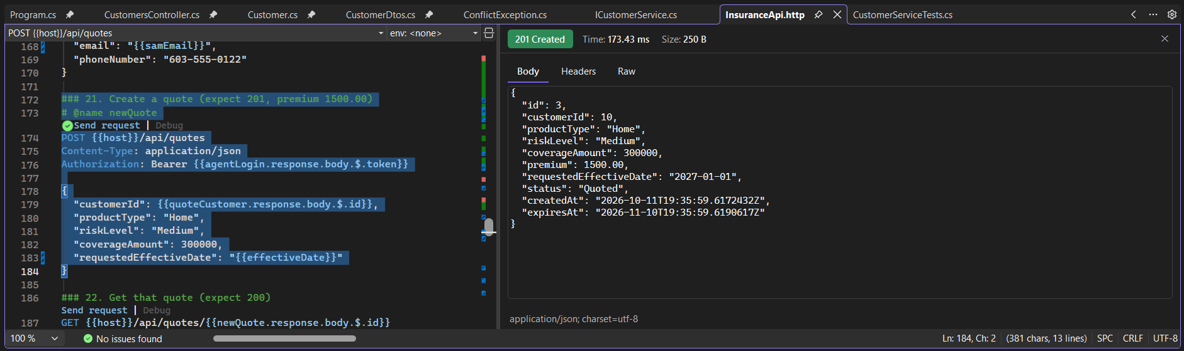

Test 22: Get that quote
Request | GET /api/quotes/3 (agent token)
What we sent | The id returned by request 21
Expected | 200 OK
Result | 200 OK. The same quote, premium 1500.00
What it proves | The quote was saved and can be read back.
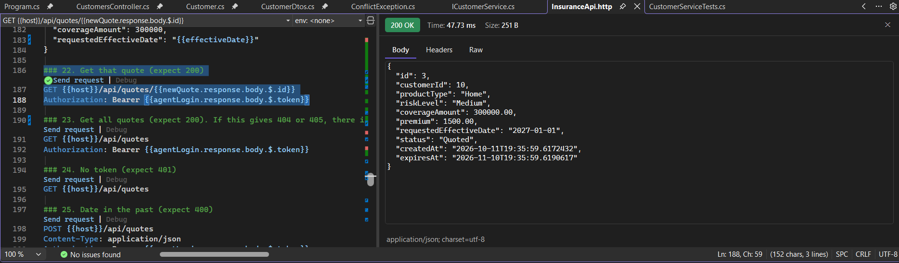

Test 23: Get all quotes
Request | GET /api/quotes (agent token)
What we sent | No body
Expected | 200 OK
Result | 200 OK. List containing the quote (id 3)
What it proves | Listing quotes works.
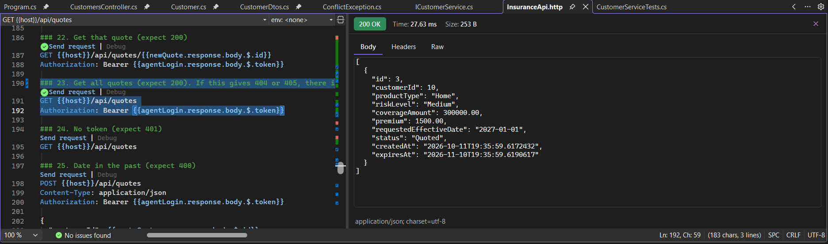

Test 24: No token
Request | GET /api/quotes (no Authorization header)
What we sent | No token on purpose
Expected | 401 Unauthorized
Result | 401 Unauthorized, with "WWW-Authenticate: Bearer"
What it proves | The quote endpoints are locked too.
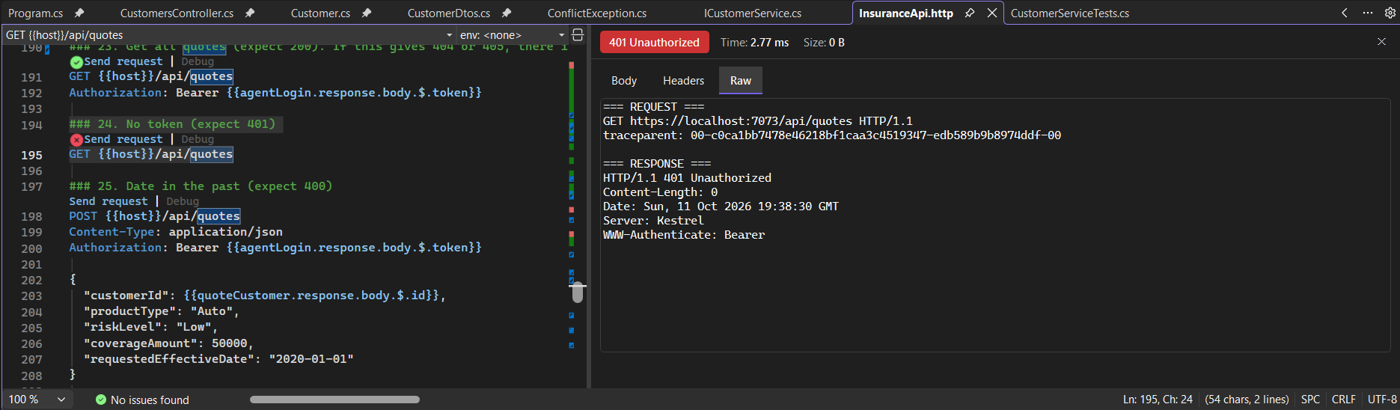

Test 25: Date in the past
Request | POST /api/quotes (agent token)
What we sent | Start date 2020-01-01
Expected | 400 Bad Request
Result | 400 Bad Request. "The effective date cannot be in the past."
What it proves | The business rule that blocks backdated coverage works.
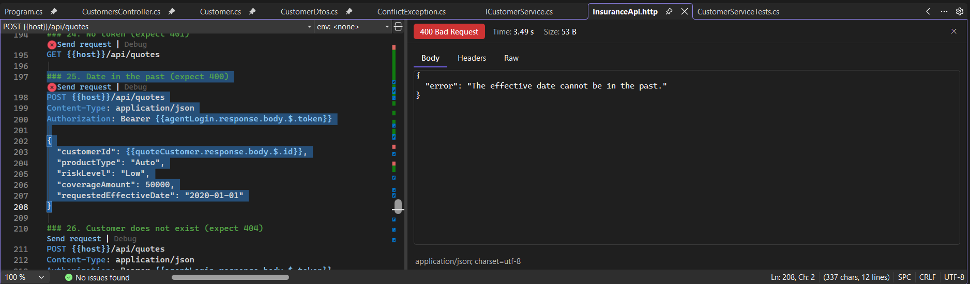

Test 26: Customer does not exist
Request | POST /api/quotes (agent token)
What we sent | customerId 99999
Expected | 404 Not Found
Result | 404 Not Found. "Customer not found."
What it proves | A quote can only be made for a customer that exists.
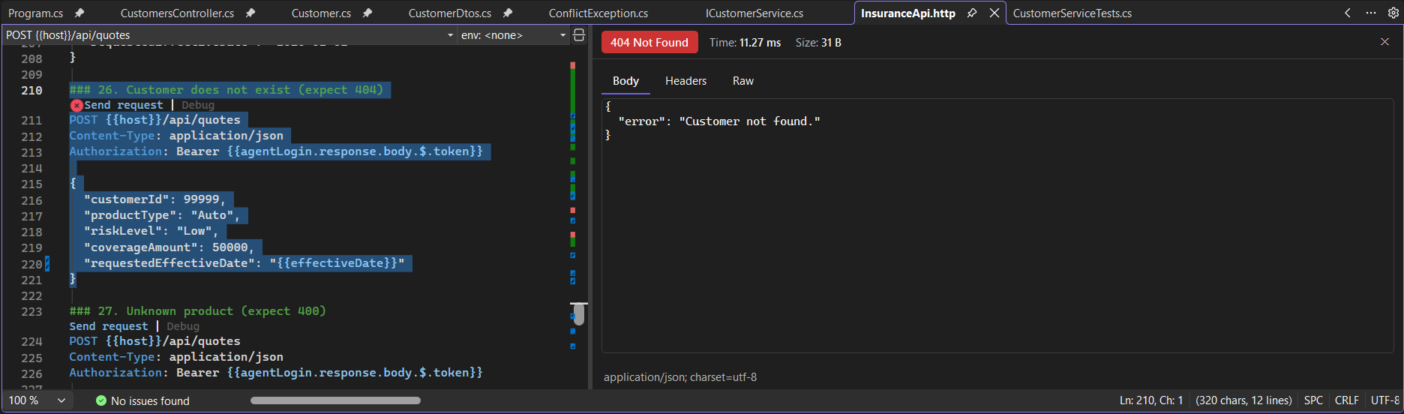

Test 27: Unknown product
Request | POST /api/quotes (agent token)
What we sent | productType "Boat"
Expected | 400 Bad Request
Result | 400 Bad Request. The value could not be converted to ProductType
What it proves | Only the allowed products (Auto, Home, Life, Health) are accepted.
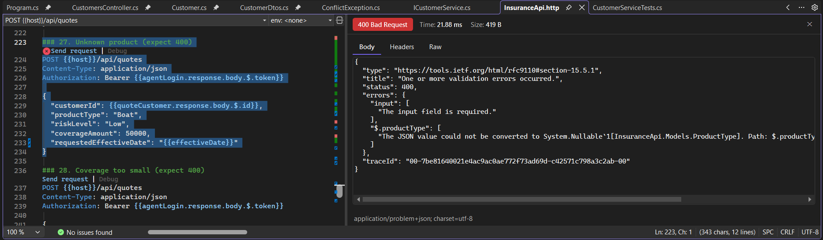

Test 28: Coverage too small
Request | POST /api/quotes (agent token)
What we sent | coverageAmount 5
Expected | 400 Bad Request
Result | 400 Bad Request. "CoverageAmount must be between 1000 and 10000000."
What it proves | The coverage range is enforced.
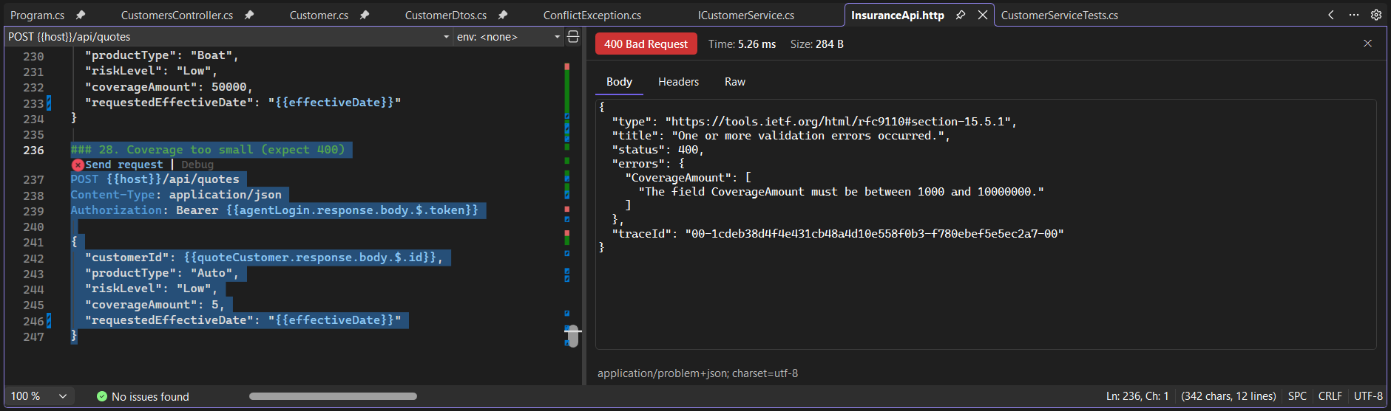

Part E: Supporting evidence

Unit tests: 7 of 7 passed
The customer service has 7 automatic xUnit tests. They use an in-memory database, so they run in about a second and never touch the real data. They cover create, duplicate email, get unknown id, update, update unknown id, delete, and delete unknown id.
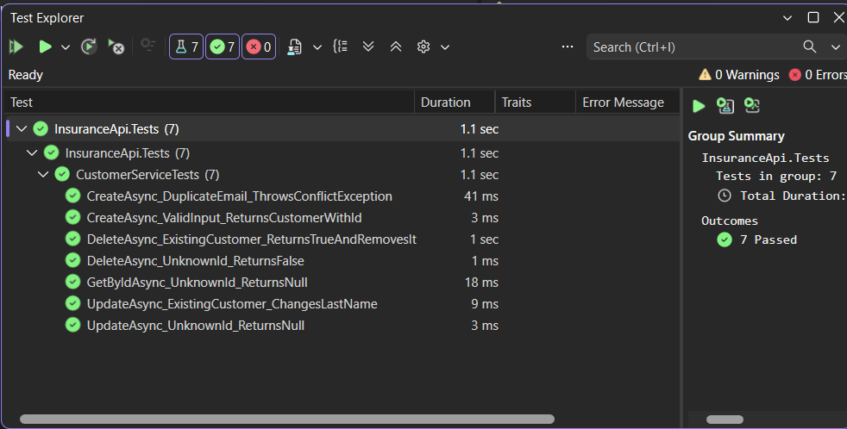

Database: saved rows in SQL Server
A query of the Customers table in SQL Server shows the saved row. This screenshot is from an earlier run (8 October), so the id and date differ from the tests above.
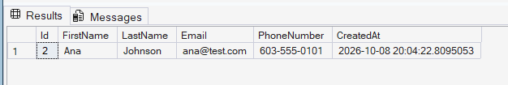

Notes
The screenshots show the demo passwords and short-lived demo tokens, which expire after one hour. They are fine for this demo project, but do not publish them with a real system.
Not covered by automatic tests yet: the quote service and the premium calculator. They are checked through the requests above (tests 21 to 28), and automatic tests are the next step.

