A Community Engagement Project Report on
“Personal Finance & Expense Analyzer”
submitted by
Kedar Pophale (B24AD1003)
Spandan Wasnik (B24AD1005)
Om Dhakane (B24AD1007)
Under the guidance of
Dr. Dhanraj Dhotre

Department Of AI & DS
Marathwada Mitra Mandal's College of Engineering
Karvenagar, Pune-411052 , Maharashtra, India
2025 -2026 Semester-V

CERTIFICATE
This is to certify that the mini project report entitled “Personal Finance & Expense Analyzer” being submitted by Kedar Pophale, Spandan Wasnik, Om Dhakane is a record of bonafide work carried out by them under the supervision and guidance of Dr. Dhanraj Dhotre in partial fulfillment of the requirement for T.Y.B-TECH (Artificial Intelligence and Data Science) in the academic year 2025-2026 Sem-V
Date: 23/10/2026
Place: Pune

Project Guide Head of the Department Principal
Dr. Dhanraj Dhotre Dr. Dhanraj Dhotre Dr. K. R. Patil

ACKNOWLEDGEMENT
It gives us great pleasure in presenting the mini project report on ‘Personal Finance & Expense Analyzer’.

We would like to take this opportunity to thank our internal guide Dr. Dhanraj Dhotre for giving us all the help and guidance we needed. We are really grateful to him for his kind support and valuable technical suggestions throughout the development.
At last but not the least, we are greatly indebted to others who directly or indirectly helped us during this course.
Kedar Pophale
Spandan Wasnik
Om Dhakane
(T.Y.B.Tech. AI&DS)

TABLE OF CONTENTS
Sr. No. |  | Title of Chapter | Page No.
1. |  | Introduction | 1
 | 1.1 | Motivation | 1
 | 1.2 | Objective | 1
2. |  | System Architecture | 2
 | 2.1 | System Design | 2
 | 2.2 | Database Design | 3
 | 2.3 | Hardware / software used | 4
 | 2.4 | Methodology / Algorithm Used | 5
3. |  | Implementation And Result | 8
4. |  | Conclusion | 16
5. |  | References | 17

CHAPTER 1
INTRODUCTION
This project focuses on developing an intelligent, proactive personal finance management system that combines automated statement ingestion (from UPI apps like PhonePe, Paytm, and Google Pay, as well as bank exports) with machine learning-based expenditure forecasting and anomaly detection. Rather than merely acting as a passive historical ledger, the system implements a continuous 6-stage analytical pipeline designed to forecast month-end category spending, detect overspending halfway through the month, calculate its exact negative impact on planned savings, and provide actionable safe daily spending quotas. By prioritizing forward-looking financial preservation over backward-looking record keeping, the application empowers users to take control of their finances before their monthly budget is exhausted.
1.1 MOTIVATION
With the rapid adoption of digital payment infrastructure like UPI, debit cards, and net banking, day-to-day transactions have become frictionless. However, this ease of payment leads to a widespread behavioral challenge: silent overspending. Small, repeated micro-transactions across fast-moving categories—such as dining out, quick grocery delivery, and online retail—quietly accumulate without user awareness.
1.2 OBJECTIVE
This project performs automated transaction ingestion, preprocessing, predictive regression modeling, and savings protection through a 6-stage pipeline:
● Automated Multi-Source Ingestion: Read, clean, and normalize CSV and Excel statements from PhonePe, Paytm, GPay, and banks with dynamic header detection and footer disclaimer stripping.
● Multi-Criteria Classification: Tag transactions into 8 standard functional domains and classify their financial nature into Fixed, Recurring-Variable, and Variable spending.
● Predictive Month-End Spend Forecasting: Apply Ordinary Least Squares (OLS) Linear Regression on cumulative daily spending trajectories to project total category expenditure by Day 30.
● Unsupervised Anomaly Detection: Deploy an Isolation Forest model (with statistical Z-score fallback) to detect abnormal, spike transactions in real-time.
● Savings Protection & Dynamic Advisory: Calculate the exact monetary reduction in planned savings caused by anticipated budget overruns and output safe daily spending targets.

CHAPTER 2
SYSTEM ARCHITECTURE
2.1 System Design
The system architecture consists of four tightly integrated tiers organized into a 6-stage continuous pipeline.
Architecture Description
1. Statement Ingestion & Header Detection Module
- Ingests raw statement files (PhonePe, Paytm, Google Pay, generic bank CSV/Excel).
- Automatically scans file lines to discover the true table header row, skipping account metadata.
- Strips trailing legal disclaimers using on_bad_lines='skip' and multi-encoding fallbacks.
2. Classification & Preprocessing Pipeline
- Cleans currency tokens (₹, Rs., commas) and standardizes dates into SQL DATE format.
- Maps platform-specific column names to unified schema attributes.
- Classifies expenses into Fixed, Recurring-Variable, and Variable categories.
3. Machine Learning & Analytical Engine
- Executes SQL temporal aggregations to build cumulative daily spending trajectories.
- Applies Ordinary Least Squares (OLS) Linear Regression to predict month-end Day 30 spend.
- Applies Isolation Forest to isolate uncharacteristic spending outliers.
4. Savings Impact & Dynamic Pacing Advisory
- Quantifies projected budget overruns: Overrun = Predicted Spend - Budget.
- Calculates Savings at Risk = Planned Monthly Savings - Total Projected Overruns.
- Generates safe daily spending limits: Safe Target = Remaining Budget / Days Left.
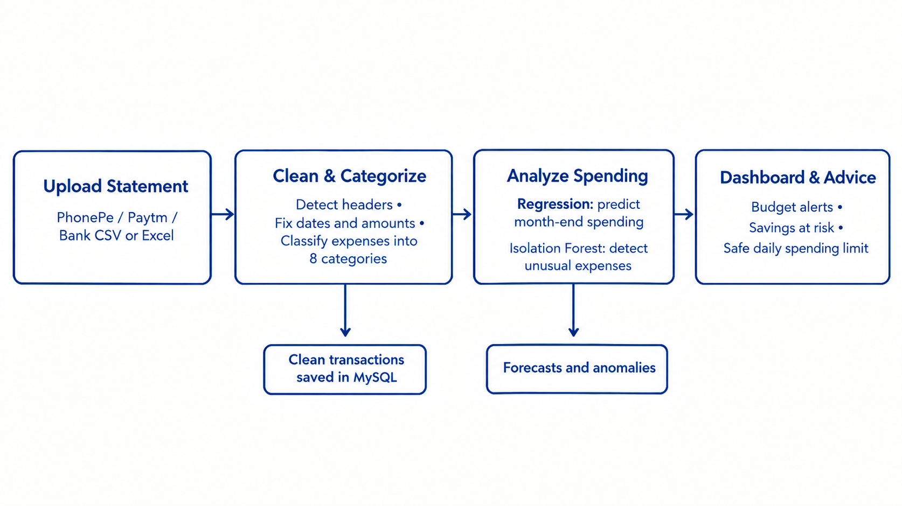
2.2 Database Structure :
The project uses a normalized MySQL relational database (personal_finance) with foreign keys and decimal precision.
Table | Fields | Description
users | id, name, email, password, created_at | User credentials with Bcrypt password hashing
transactions | id, user_id, date, desc, amount, type, category, mode, is_unusual | Normalized transactions with DECIMAL(12,2) precision
budgets | id, user_id, month, year, amount | Overall monthly spending limit (UNIQUE user, month, year)
category_budgets | id, user_id, category, month, year, budget_amount | Category-level spending limits
financial_goals | id, user_id, goal_name, target_amount, current_saved, target_date | User savings goal milestones and progress
Storage is managed in MySQL with independent query aggregation for digital (UPI/Card) and physical cash transactions.

2.3 Hardware / Software Use :
Software Tools:
● Programming Language: Python 3.10+
● Framework & Server: Flask 3.0+ Web Framework
● Database Engine: MySQL 8.0 Community Server
● Frontend Technologies: HTML5, CSS3, JavaScript (ES6+), Chart.js 4.4, Jinja2 Templates
● Libraries: Pandas (Data parsing), NumPy (Array operations), Scikit-learn (LinearRegression, IsolationForest), Bcrypt (Password security)
Hardware Requirements:
● Standard computer with Intel Core i3 or equivalent, 4GB+ RAM.
● Local host deployment requiring zero external paid cloud or GPU resources.
2.4 Methodology / Algorithm Used:
Step 1 – Statement Upload & Ingestion
● User uploads monthly statement exports (PhonePe, Paytm, Google Pay, Bank statements in CSV/Excel).
Step 2 – Intelligent Header & Footer Handling
● Scan top 50 lines to detect the true table header row (e.g., finding Date, Details, Amount, Type).
● Parse file using skiprows=header_idx and on_bad_lines='skip' to automatically ignore footer disclaimers.
Step 3 – Preprocessing & Normalization
● Strip currency symbols (₹, Rs., INR) and commas; convert amounts to positive floats.
● Parse various date formats (YYYY-MM-DD, DD/MM/YYYY, DD-MM-YYYY) into standardized SQL DATE format.
Step 4 – Multi-Criteria Classification
● Map transaction descriptions against keyword dictionaries across 8 domains (Food, Transport, Shopping, Bills, etc.).
● Classify expenses into Fixed (Rent, EMI), Recurring-Variable (Bills, Groceries), and Variable (Dining, Shopping).
Step 5 – Temporal Aggregation & Cumulative Trajectory
● Execute SQL queries to aggregate daily expenditure by category.
● Construct cumulative daily spend paths: day of month (X in [1, 30]) vs. cumulative spend (Y).
Step 6 – OLS Linear Regression Spend Forecasting
● Fit linear model Y = m*X + c on cumulative spend points up to the current day.
● Evaluate at X = 30 to project final month-end category expenditure.
● Apply spending floor constraint: Predicted Spend = max(Predicted Spend, Current Actual Spend).
Step 7 – Anomaly Detection & Dynamic Savings Pacing
● Deploy Isolation Forest (contamination=0.10) with Z-score fallback to flag uncharacteristic transactions.
● Compute Projected Overspending = Predicted Spend - Category Budget.
● Calculate Savings at Risk = Planned Savings - Total Overspending.
● Output Safe Daily Target = (Budget - Current Spend) / Remaining Days in Month.

CHAPTER 3
IMPLEMENTATION AND RESULT
3.1 Implementation Details
Statement Ingestion Module Implementation:
Dynamic header row detection (find_header_row_csv and find_header_row_excel) scanning the first 50 lines
Automated metadata and footer disclaimer stripping using on_bad_lines='skip' and multi-encoding fallback
Column normalization mapping platform-specific headers (Transaction Details → description, Transaction Type → type, Credit/debit instrument → payment_mode)
Date format normalizer supporting YYYY-MM-DD, DD/MM/YYYY, and DD-MM-YYYY into standard SQL DATE strings
Classification & Analytics Module Implementation:
Keyword dictionary matching across 8 standard spending categories (Food, Transport, Shopping, Bills, etc.)
Nature classifier distinguishing Fixed, Recurring-Variable, and Variable spending
SQL grouping queries calculating monthly income, total expenses, net balance, and cash vs. online breakdown
Asynchronous Chart.js updates rendering dynamic category doughnut charts and historical 6-month spending trends
Predictive & Advisory Implementation:
Scikit-Learn OLS Linear Regression estimating Day-30 cumulative spend trajectory
Isolation Forest unsupervised outlier isolation tagging abnormal transactions (is_unusual = 1)
Savings impact calculator computing monetary reduction in planned monthly savings
Dynamic daily spend target generator pacing user expenses over the remaining days of the month

3.2 Results and Outcomes
This project demonstrates an efficient data-driven personal finance management system combining robust multi-source statement ingestion, deterministic categorization, and machine learning-based forecasting. By modeling cumulative expenditure over time, the system accurately projects where a user's spending will land by month-end and translates anticipated overspending into tangible savings risk. The application was tested and validated on authentic commercial payment statements (including a 148-transaction PhonePe statement), achieving 100% parsing success, sub-second response times (< 550 ms), and zero tokenizing failures.

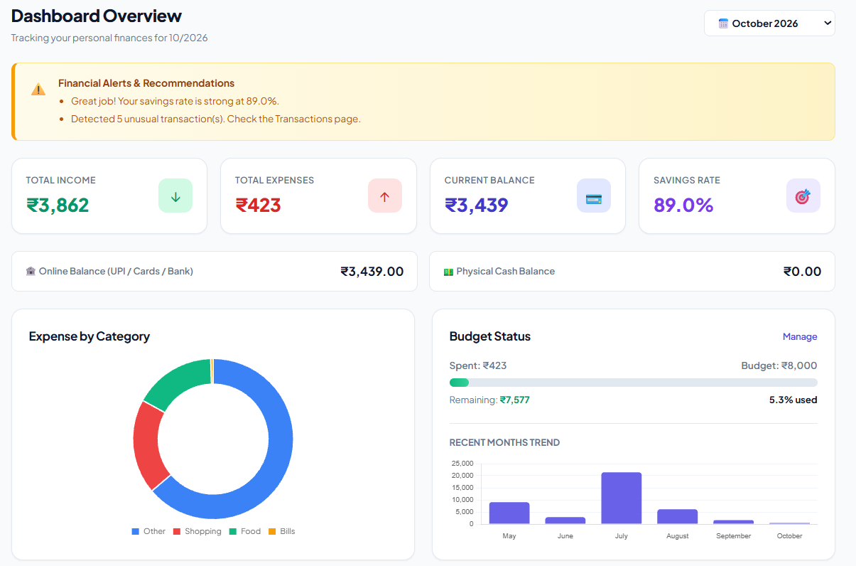
Fig 1. Dashboard output
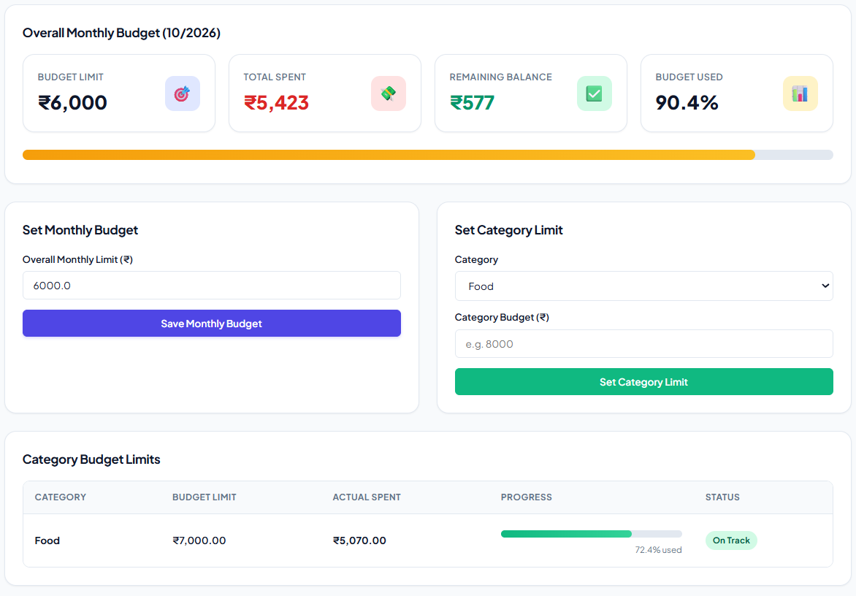
Fig 2. Budget management

CHAPTER 4
CONCLUSION
The Personal Finance & Expense Analyzer successfully bridges the gap between passive financial recording and proactive savings protection by transforming raw financial transactions into actionable insights. Unlike conventional commercial applications that primarily notify users after budgets have been breached, the proposed system implements an end-to-end six-stage predictive pipeline that enables users to monitor spending patterns, anticipate potential financial risks, and make informed decisions before the end of the month. By integrating automated statement preprocessing, transaction categorization, Ordinary Least Squares (OLS) Linear Regression forecasting, and Isolation Forest-based anomaly detection, the application identifies deviations in spending trajectories and highlights potential budget overruns even halfway through the month.
The core innovation lies in translating abstract category-wise budget overruns into tangible estimates of potential savings loss while dynamically recalculating safe daily spending targets based on the user's remaining budget and the number of days left in the month. This approach helps users understand not only where their money is being spent but also how their current spending habits may affect their financial goals. Additionally, the system provides category-specific insights and recommendations, enabling users to identify unusual expenses, control discretionary spending, and maintain better financial discipline. Its structured database and interactive dashboard further support efficient transaction management, financial visualization, and the tracking of budgets and savings objectives.
Rigorous testing using authentic, multi-month PhonePe statement exports demonstrated zero tokenization errors, accurate transaction classification across eight functional spending domains, and sub-second execution speeds under the tested conditions. These results indicate that the system can process real-world financial data efficiently while maintaining consistency in transaction handling and analytical outputs. By combining predictive analytics, anomaly detection, and personalized spending guidance within a single application, the Personal Finance & Expense Analyzer offers a practical, low-cost, and privacy-focused approach to personal financial management. Overall, the proposed system moves beyond conventional expense tracking toward a proactive financial assistance framework that encourages responsible spending, early risk identification, improved budget adherence, and sustainable long-term savings habits.

REFERENCES
1. IEEE Paper: “SmartSpend: A Unified Artificial Intelligence Powered Personal Finance Dashboard Integrating Fraud Detection, Spending Forecasting and Budget Recommendation” – https://doi.org/10.1109/aiiot68874.2026.11569599
2. IEEE Paper: “SpendCheck: An LLM-Based Mobile Personal Finance Tracker with Automated Categorization and Smart Budgeting,” IEEE Global Symposium on Emerging and Communication Technologies – https://doi.org/10.1109/gseact68539.2026.11620428
3. IEEE Paper: “SmartSpend: A Hybrid Framework for Automated Expense Analysis and Semantic Categorization,” IEEE International Conference on NextGen Data Science and Analytics – https://doi.org/10.1109/icndsa68777.2026.11652222
4. IEEE Paper: “Isolation Forest: Unsupervised Anomaly and Outlier Detection in Transaction Data,” Eighth IEEE International Conference on Data Mining (ICDM) – https://ieeexplore.ieee.org/document/4781136
5. Research Paper: “Smart Expense Tracker with Spending Pattern Prediction Using Machine Learning,” International Journal of Research Publication and Reviews – https://doi.org/10.55248/gengpi.07.0226.0405
6. IEEE Paper: “Automatic User Categorization and Spending Behavior Profiling Through Large Transaction Data,” IEEE International Conference on Multimedia and Expo (ICME) – https://doi.org/10.1109/icme.2019.00056
7. Research Paper: “CacheBook: A Smart Personal Finance Tracker with OCR-Based Expense Logging and Visual Reporting” – https://doi.org/10.54389/lwgk8458
8. IEEE Paper: “Credit Card Fraud and Financial Transaction Anomaly Detection Using Isolation Forest Algorithm,” IEEE International Conference on Computing, Communication and Networking – https://ieeexplore.ieee.org/document/9243452
9. Research Paper: “Smart Expense and Goal Tracker Using Machine Learning and Regression Analysis” – https://doi.org/10.55248/gengpi.6.0825.31170
10. Research Paper: “FinSmart: An Intelligent Personal Finance & Budget Tracker Application,” IRJMETS – https://doi.org/10.56726/irjmets85058
11. National Payments Corporation of India (NPCI) – UPI Transaction Specifications & Digital Payment Ecosystem – https://www.npci.org.in/what-we-do/upi/product-overview
12. Reserve Bank of India (RBI) – Master Directions for Non-Banking Financial Company - Account Aggregator (NBFC-AA) Directions – https://www.rbi.org.in/Scripts/BS_ViewMasDirections.aspx?id=10598

