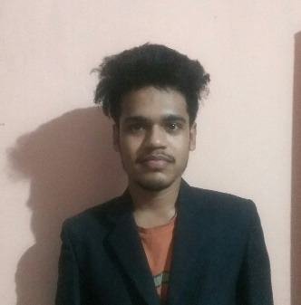

**NAME**: Spandan Joshi

**BRANCH** : ECE

**E-mail**: spandanj685@gmail.com

**Mobile**: (+91)9348982470

# CAREER *OBJECTIVE :*

I seek a job as a web developer to secure a position in a company where I can use my knowledge of web development technology that appreciates both innovations and creativities which results in enhancement of my knowledge as well as skills. And also be able to tackle any challenging situation smartly.

# EDUCATIONAL QUALIFICATION :

|  |  |  |  |  |
| --- | --- | --- | --- | --- |
| **QUALIFICATION** | **INSTITUTE /SCHOOL** | **BOARD** | **STREAM** | **PERCENTAGE/**  **CGPA** |
| Bachelor of Technology | Gandhi Institute of Engineering and Technology,  Gunupur | BPUT | Electronics and Communication Engineering | 7.06 CGPA |
| 12th | Saraswati +2 science collage , Bhawanipatna | CHSE | Mathematics, Physics, Chemistry,  Biology | 54% |
| 10th | SaraSwati Shishu  Vidya Mandir ,  Mukhiguda | HSE | Mathematics, General Science, Social Science, English, Odia ,  Sanskrit | 78% |

**TECHNICAL SKILLS :**

* **Programming language :**  C, HTML 5, CSS 3,Javascript ,Bootstrap ,PHP, Laravel , MySql
* **Web development Stack : MERN**(MongoDB , Express JS , React JS ,Node JS)

**TRAINING AND PROJECT DONE :**

* Undergone a summer internship in Embedded C .
* Summer training on Programming with Python in GIET UNIVERSITY.
* Ecommerce Website using PHP , MySql & AJAX.
* Crud operation using MERN Stack.
* Instagram Clone using MERN Stack.
* Ecommerce website using Laravel & MySql.

# ACHEIVEMENTS AND EXTRA CURRICULAR ACTIVITES :

* Attended Workshop on IOT at IIT Kharagpur.
* One day workshop on Designing PCB and Automatic Street Light Controller.
* Attended Skill Development Program on Basics of Vehicle Dynamics And Fiber Molding

**AREAS OF INTEREST:**

* Full Stack Web Devloper
* UI/UX Designing
* Instagram Marketing

# HOBBIES :

* Web Programming
* Listening to music
* Politics
* Reading blogs

# PERSONAL INFORMATION :

Date of Birth : 14 October 1999

Gender : Male

Father’s name : Bhagirathi Joshi

Nationality : Indian

Languages : English , Hindi , Odia

Permanent address : At/po -Sosia , Kalahandi ,Odisha

Date:09/05/2020 **Full Signature**

PLACE:Gunupur Spandan Joshi