Team Tech Tribe - Sai Spandana Chalasani & Sai Sathvika Chalasani

Appendix
Contents
Problem Statement 2
a) Societal Issue Being Addressed 2
b) Why This Problem Matters 2
System Design 3
a) Architecture Overview 3
b) Why Qdrant Is Important 4
Multimodal Strategy 4
a) Data Types Used 4
b) Embedding and Search Process 4
Search / Memory / Recommendation Logic 5
a) How Search Works 5
b) How Memory Works 6
Limitations & Ethics 7
a) System Limitations 7
b) Ethics and Safety 7

Problem Statement

a) Societal Issue Being Addressed
Today, people in healthcare face a big problem. There is too much medical information, and it is spread across many places. Doctors, researchers, and students have to read long research papers and also look at medical images like X-rays. Finding the right information quickly is very hard.
Doctors may spend a lot of time searching for useful papers. Researchers find it difficult to connect medical text with real images. Patients and families often feel confused because medical information online is complex or unreliable.
This project tries to solve this problem by building a simple multimodal healthcare search system using Qdrant. The system helps users search medical text and medical images together in one place.
The system uses:
- Around 2,200 medical research articles from PubMed Central (PMC)
- Around 5,000 chest X-ray images from the NIH Chest X-ray dataset
By combining text, images, and memory, the system makes medical information easier to find and understand.

b) Why This Problem Matters
- Medical information is very important because it affects human lives. Wrong or unclear information can cause serious harm.
- Normal search engines work only with keywords. They do not understand meaning or context. Because of this, users often get many results that are not truly useful.
This problem matters because:
- Doctors and researchers need quick and correct information
- Healthcare workers face stress due to information overload
- Patients and families need clear and trustworthy explanations
This system helps by:
- Using meaning-based search instead of keyword search
- Supporting both text and image search
- Remembering past interactions to give better results
- Showing results based on real research papers and images

System Design

a) Architecture Overview
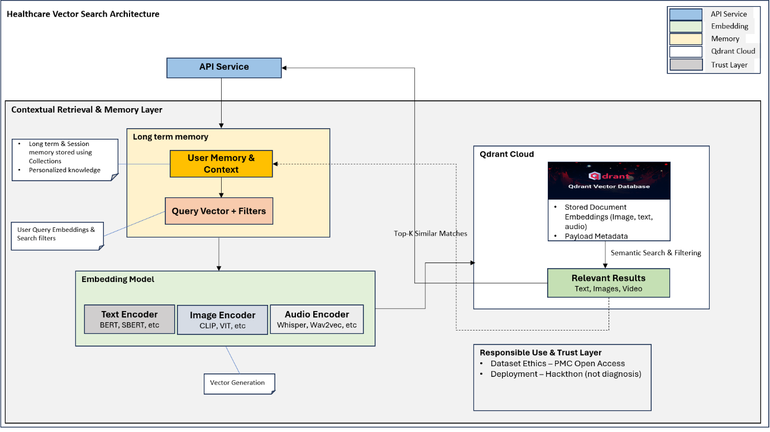
The system is built in a simple and modular way. Each part has a clear role. Qdrant is the main component that handles search and memory.
- API Service Layer
The API layer (built using FastAPI) connects the user to the system. It receives user queries, manages sessions, and sends data to other parts of the system.
- Embedding Model Layer
Different data types are converted into vectors:
- Text is converted using a text embedding model (all-MiniLM-L6-v2)
- Images are converted using an image model (CLIP - openai/clip-vit-base-patch32)
- These vectors help the system understand similarity.
- Memory Layer
The system has memory so it can remember context:
- Session memory remembers short-term conversation
- Long-term memory remembers important past interactions
- This helps the system give more relevant results.
- Qdrant Cloud
Qdrant stores:
- All vector embeddings
- Metadata like data source and type
- Separate collections for text, images, and memory
- It returns the most relevant results for each search

- Responsible Use & Trust Layer
The system is designed safely:
- Uses open and trusted datasets
- Gives clear disclaimers
- Does not give medical diagnosis
- Shows where information comes from

b) Why Qdrant Is Important
Qdrant is the heart of the system. It makes fast and accurate semantic search possible. In this project, Qdrant Cloud is used as a managed vector database to reliably store and retrieve embeddings without infrastructure overhead.
Qdrant helps to:
- Store text, image, and memory vectors securely in Qdrant Cloud collections
- Find similar data quickly using high-performance vector semantic search
- Use memory in a meaningful way by retrieving relevant session and long-term user context
- Show clear and explainable results through similarity scores and stored metadata (payloads)

Multimodal Strategy

Data Types Used
The system uses different types of data:
- Text Data
- Medical research articles from PMC
- Used for medical knowledge search
- Image Data
- Chest X-ray images from NIH dataset
- Used to find similar medical images
- Memory Data
- Session memory
- Long-term user memory

Embedding and Search Process
- Text is encoded using a Sentence-BERT–based model (all-MiniLM-L6-v2). This model generates dense vector representations that capture semantic relationships and contextual meaning, rather than relying on simple keyword matching.
- Images are encoded using a CLIP-based (openai/clip-vit-base-patch32) image encoder built on a Vision Transformer (ViT). The encoder converts visual features and patterns into normalized dense vectors, making them suitable for efficient cosine similarity–based retrieval.
- Session-level and long-term memory content is embedded using the same text embedding model as biomedical text. This ensures consistency and compatibility during semantic search and when injecting contextual memory into user queries.
When a user searches:
- The user’s query is transformed into a numerical vector using the appropriate encoder, depending on the query type (for example, text or image). This allows the system to understand the query in a semantic way.
- The system retrieves relevant session-level and user-specific memories from Qdrant using semantic search. This ensures that past interactions and contextual knowledge are taken into account.
- The retrieved memory content can be injected into the original query, enriching it with additional context. This helps create a more context-aware representation of the user’s intent.
- The enriched query vector is then used to perform a Top-K similarity search within the appropriate Qdrant collection (such as text, image, or memory)
- The system returns the most relevant results along with similarity scores and associated metadata. This enables transparency and explainability, showing why each result was retrieved.

Search / Memory / Recommendation Logic

How Search Works
The system performs semantic, multimodal retrieval using Qdrant as the core vector search engine. Retrieval behaviour automatically adapts based on the type of query provided by the user.
- Query Processing
When a user submits a request, the system:
- Identifies the query modality (such as text, image, audio, or video).
- Generates a dense vector embedding using an encoder tailored to that modality.
- Routes the query to the appropriate Qdrant collection, such as the text corpus, image corpus, or memory store.

- Context-Aware Retrieval for Text Queries
Text-based queries are enhanced with contextual understanding:
- The system retrieves relevant session-level and long-term user memory using semantic similarity search.
- This retrieved memory is injected into the current query, creating a context-enriched query representation.
- As a result, the system can interpret the user’s intent in light of previous interactions and personalized context.

- Vector Similarity Search
- The query vector is used to perform a Top-K cosine similarity search in Qdrant.
- Qdrant efficiently indexes high-dimensional embeddings and returns the most semantically relevant results.
- Payload metadata—such as dataset source, modality, and content type—can be used for filtering, auditing, and traceability.

- Evidence-Based Result Generation
- Each retrieved result includes a similarity score along with its associated metadata.
- The system clearly distinguishes between information retrieved from external knowledge sources and content derived from session or user memory.
- This design ensures transparency, explainability, and minimizes the risk of hallucinated or ungrounded responses.

How Memory Works
- Types of Memory
Session Memory
- Captures short-term context within a single user session.
- Helps maintain conversational continuity across multiple turns.
- Stored in a dedicated Qdrant collection to keep session context isolated and lightweight.
Long-Term User Memory
- Stores durable knowledge derived from repeated or meaningful interactions.
- Persists across sessions and enables personalization.
- Maintained in a separate Qdrant collection to clearly distinguish it from temporary session context.

- Memory Storage
After each eligible interaction, the system stores:
- A semantic embedding of the interaction content.
- Associated metadata such as user ID, session ID, timestamp, and content type.
All memory entries are embedded using the same text encoder as search queries, ensuring full compatibility during semantic retrieval.

- Memory Retrieval and Reuse
- At query time, relevant memory entries are retrieved from Qdrant using vector similarity search.
- Selected memory content is injected into the current query as contextual signals.
This enables the system to:
- Adapt responses based on previous interactions.
- Maintain topic continuity across turns.
- Deliver personalized, context-aware retrieval results.

- Memory Evolution and Control
Memory collections are designed to support:
- Updates: New interactions can reinforce or refine existing memory.
- Deletion: Memory entries can be explicitly removed for session cleanup or privacy compliance.
- Clear separation of concerns: External knowledge, session context, and long-term interaction history are stored independently.

Limitations & Ethics

System Limitations
- The image dataset (NIH Chest X-ray) is limited to frontal chest radiographs and does not cover other imaging modalities (CT, MRI, ultrasound).
- Text articles are sourced from PubMed Central and may not reflect the most recent clinical guidelines.

Ethics and Safety
- Dataset Bias
- PubMed Central articles may reflect publication bias, with greater coverage of well-studied diseases, conditions, and populations.
- The NIH Chest X-ray dataset is drawn from specific clinical environments and may not generalize across regions or healthcare systems worldwide.
- As a result, the system does not claim epidemiological completeness or representativeness.
- Safety Boundaries
- The system intentionally avoids making diagnostic claims or treatment recommendations.
- Responses include clear disclaimers emphasizing that the information is for educational and informational purposes only.
- No automated clinical decision-making, risk assessment, or scoring is performed.

- Privacy Protection
- No personal health information (PHI) is ingested, processed, or stored.
- Session and user memory are limited to anonymized interaction content.
- Memory collections are logically separated from external knowledge sources to minimize privacy risk and prevent unintended data mixing.

- Explainability and Transparency
- All system outputs are grounded in retrieved documents or images rather than generated speculation.
- Payload metadata and similarity scores provide traceability into why specific results were returned.
The system clearly distinguishes between:
  - External medical knowledge
  - Session-level context
  - Long-term user memory

