ASSIGNMENT-1
NAME: SHIVA SPANDANA
2303A51320
BATCH-19

Task 1: AI-Generated Logic Without Modularization (Fibonacci Sequence Without Functions)
Scenario:
You are asked to write a quick numerical sequence generator for a learning platform prototype.
Prompt: #Fibonacci series up to n terms
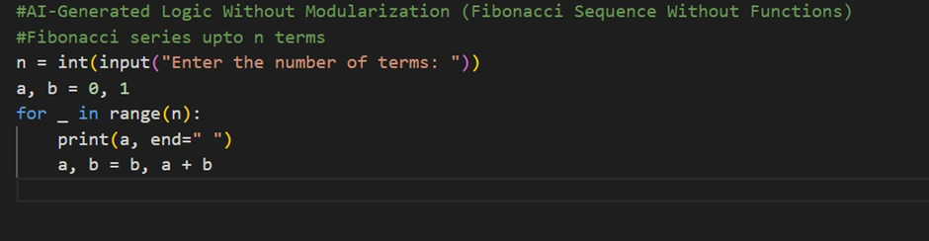
OUTPUT:
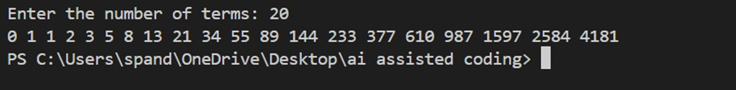
OBSERVATION:
GitHub Copilot was able to create a correct Fibonacci sequence using simple and direct logic. The code is short, easy to understand, and works well for quick tasks without using any functions. However, the calculation and printing are mixed together, and there is no check for wrong input, which makes the code less reusable and harder to improve later. This example shows that Copilot is good at quickly generating working code, but the code may need better structure for larger or long-term use.

Task 2: AI Code Optimization & Cleanup (Improving Efficiency)
Scenario :
The prototype will be shared with other developers and needs optimization.
Prompt: #Optimize this code
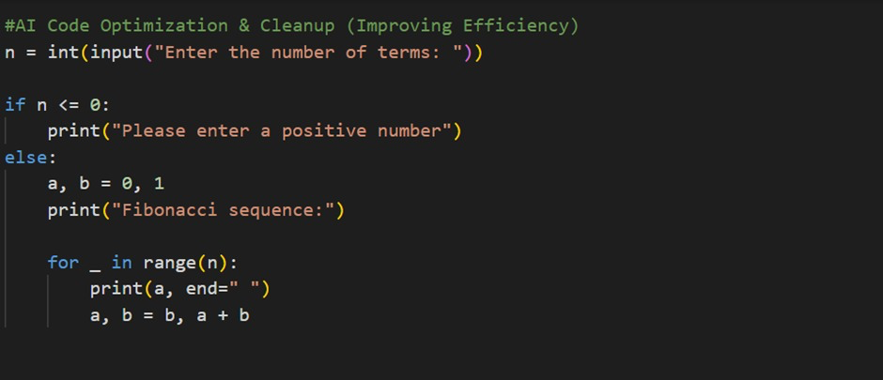
OUTPUT:
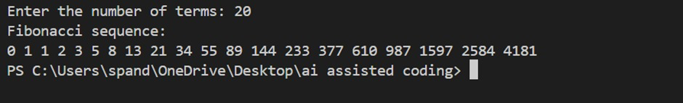
OBSERVATION:
GitHub Copilot generated a correct and optimized Fibonacci sequence using an iterative approach with proper input validation. The code clearly handles invalid input by checking for non-positive values before generating the sequence, which improves reliability. It uses simple variable updates and avoids user-defined functions, making the program easy to follow and suitable for small tasks. However, the Fibonacci logic and output are still closely tied together, which limits reusability and scalability. This example shows Copilot’s ability to improve code quality with basic validation while still having room for better modular structure in larger applications.

Task 3: Modular Design Using AI Assistance (Fibonacci Using Functions)
Scenario:
The Fibonacci logic is now required in multiple modules of an application.
Prompt: Optimize this code using functions
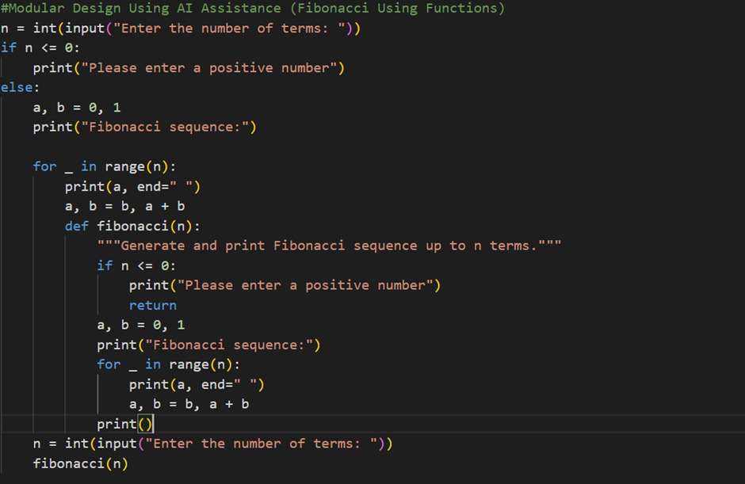
OUTPUT:
OBSERVATION:
GitHub Copilot attempted to combine both inline logic and a function-based approach in the same program, but the resulting code has structural issues. The Fibonacci logic is duplicated, and the function definition is incorrectly placed inside the loop, which reduces clarity and can cause logical errors. Although the intention was to demonstrate modularization by defining a fibonacci function, improper indentation and missing documentation formatting make the code harder to read and maintain. This example shows that while Copilot can generate correct Fibonacci logic, careful human review is still necessary to ensure proper code organization, correct structure, and effective use of functions for clean and reusable design.

Task 4: Comparative Analysis – Procedural vs Modular Fibonacci Code
Scenario :
You are participating in a code review session
Prompt: Description on comparison between with functions and without function
Observation: Code Review Comparison
This module illustrates the evolution of Fibonacci sequence generation by comparing an inline, non-modular approach with a function-based, modular design. In the version without functions, the logic is written directly in the main code using simple variable assignment (a, b = 0, 1), which makes the program easy to write but limits input validation, reusability, and maintainability. The Fibonacci logic is tightly coupled with input and output operations, making the code harder to test or modify independently. In contrast, the modular approach encapsulates the Fibonacci logic within a function, resulting in better organization, clearer separation of concerns, and improved readability. This design allows easier testing and debugging, supports stronger input validation through early returns, and encourages reusability across different parts of an application while following the DRY principle. Overall, modularization improves scalability, clarity through documentation, centralized error handling, and provides opportunities for performance optimization at the function level.

Task 5: AI-Generated Iterative vs Recursive Fibonacci Approaches (Different Algorithmic
Approaches for Fibonacci Series)
Scenario :
Your mentor wants to assess AI’s understanding of different algorithmic paradigms.
Prompt: Give me a code using iterative and recursive approach.
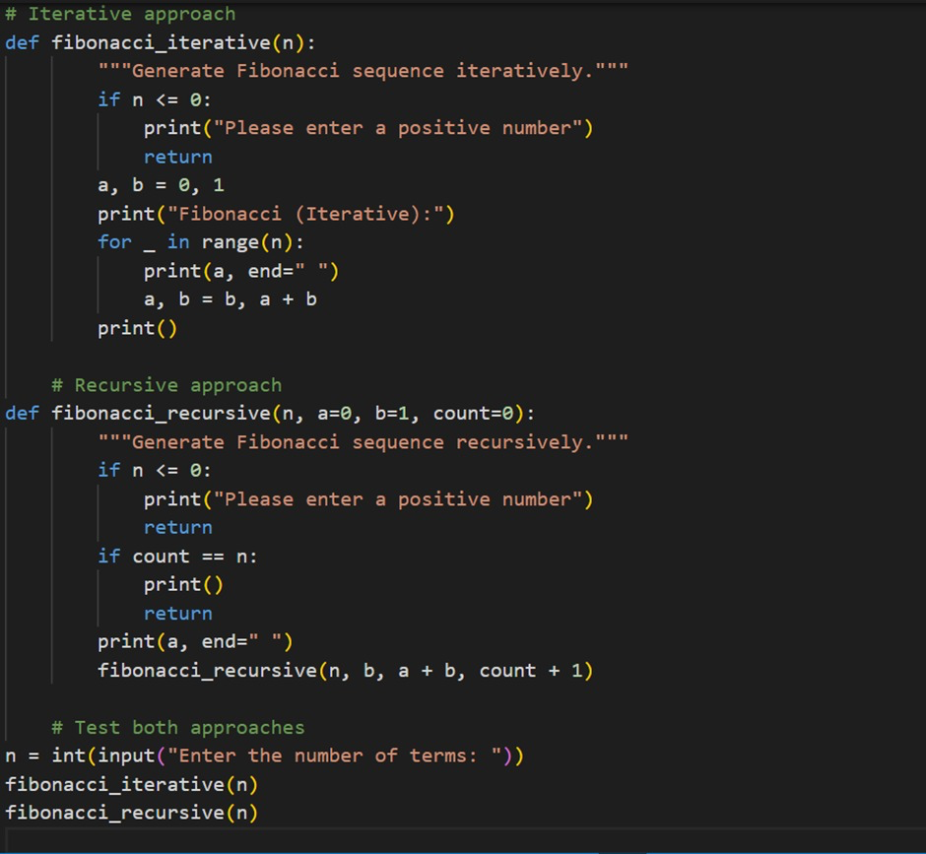

OUTPUT:
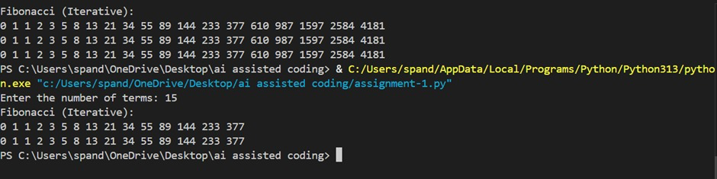
OBSERVATION:
GitHub Copilot was able to generate both iterative and recursive implementations of the Fibonacci sequence using a modular, function-based approach. The code is well organized, with clear separation between logic and execution, making it easier to read, test, and reuse. Input validation is handled within the functions, improving reliability and preventing incorrect execution. The iterative method is efficient and suitable for larger values of n, while the recursive method demonstrates an alternative logical approach for learning purposes. However, the recursive version may not scale well for very large inputs due to repeated function calls. Overall, this example shows Copilot’s strength in producing structured, readable, and maintainable code, while also highlighting practical trade-offs between different programming approaches.

