**Home Page**

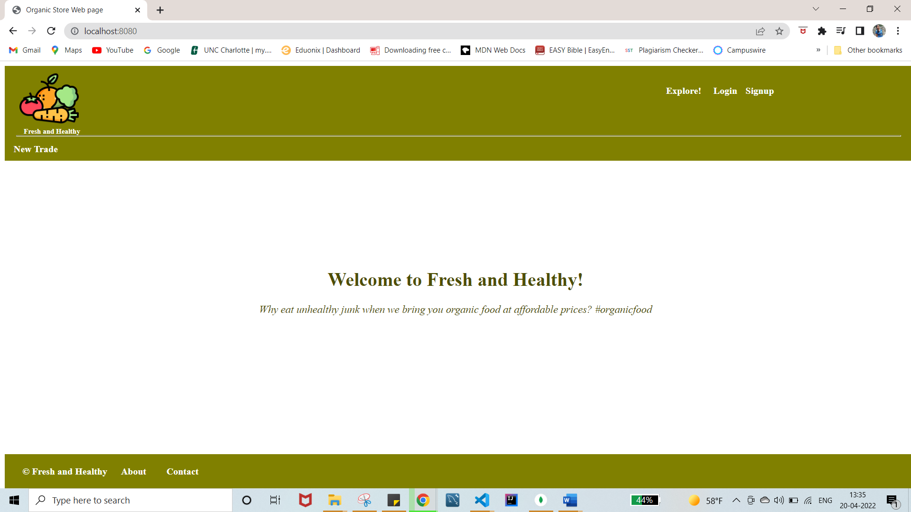

**Explanation:**

The entire project is of MVC architecture. The project skeleton consists of Model, Views, Controller, Routers modules. App.js is the initial step of the project.

Under the Views folder, all views are placed which shows details based on requirement.

In the Model folder, a file named item.js is created to represent items available for trading. Each item object consists of attributes such as id(unique), Name, Category, Details, StoreAddress, and image(currently default).

In the Routers folder, traderoute.js includes RESTful routes for requests associated with trading items and mainroute.js includes routes for the cart-related and general site navigation like login, signup, contact, and about.

In the Controllers folder, tradecontroller.js includes controller functions to handle requests associated with items and trades and maincontroller.js include controller functions to handle requests associated with cart related items general site navigation.

Whenever a wrong URL is entered (bad request) or any other errors all are handled using an error handler which is defined in the app.js file. Every time a wrong url is entered users get a message saying that the server cannot locate the url mentioned navigating to the home page.

The landing page of the website is the index.ejs page with a welcome note on it. When the user clicks on Explore!, they are redirected to the list of products(trades.ejs) offered by the website. This view displays the list of all products under the specific category. From the list, users can click on the specific product and see all its details(trade.ejs).

The trade.ejs displays all details of a specific product such as Name, Category, Details, and StoreAddress and image(default one currently). This page also consists of 4 buttons named Edit, Delete, Add to cart, Save for later. Users can edit and delete products from Edit and Delete buttons respectively.

When the Edit button is clicked users are redirected to edit.ejs view where one can see a form with prefilled values of a specific product and edit those values. Once the value(s) are updated and click on the Update button users are redirected to trade.ejs view with updated values. The specific product can be deleted using the delete button.

If anyone wants to join us to sell their products on our website, they can click on New Trade and fill in the details of the products(newtrade.ejs). In this view, users need to fill out the form and click on Add Item button then they will be redirected to trades.ejs view with a new item added below its category to the existing list as shown in the below snap.

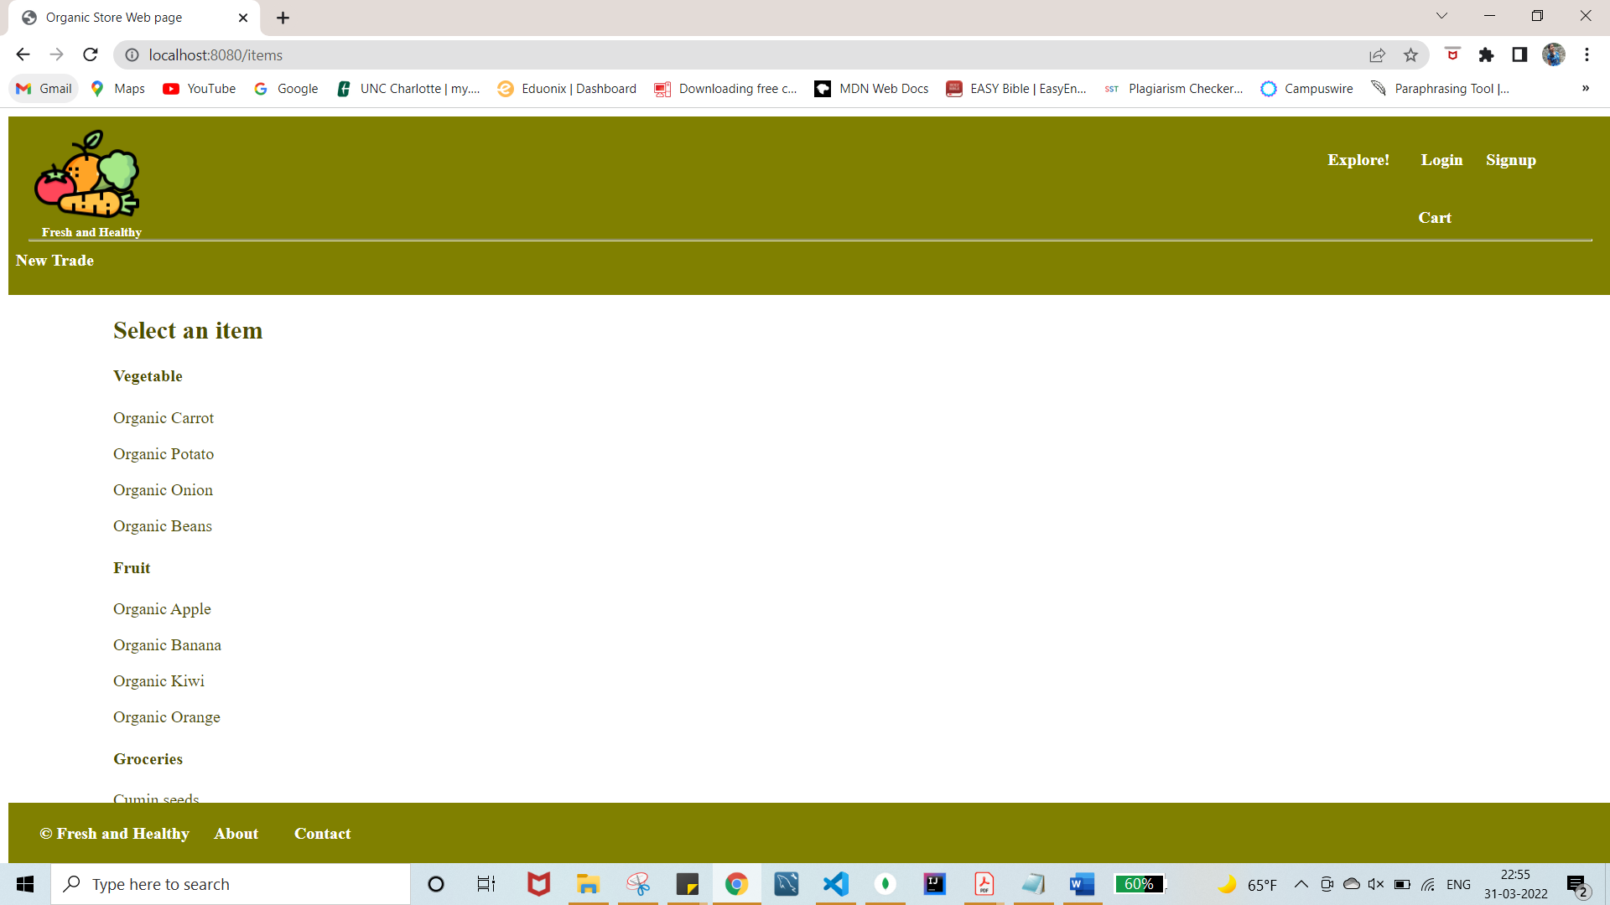

There are other links on the home page that work as navigation. They are Login, Signup, About, and Contact. When users click on Login they are redirected to login.ejs view which allows existing users to login into their account and new users to signup(signup.ejs). When users click on signup! It directs to signup.ejs view where a new user can create an account and then login again.

About link on the bottom of the page displays about.ejs view and Contact link direct to contact.ejs view, where users can fill out a form to post their queries. Once the form is filled the message view(message.ejs) is rendered with a message.

User Integration and Session Tracking have been implemented in this part of the project. Data sessions are implemented as part of securing consumers' data. Flash messages are used to manage many types of customized errors and display them on the website. Data modeling, such as leveraging the user's reference in the item model, as well as a dynamic navigation bar, are both implemented. User Authorization such as restricting different kinds of users to perform only certain actions on the website is also included.

**Additional Features:**

An additional feature known as Cart is added to the project where users can add products to the cart with the quantity required. On trade.ejs page users can enter the quantity of the product and click on add to cart button they will be redirected to cartpage.ejs which displays the items and quantity added to the cart along with navigation to the cart.

When Cart button on the home page is clicked it redirects to the cart page(cart.ejs) where all the items present in the cart are visible. After going to Cart.ejs users can see details of the cart items by clicking on them which redirects to carttrade.ejs as shown below.

Carttrade.ejs

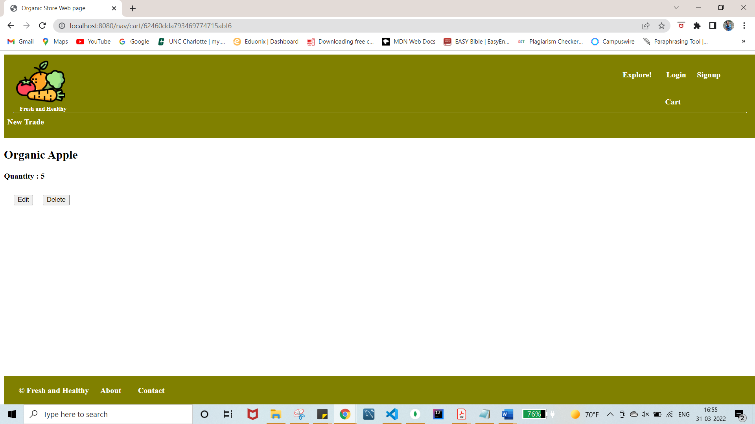

On the above page, users can perform edit and delete actions on the item which is being displayed. When users click on edit page they are redirected cartedit.ejs page and they can edit the quantity of the item.

Cartedit.ejs

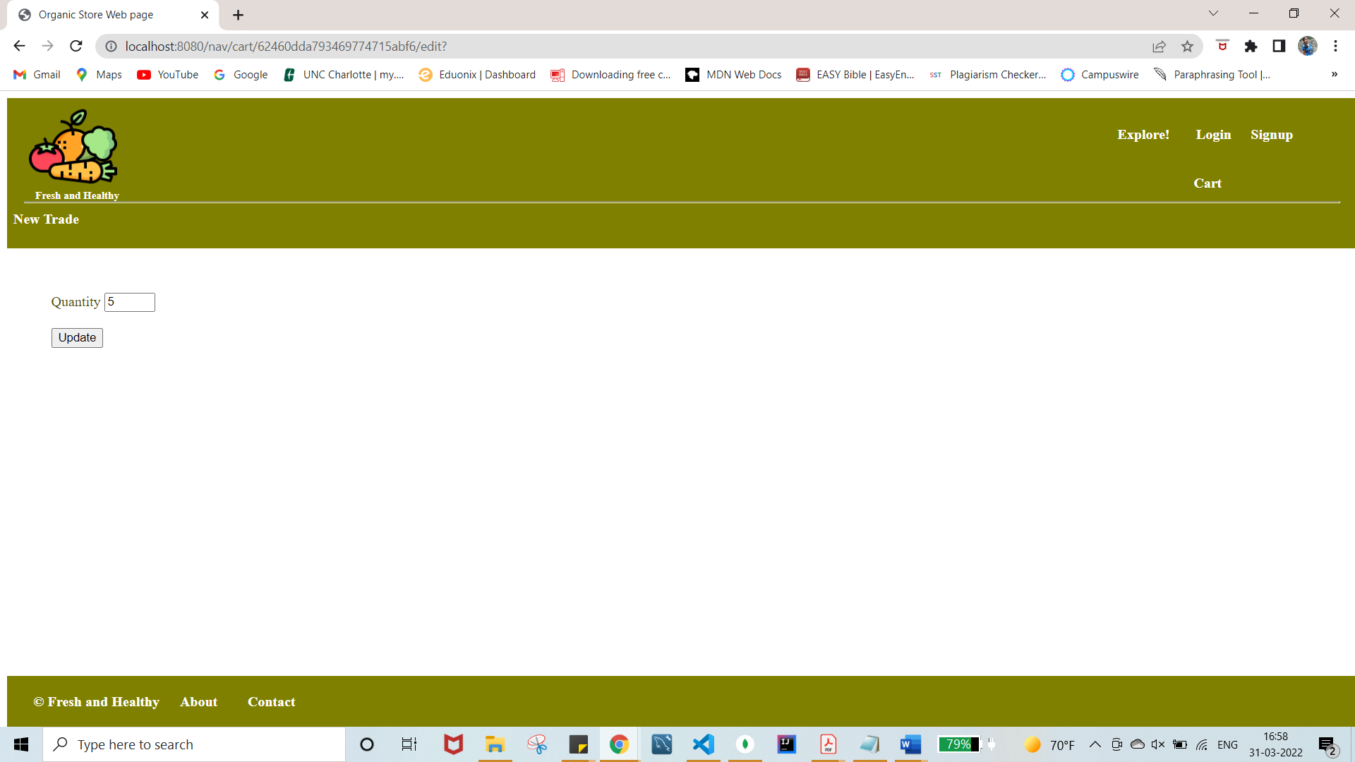

After updating the quantity of item it redirects to carttrade.ejs page which shows the updated quantity value. Along with this items in the cart can also be deleted by using the delete button.

A new Schema and model object are created in cart-item.js file under the models folder to access cart-related items from DB. All cart items are stored in the same DB Webapp but in a different collection named cart.

The cart-item model and user model are also combined to make sure that only authenticated users can perform cart-related actions and that every user’s cart is accessible only to them.

In order to implement the data modeling, i.e to relate the Trade model and the user model an additional attribute called CreatedBy has been added to the existing trade model and Added By attribute has been added to the cart-item model.

During this stage of the project, additional features like trading an item and saving items in the wishlist were added.

The trading feature allows users to trade their own item for an item from a trades list provided by others. When a user creates a new offer, it appears on their profile page, where they can cancel it if they so desire. The owner of the offered item can either accept or reject the offer made by the current user by going to their profile page and clicking the manage offer option.

Users can add items from the list to their wishlist and unsave them at any time.

**Changes made to the previous phase:**

A few changes have been made to the existing project in order to implement the trading and save for later features.

New attributes such as Status(String), OfferName(String), Saved(Boolean), and Offered(Boolean) to the item.js model(trade items) have been added.

Two new models “item_offer.js” and “item_save.js” are created in order to save offer items and saved items respectively. Both the models are modeled with User model using “OfferedBy” and “SavedBy” field respectively.

Initially, for any new trade created by the users the values of Status, OfferName, Saved, and Offered are “Available”, “”, false and false respectively.

Only objects that were not created by the user have the trade button enabled. When a user selects the trade button, they are taken to the item-trade.ejs page, which provides a list of the user's items from which they can choose one to trade with the previously selected item. The status of both products changes to "Offer Pending" after the offer is made, and the user is redirected to the profile page, which includes all the details about offers and trade items.

The Cancel offer button on the profile page can be used to cancel any existing offers. The owner of the trade item has the option of accepting or rejecting the user's offer after it has been made. If the offer is accepted, the status of both goods in the offer is changed to "Traded" or "Available" if the offer is rejected.

When an item is offered for trade, the value of its Offered attribute changes from false to true, and the offerName value is the name of the object through which the offer was made.

The Saved attribute value is updated from false to true when an item is saved to the wishlist (false). A saved item can be unsaved from the profile page or deleted from the wishlist page.

Web app security and server side input validation are also enabled in addition to the previous functionalities.

Trade Button to make an offer to others product:

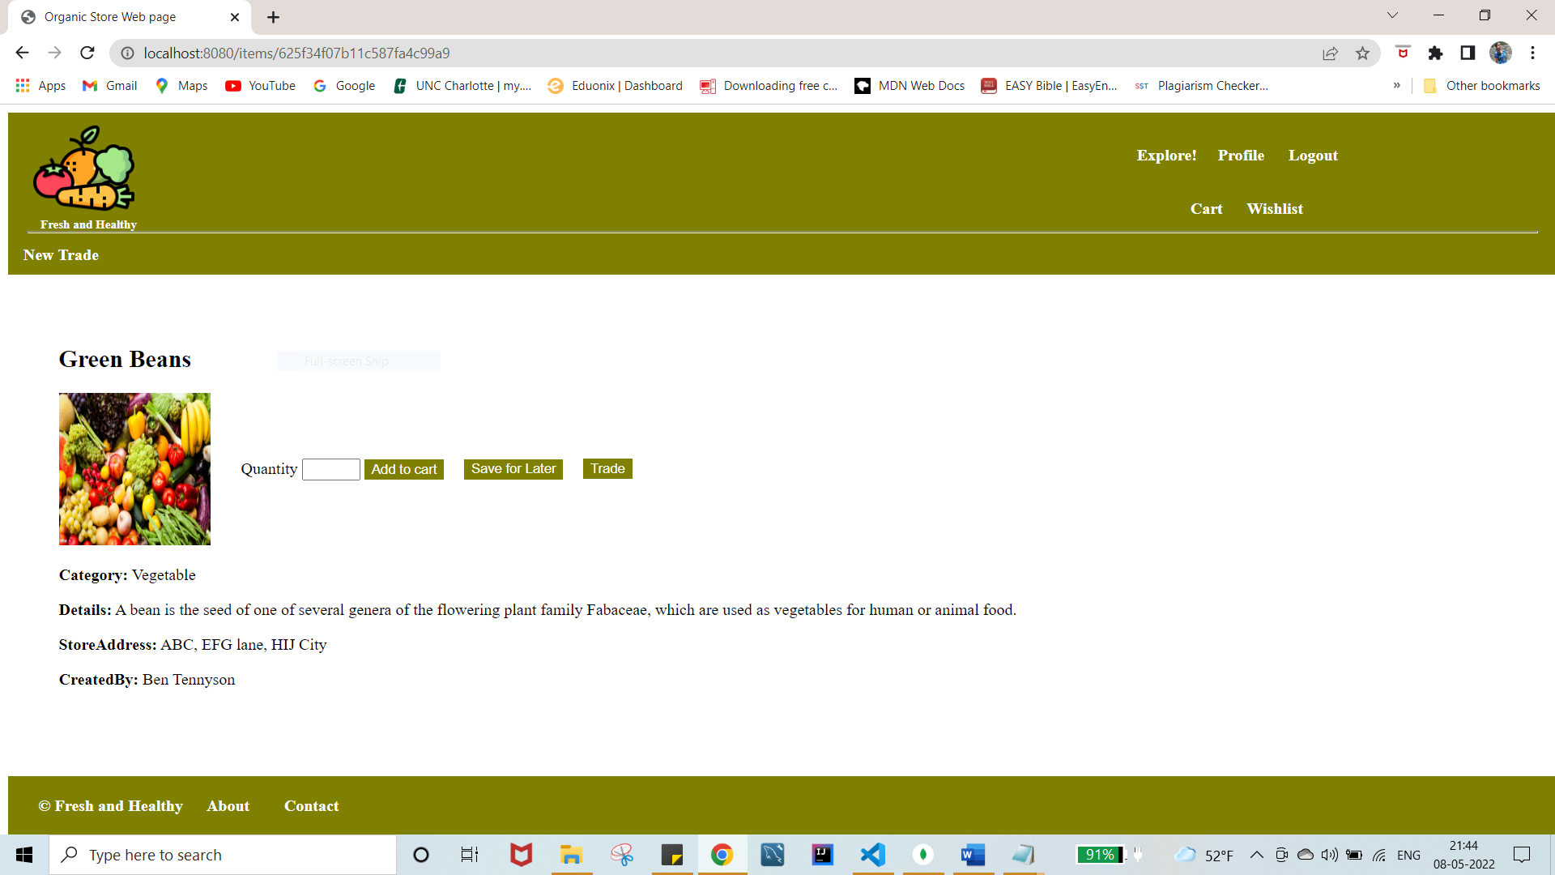

item-trade.ejs(list of items to trade from)

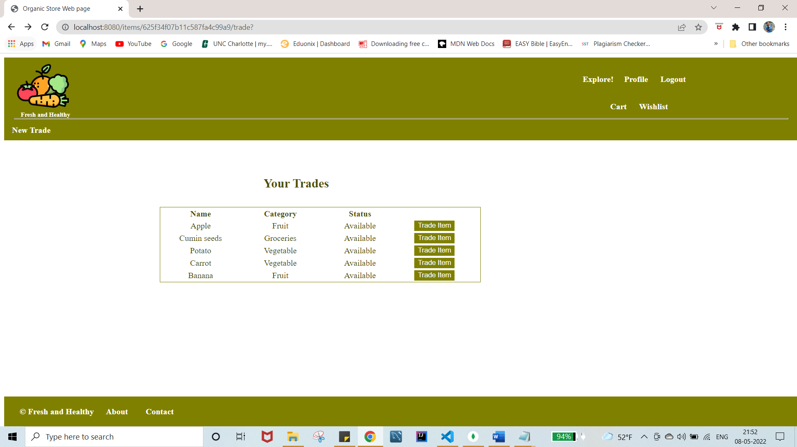

Profile Page after making an Offer

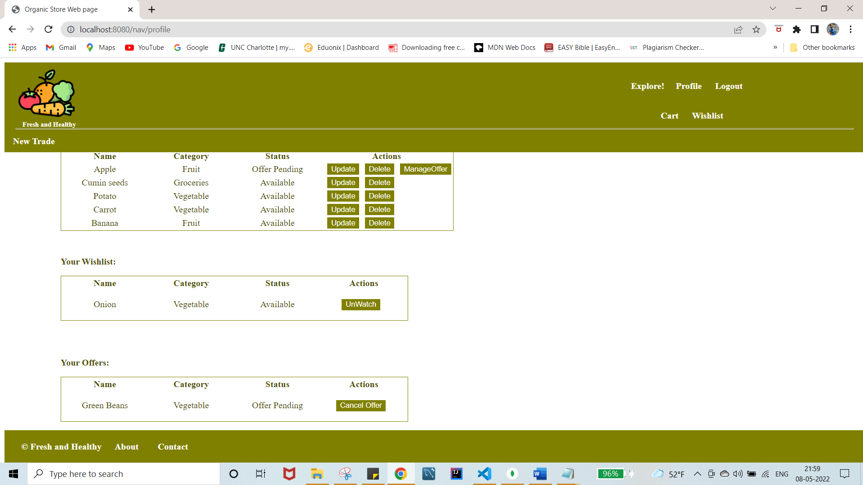

Manage-offer view to cancel offer

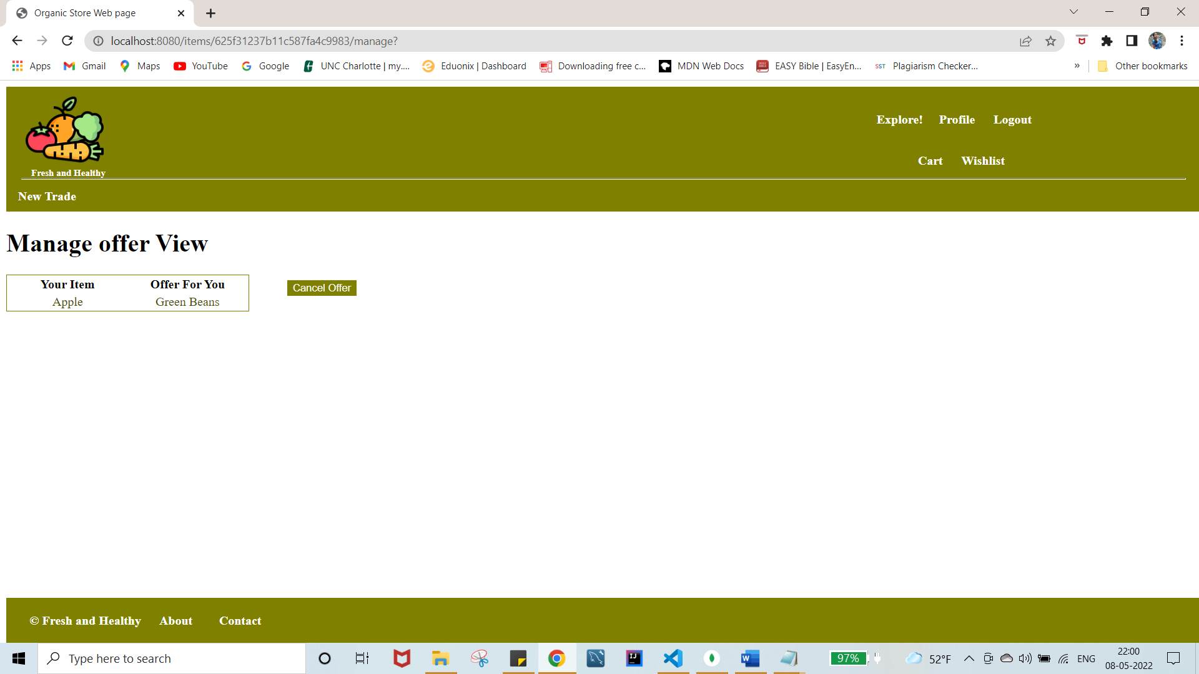

Manage offer view to accept/reject the offer made by others on your item

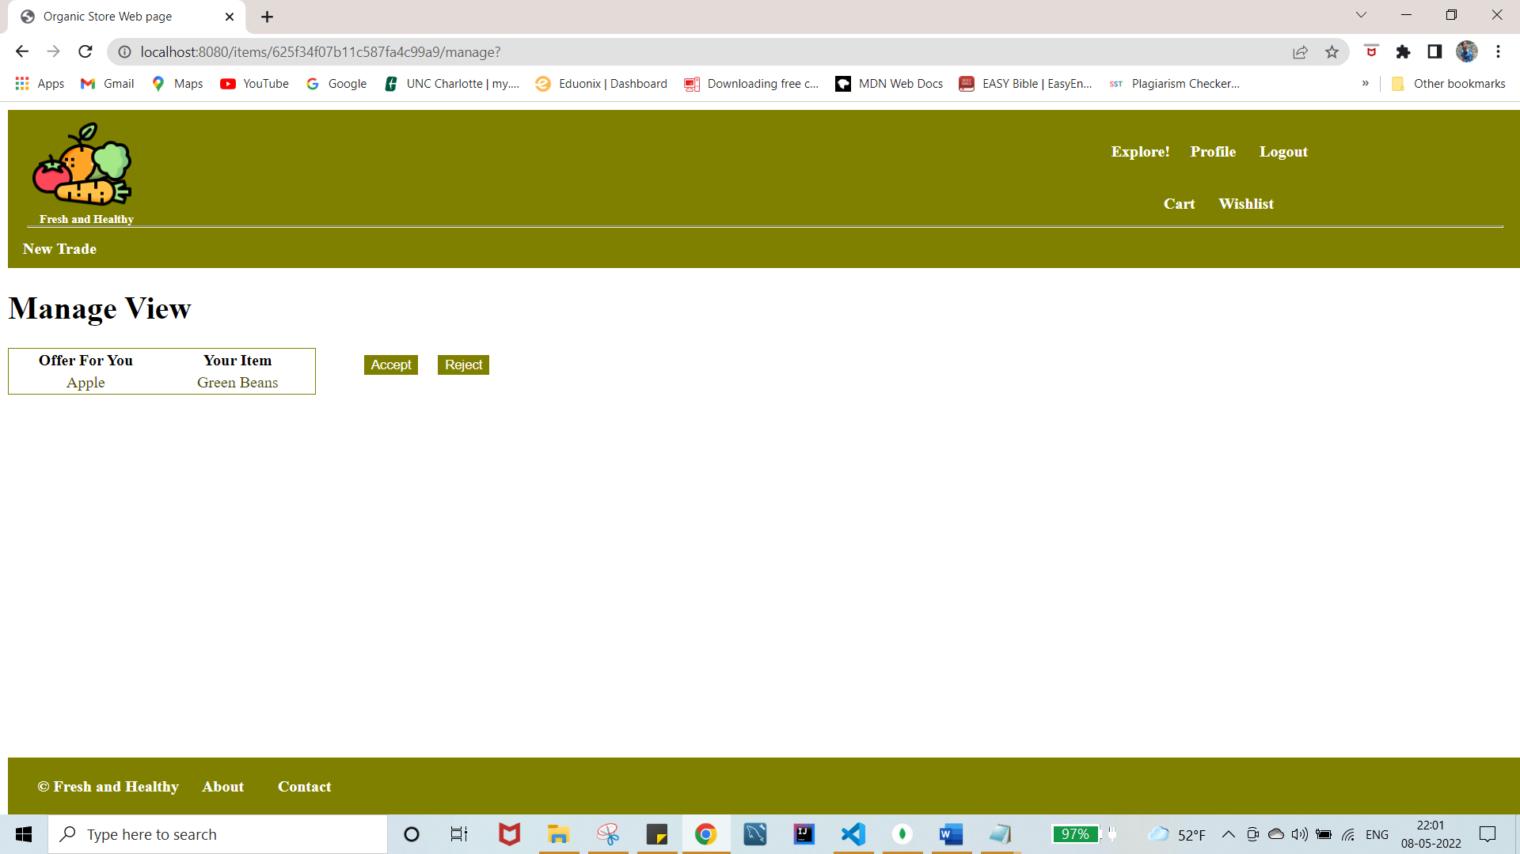

**Challenges Faced:**

Implementing the trading feature has been the most difficult part of the project. As this feature requires to be implemented with all dynamic values of the items and it also includes combining different models based on the requirement.

**Concepts learned:**

* Session Tracking
* Data modeling
* User Authorization.
* Web App Security
* Server-side input validation.