EXPERIMENT: INSTALLATION AND CONFIGURATION OF OWASP ZAP
Name: M.spandana
Roll No.:2420090150

1. Aim
To install and configure OWASP ZAP (Zed Attack Proxy), understand its interface, capture browser traffic through the proxy, and perform a basic security assessment of a web application that is owned by the tester or explicitly authorized for testing.

2. Software Requirements
- Operating system: Windows 10/11 (64-bit).
- OWASP ZAP installer for Windows, downloaded from the official website.
- A compatible browser such as Firefox or Chrome.
- Java/runtime prerequisites, if required by the selected ZAP package.
- A local test application or a web application for which written testing permission is available.

3. Theory
OWASP ZAP is a free, open-source web application security testing tool. It acts as an intercepting proxy between a browser and a web application. It can record HTTP/HTTPS requests and responses, explore application pages, and report potential security issues. Alerts are indicators that require validation; they are not automatically proof that a vulnerability exists.

4. Procedure: Installation and Configuration

Step 1 — Download ZAP
Open the official OWASP ZAP website at https://www.zaproxy.org/download/. Select the appropriate Windows installer. Use the official download source.
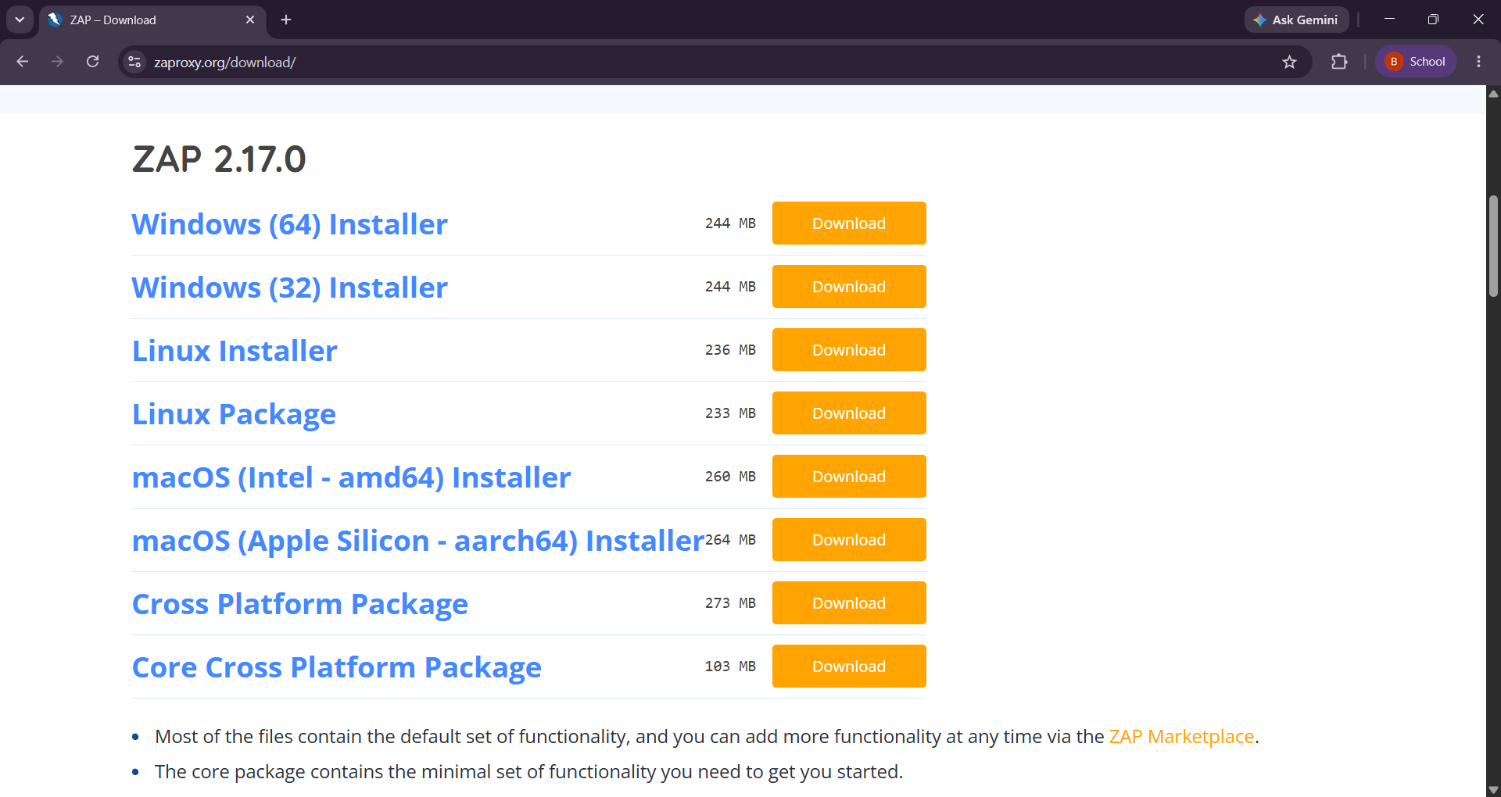

Step 2 — Install the application
Run the downloaded installer. Follow the setup wizard, accept the licence terms, choose the standard/default installation unless your lab specifies otherwise, and finish the installation. If the selected package lists a runtime prerequisite, install the supported version noted by the official documentation.


Step 3 — Launch ZAP
Open OWASP ZAP from the Windows Start menu. Read and accept the licence terms if prompted. When asked about the session, choose a temporary session or save the session to a file as required.
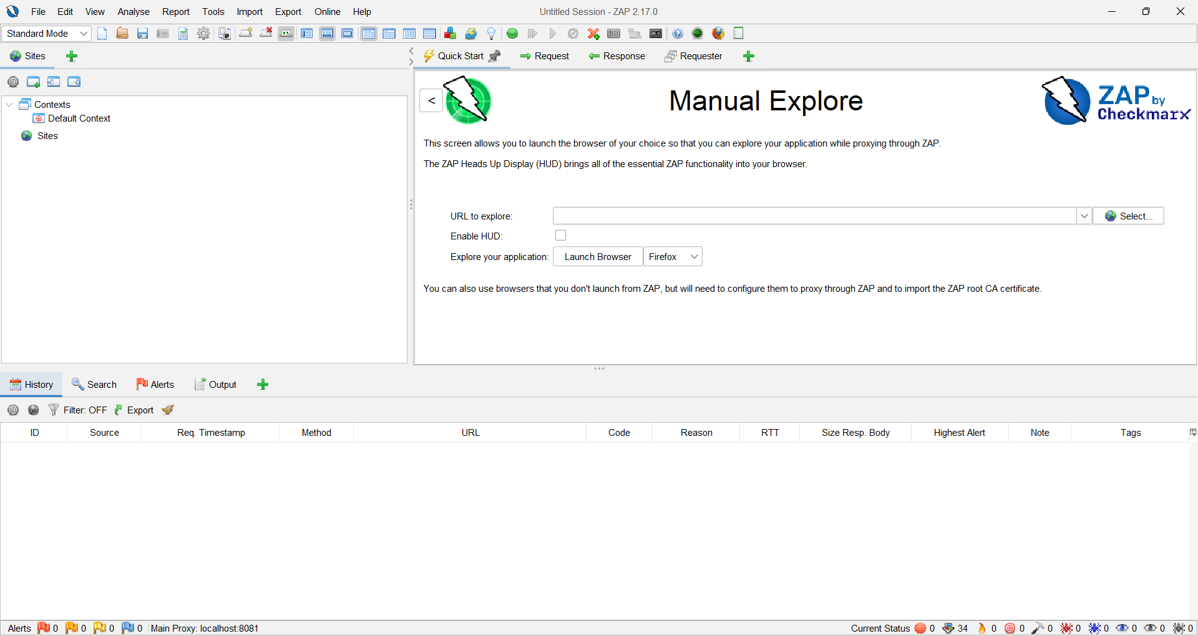

Step 4 — Open Quick Start
Select the Quick Start tab. Review the available options, including Manual Explore and Automated Scan.

Step 5 — Explore through a browser
Choose Manual Explore. Enter the URL of your local or authorized test application, select a browser, and click Launch Browser. Browse a few pages and interact with safe, non-destructive features.


Step 6 — Verify captured traffic
Return to ZAP. Check the Sites tree and History tab. Confirm that the application host and HTTP requests/responses appear. If HTTPS traffic is not visible, follow the current ZAP documentation for browser/proxy certificate configuration; do not bypass certificate warnings for unrelated sites.

5. Procedure: Basic Security Scan
- In ZAP, open Quick Start → Automated Scan.
- Enter the base URL of a local test application or another explicitly authorized target.
- Check the target URL carefully before starting. Use a test environment and test data.

- Click Attack and allow the scan to run. A spider/crawler may discover pages before active checks are performed.

- When the scan finishes, open the Alerts tab and review each alert’s risk, confidence, URL, evidence, and recommended solution.
6.Record only the findings actually observed. Save the session or export a report if permitted by your lab.

