Exp 9 :STATIC CODE ANALYSIS
NAME : M.Spandana
Roll no : 2420090150
Sec -1
step 1: open cmd->type "StartSonar" and press enter
procces[ce] is up
SonarQube is operational
the above 2 lins should come for sure
we should not close the cmd ,minimize it 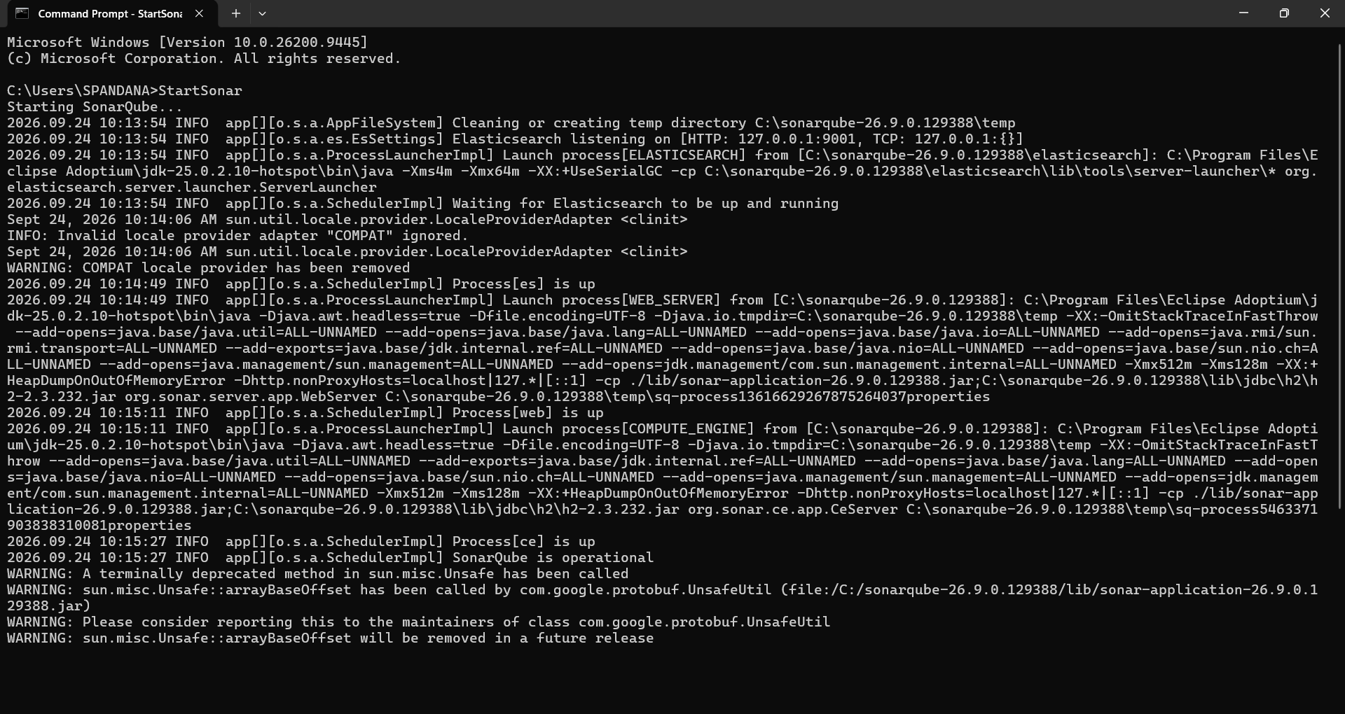
step 2 :open webbrowser type localhost:9000
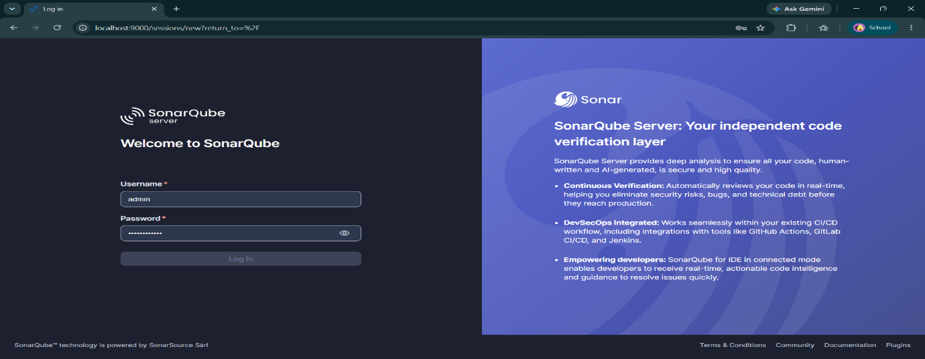
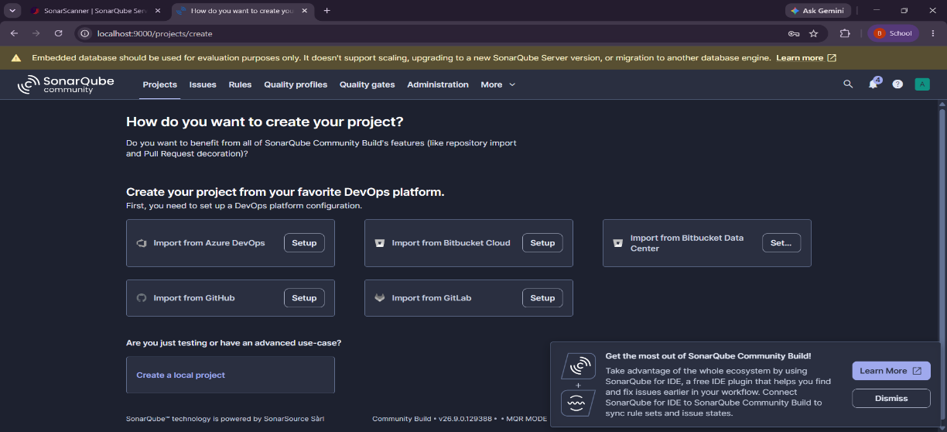
step 3: click on create a local project
step 4 : enter project name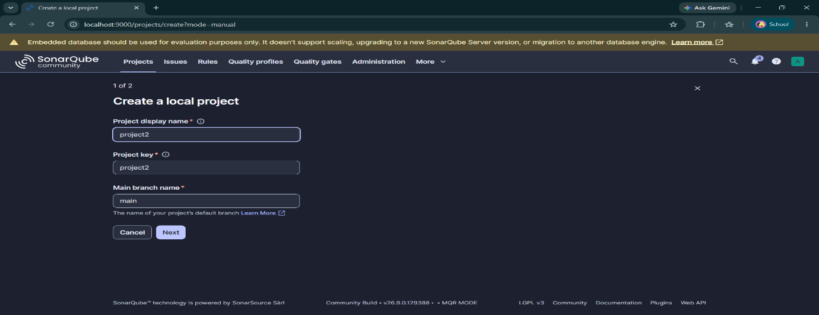
step 5: click on follows the instance’s default,click on create project
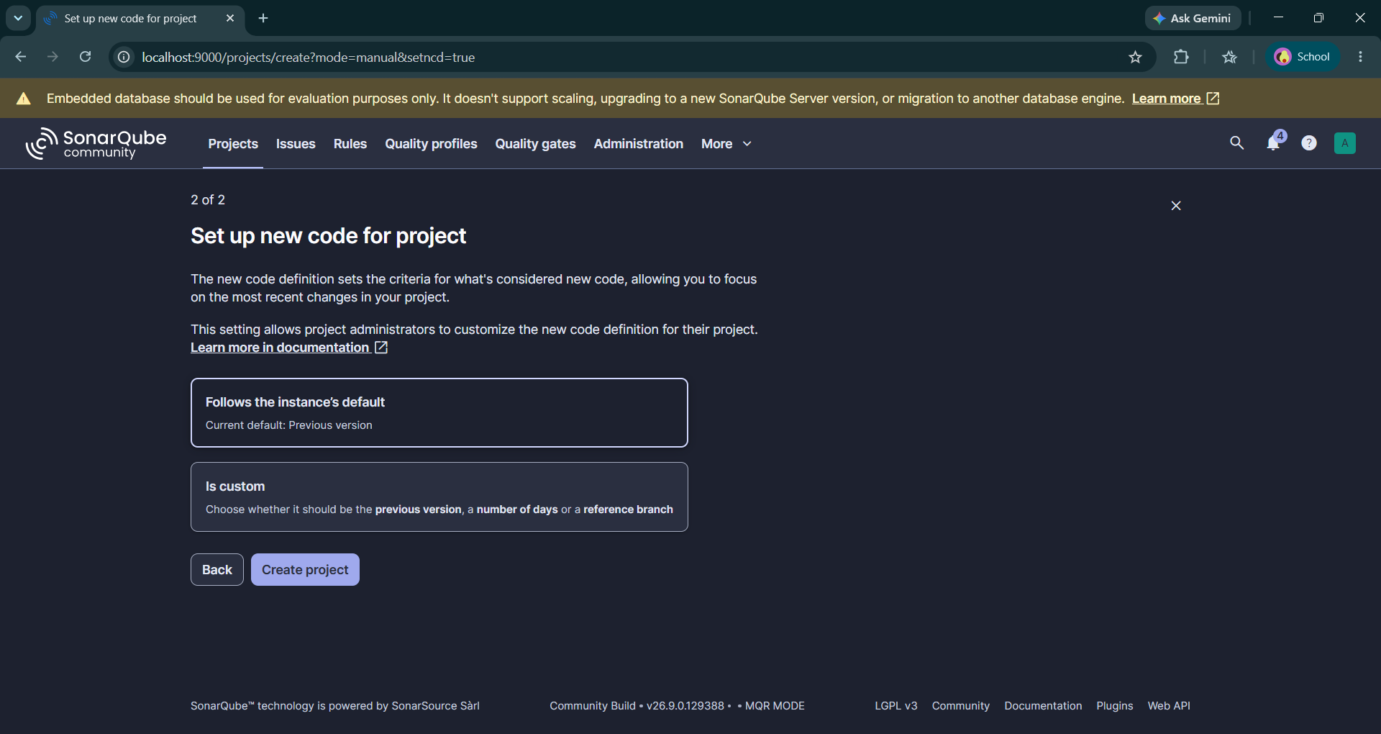

step 6:then click on locally.
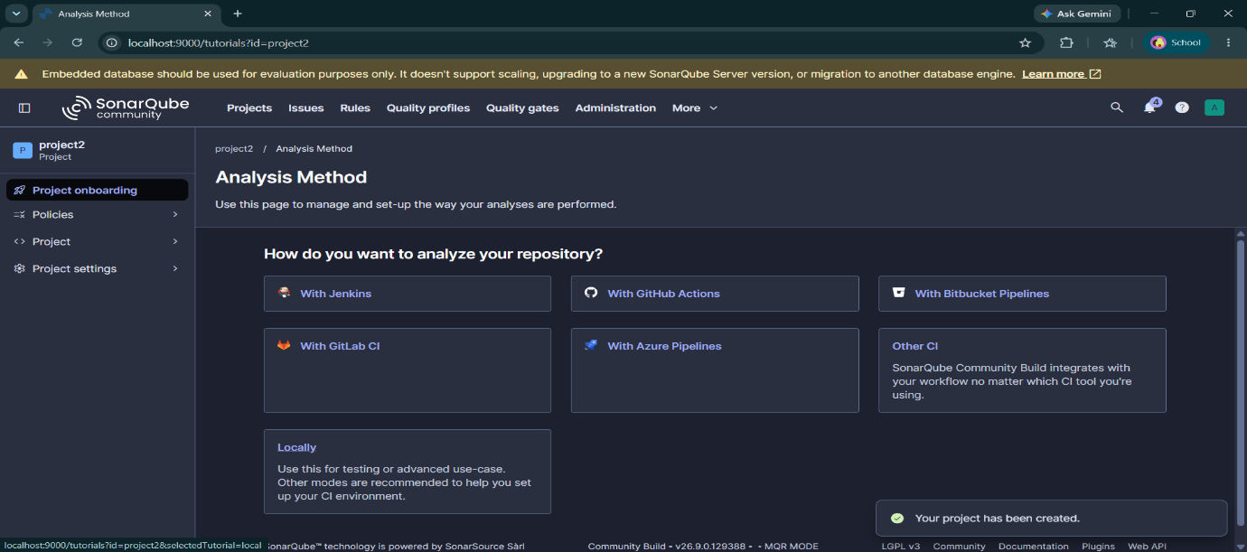
step 7:click on generate
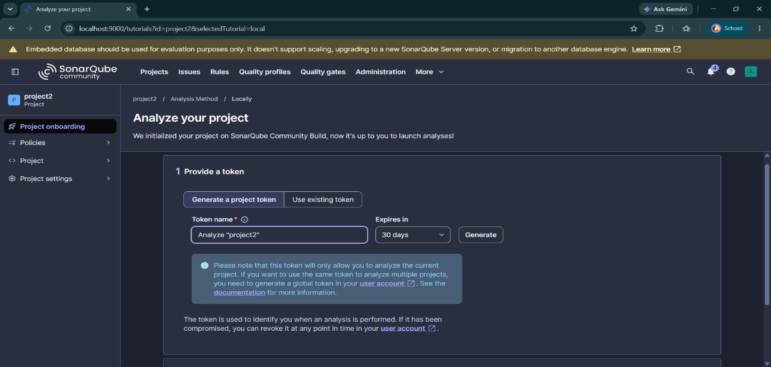
step 8:click on continue
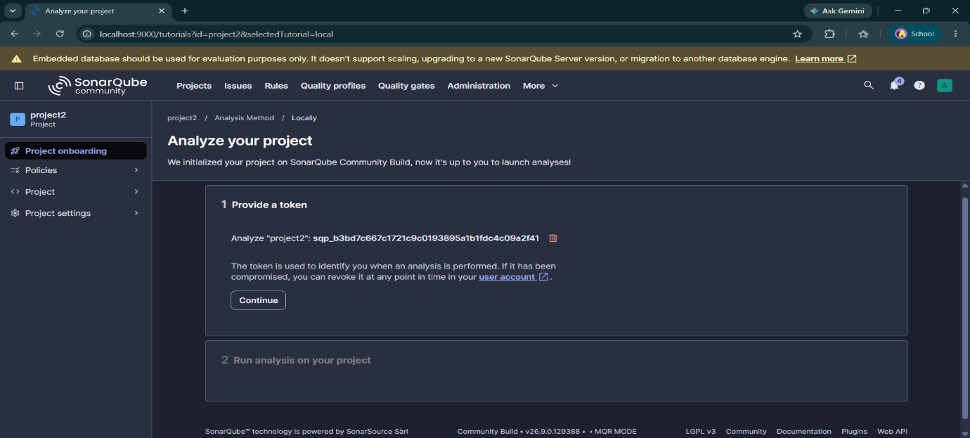
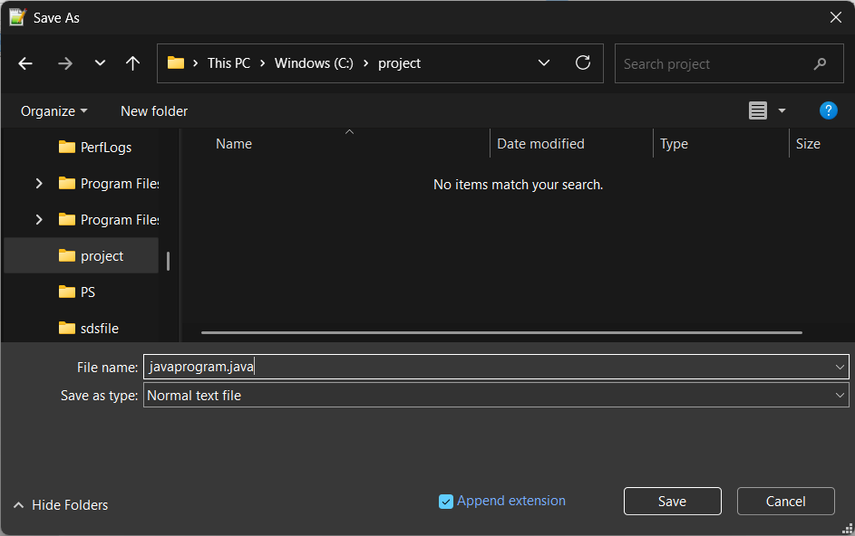
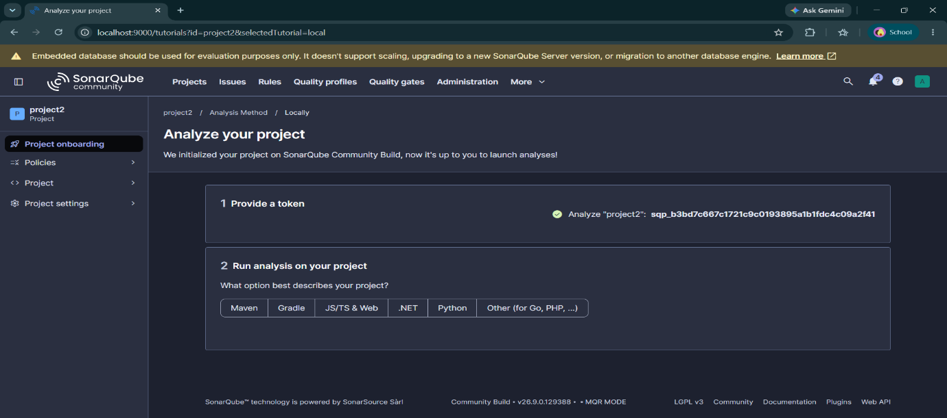
step 9:write the code in notepad++,and save it.
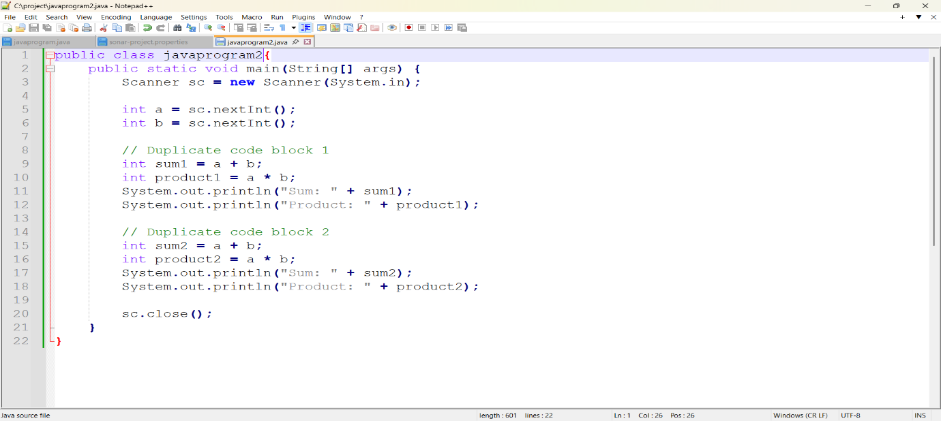
step 10:write the sonar project.properties code and save it.
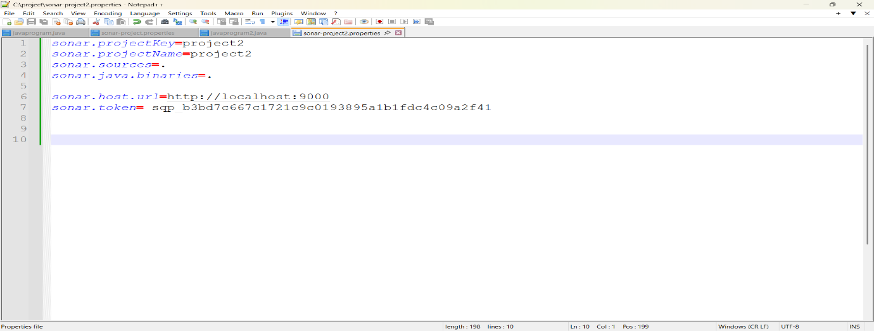
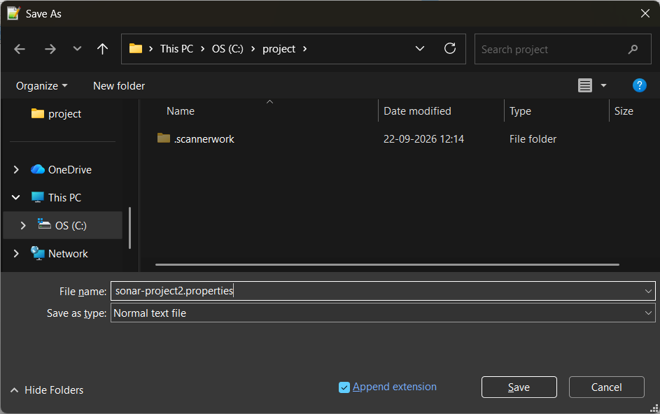
step 11:type sonar scanner -v and enter,
Then,give path of the folder in cmd
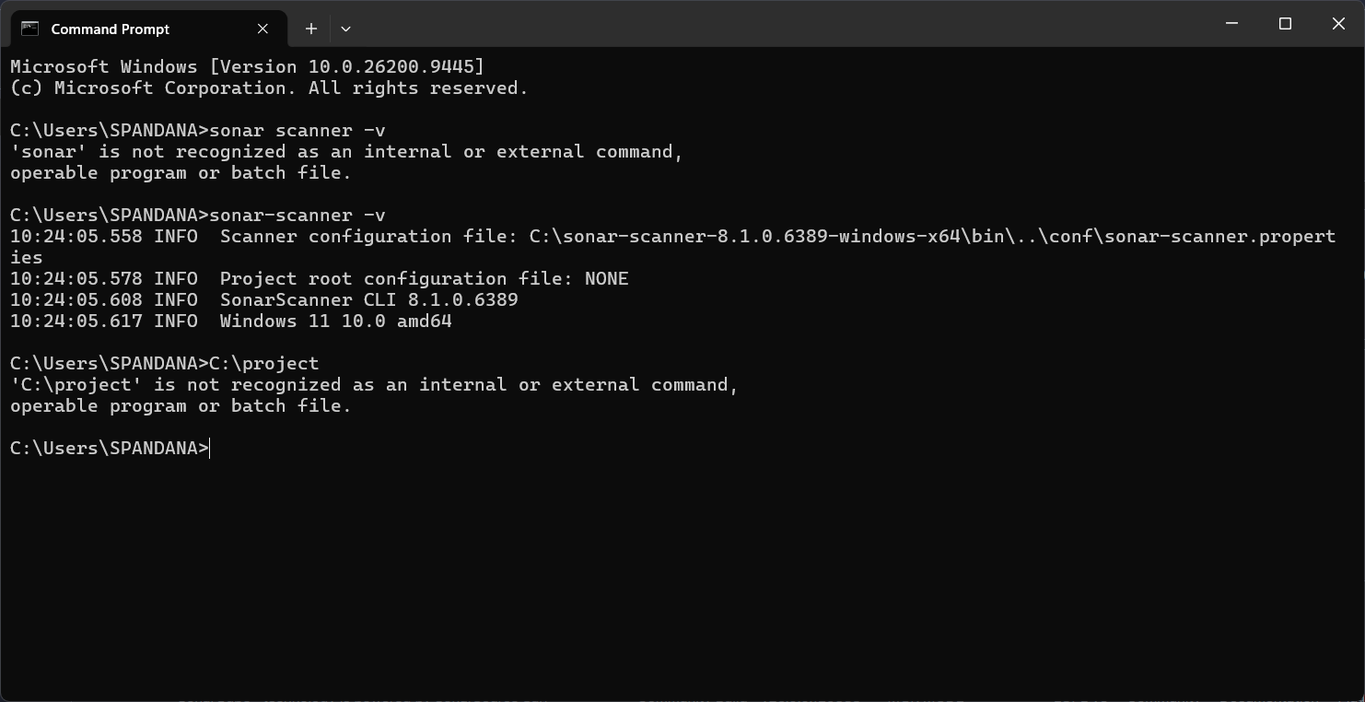
step 12: then type javac javaprogram.java
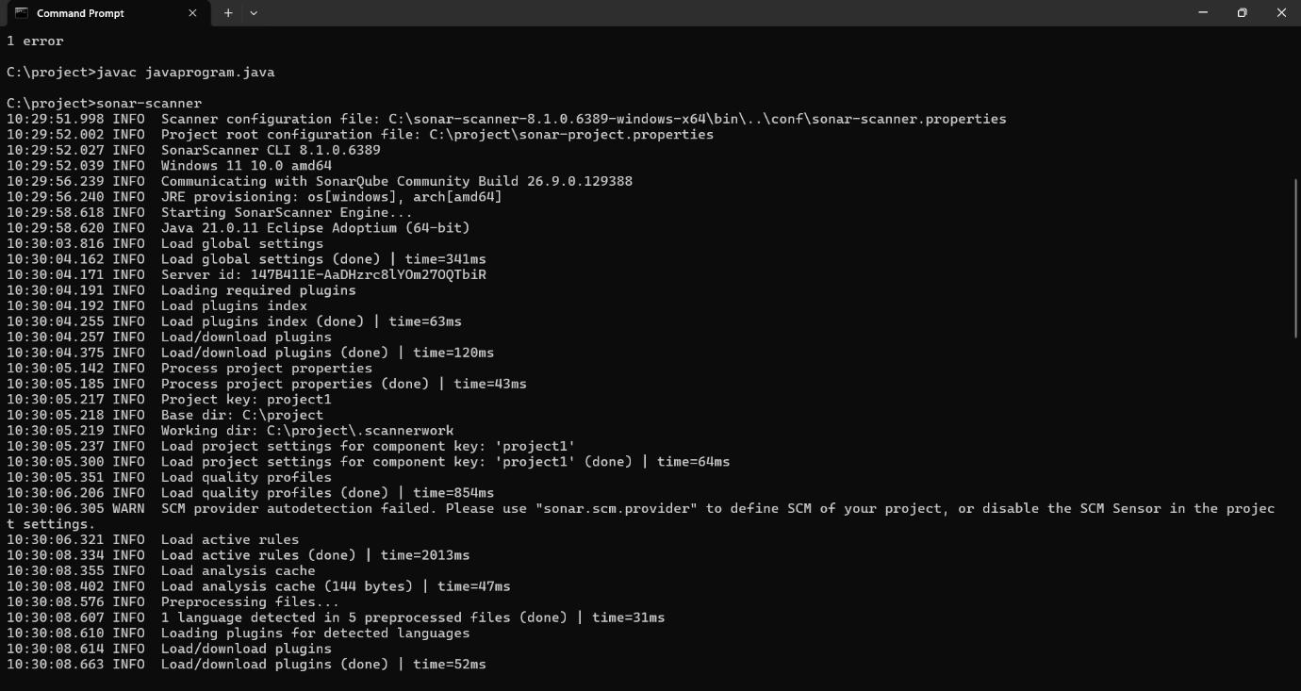
step 13: then type sonar-scanner
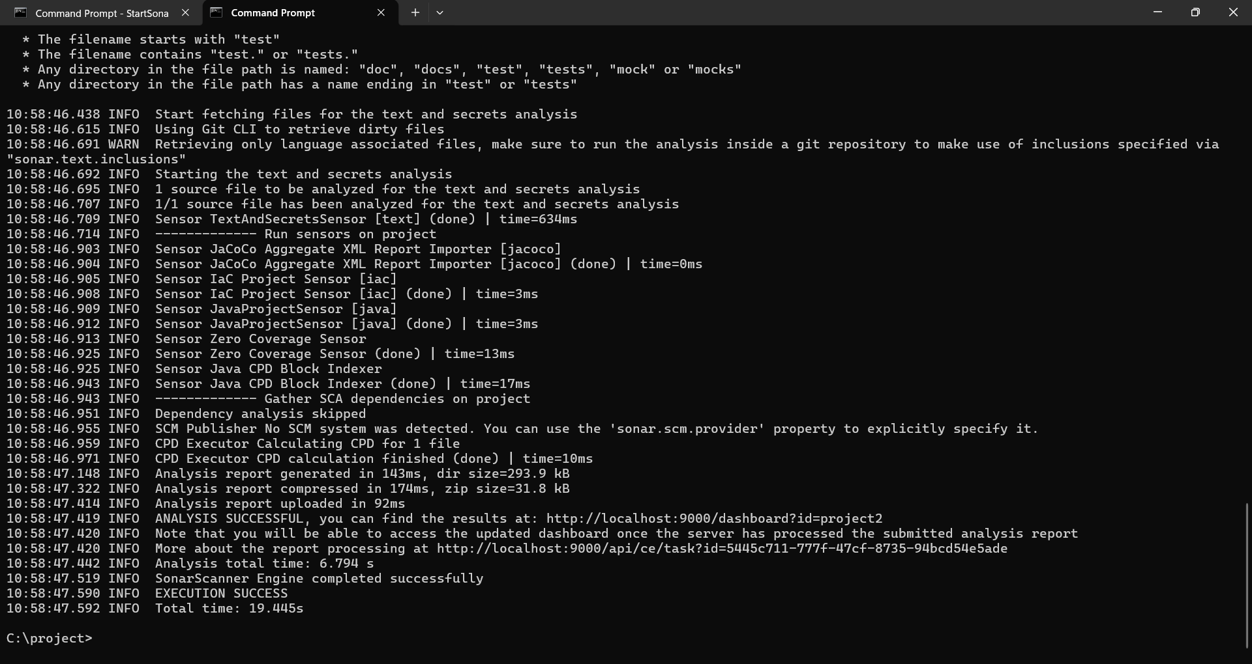
then it should show execution success
Step 13: then open local host and check if project was executed
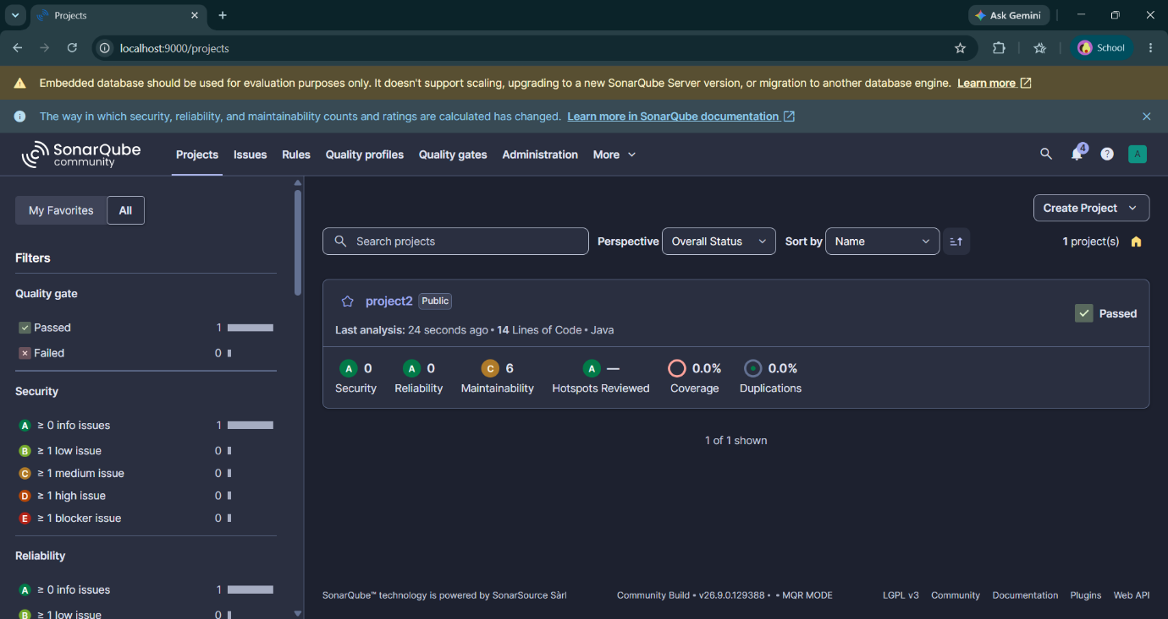
Then check for issues
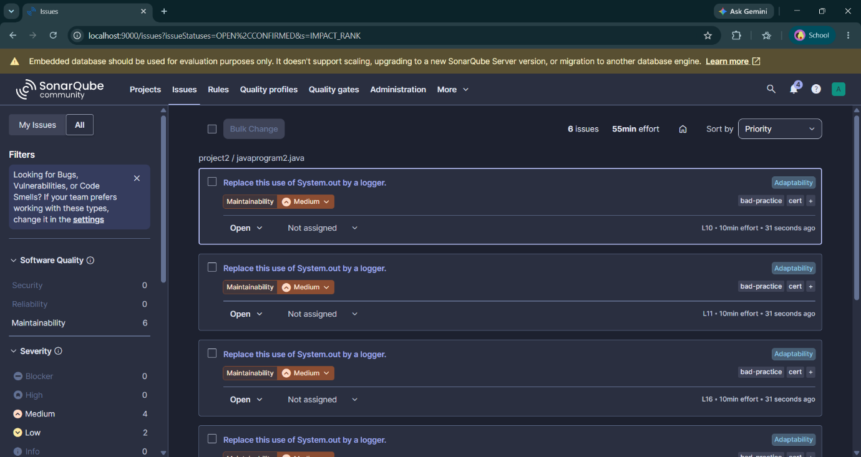
step 14: then exit from the sonarqube

