INTERNSHIP PROJECT REPORT

Adaptive Multi-Cell Battery Intelligence & Cloud Monitoring System

Internship Track: Embedded Systems / IoT
Platform: ESP32, Wokwi & Blynk IoT
Project Domain: Battery Management, Embedded Systems & Cloud Telemetry
Submitted By: Reddy Spandana
Internship Project: Battery Intelligence Management System
Tools & Technologies:
ESP32 • Arduino IDE • Wokwi • Blynk IoT • C/C++ • LCD I²C • Wi-Fi • IoT Telemetry

- Introduction
The internship project was about how to design and implement an intelligent multi-cell battery monitoring and management system using an ESP32 based embedded platform. This system is designed to track the voltage of each cell, determine battery health, detect abnormal operating conditions, provide fault protection, and send relevant telemetry data to a cloud-based monitoring system.
The project was implemented in incremental steps starting with initial battery intelligence and safety monitoring and building up to event-driven protection, fault-tolerant operation, cloud telemetry and an executive-level dashboard for IoT. The final system merges embedded sensing technology with real-time diagnostics and safety logic, Wi-Fi communications, Blynk cloud visualization, historical telemetry, fault reporting, and operator recommendations into a single, comprehensive battery intelligence system.
- Background
Voltage imbalance, weak-cell conditions, sensor failures, and unsafe operating states are typical issues that can occur with multi-cell battery packs, thus requiring continuous monitoring. A simple monitoring system, which provides only raw voltage values, may not give enough information in time to enable diagnosis of problems and protection.
The project has developed an intelligent monitoring architecture that can:
- Four single battery cells are monitored.
- The average pack voltage is calculated.
- Diagnosing abnormal voltage situations.
- Identification of Sensor/ADC defects.
- Control different operating modes of the system.
- Controlling safety outputs such as the relay and indicators.
- Keeping a record of fault and event data.
- Sending telemetry to the Blynk IoT cloud.
- The ability to visualize historical voltages.
- Delivering battery health, risk, diagnostics and recommendations on an executive dashboard.
All the modules of the system were simulated on Wokwi and tied to Blynk for cloud-based telemetry and visualization.
- Learning Objectives
- Get insight in to embedded battery monitoring and management.
- Use multi-cell voltage sensing and battery-state analysis.
- Design safety and protection systems that respond to events.
- Create redundant embedded operation.
- Connect to the internet and send data from your devices to the cloud with Blynk.
- Put together a battery intelligence dashboard for executives.
- Gain hands on experience with ESP32, Wokwi, Blynk, Wi-Fi and embedded C/C++.

- Activities and Tasks
- Task 1 – Adaptive Multi-Cell Battery Intelligence Engine :-
Objective:
The goal of this task was to design and build a battery intelligence engine, which will continuously monitor a simulated 4-cell lithium battery pack, and extract meaningful battery data from each cell measurement.
Implementation:
It was designed and simulated in Wokwi with an ESP32. Four analog inputs were tied up with the four battery cells. The analog readings were mapped to the corresponding voltage readings using the range of the ADC on the ESP32.
The system continuously monitors:
- Cell 1 voltage
- Cell 2 voltage
- Cell 3 voltage
- Cell 4 voltage
- Average pack voltage

The individual readings are analysed to detect abnormal cell conditions. Cells will be identified as weak cells and overvoltage condition using threshold-based analysis. The system also detects sudden voltage changes when implemented by comparing consecutive readings.
The battery intelligence data is available in the embedded LCD interface and on the Blynk cloud dashboard.
Key Features:
- Four-cell real-time voltage monitoring
- Calculate the voltage of each individual cell.
- Average pack voltage calculation
- Weak-cell detection
- Overvoltage detection
- Cell-level monitoring
- Battery operating-state classification
- Visualization of battery telemetry data in cloud.
Testing and Result:
The system was tested using a change of the potentiometer values on the Wokwi potentiometer for each cell. The voltage condition was successfully observed using Serial Monitor and dashboard with different voltage conditions. When the values of cells drop below the set limits or exceed the overvoltage limit, the system responded properly.
Evidence:
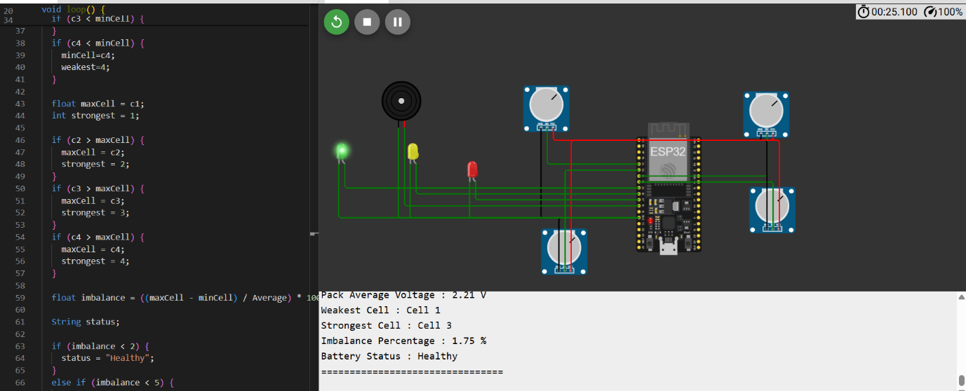
Figure 1: Real-Time Multi-Cell Voltage Monitoring and Battery Health Classification.
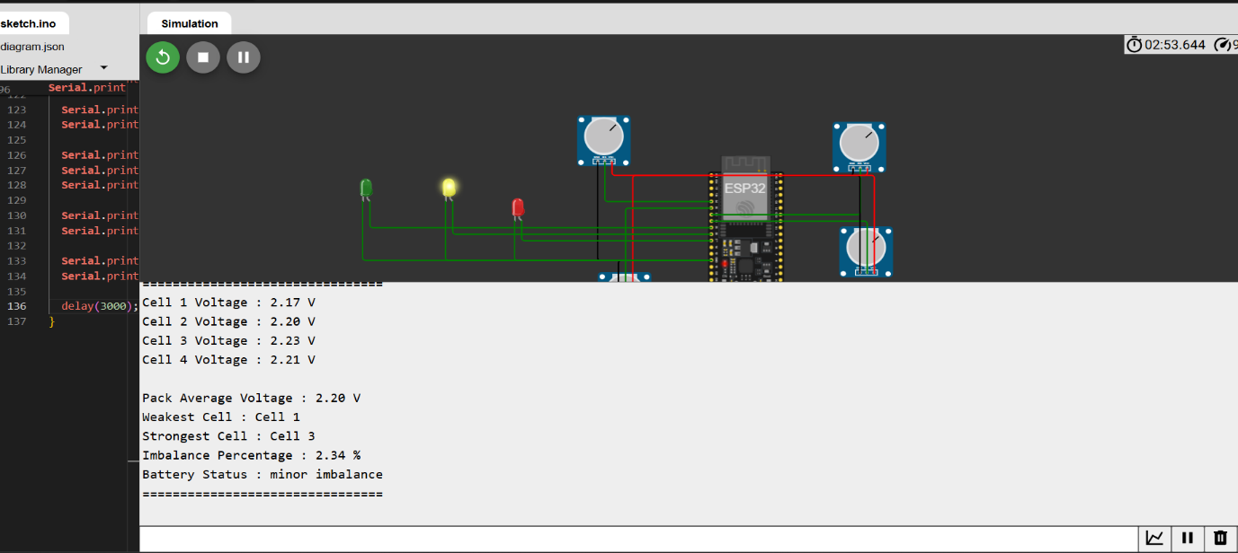
Figure 2: Detection of Minor Cell Imbalance.

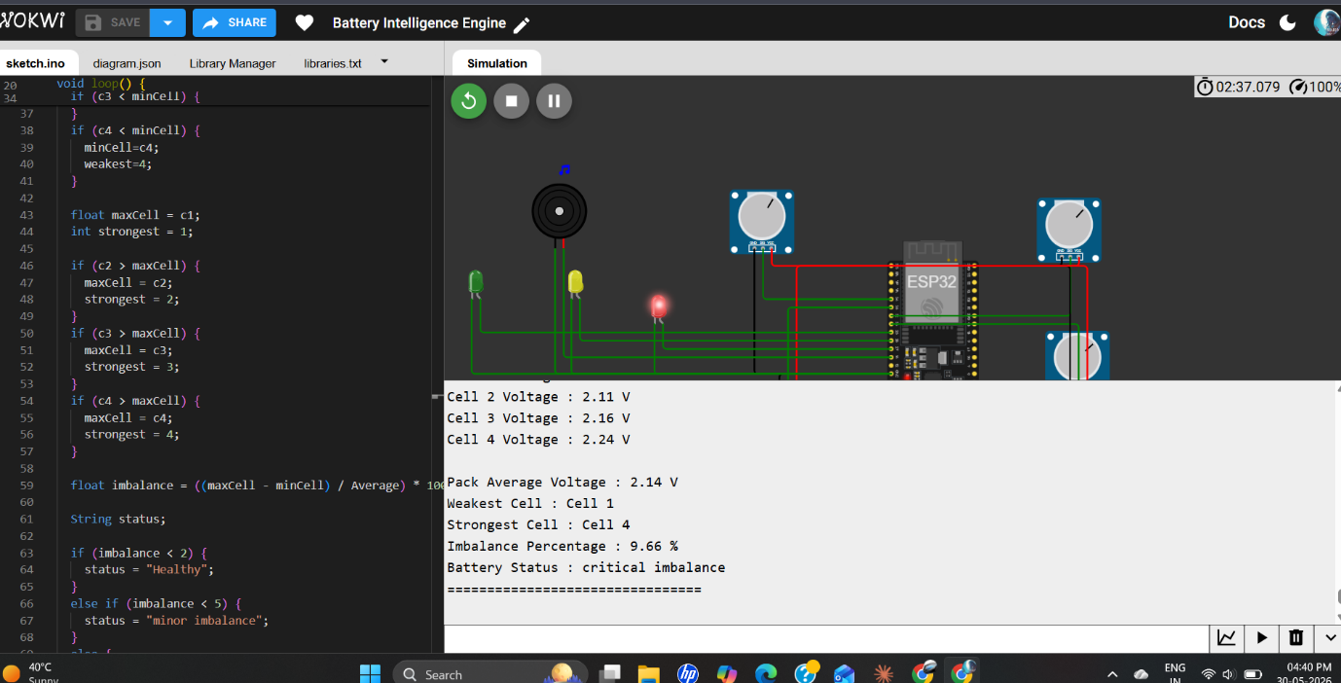
Figure 3: Critical Battery Imbalance Detection and Visual Warning
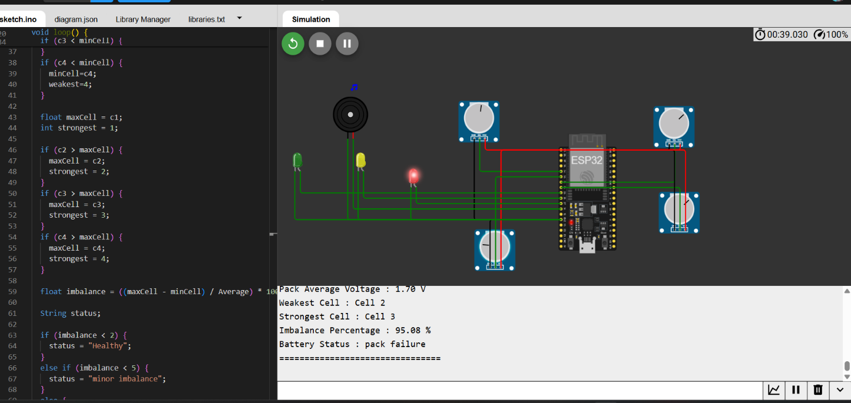
Figure 4: Pack Failure Detection Under Severe Cell Imbalance

- Task 2 – Event Driven Safety Protection Kernel
Objective:
The goal of this task was to create a safety protection controller that is non-blocking, detecting abnormal battery conditions, and able to operate by controlling relays, alarm beepers, LEDs, and LCD warnings.
Implementation:
Event-driven fault detection was used as the basis for the implementation of the safety kernel. The system continually checks the battery readings and detects the following situations:
- Weak cell voltage
- Overvoltage
- Sensor faults
- Rapid voltage fluctuations
- Abnormal ADC behavior
Depending on the condition detected, the protection system operates a relay, buzzer, red LED, green LED and LCD messages. The implementation of timing dependent operations like recovery or ADC-freeze detection was accomplished by the millis() function, not by blocking delays in the main operating logic. A recovery timer was also added so that the relay does not reconnect when a fault goes away.

Protection Behavior:
If a fault is found:
- Relay is turned OFF.
- The green LED is turned OFF.
- The red LED is illuminated.
- Buzzer will give an audible warning.
- Fault condition(s) is displayed on the LCD.
There were different warning patterns for various conditions including sensor faults, unstable voltage, weak cells, and over voltage.
Testing and Result:
Protection kernel was tested by varying cell voltages using Wokwi potentiometers. There were successful detection cases of Weak-cell, overvoltage, and voltage fluctuation. The relays and warning indicators acted on the faults that were detected. Also, the recovery mechanism was tested by restoring the battery readings to normal operating values.
Evidence:
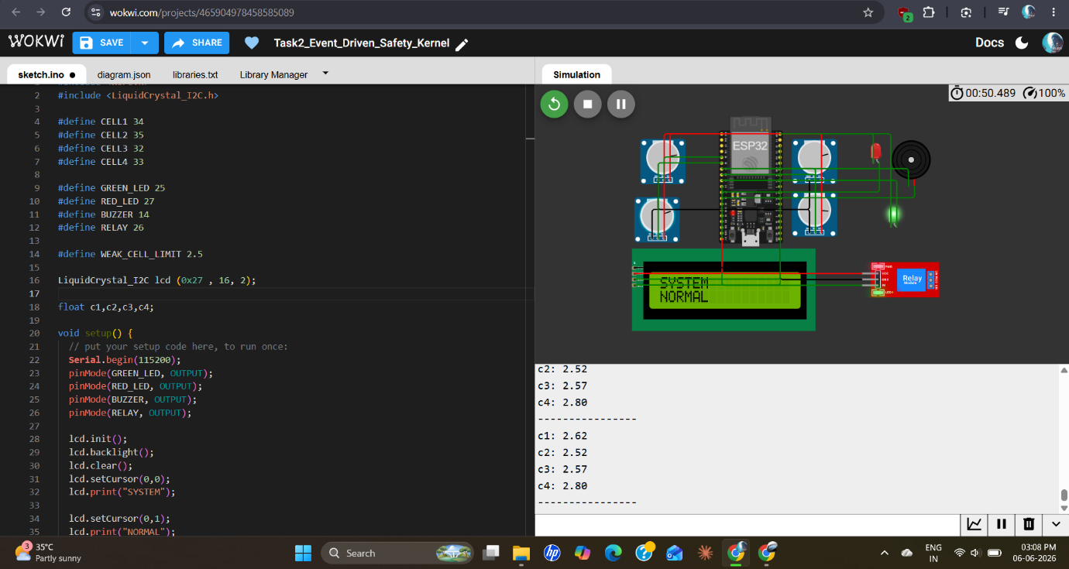
Figure 5: Normal Battery Operation with Safety System Active

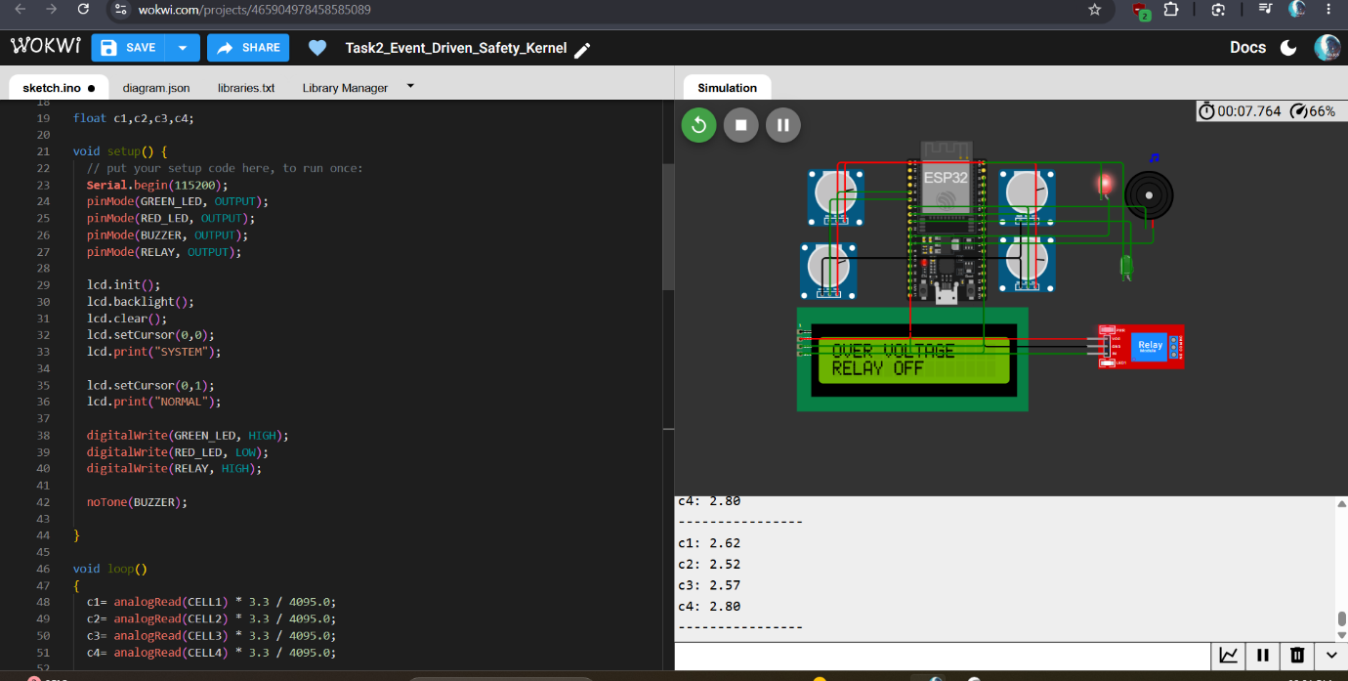
Figure 6: Over Voltage Detection and Automatic Relay Cutoff

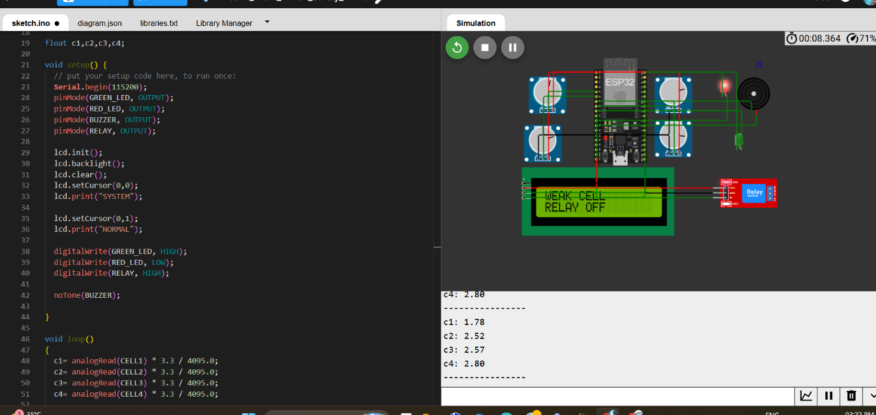
Figure 7: Weak Cell Protection with Audible and Visual Alerts

Demonstration video:-
https://drive.google.com/file/d/1a7-aXGNMqnjm7N09YkHbnE9qoxC7oK20/view?usp=sharing
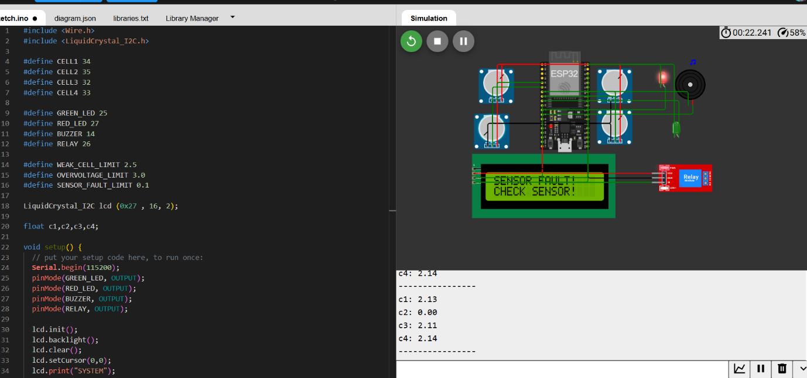
Figure 8: Sensor Fault Detection and Safety Shutdown
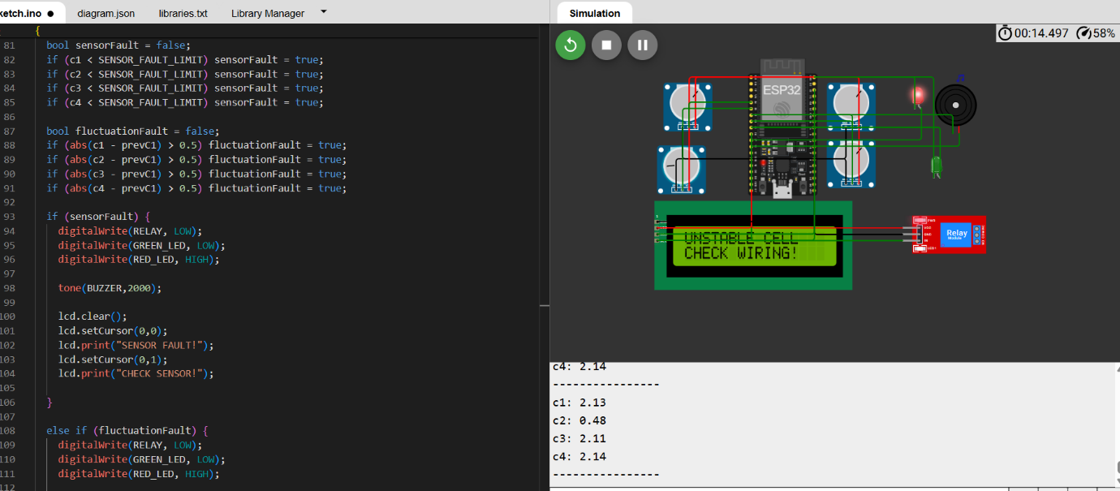
Figure 9: Unstable Cell Detection and Recovery Protection
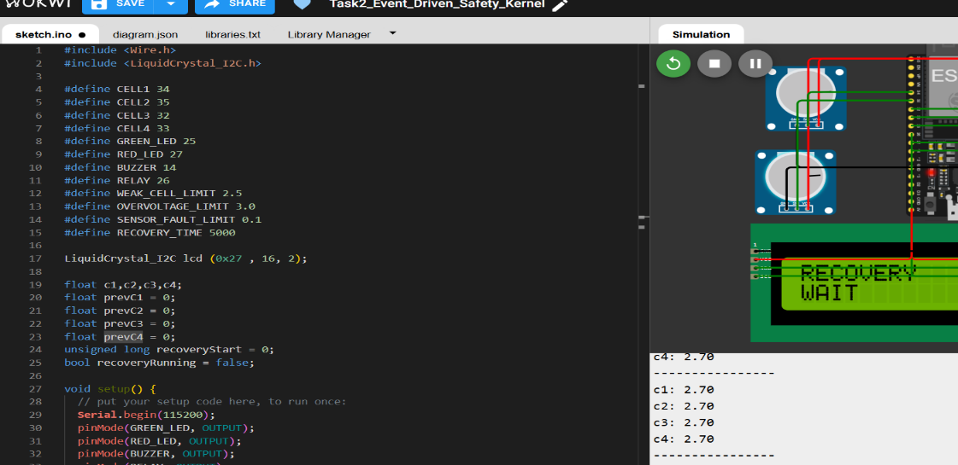
Figure 10: Recovery State and Controlled System Restoration
- Task 3 – Intelligent Embedded HMI & Diagnostic Interface
Objective:
The aim of the task was to create a structured LCD based Human-Machine Interface which will allow the operator to know the battery information, system status and diagnostic information.
Implementation:
An LCD 16×2 was added to the ESP32 for local system information. The interface rotates through a number of diagnostic screens, rather than just showing a static message.
The following are the screens that are put in place:
- Cell 1’s data and Cell 2’s data.
- Cell 3's data and Cell 4's data.
- Pack information and average voltage
- System status
- Operating mode
The screen is rotated using non-blocking timings with the millis() function.
If faults arise the normal screen rotation will be stopped and the fault information will appear on the LCD screen. This offers a prioritized interface for faults, with the important safety information being displayed first.
HMI Features
- Automatic screen rotation
- Live voltage information
- Pack average display
- System status display
- Operating-mode display
- Fault-priority messages
- Non-blocking screen timing
- Local operator diagnostics

Testing and Result:
Normal and fault conditions tests of the LCD interface. The diagnostic screens were automatically rotated in normal operation. In case of faults, the warning message was shown instead of screen rotation continuing normally.
Evidence:
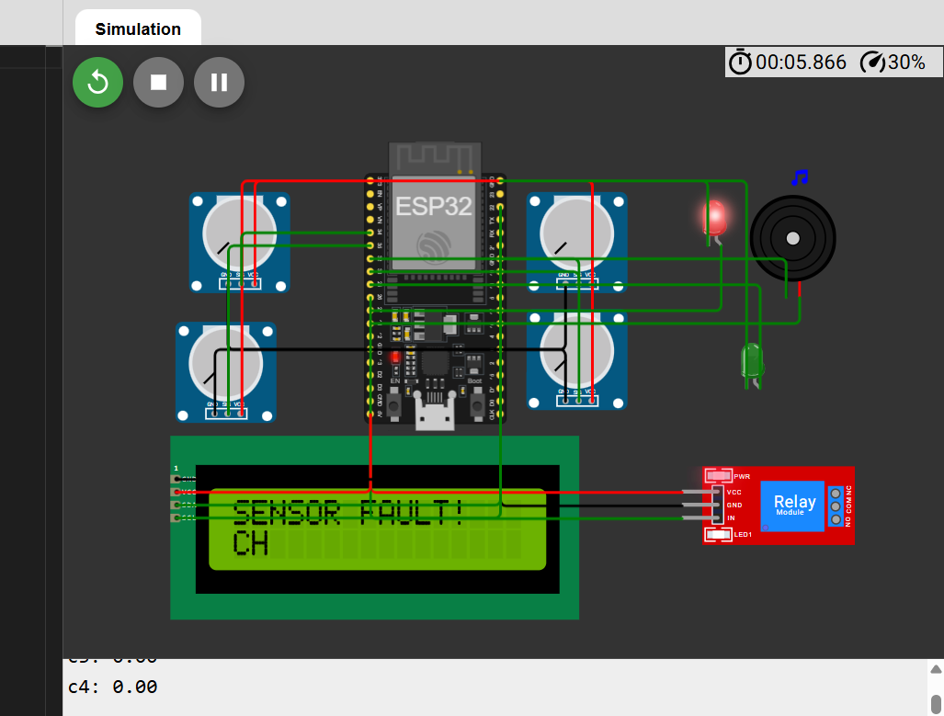
Figure 11: Intelligent HMI Display Showing Sensor Fault Warning

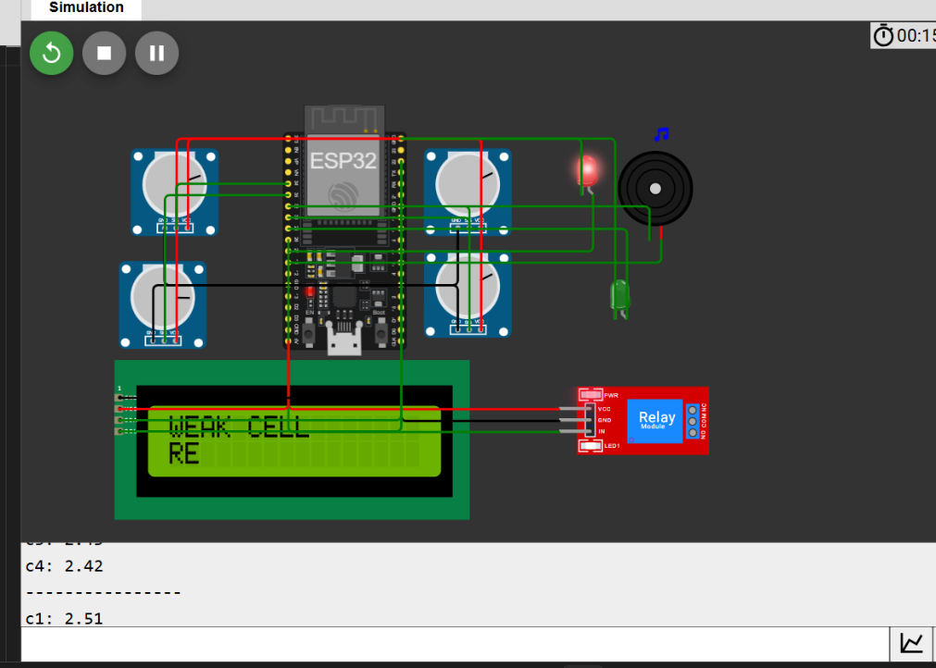
Figure 12: Intelligent HMI Display Showing Weak Cell Warning
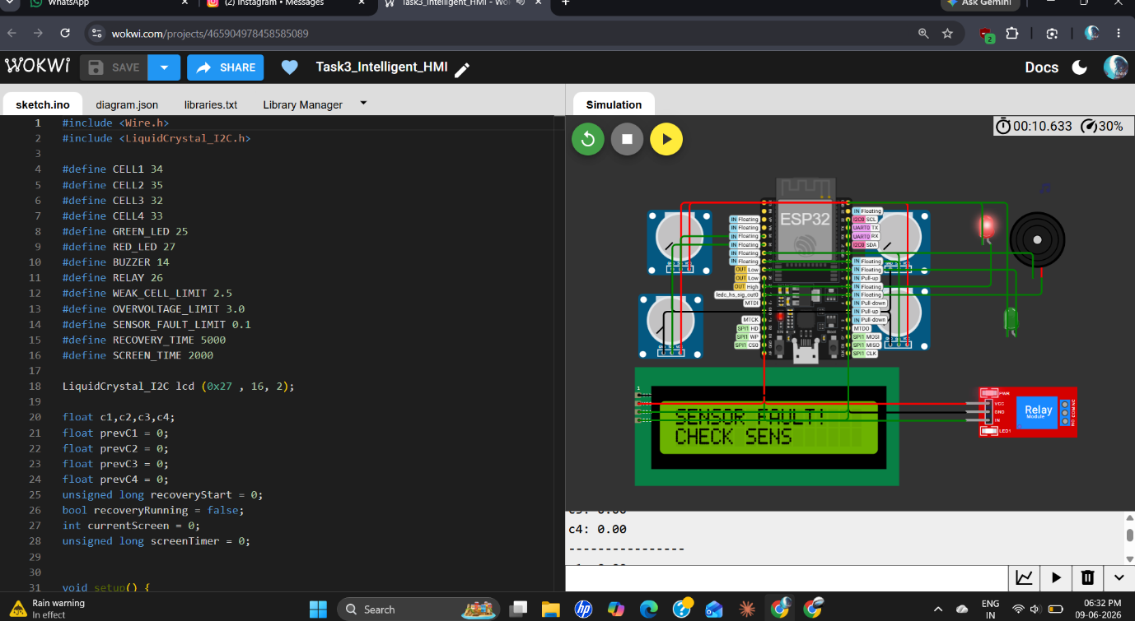
Figure 13: Sensor Fault Detection
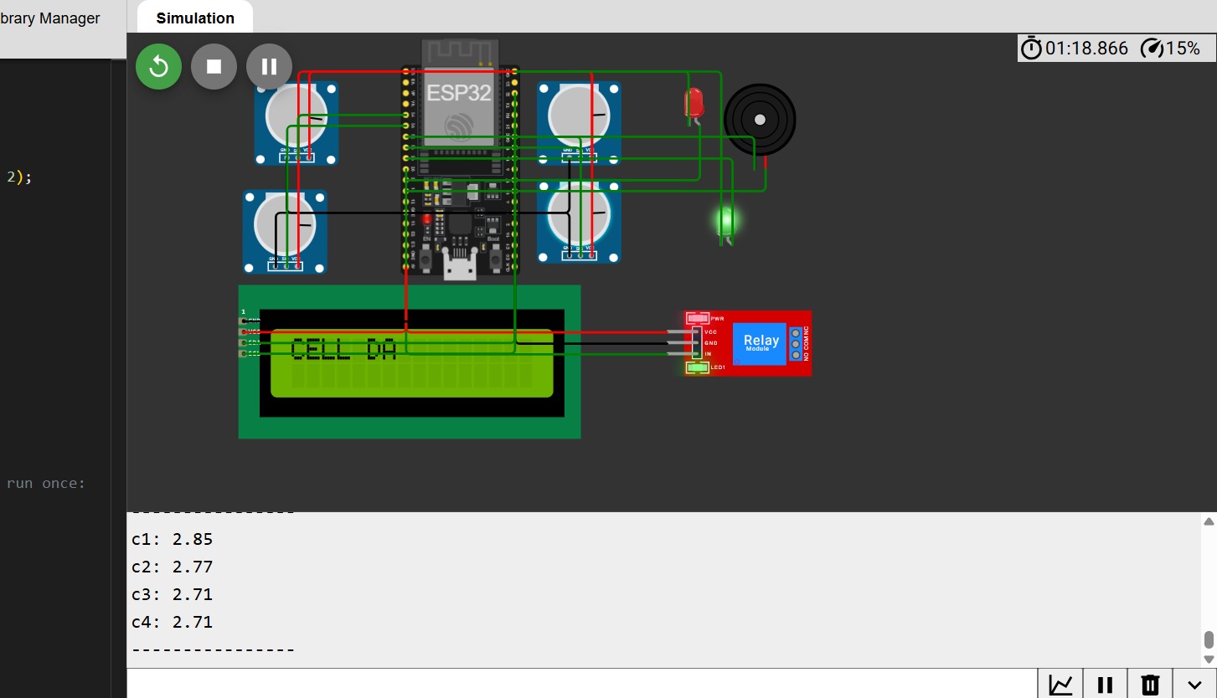
Figure 14: Intelligent HMI Display Showing Battery Status and System Condition

Demonstration Video:
https://drive.google.com/file/d/145ifaTc1BvVXwlusI3x41Mt7qo_brU7M/view?usp=sharing

- Task 4 – Fault-Tolerant Embedded Runtime System
Objective:
The purpose of this task was to build a runtime subsystem to be able to identify abnormal hardware/software scenarios and to switch to the required operational modes.
Implementation:
Four operating modes were developed for a system-state architecture:
- NORMAL
- DEGRADED
- FAILSAFE
- SHUTDOWN
The system monitors a number of fault conditions, such as:
- Sensor faults
- Weak-cell conditions
- Overvoltage Voltage fluctuations
- ADC frozen conditions
Based on the conditions detected at runtime, the operating mode is determined. It has multiple fault-counting system to detect simultaneous faults. Once that number of faults is reached, the system becomes in SHUTDOWN.
The ESP32 millis() value is also used to time stamp fault events.
Operational Modes:
Mode Description
- NORMAL: Battery system is operating normally.
- DEGRADED: A sensor problems are detected, but the system is in a restricted operating mode.
- FAILSAFE: protective action is required if a significant battery or runtime fault has occurred. If a significant battery or runtime fault occurs, a protective action is required.
- SHUTDOWN: Multiple serious faults, shutdown system now!.

Testing and Result:
Individual and simultaneous faults were introduced in the runtime system to test it.
For instance, the Serial Monitor showed transitions like:
- Current Mode = DEGRADED
- Fault = SENSOR FAULT
and:
- Current Mode = FAILSAFE
- Fault = WEAK CELL
More was observed to be the case with ADC freeze detection:
- Current Mode = FAILSAFE
- Fault = ADC FROZEN
System effectively isolated faults and activated relays and warning outputs based on the operating mode.
Evidence:
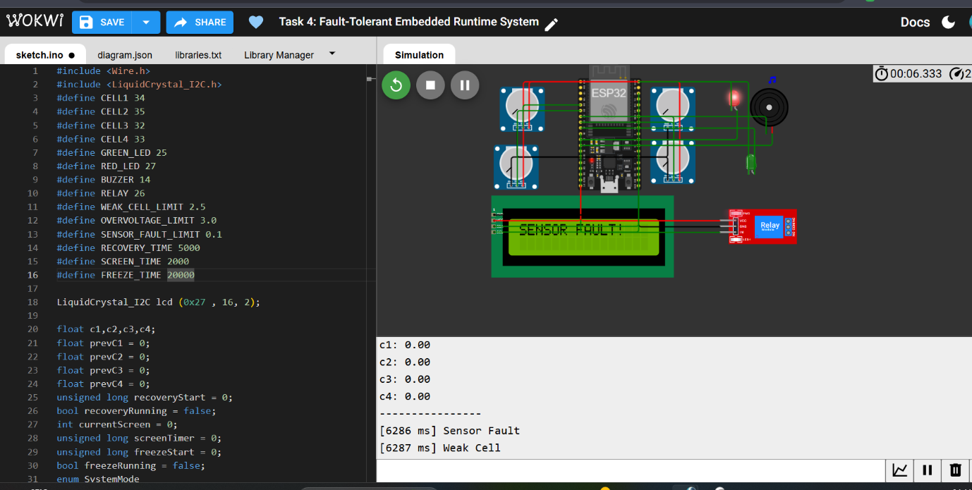
Figure 15: Fault-Tolerant Runtime System Detecting a Sensor Fault

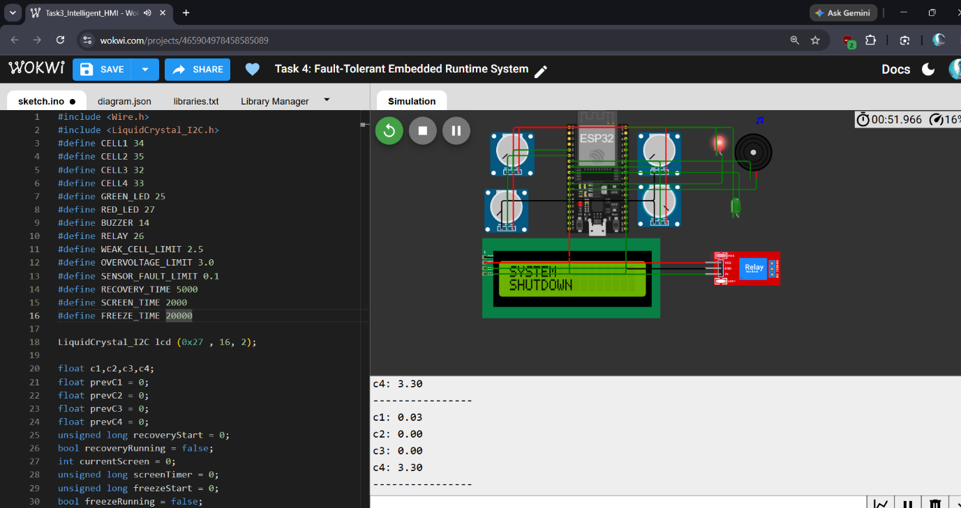
Figure 16: System Shutdown Mode Under Critical Fault Conditions

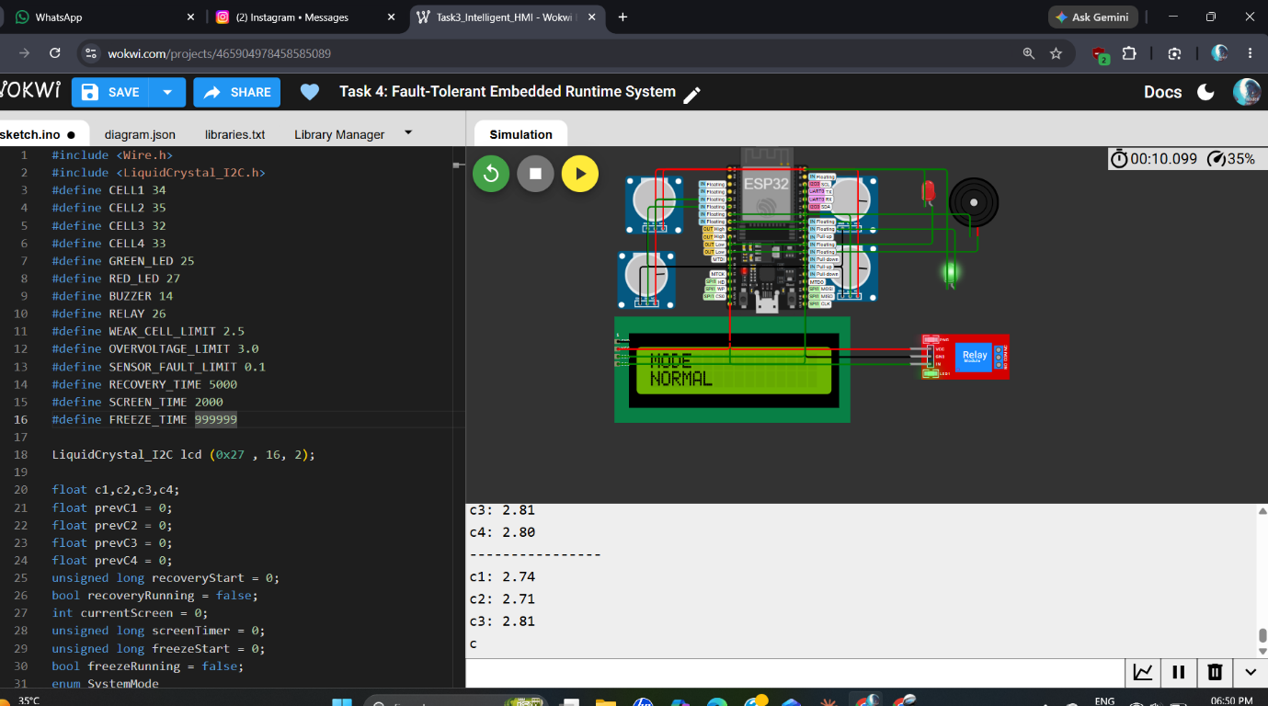
Figure 17: Normal Operating Mode of the Fault-Tolerant Runtime System

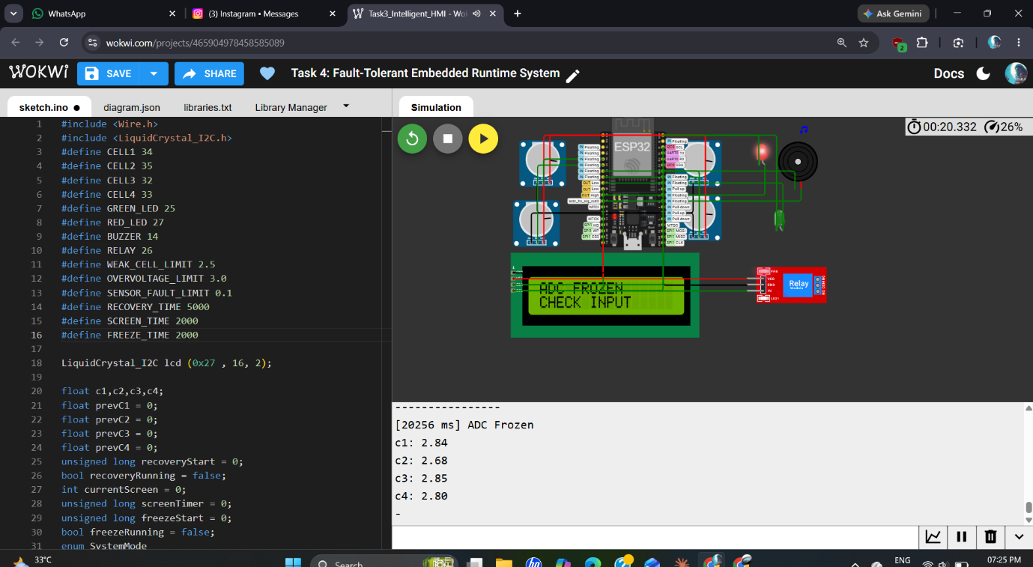
Figure 18: ADC Freeze Detection and Fault Handling

Demonstration Video:-
https://drive.google.com/file/d/1tSMTrRr6ZuPrmiyorqpDy9huw3mpzTKh/view?usp=sharing

- Task 5 – Intelligent Cloud Telemetry Architecture
Objective:
The goal of this task was to integrate the embedded battery monitoring system with the Blynk IoT platform and build a cloud-based telemetry without disrupting the normal embedded operation.
Implementation:
The ESP32 had to be plugged into the Wokwi Wi-Fi network and set up to communicate with Blynk with the authentication key and virtual data streams provided.

Telemetry was set up over several virtual pins of the Blynk:
- Cell 1 voltage
- Cell 2 voltage
- Cell 3 voltage
- Cell 4 voltage
- Average voltage
- System mode
- Fault status
- Wi-Fi status
- RSSI
The built-in event queue and Blynk terminal interface were also used to process other event related information.
Also RSSI information is used for monitoring the WiFi signal quality in the system. Post cloud connectivity, event information may be synced via the queue. The embedded battery protection logic continues to operate locally, as the safety logic is not 100% cloud reliant.
Cloud Communication Features:
- Wi-Fi connectivity
- Blynk cloud communication
- Virtual datastreams
- Wi-Fi status monitoring
- RSSI monitoring
- Event queue
- Event synchronization
- Asynchronous-style cloud communication
- Transmission of local embedded operation which is independent of dashboard availability.
Testing and Result:
It was connected to Wi-Fi and to Blynk with success. The Serial Monitor returned the following:
- WiFi Connected
- Blynk Connected
System information and live battery values were then posted on the Blynk dashboard. Fault conditions were also represented, enabling the cloud dashboard to be used to provide remote visibility of battery and system status.
Evidence:
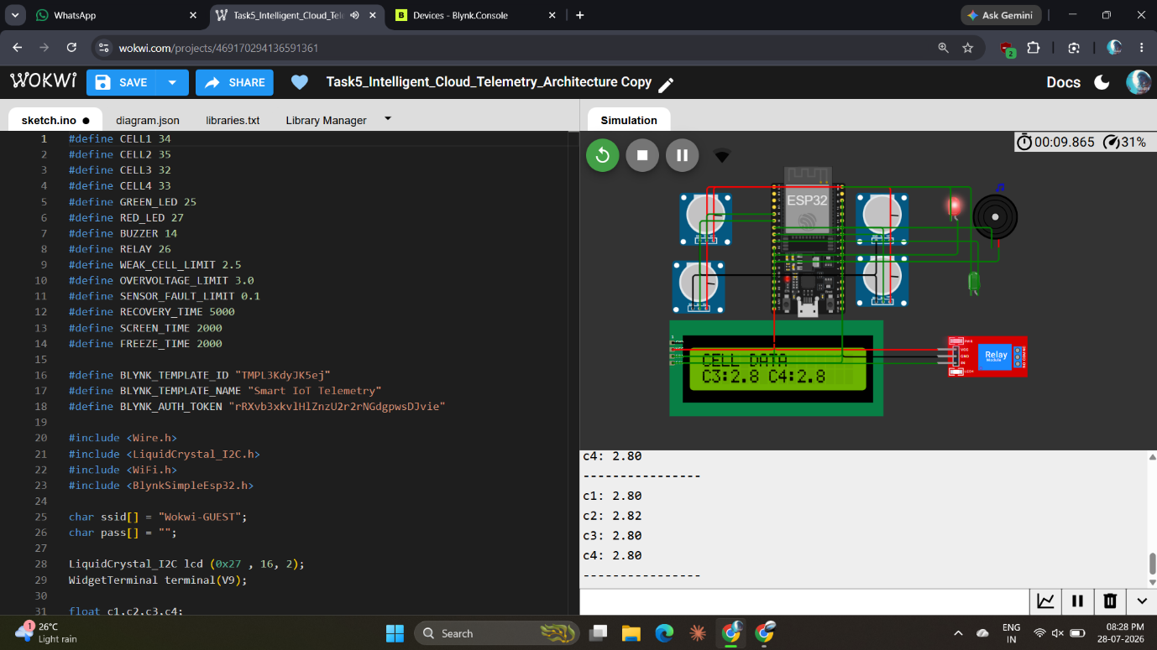
Figure 19: Wokwi Simulation of the Intelligent Cloud Telemetry System

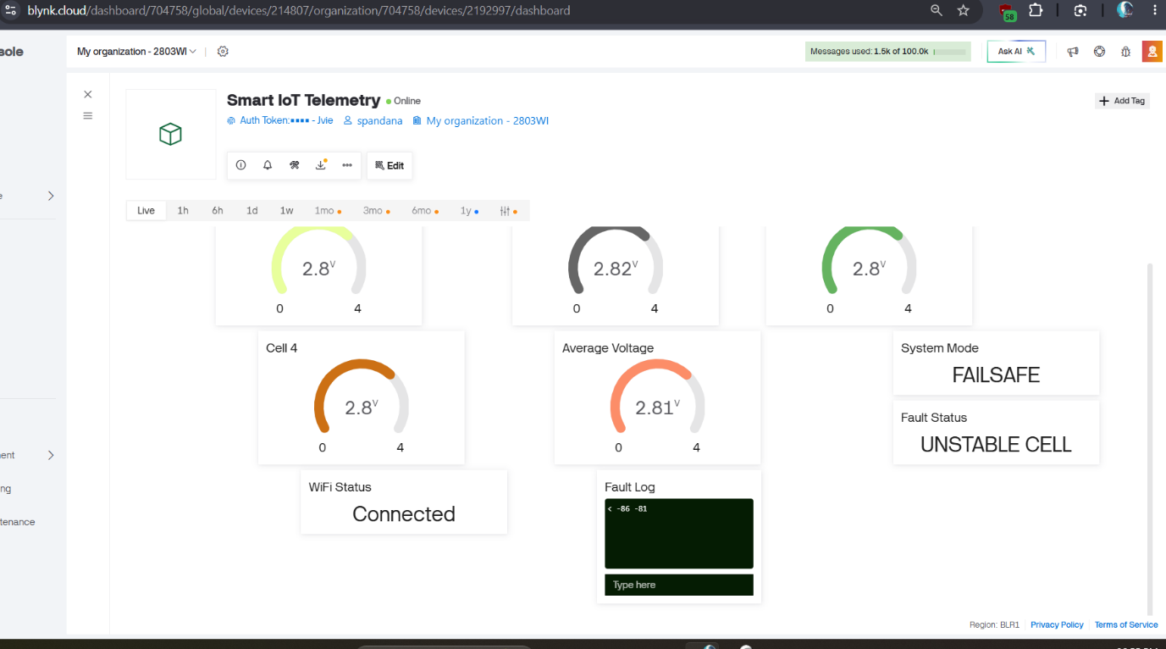
Figure 20: Blynk Dashboard Displaying Unstable Cell Detection in FAILSAFE Mode

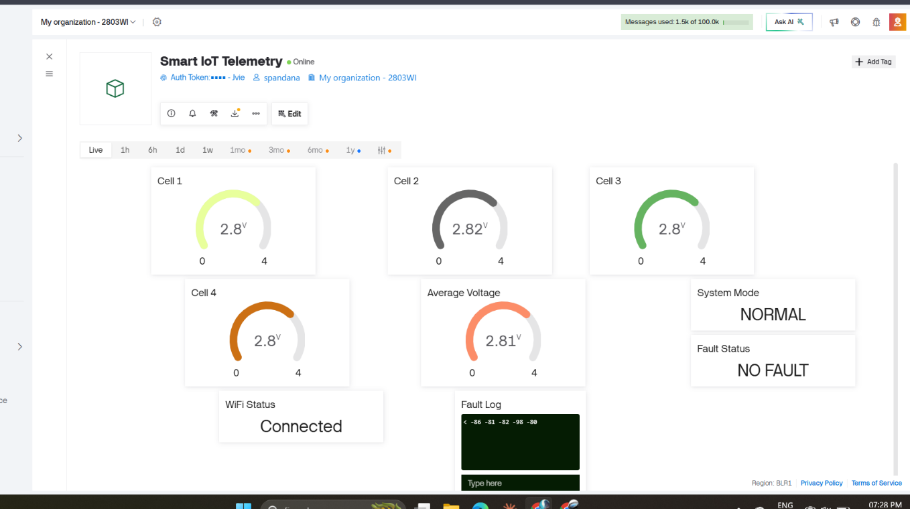
Figure 21: Blynk Dashboard Showing Normal Battery Operation with No Fault

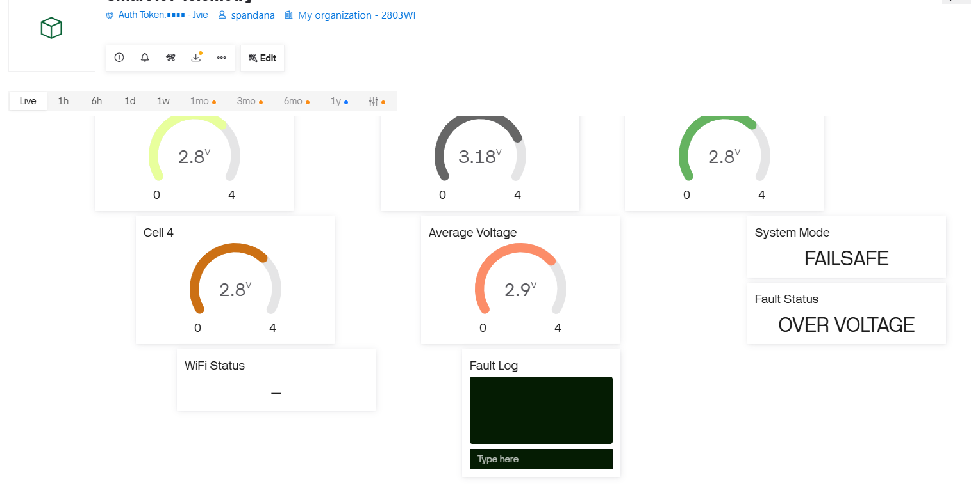
Figure 22: Blynk Dashboard Showing Overvoltage Detection in FAILSAFE Mode

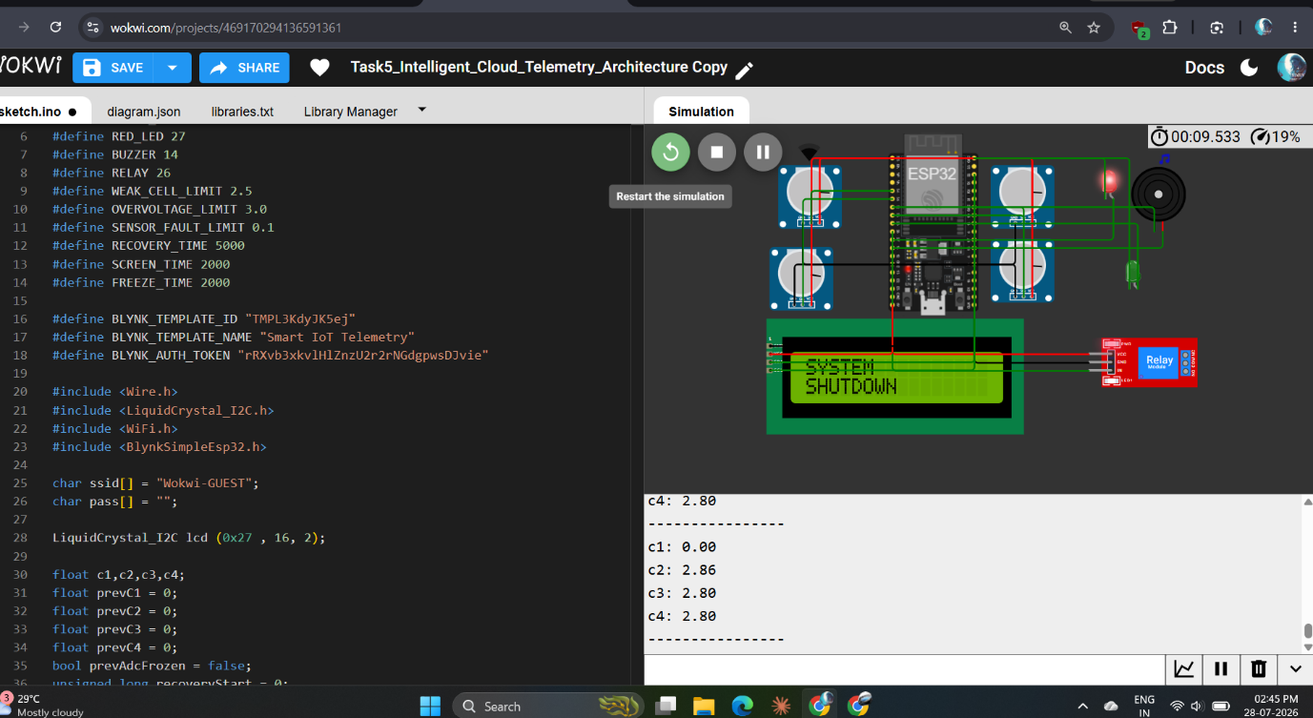
Figure 23: Wokwi Simulation Showing Automatic System Shutdown

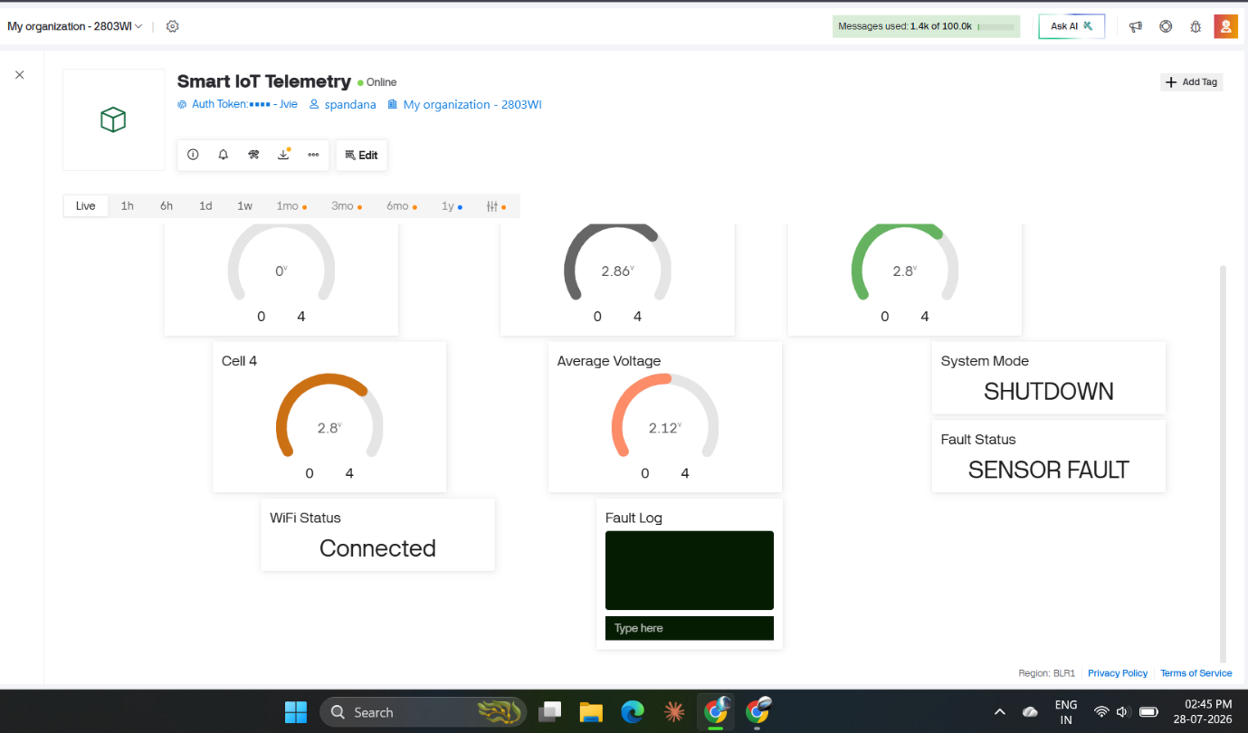
Figure 24: Blynk Dashboard Showing Sensor Fault and System Shutdown

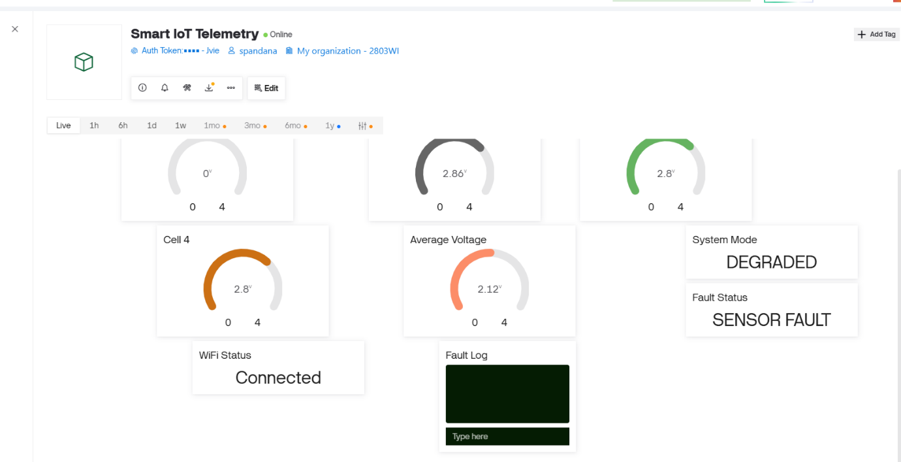
Figure 25: Blynk Dashboard Showing DEGRADED Mode During Sensor Fault

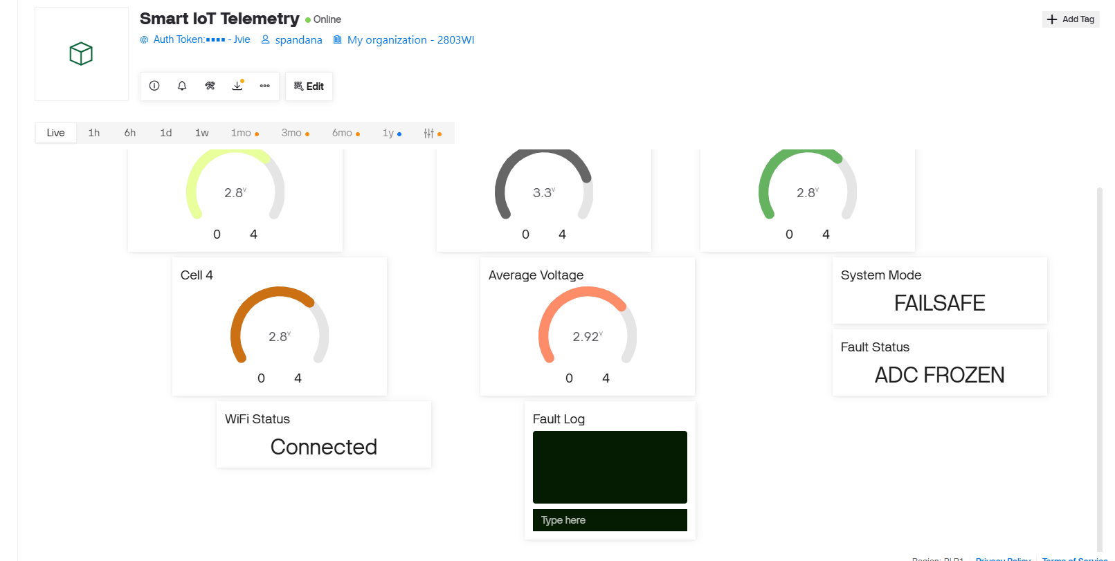
Figure 26: Blynk Dashboard Showing ADC Freeze Detection in FAILSAFE Mode
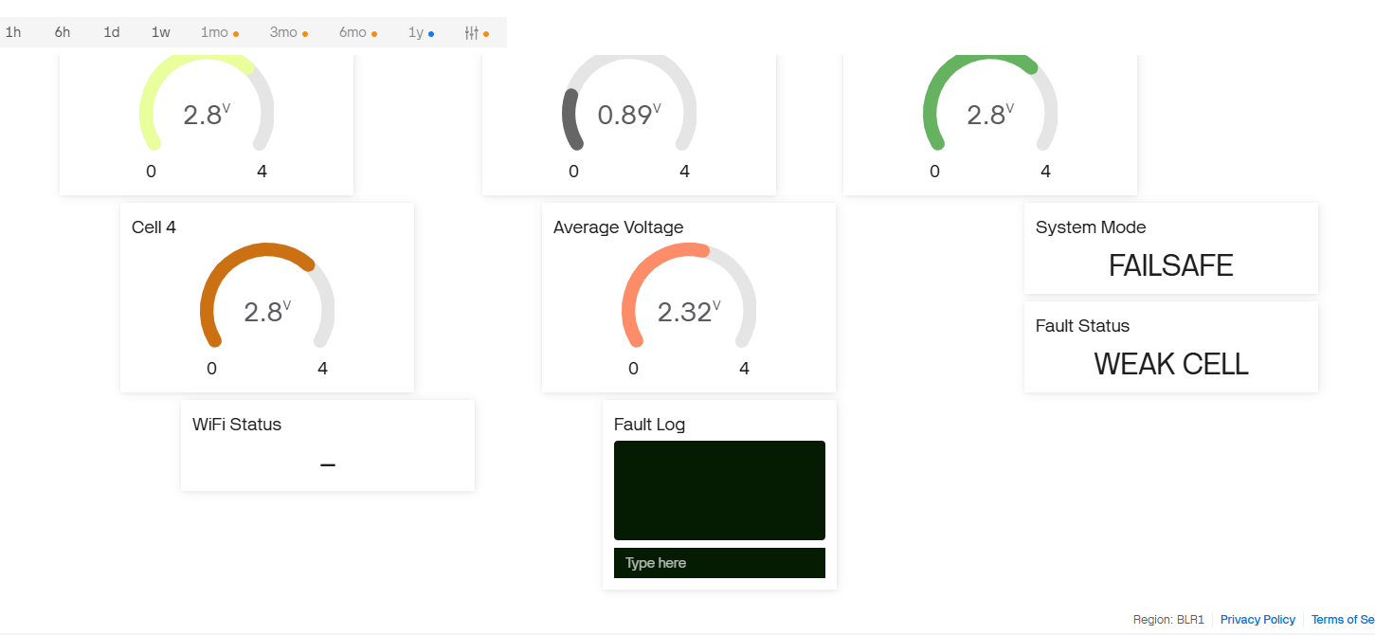
Figure 27: Blynk Dashboard Showing Weak Cell Detection in FAILSAFE Mode

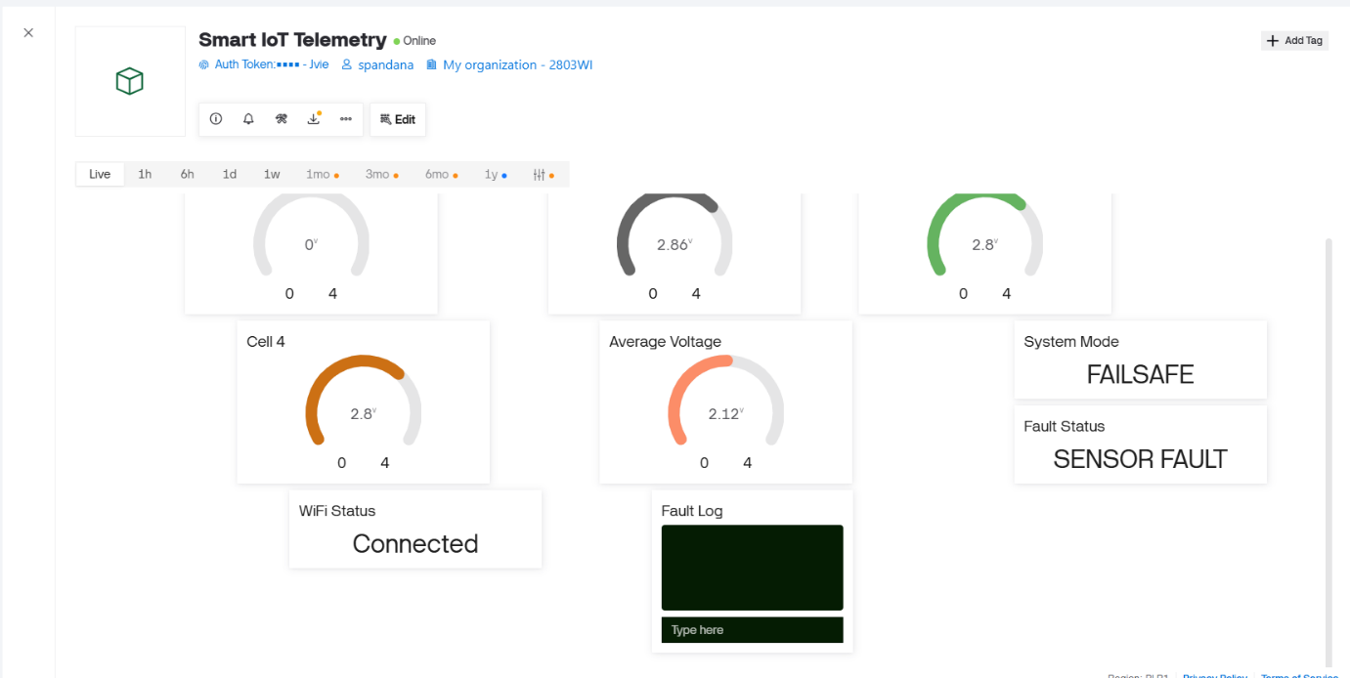

Figure 28: Blynk Dashboard Showing sensor fault Detection in FAILSAFE Mode

- Task 6 – Executive Battery Intelligence Dashboard

Objective:
The goal of this task was to create a professional Blynk based executive dashboard that would be able to display battery intelligence, operational status analysis, historical trends, diagnostics, fault data, and actionable recommendations to the operator.

Implementation:
To avoid overlapping the previous telemetry template a separate Blynk dashboard was created, specifically for Task 6. The dashboard was broken into segments for live battery data, battery intelligence, diagnostics and historical data.

Live Operational Monitoring:
The dashboard offers real-time monitoring of the following:
- Cell 1 voltage
- Cell 2 voltage
- Cell 3 voltage
- Cell 4 voltage
- Average voltage

Gauge widgets were used to immediately visualize the value of individual cells and pack voltage.

Battery Intelligence:
Other dashboard indicators that were added for:
- Battery Health
- Risk Level
- Recommendation
- Relay Status
Battery Health gives a numerical representation of the current condition of the system in a simplified manner. The operating state will be categorized in Risk Level, and the Recommendation field will contain an operator-friendly response to the detected condition.

Diagnostics:
Also, the dashboard gives you:
- System Mode
- Fault Status
- Wi-Fi Status
- RSSI
This enables an operator to keep track of both the battery and embedded system underneath.

Historical Monitoring:
A voltage trend chart was set up to show:
- Cell 1
- Cell 2
- Cell 3
- Cell 4
- Average Voltage
This allows the operator to see how the voltage reacts over time and not just a snapshot of the voltage.

Fault History:
A Blynk Terminal widget to display the fault and event information produced by the embedded system was added.

Testing and Result:
The dashboard was subjected to normal and abnormal operating conditions. During normal operation, the dashboard correctly displayed the live cell voltages, average voltage, battery health, risk level, system mode, relay status, fault status, Wi-Fi status, RSSI and recommendation. During abnormal conditions, the dashboard updated the risk level, fault status, system mode and recommendation accordingly.
When the fault condition occurred the operating state of the embedded system was changed and the dashboard information updated accordingly. The final dashboard then consolidates live telemetry, battery intelligence, diagnostics, historical trends, fault information, etc. and offers operator guidance.
Evidence:
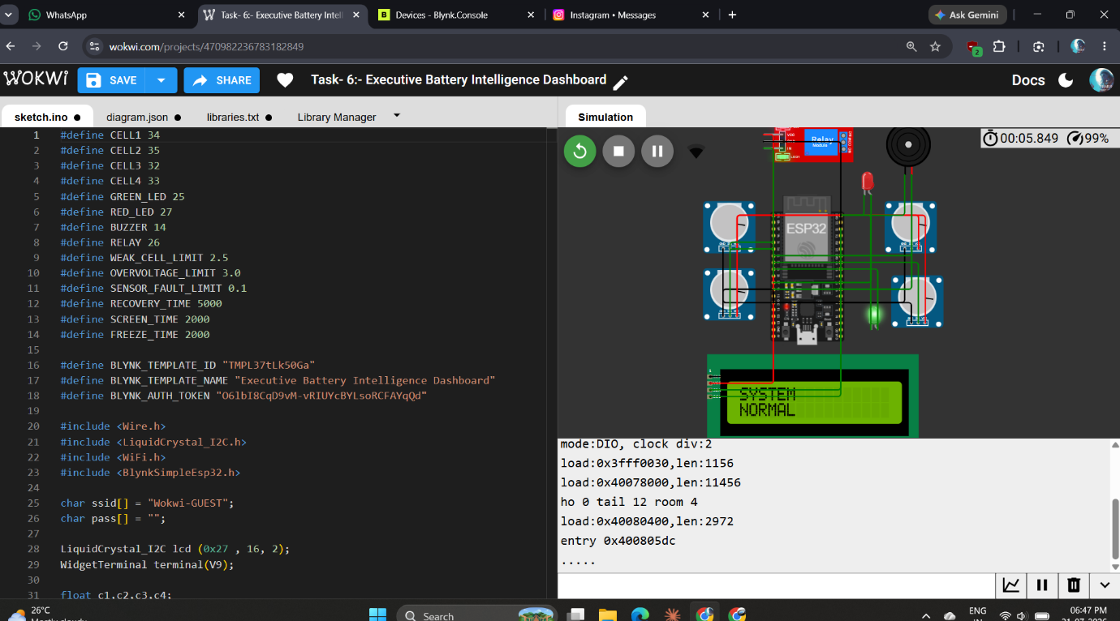
Figure 29: Wokwi Simulation of the Executive Battery Intelligence Dashboard
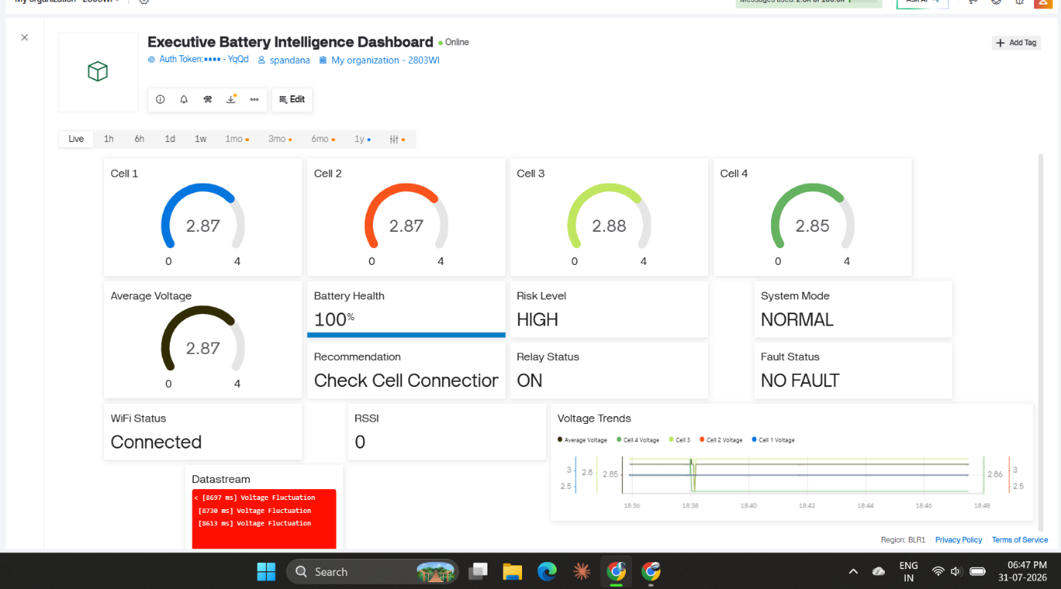
Figure 30: Blynk Dashboard Showing Normal Battery Operation and Real-Time Telemetry
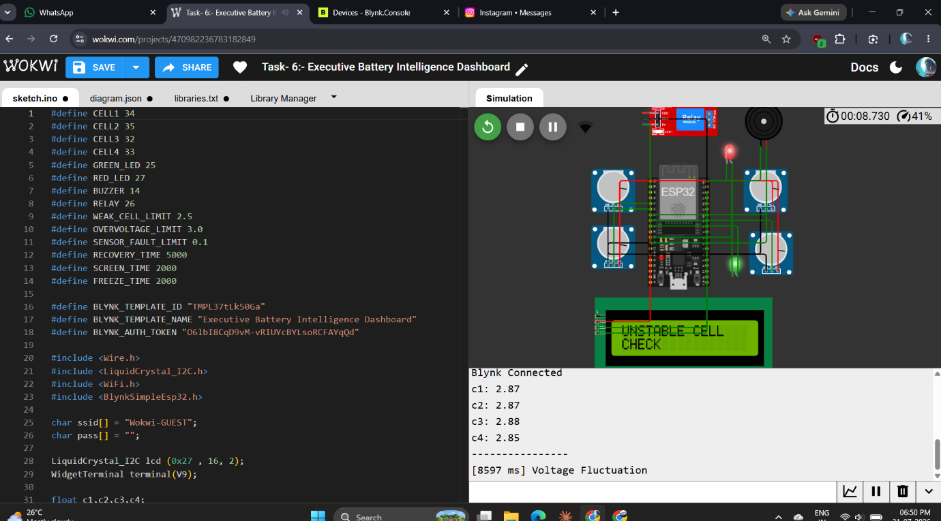
Figure 31: Wokwi Simulation Showing Unstable Cell Detection

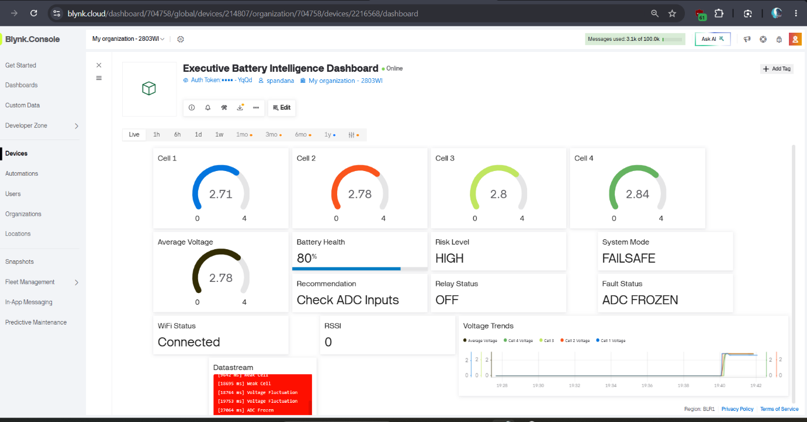
Figure 32: Blynk Dashboard Showing ADC Frozen Detection in FAILSAFE Mode

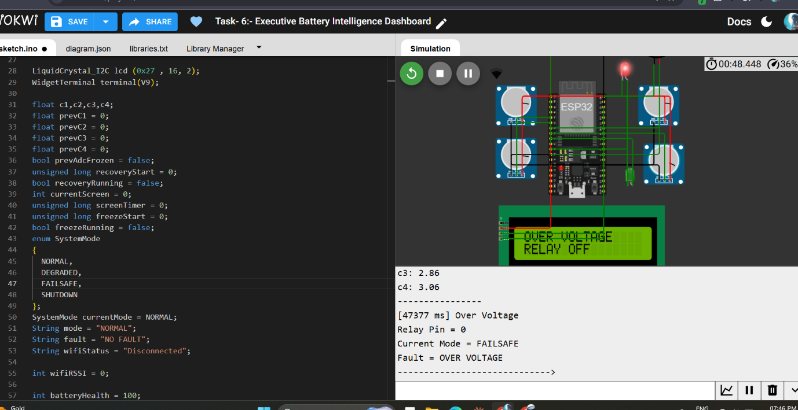
Figure 33: Wokwi Simulation Showing Overvoltage Detection and Relay Disconnection

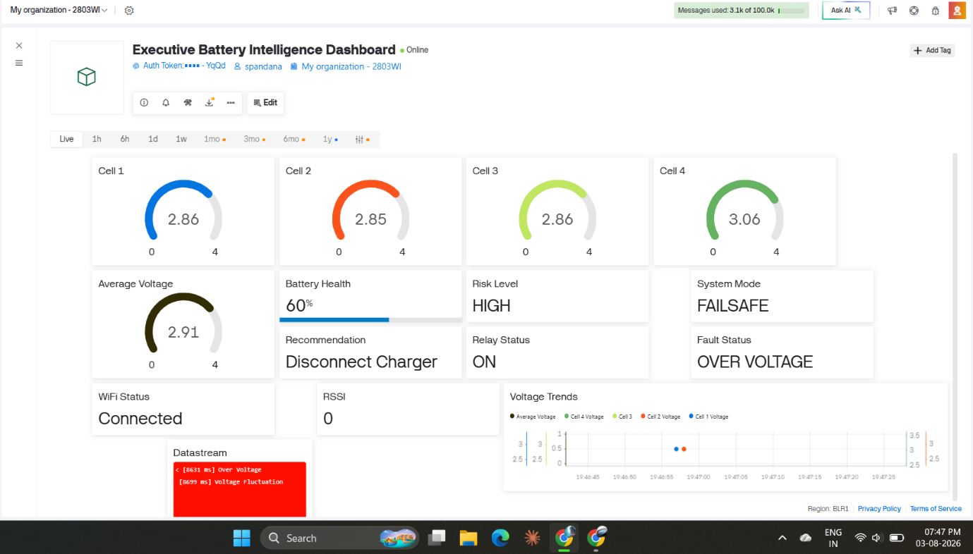
Figure 34: Blynk Dashboard Showing Overvoltage Condition and Safety Recommendation

- Skills and Competencies:
Developed The project gave hands-on experience to the students in both technical and engineering aspects.
Technical Skills:
- Embedded C/C++ programming
- ESP32 programming
- Collecting analog input and sensor data.
- Battery voltage monitoring Interfacing with LCD and I²C.
- GPIO and relay control.
- Volume Control and LED Control functions with buzzer and LED.
- millis()-based non-blocking programming
- Event-driven embedded architecture Getting ready to detect faults and manage state.
- Preparing for fault detection and state management.
- Wi-Fi communication
- Blynk IoT cloud integration
- Virtual datastream configuration
- Cloud telemetry
- Dashboard development
- The simulation and testing of Wokwi.
Engineering Skills:
- Modular embedded-system design
- The ability to analyze and isolate faults.
- Real-time debugging
- State-machine-based system management
- Testing in unusual operating conditions.
- Cloud-device synchronization
- Identifying communication and dashboard problems
- Incremental development and validation.

Professional Skills:
- In addition, the internship was reinforced:
- Problem-solving
- Independent technical research
- Debugging and troubleshooting
- Technical documentation
- System testing
- Requirement-based development
- Analytical thinking
- Project organization

- Feedback
The internship offered hands-on experience with the development of an integrated embedded and IoT-based battery management system. During the implementation, the project was constantly tested, debugged, and iterated both for the behavior of the hardware and the telemetry data in the cloud.
The development process identified some aspects of the initial implementation that needed improvement, such as fault-state transition, relay control, telemetry synchronization, Blynk datastream configuration and dashboard state consistency.
The Wokwi simulation testing of various battery conditions was helpful to verify the protection and monitoring logic. The iteration of debugging also led to a better understanding of the behaviour of embedded systems in unusual situations and what should happen to the cloud dashboard when the device state is changed.

- Challenges and Solutions
There were a number of problems encountered in the system development and test. The challenges served to better enhance the reliability and general understanding of the architecture implemented.

Challenge | Solution
The initial sensor readings were found to be zeros when starting up the system. | The fault-handling logic was verified during the start-up sequence to detect invalid sensor conditions.
Identification of rapid voltage changes | Previous readings and current readings were compared to detect rapid changes in voltage.
ADC frozen condition | A time based detection was added to detect when the reading was not changing for a set period of time, using millis().
Multiple simultaneous faults | Fault conditions were counted and the system was put in SHUTDOWN if the set fault threshold was exceeded.
Relay recovery after faults | To avoid unnecessary switching and prevent immediate relay reactivation, relay recovery timing has been implemented after faults.
Blynk initially remaining offline | Wi-Fi and Blynk connection handling was tested, and the cloud configuration was adjusted until it became connected.
Blynk dashboard displaying stale values | Position and synchronisation of Blynk.virtualWrite() operations were examined to ensure that existing system values were sent.
Battery Health displaying incorrect values | The V10 datastream configuration and battery-health logic were checked and corrected.
Dashboard state inconsistencies during transitions | During transitions, state inconsistencies on the dashboard were checked by using serial debugging before finalization of the state of the dashboard
Testing the system under abnormal conditions | Weak cells, overvoltage, sensor fault, fluctuation, etc. were simulated by using Wokwi potentiometers for the testing of the system under abnormal conditions.

These tests have shown the need for incremental testing and debugging when creating embedded systems with real-time safety and cloud communication requirements.
- Outcomes and Impact:
As a outcome of the internship, an integrated multi-cell battery intelligence and IoT monitoring system utilizing ESP32, Wokwi, and Blynk was developed. The final system can monitor a simulated 4-cell battery pack and can provide local and cloud-based intelligence.
The key findings are:
- Monitoring of four cell voltages in real-time.
- Calculation and monitoring of average pack voltage.
- Detection of weak-cell or over voltage.
- Anomalies in sensors, voltage fluctuations and freezing of ADC.
- Automatic relay protection and abnormal condition alarming.
- Various operating modes: NORMAL, DEGRADED, FAILSAFE and SHUTDOWN.
- Timestamped fault logging for diagnostic purposes.
- Local monitoring and fault-priority display on LCD screen.
- Cloud connectivity with Wi-Fi and Blynk.
- Cloud telemetry for event and fault information.
- Monitoring of any WIFI or RSSI.
- Visualization of the voltage levels throughout history using Blynk dashboard.
- Battery Health and Risk Level indicators.
- Smart recommendations for operators according to detected conditions.
- Controlled Executive Dashboard for diagnostics and battery operation monitoring.
The project thus evolved from simple battery sensing to building an integrated intelligent monitoring architecture that enabled embedded safety capabilities, diagnostics, cloud communication and visualization.

- Conclusion
The internship project was a success in developing the integrated Adaptive Multi-Cell Battery Intelligence and Cloud Monitoring System with ESP32, Wokwi and Blynk. The project evolved in six steps starting with battery intelligence with multiple cells, moving to safety protection, embedded HMI, fault-tolerant runtime management, cloud telemetry, and lastly an executive battery intelligence dashboard.
The finished system integrates all of these functions into a single system, including real time sensing, fault detection, safety protection, local diagnostics, communication to the cloud, historical monitoring, risk analysis and operator recommendations. The implementation was a wonderful hands-on experience with embedded systems, IoT communication, event-driven programming, fault management, real-time debugging, and cloud dashboards.
The iterative testing process also illustrated the need for testing both normal and abnormal system behaviour. In general, the internship gave a practical experience of designing a full-fledged embedded IoT application, from capture of sensor data, through the definition of safety logic and the development of the controller, to the implementation of the monitoring logic in the cloud and the generation of intelligent visualizations.

