Project Title:
UART Communication Protocol using Verilog

Internship Domain:
VLSI Design

Submitted By:
Reddy Spandana

Intern Id:
382

Submitted To:
SipQode Internship

Abstract
Universal Asynchronous Receive Transmitter (UART) is one of the most prevalent serial communication protocols that are utilized to exchange data between digital devices like microcontrollers, computers, sensors and embedded systems. This project is about designing and implementing a UART Transmitter using Verilog Hardware Description Language (HDL). The data sent by the transmitter is converted from 8-bit parallel data into serial data, with the addition of the necessary start and stop bits based on the UART communication protocol. AMD Vivado 2025.2 was used for design development and behavioral simulation for the functional verification. The result of the simulation will show that the serial data transmission is reliable for the UART transmitter at the given baud rate. This project is rich in gaining practical experience in digital communication, design using VLSI, and Verilog programming which serves as a useful learning experience in VLSI and digital system design.
Objectives
The main goal of this project is to:
- To learn how UART (Universal Asynchronous Receiver Transmitter) circuit works.
- To create and simulate a UART Transmitter in Verilog HDL. To convert 8-bit parallel input data into serial output data, generate the appropriate start and stop bits.
- To generate baud rate for accurate serial communication. To simulate behavioural correctly with AMD Vivado 2025.2 and also to validate the functionality of the design to be simulated.
- To examine the simulation waveforms and make sure that serial data is transmitted properly.
- To acquire hands-on experience and knowledge of digital design and hardware description language programming with FPGA(s).
- To design a re-usable UART transmitter module to be used in larger embedded/communication systems.

Software Requirements
Requirement | Specification
Operating System | Windows 11
Design Software | AMD Vivado ML Edition 2025.2
Programming Language | Verilog HDL
Simulation Tool | Vivado Simulator
Clock Frequency | 100 MHz
Baud Rate | 9600 bps
Processor | Intel/AMD Processor
RAM | Minimum 8 GB
Storage | At least 2 GB free disk space

Project Architecture
The UART Transmitter is comprised of a transmitter module and a functional verification test bench. The transmitter takes 8 bits of parallel data and converts it to serial data with a start bit and stop bit, and sends the data at the desired baud rate. The testbench produces the reset signal, clock signal, input data and transmission control signal; and simulates the functionality of the transmitter to verify.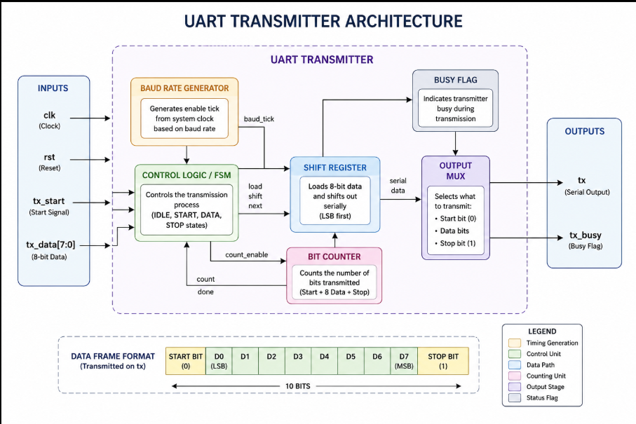

Architecture Description
clock (clk): Supplies the necessary timing for UART transmitting.
  - Reset (rst): Resets the transmitter to its default settings.
  - Transmit Start (tx_start): Start the process of transmitting.
  - Transmit Data (tx_data): Receives 8 bit parallel data.
  - Baud Rate Generator: Generates timing for desired baud rate.
  - Shift Register: Parallel to Serial (PTS).
  - Bit Counter: Counts bits transmitted and when transmission is finished.
  - Serial Output (tx): Outputs the transmitted serial data with start and stop bits.
Module Description
The UART Transmitter module is in charge of parallel data converting parallel data to serial data following the UART communication protocol. It takes in the data, adds the necessary start and stop bits and sends it serially at the configured baud rate. The module also outputs a busy signal to stop loading of new data being loaded until the current transmission finishes.
Input Signals
Signal | Description
clk | 100 MHz system clock
rst | Active-high reset signal
tx_start | Starts the transmission process
tx_data[7:0] | 8-bit parallel input data

Output Signals
Signal | Description
tx | Serial output data
tx_busy | Indicates the transmitter is busy

Internal Components
- Baud Rate Generator
- Shift Register
- Bit Counter
- Control Logic
- Busy Flag

Working Principle
The UART transmitter is a serial transmitter that uses one communication line to send one bit at a time. The transmitter is kept silent, whilst the output line is kept high initially. The module stores the 8-bit input data in an input shift register when the tx_start signal is high, and activates the transmitter to the busy state. The transmission starts with a start bit (logic '0') followed by the 8 data bits most significant bit (MSB) first. A baud rate generator is used to control the timing to ensure that each bit is sent for the right amount of time. A stop bit (logic 1) is transmitted at the end of the frame (after 8 data bits). After stop bit sent, the tx_busy signal goes low and the tx goes into its idle state, awaiting the next transmission.

Verilog Implementation
In this work, the UART transmitter design is written in Verilog Hardware Description Language (HDL) and simulated in the AMD Vivado ML Edition 2025.2. There are two source files in the implementation:
1. uart_tx.v:- In this is the primary design module in charge of UART transmission. It is used for the following purposes: Initialises the transmitter on reset. Produces the baud rate timing. Loads the data to be shifted into the shift register. Sends out stop bit, data bits followed by start bit. Puts the tx_busy signal out while transmitting.
2. uart_tx_tb.v:- This is a special module for functional verification of the UART transmitter. It does the following things: Produces a 100 MHz clock signal. Resets the signal to reset Loads sample data (8'hA5) to be sent out. Produces the tx_start pulse. Looks at the output of the transmitter via simulation waveforms.
Code Snippets:-
The main Verilog module is uart_tx.v, shown in figure1.
The module uart_tx_tb.v is a testbench module as shown in figure 2.

- Figure 1: uart_tx.v (Main Verilog module)
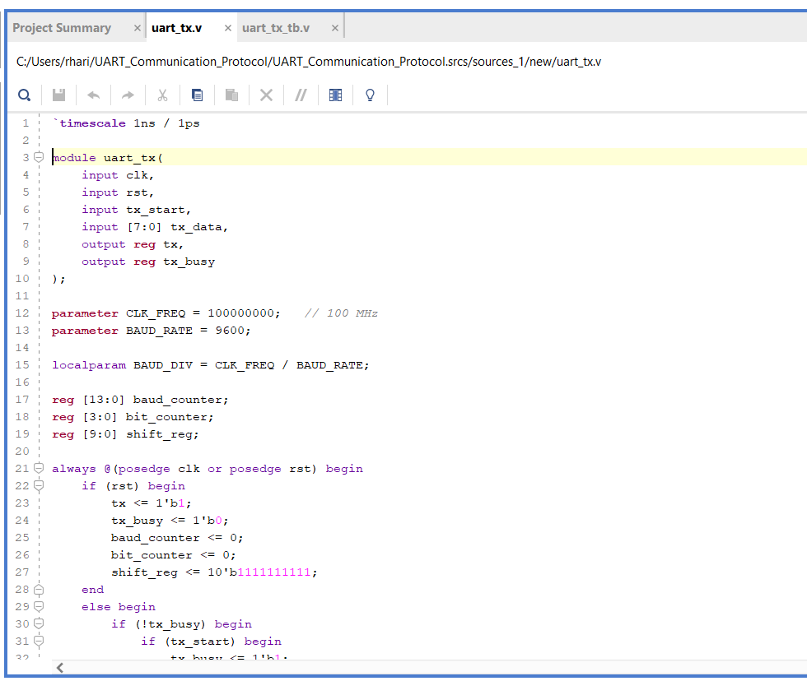
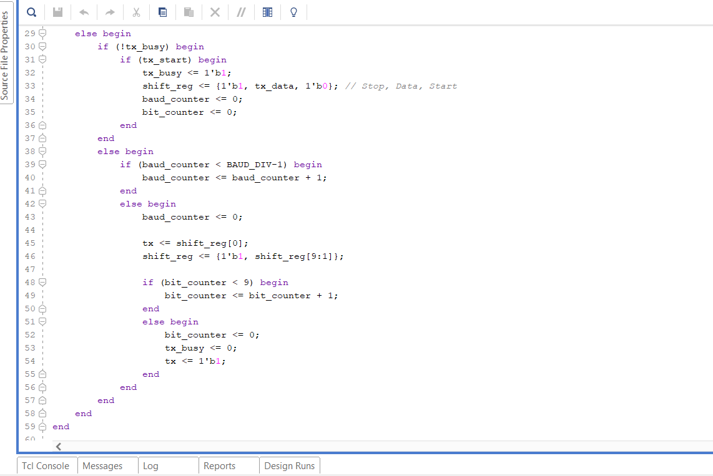
- Figure 2: uart_tx_tb.v (Testbench module)
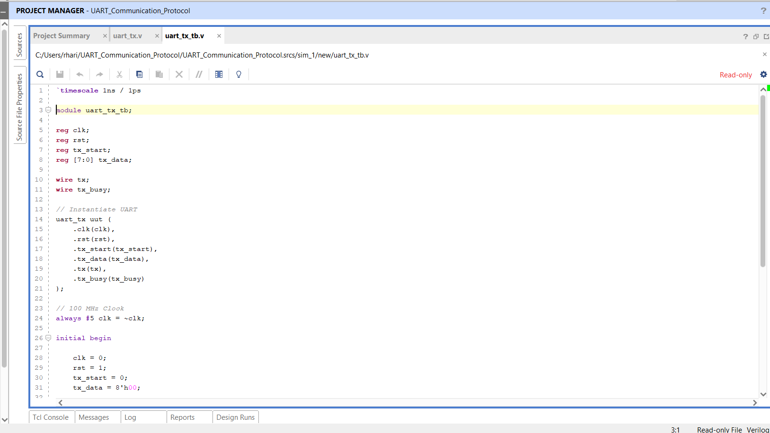
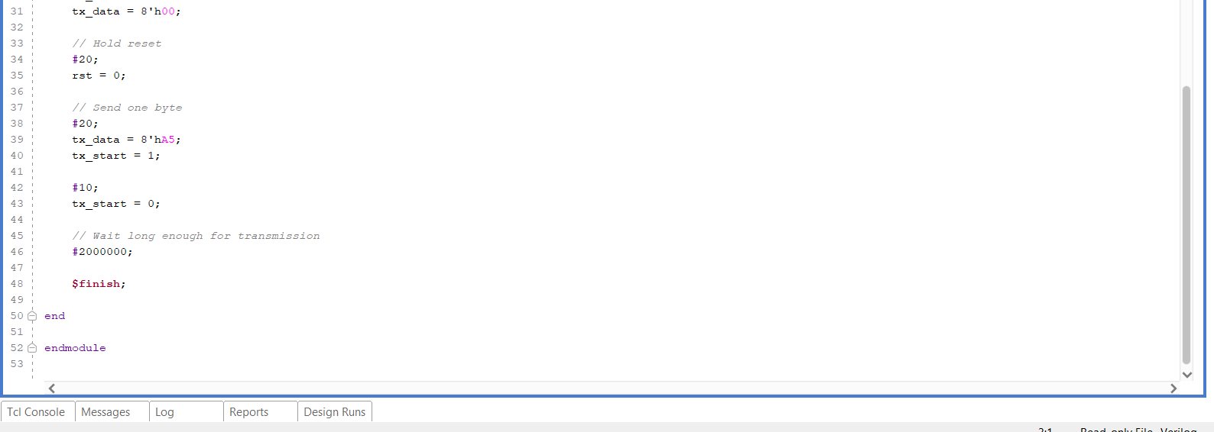
Simulation Results
Description
The UART transmitter was successfully simulated with AMD Vivado ML Edition 2025.2. The simulation confirms that the transmitter performs correctly on parallel data input and serial data output using the UART protocol, with 8 bits. In the simulation, everything is reset, the transmission is started with the tx_start signal and the data byte 8'hA5 is transmitted serially. Each of the bits is generated properly because the waveform confirms it.

Figure 3: UART Transmission Simulation Waveform
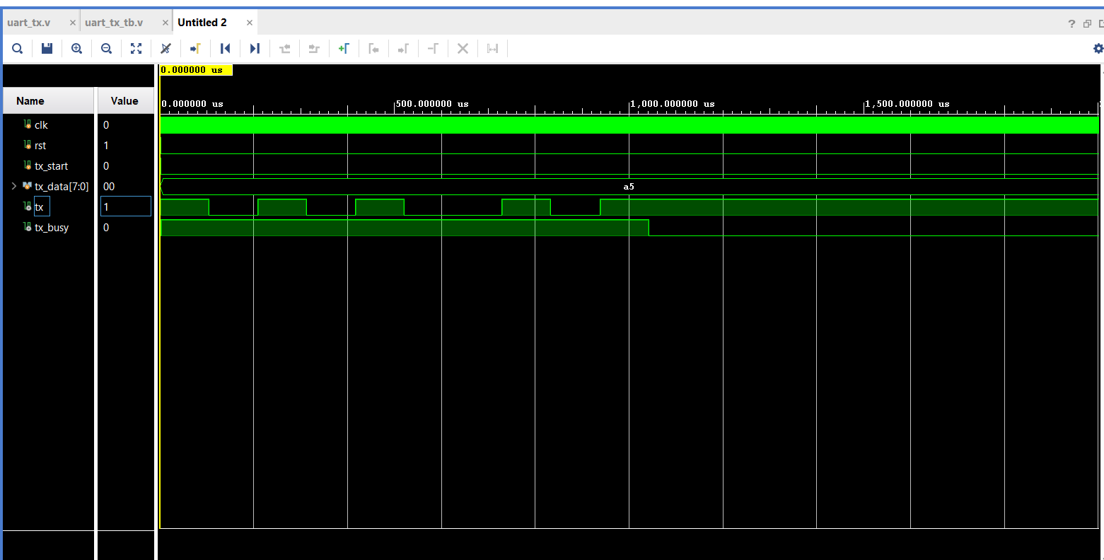
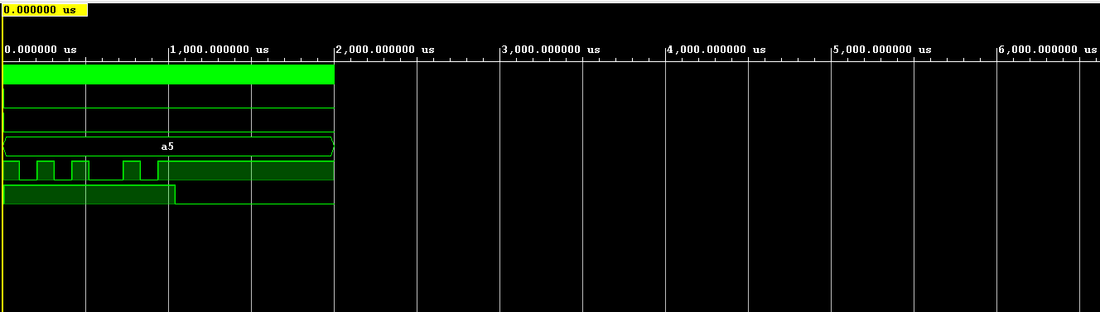
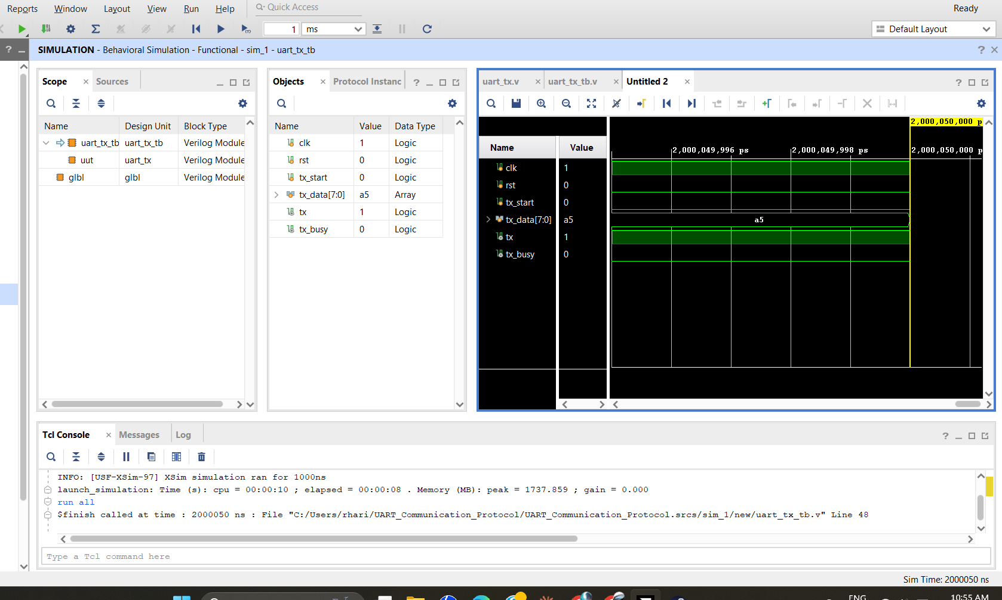
Applications
UART is widely used in a diversity of digital and embedded systems. Some typical applications are:Communication between microcontrollers and computers.
- Serial communication in embedded systems.
- FPGA-based communication interfaces.
- GPS, Bluetooth, and GSM modules.
- Industrial automation systems.
- IoT devices and sensor networks.
- Debugging and data logging applications.

Advantages
The advantages of the UART transmitter are:
- Simple and efficient communication protocol.
- Low hardware complexity.
- Reliable asynchronous data transmission.
- Easy implementation using Verilog HDL.
- Suitable for FPGA and embedded system applications.
- Low power consumption.
- Cost-effective communication interface.

Conclusion
Verilog HDL code has been developed and behaviorally simulated in the AMD Vivado ML Edition 2025.2 the UART Communication Protocol has been implemented. Transmitter is able to properly convert 8 bit parallel data to serial data and adds stop and start bits as required. This simulation waveform verifies that the design is working correctly, with reliable UART communication. This project gave experience of understanding digital Communication Protocols, Verilog and system Design in FPGA's.
References
- AMD. (2025). Vivado Design Suite User Guide. AMD Documentation. Available at: https://docs.amd.com
- AMD. (2025). Vivado Design Suite User Guide: Logic Simulation (UG900). AMD Documentation. Available at: https://docs.amd.com
- Palnitkar, S. (2003). Verilog HDL: A Guide to Digital Design and Synthesis (2nd Edition). Prentice Hall.
- Floyd, T. L. (2017). Digital Fundamentals (11th Edition). Pearson Education.
- Stallings, W. (2017). Data and Computer Communications (10th Edition). Pearson Education.
- National Semiconductor. (2000). UART (Universal Asynchronous Receiver Transmitter) Fundamentals. Texas Instruments/National Semiconductor Application Notes.
- IEEE Standards Association. (2005). IEEE Standard for Verilog Hardware Description Language (IEEE Std 1364-2005).

