**WEEK 6 : HANDS ON**

1. In this hands-on lab, you will learn how to:

* Set up a react environment
* Use create-react-app

**CODE:**

**App.js:**

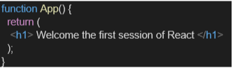

**OUTPUT:**

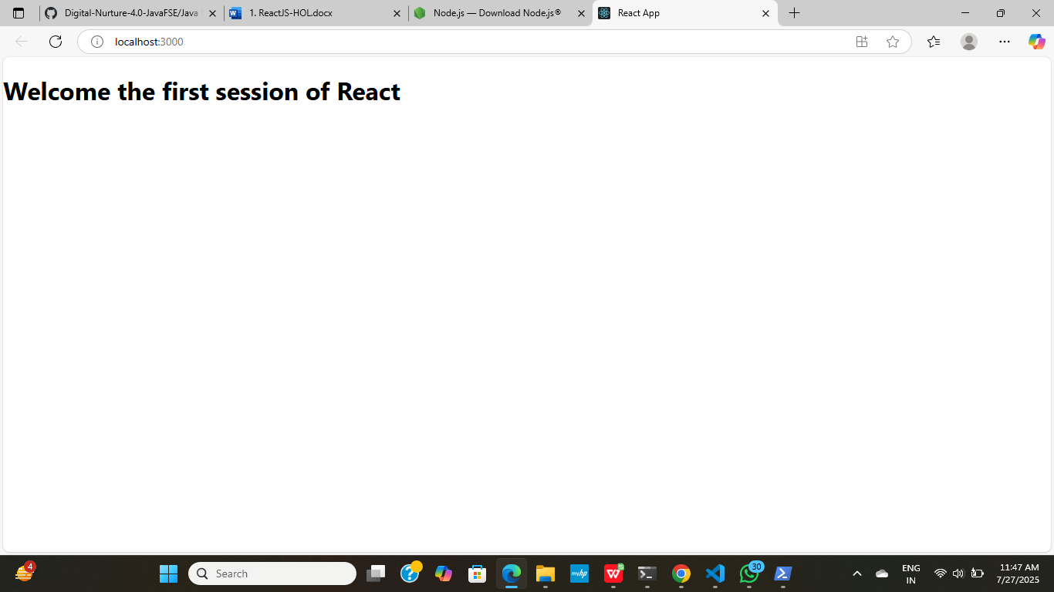

2.In this hands-on lab, you will learn how to:

* Create a class component
* Create multiple components
* Render a component

**CODE:**

**Home.js:**

import React, { Component } from 'react';

class Home extends Component {

render() {

return (

<div>

<h3>Welcome to the Home Page of Student Management Portal</h3>

</div>

);

}

}

export default Home;

**About.js:**

import React, { Component } from 'react';

class About extends Component {

render() {

return (

<div>

<h3>Welcome to the About page of Student Management Portal</h3>

</div>

);

}

}

export default About;

**Contact.js:**

import React, { Component } from 'react';

class Contact extends Component {

render() {

return (

<div>

<h3>Welcome to the Contact page of Student Management Portal</h3>

</div>

);

}

}

export default Contact;

**App.js:**

import logo from './logo.svg';

import './App.css';

import Home from './Components/Home'; // Import Home component

import About from './Components/About'; // Import About component

import Contact from './Components/Contact'; // Import Contact component

function App() {

return (

<div className="container">

<Home /> {/* Render Home component */}

<About /> {/* Render About component */}

<Contact /> {/* Render Contact component */}

</div>

);

}

export default App;

**OUTPUT:**

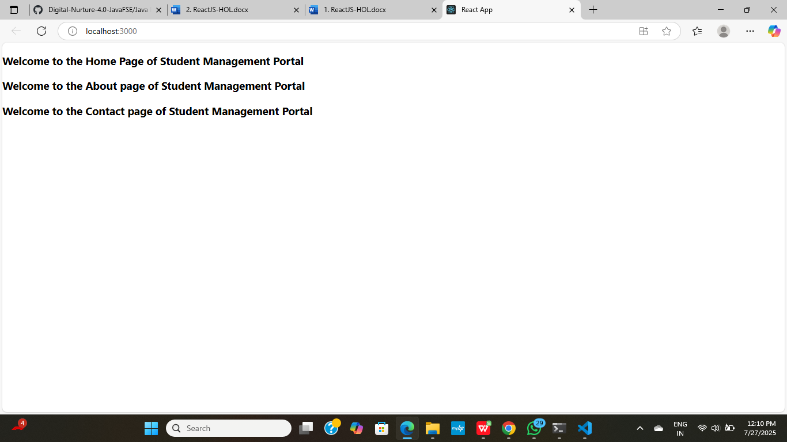

3.In this hands-on lab, you will learn how to:

* Create a function component
* Apply style to components
* Render a component

**CODE:**

**CalculateScore.js:**

import '../Stylesheets/mystyle.css'; // This import will be valid after Step 4

const percentToDecimal = (decimal) => {

return (decimal * 100).toFixed(2) + '%';

};

const calcScore = (total, goal) => {

return percentToDecimal(total / goal);

};

export const CalculateScore = ({ Name, School, total, goal }) => {

return (

<div className="formatstyle">

<h1 style={{ color: "brown" }}>Student Details:</h1>

<div>

<b><span className="Name">Name: </span></b>

<span className="Name">{Name}</span>

</div>

<div>

<b><span className="School">School: </span></b>

<span className="School">{School}</span>

</div>

<div>

<b><span className="Total">Total: </span></b>

<span className="Total">{total}</span>

<span> Marks</span>

</div>

<div>

<b><span className="Score">Score: </span></b>

<span className="Score">

{calcScore(

total,

goal

)}

</span>

</div>

</div>

);

};

**mystyle.css:**

.Name {

font-weight: 300;

color: blue;

}

.School {

color: crimson;

}

.Total {

color: darkmagenta;

}

.formatstyle {

text-align: center;

font-size: large;

}

.Score {

color: forestgreen;

}

**App.js:**

import './App.css';

import { CalculateScore } from './Components/CalculateScore'; // Import CalculateScore

function App() {

return (

<div>

<CalculateScore Name={"Steeve"} School={"DNV Public School"} total={284} goal={300} />

</div>

);

}

export default App;

**OUTPUT:**

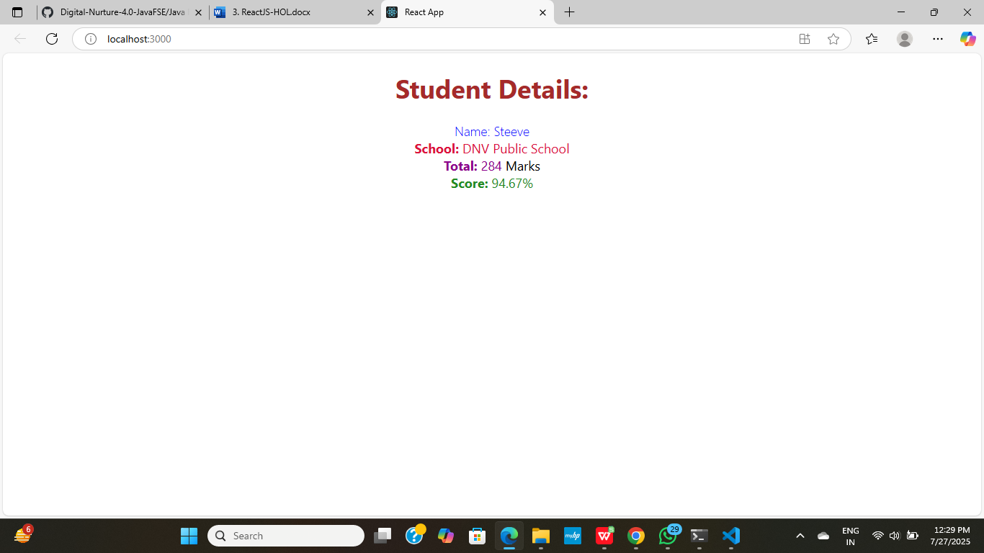

4. Create a new class based component named as **Posts** inside **Posts.js** file

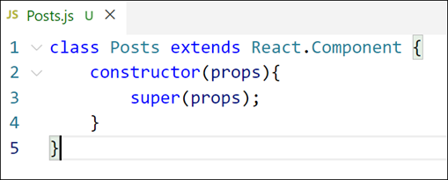

Figure 3: Posts Component

**CODE:**

**Posts.js**

import React from 'react';

class Posts extends React.Component {

constructor(props) {

super(props);

this.state = {

posts: [

{ id: 1, title: 'First Post', content: 'This is the first post.' },

{ id: 2, title: 'Second Post', content: 'This is the second post.' },

{ id: 3, title: 'Third Post', content: 'This is the third post.' }

]

};

}

render() {

return (

<div>

<h2>Posts</h2>

<ul>

{this.state.posts.map(post => (

<li key={post.id}>

<h4>{post.title}</h4>

<p>{post.content}</p>

</li>

))}

</ul>

</div>

);

}

}

export default Posts;

**App.js**

import logo from './logo.svg';

import './App.css';

function App() {

return (

<div className="App">

<header className="App-header">

<img src={logo} className="App-logo" alt="logo" />

<p>

Edit <code>src/App.js</code> and save to reload.

</p>

<a

className="App-link"

href="https://reactjs.org"

target="_blank"

rel="noopener noreferrer"

>

Learn React

</a>

</header>

</div>

);

}

export default App;

**OUTPUT:**

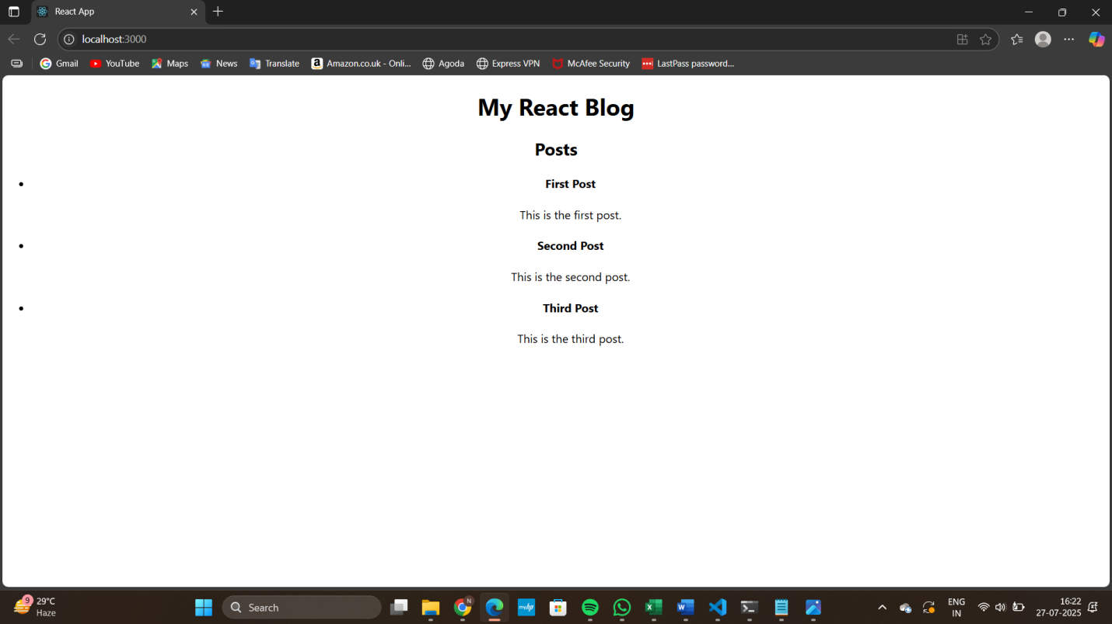

5. Initialize the component with a list of Post in state of the component using the constructor

**Posts.js**

import React from 'react';

class Posts extends React.Component {

constructor(props) {

super(props);

// Initializing state with a list of posts

this.state = {

posts: [

{ id: 1, title: "React Basics", content: "Learn about components, props, and state." },

{ id: 2, title: "React Lifecycle", content: "Understand how React components mount and update." },

{ id: 3, title: "React Hooks", content: "Explore useState, useEffect, and more (in functional components)." }

]

};

}

render() {

return (

<div>

<h2>Posts</h2>

<ul>

{this.state.posts.map(post => (

<li key={post.id}>

<h3>{post.title}</h3>

<p>{post.content}</p>

</li>

))}

</ul>

</div>

);

}

}

export default Posts;

**OUTPUT:**

