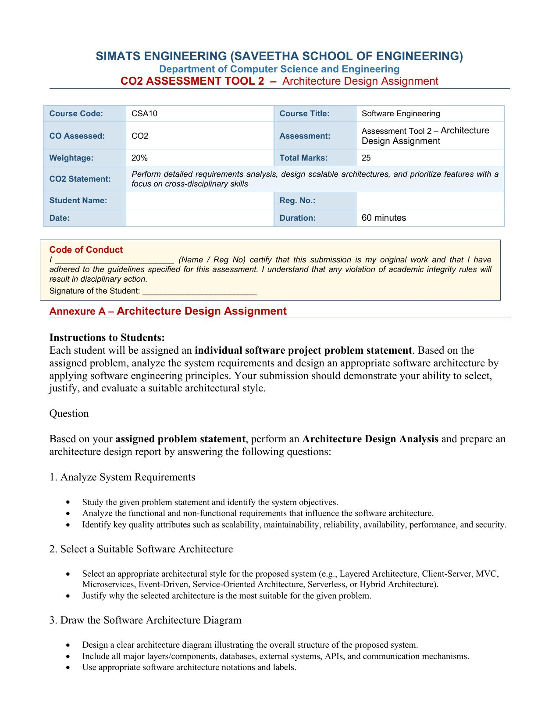

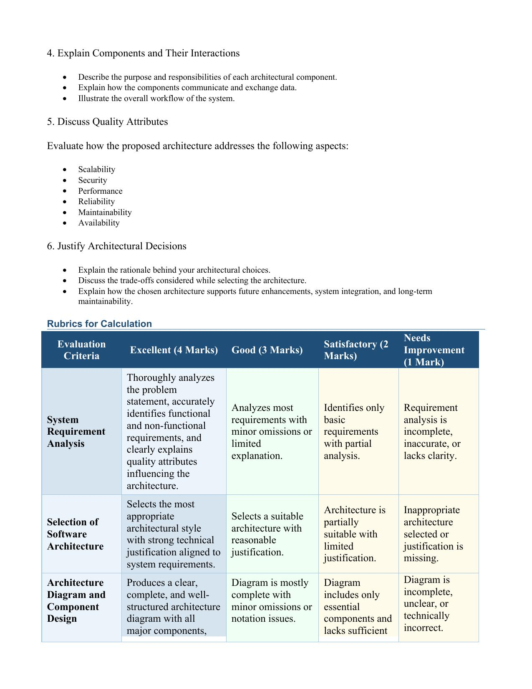

SIMATS ENGINEERING
(SAVEETHA SCHOOL OF ENGINEERING)
Department of Computer Science and Engineering
CO2 ASSESSMENT TOOL 2 – ARCHITECTURE DESIGN ASSIGNMENT
ARCHITECTURE DESIGN REPORT
Intelligent Smart Port Operations and Cargo Management Platform
Problem Statement No. 38

Course Code : CSA10
Course Title : Software Engineering
CO Assessed : CO2
Student Name : Spandana S
Registration Number : 192525160
Faculty In-Charge : Latha
Date : 04-08-2026
Signature of the Student: Spandana S

Table of Contents
1. Industry Context and Problem Statement
2. System Requirements Analysis
3. Selected Software Architecture and Justification
4. Software Architecture Diagram
5. Technology Stack
6. Components and Their Interactions
7. Data Flow and Communication Mechanisms
8. Deployment Architecture
9. Discussion of Quality Attributes
10. Risk Analysis and Mitigation
11. Justification of Architectural Decisions and Trade-offs
12. Expected Outcomes
13. Conclusion
14. References

1. Industry Context and Problem Statement

1.1 Industry Context
Modern seaports handle very high volumes of cargo and vessel traffic on a daily basis, which demands efficient logistics coordination and continuous, real-time operational monitoring. The convergence of Artificial Intelligence (AI), the Internet of Things (IoT), Radio Frequency Identification (RFID), Global Positioning System (GPS) tracking, and cloud computing technologies has enabled intelligent cargo tracking, automated scheduling, and predictive analytics. These technologies collectively improve port productivity, reduce operational delays, and provide port authorities with the visibility required to manage complex, time-critical operations.

1.2 Problem Statement
Port authorities frequently experience operational inefficiencies caused by cargo congestion, manual and paper-based documentation, delayed vessel scheduling, and limited visibility of cargo movement across the port ecosystem. These challenges directly increase vessel turnaround time and overall logistics costs. There is a need for an Intelligent Smart Port Operations and Cargo Management Platform that can monitor cargo movement using IoT devices, optimize berth allocation and vessel scheduling, predict cargo handling delays using AI, automate documentation processes, and provide real-time operational dashboards. The system must enhance logistics efficiency while supporting secure and transparent port operations.

1.3 System Objectives
- Monitor cargo movement in real time.
- Optimize berth and vessel scheduling.
- Predict cargo handling delays using AI.
- Automate logistics documentation.
- Improve warehouse coordination.
- Generate operational performance reports.
- Enhance cargo security.
- Increase overall port operational efficiency.

1.4 Key Stakeholders
The platform serves a diverse set of stakeholders, each with distinct interaction needs that directly influence the architecture. Port Authority Administrators require consolidated operational dashboards and performance reports. Terminal and Yard Operators need real-time cargo and berth status. Drivers and Logistics Staff use mobile applications for pickup, drop-off, and dispatch instructions. Customs and Government Agencies require secure, auditable access to shipping documentation. Shipping Lines and Carriers need synchronized vessel schedules and berth confirmations. Third-Party Logistics (3PL) and ERP Partners integrate through APIs for end-to-end supply-chain visibility. System Administrators manage users, roles, and platform configuration.
Supporting this range of stakeholders through a single, tightly coupled system would be impractical, since each group has different performance, security, and access needs. This diversity of stakeholders is one of the key drivers behind selecting a modular, service-oriented architecture in which each concern can be exposed through a purpose-built interface without overloading a single monolithic application.

2. System Requirements Analysis

2.1 Functional Requirements
The functional requirements below define the specific capabilities that the Intelligent Smart Port Operations and Cargo Management Platform must provide, derived directly from the stated objectives and problem statement.
ID | Functional Requirement
FR-01 | The system shall monitor cargo movement in real time using RFID tags and GPS-enabled IoT devices.
FR-02 | The system shall optimize berth allocation and vessel scheduling using AI-based scheduling algorithms.
FR-03 | The system shall predict cargo handling and vessel delays using machine learning models trained on historical and real-time operational data.
FR-04 | The system shall automate documentation processes, including customs forms, bills of lading, and manifests, using OCR and digital workflows.
FR-05 | The system shall coordinate warehouse operations, including storage allocation, inventory tracking, and dispatch scheduling.
FR-06 | The system shall generate real-time operational dashboards and periodic performance reports for port authorities.
FR-07 | The system shall enforce role-based access control and maintain audit logs to enhance cargo and data security.
FR-08 | The system shall integrate with external customs, shipping-line, and third-party ERP/logistics systems through APIs.
FR-09 | The system shall generate automated alerts and notifications for delays, congestion, and operational anomalies.
FR-10 | The system shall support concurrent, multi-user access across web dashboards, mobile applications, and partner portals.
FR-11 | The system shall provide predictive congestion forecasts for yard and berth areas based on historical and live traffic patterns.
FR-12 | The system shall log all user and service actions for audit and compliance purposes.
FR-13 | The system shall support configurable rules for berth-allocation priority (e.g., vessel size, cargo type, contractual priority).
FR-14 | The system shall provide search and filter capabilities across cargo, vessel, and shipment records.
FR-15 | The system shall expose public APIs so that shipping lines and ERP partners can query shipment and vessel status programmatically.

2.2 Non-Functional Requirements and Key Quality Attributes
Non-functional requirements define the quality attributes that constrain and shape the software architecture. For a mission-critical, real-time, IoT-intensive system such as this, scalability, performance, reliability, availability, security, and maintainability are of primary importance.
Attribute | Requirement Description
Scalability | The system must handle increasing volumes of cargo, vessels, and IoT sensor data without performance degradation, scaling horizontally during peak shipping seasons.
Performance | Dashboards must reflect cargo and vessel status within a few seconds; AI-based predictions must be generated within an operationally acceptable time window.
Reliability | The system must ensure accurate and consistent data capture from IoT devices with minimal data loss, even under intermittent network conditions.
Availability | Port operations run 24 x 7; the system must maintain high uptime (target 99.9%) with automated failover mechanisms.
Security | Sensitive cargo, customs, and vessel data must be protected through encryption, strong authentication, and access control, in line with regulatory compliance requirements.
Maintainability | Individual modules (e.g., new IoT sensor types, updated AI models) must be updatable and deployable independently, without disrupting the rest of the system.
Interoperability | The platform must integrate with heterogeneous external systems (customs, EDI, ERP) using standard protocols and APIs.
Usability | Dashboards and mobile interfaces must be intuitive for port staff, terminal operators, and logistics partners with varying technical expertise.
Portability | Core services should be deployable across different cloud providers or on-premises infrastructure using containerization, avoiding vendor lock-in.
Auditability / Compliance | All security-relevant actions and document changes must be logged and traceable to support customs and regulatory compliance audits.

3. Selected Software Architecture and Justification

3.1 Selected Architectural Style
A Hybrid Architecture combining Microservices Architecture and Event-Driven Architecture (EDA) is selected for the Intelligent Smart Port Operations and Cargo Management Platform, layered internally into presentation, gateway, service, messaging, analytics, data, and IoT/edge tiers.

3.2 Justification for the Selected Architecture
- Independent scalability: Each functional area of port operations — cargo tracking, berth scheduling, predictive analytics, documentation, warehouse coordination — is implemented as an independent microservice that can be scaled horizontally based on its own load, such as scaling the Cargo Tracking Service during peak vessel arrivals without scaling the entire system.
- Real-time IoT data handling: Thousands of RFID readers, GPS trackers, and IoT sensors continuously generate high-velocity data streams. An event-driven messaging backbone (Kafka/MQTT) is essential to ingest, buffer, and distribute this data asynchronously to interested services without tight coupling or blocking.
- Loose coupling and resilience: Microservices communicating through events rather than direct synchronous calls reduces cascading failures; if the AI Predictive Analytics Service is temporarily unavailable, cargo tracking and scheduling continue to function normally.
- Independent development and deployment: Different modules (AI models, documentation automation, dashboards) evolve at different rates. Microservices allow each to be developed, tested, and deployed independently, which directly supports maintainability.
- Support for heterogeneous integrations: External systems such as customs authorities, shipping lines, and ERP platforms can be integrated through dedicated service adapters behind the API Gateway without disturbing core operations.

3.3 Comparison with Alternative Architectural Styles
Style | Reason Not Selected as Primary Style
Layered / Monolithic | Simple to build initially, but tightly coupled and difficult to scale individual functions independently. Not suitable for a system with many independent, high-volume functional areas and continuous IoT streams.
Client-Server | Adequate for simple request-response interactions but lacks native support for high-throughput, asynchronous, real-time event streams generated by thousands of IoT devices.
MVC | Useful for structuring the internal logic of a single web application (e.g., the dashboard) but not suitable as an overall distributed system architecture.
Service-Oriented Architecture (SOA) | Conceptually similar to microservices but typically relies on a heavier Enterprise Service Bus, adding overhead not required at this scale.
Serverless | Well suited for specific bursty tasks (e.g., document OCR), but unsuitable as the sole architecture for continuous, low-latency IoT stream processing due to cold-start latency; considered as a future optimization for select workloads.

The Hybrid Microservices + Event-Driven Architecture was therefore selected as it best balances scalability, real-time responsiveness, resilience, and maintainability for the specific demands of smart port operations.

4. Software Architecture Diagram
The diagram below illustrates the complete architecture of the Intelligent Smart Port Operations and Cargo Management Platform, showing all major layers, components, databases, external systems, APIs, and communication mechanisms.
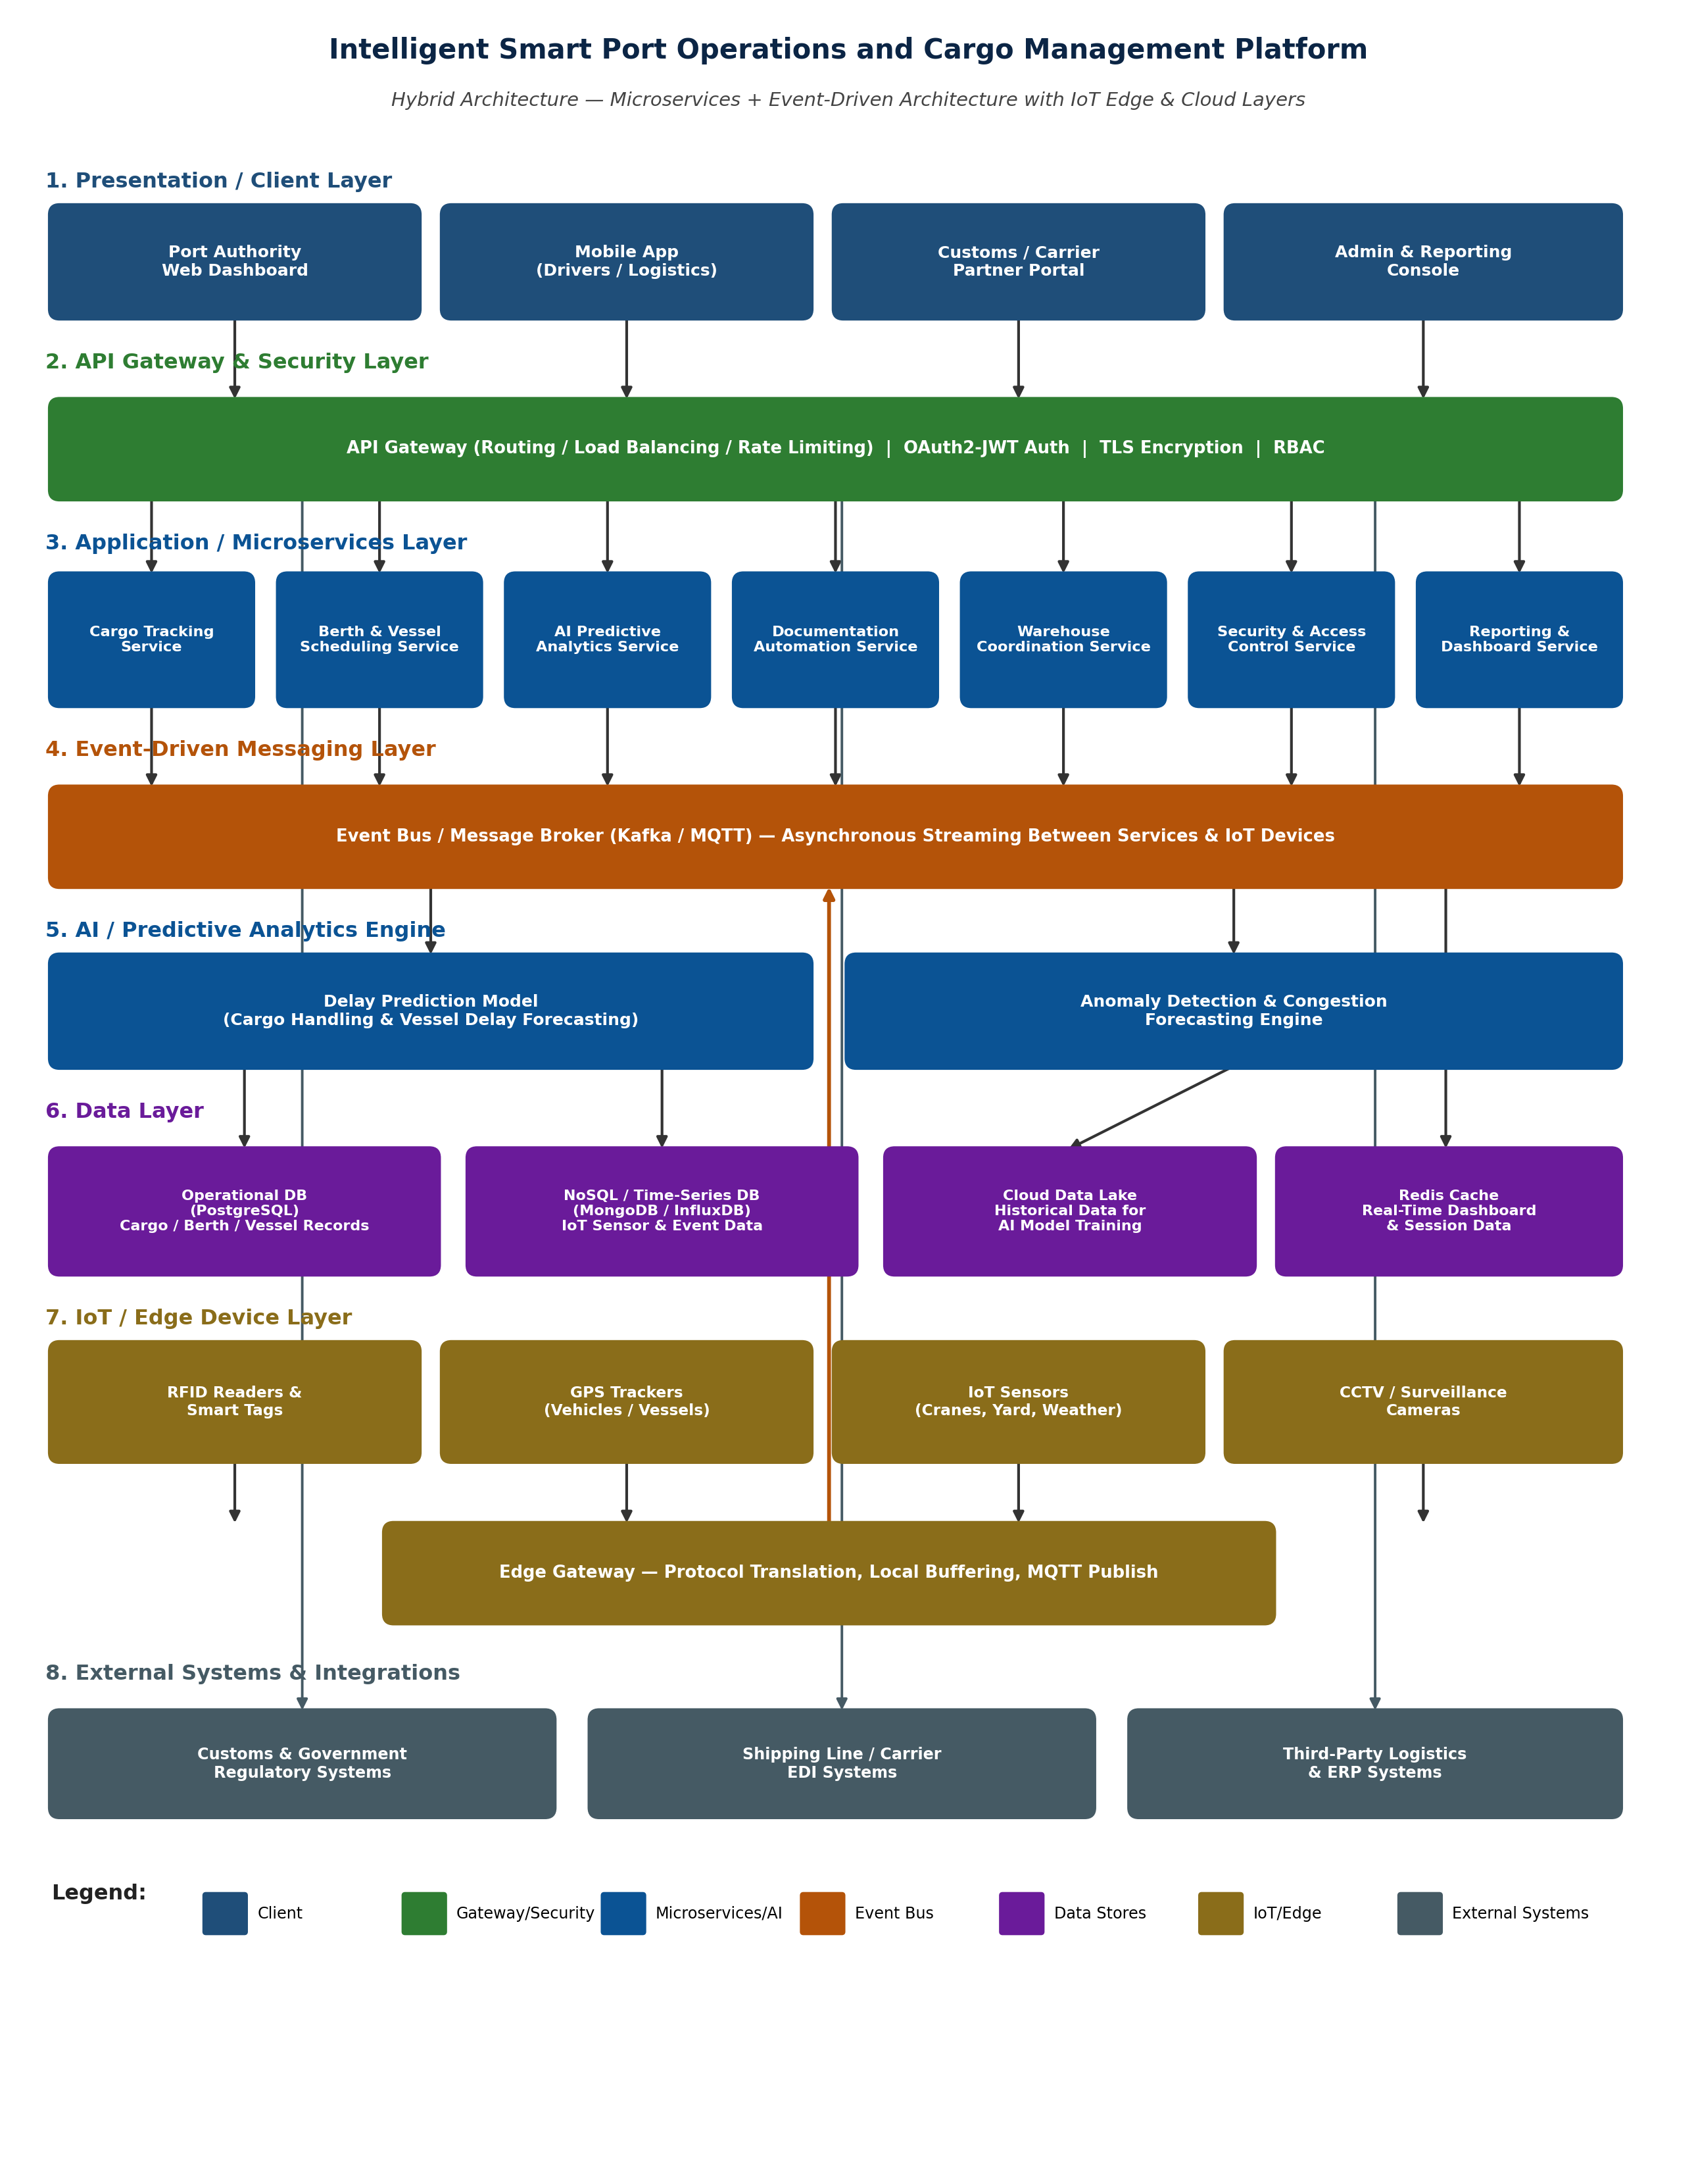
Figure 1: System Architecture of the Intelligent Smart Port Operations and Cargo Management Platform

5. Technology Stack
The following technology stack is recommended to realize the proposed Hybrid Microservices and Event-Driven Architecture. These choices are illustrative of a modern, cloud-native, containerized implementation and may be adapted to institutional or vendor preferences without affecting the underlying architectural style.
Layer / Concern | Representative Technologies
Client Applications | React.js / Angular (Web Dashboard), React Native / Flutter (Mobile App), REST/GraphQL consumption for partner portal integrations.
API Gateway | Kong / NGINX / AWS API Gateway — routing, rate limiting, authentication enforcement, TLS termination.
Microservices Runtime | Spring Boot (Java) / Node.js (Express/NestJS) / Python (FastAPI), packaged as Docker containers and orchestrated with Kubernetes.
Event Bus / Messaging | Apache Kafka for high-throughput event streaming; MQTT broker (e.g., Eclipse Mosquitto / HiveMQ) for lightweight IoT device connectivity at the edge.
AI / Machine Learning | Python with TensorFlow / PyTorch / Scikit-learn for model development; MLflow for model versioning; models served via a dedicated inference service.
Operational Database | PostgreSQL / MySQL for structured, transactional records (cargo, berth, vessel, users).
NoSQL / Time-Series Store | MongoDB for semi-structured event data; InfluxDB / TimescaleDB for high-frequency IoT sensor time-series data.
Data Lake & Analytics | Cloud object storage (e.g., Amazon S3 / Azure Data Lake) for historical data; Apache Spark for large-scale batch analytics and model training pipelines.
Caching | Redis for low-latency dashboard reads and session management.
IoT Connectivity | RFID middleware, GPS/GNSS modules, industrial IoT sensors communicating over MQTT/CoAP through the Edge Gateway.
Cloud Infrastructure | AWS / Microsoft Azure / Google Cloud Platform with Kubernetes (EKS/AKS/GKE) for container orchestration and auto-scaling.
Security | OAuth 2.0 / OpenID Connect for authentication, JWT for stateless authorization, TLS 1.2+ for encryption in transit, KMS-based encryption at rest.
Monitoring & Logging | Prometheus and Grafana for metrics and dashboards; the ELK stack (Elasticsearch, Logstash, Kibana) or equivalent for centralized log aggregation; distributed tracing via OpenTelemetry/Jaeger.
CI/CD & DevOps | Git-based version control, Jenkins/GitHub Actions for CI/CD pipelines, Helm for Kubernetes deployment management.

6. Components and Their Interactions

6.1 Component Responsibilities
Component | Purpose and Responsibilities
Client Layer (Web Dashboard, Mobile App, Partner Portal, Admin Console) | Provides role-specific user interfaces for port authorities, drivers/logistics staff, shipping/customs partners, and administrators to view and interact with the platform.
API Gateway & Security Layer | Serves as the single entry point for all client requests; performs routing, load balancing, rate limiting, OAuth2/JWT authentication, TLS encryption, and role-based access control (RBAC).
Cargo Tracking Service | Consumes RFID and GPS events from the event bus and updates real-time cargo location and status in the operational and NoSQL data stores.
Berth & Vessel Scheduling Service | Manages berth allocation and vessel arrival/departure schedules, applying optimization logic to minimize vessel turnaround time.
AI Predictive Analytics Service | Hosts and invokes the delay-prediction and anomaly-detection models, consuming both real-time events and historical data to forecast cargo handling and vessel delays.
Documentation Automation Service | Automates processing of customs forms, bills of lading, and manifests using OCR and digital workflows, reducing manual paperwork.
Warehouse Coordination Service | Manages storage yard allocation, inventory tracking, and dispatch scheduling within port warehouses.
Security & Access Control Service | Manages user roles and permissions and maintains audit logs of security-relevant actions across the platform.
Reporting & Dashboard Service | Aggregates operational and analytical data to power real-time dashboards and generate periodic performance reports.
Event Bus / Message Broker (Kafka/MQTT) | Provides asynchronous, durable, publish-subscribe messaging that decouples IoT devices and microservices, enabling real-time, resilient data flow.
AI/ML Engine (Delay Prediction, Anomaly Detection) | Executes trained machine-learning models for forecasting cargo/vessel delays and detecting congestion or unusual operational patterns.
Data Layer (Operational DB, NoSQL/Time-Series DB, Data Lake, Redis Cache) | Persists structured operational records, high-velocity sensor/event data, historical data for AI training, and cached data for fast dashboard access.
IoT / Edge Layer (RFID, GPS, Sensors, CCTV, Edge Gateway) | Captures real-world cargo, vessel, and yard data at the source and forwards it to the event bus through an edge gateway that performs protocol translation and local buffering.
External Systems (Customs, Shipping-Line EDI, ERP/3PL) | Exchange documentation and logistics data with the platform through the API Gateway, enabling synchronized end-to-end supply-chain operations.

6.2 Overall System Workflow
The following steps describe the end-to-end operational workflow and communication mechanisms of the platform:
- IoT devices — RFID readers, GPS trackers, environmental sensors, and CCTV cameras — continuously capture data on cargo location, vehicle/vessel position, and yard conditions.
- The Edge Gateway aggregates and buffers this data locally, performs protocol translation, and publishes it as events to the Kafka/MQTT event bus.
- Subscribing microservices — primarily the Cargo Tracking Service and Berth & Vessel Scheduling Service — consume relevant event topics and update the operational database and NoSQL/time-series store in near real time.
- The AI Predictive Analytics Service consumes both live events and historical data from the data lake to generate delay predictions and detect anomalies, publishing insights back onto the event bus for other services to consume.
- The Documentation Automation Service digitizes and validates customs and cargo documents, updating records and notifying the Security & Access Control Service for audit logging.
- The Reporting & Dashboard Service aggregates data from the operational database, Redis cache, and AI insights to power real-time dashboards, delivered through the API Gateway to the Web Dashboard, Mobile App, and Partner Portal.
- External systems — customs authorities, shipping lines, and ERP/3PL platforms — exchange data with the platform via API-Gateway-mediated integrations, keeping documentation and logistics planning synchronized.
- Every request, whether from an internal client or an external system, passes through the API Gateway, which enforces authentication, authorization, and routing before reaching the internal microservices, ensuring secure and controlled access throughout the workflow.

7. Data Flow and Communication Mechanisms
The platform uses a deliberate mix of synchronous and asynchronous communication, chosen according to the latency and consistency needs of each interaction. Time-critical, user-facing requests use synchronous REST/HTTPS calls through the API Gateway, while high-volume IoT telemetry and inter-service notifications use asynchronous, event-driven messaging through Kafka/MQTT. This mixed approach allows the platform to remain responsive for interactive use cases while efficiently absorbing high-velocity sensor data without overwhelming any single service.
Interaction | Mode | Protocol / Mechanism | Description
Client ↔ API Gateway | Synchronous | HTTPS / REST (JSON) | Dashboard, mobile app, and partner portal requests for cargo status, schedules, and reports.
API Gateway ↔ Microservices | Synchronous | REST / gRPC over internal network | Authenticated, routed requests forwarded to the appropriate microservice; gRPC used for latency-sensitive internal calls.
IoT Devices → Edge Gateway | Near real-time, buffered | MQTT / CoAP | RFID, GPS, and sensor readings published from the field to the local edge gateway.
Edge Gateway → Event Bus | Asynchronous, streaming | MQTT bridge to Kafka topics | Buffered device data forwarded as structured events to the central event bus.
Microservices ↔ Event Bus | Asynchronous, publish-subscribe | Kafka topics | Services publish state changes (e.g., cargo scanned, berth allocated) and subscribe to topics relevant to their function, enabling loose coupling.
Microservices ↔ Data Layer | Synchronous (transactional) / Asynchronous (analytics) | SQL (JDBC/ORM), NoSQL drivers | Read/write of operational records (SQL) and high-volume sensor/event data (NoSQL/time-series).
AI Predictive Analytics Service ↔ Data Lake | Batch / scheduled | Object storage APIs, Spark jobs | Historical data extraction for model training and periodic retraining pipelines.
Platform ↔ External Systems | Synchronous / batch | REST APIs, EDI (e.g., EDIFACT), webhooks | Exchange of customs declarations, shipping manifests, and ERP data with external partners.

8. Deployment Architecture
The platform is designed for deployment on a cloud-native, containerized infrastructure to satisfy its scalability and availability requirements.
- Each microservice is packaged as an independent Docker container and deployed on a Kubernetes cluster, allowing independent scaling, rolling updates, and automated failover through replica sets and health checks.
- The cluster is deployed across multiple availability zones within the cloud provider's region to protect against zone-level outages, with the API Gateway load-balancing traffic across healthy instances.
- The Kafka/MQTT messaging layer runs as a managed or self-hosted, replicated cluster to guarantee message durability even if individual broker nodes fail.
- The Edge Gateway is deployed on-premises at the port (or on nearby edge computing nodes) to minimize latency between IoT devices and the ingestion layer, while the core microservices, data layer, and AI engine run in the cloud.
- The operational database uses a primary-replica configuration with automated backups, while the data lake and NoSQL stores are configured with built-in replication for fault tolerance.
- A CI/CD pipeline automates build, test, and deployment of each microservice independently, supported by centralized monitoring (Prometheus/Grafana) and logging (ELK stack) for operational visibility across the distributed deployment.
This deployment model directly supports the availability, scalability, and reliability requirements identified in Section 2, while allowing the platform to grow incrementally as port operations expand.

9. Discussion of Quality Attributes
This section evaluates how the proposed Hybrid Microservices + Event-Driven Architecture addresses the key quality attributes identified for the platform.
Scalability
Each microservice can be scaled horizontally and independently based on demand — for example, scaling the Cargo Tracking Service during peak vessel arrivals. The Kafka/MQTT event bus supports partitioned, high-throughput topics that allow additional consumer instances to be added as IoT data volume grows. Cloud-native, container-orchestrated deployment (e.g., Kubernetes) further enables automatic scaling based on real-time load.
Security
The API Gateway enforces OAuth2/JWT authentication, TLS encryption in transit, and role-based access control (RBAC) for every request. The dedicated Security & Access Control Service manages permissions and maintains audit logs. Sensitive customs and cargo data is encrypted at rest, and the IoT edge network is segmented from core services to reduce the attack surface.
Performance
Redis caching serves frequently accessed dashboard data with low latency. Asynchronous, event-driven processing avoids blocking operations, while the Edge Gateway buffers IoT data to reduce network round-trips. Horizontally scaled service instances maintain low response times even under concurrent load from multiple dashboards and partner integrations.
Reliability
The event bus persists messages in a durable, replicated log, preventing data loss during service outages or network fluctuations. Retry mechanisms and dead-letter queues handle failed message processing, while redundant service instances avoid single points of failure in the data-capture pipeline.
Maintainability
The modular microservices design allows each component — such as the AI Predictive Analytics Service or Documentation Automation Service — to be developed, tested, versioned, and deployed independently. Well-defined API contracts and containerization (Docker) simplify updates without impacting unrelated services.
Availability
Containerized services are orchestrated with health checks and automatic restarts, and multi-zone cloud deployment with load balancing at the API Gateway minimizes downtime. The event bus's buffering capability allows the system to tolerate temporary consumer downtime without losing captured operational data, supporting the 24 x 7 nature of port operations.

10. Risk Analysis and Mitigation
The following risks were identified as most relevant to the proposed architecture, along with their likelihood, potential impact, and corresponding mitigation strategies built into the design.
Risk | Likelihood | Impact | Mitigation Strategy
IoT device or sensor failure causing data gaps | Medium | High | Edge Gateway buffering with local storage during connectivity loss; automated device health monitoring and alerting; redundant sensors on critical assets.
Event bus (Kafka/MQTT) outage disrupting real-time updates | Low | High | Multi-broker clustering with replication; consumer retry logic; graceful degradation to cached/last-known-good data on dashboards.
Unauthorized access to sensitive cargo or customs data | Medium | High | OAuth2/JWT authentication, RBAC, TLS encryption, network segmentation, and continuous audit logging via the Security & Access Control Service.
Inaccurate AI delay predictions due to model drift | Medium | Medium | Scheduled model retraining on fresh data, monitoring of prediction accuracy, and human-in-the-loop review for high-impact scheduling decisions.
Service cascading failure under peak load | Low | Medium | Circuit breakers between services, rate limiting at the API Gateway, and horizontal auto-scaling based on real-time metrics.
Vendor/cloud lock-in limiting future flexibility | Low | Medium | Containerized, cloud-agnostic deployment (Kubernetes) and use of open standards (Kafka, MQTT, REST) to preserve portability.
Integration failure with external customs/ERP systems | Medium | Medium | Well-defined API contracts, sandbox testing with partners, and fallback manual-entry workflows for critical documentation.

11. Justification of Architectural Decisions and Trade-offs

11.1 Rationale Recap
The Hybrid Microservices + Event-Driven Architecture was chosen because the platform must simultaneously satisfy several demanding requirements: continuous ingestion of high-volume IoT data, independent scalability of functionally distinct modules, resilience to partial failures, and the ability to evolve individual components (particularly AI models) without disrupting core operations. No single classical style (layered, client-server, MVC, or pure SOA) addresses all of these needs as effectively as this hybrid combination.

11.2 Trade-offs Considered
- Operational complexity vs. scalability: Microservices introduce additional operational overhead — service discovery, distributed tracing, and inter-service communication — compared to a monolith. This is accepted because independent scalability and fault isolation are essential for a 24 x 7, mission-critical port environment where a failure in one module must not bring down the entire system.
- Eventual consistency vs. strong consistency: Event-driven processing improves decoupling and throughput but introduces eventual consistency for some data. Core transactional operations, such as berth allocation, continue to rely on the operational relational database's ACID guarantees, while less time-critical data such as sensor streams and analytics tolerate eventual consistency.
- Upfront investment vs. long-term cost: The hybrid model requires greater initial investment in DevOps tooling, monitoring, and container orchestration. This investment is justified by lower long-term maintenance costs and the ability to evolve the platform incrementally as new port technologies emerge.
- Latency vs. reliability at the edge: Buffering data at the Edge Gateway adds a small amount of latency compared to direct device-to-cloud transmission, but it prevents data loss during network interruptions, which is judged more important for operational accuracy than shaving a few milliseconds off ingestion time.
- Flexibility vs. governance: Independent, autonomous microservice teams increase development speed but require strong API governance and contract testing to prevent integration drift; this is addressed through well-documented API contracts and versioning policies.

11.3 Support for Future Enhancements and Long-Term Maintainability
- Integration of 5G-enabled autonomous vehicles and drones for automated yard inspection can be added as new IoT producers on the existing event bus without redesigning the core system.
- A digital twin of the port could be layered on top of the AI Predictive Analytics Service for simulation-based planning.
- Blockchain-based documentation could be introduced within the Documentation Automation Service for tamper-proof customs and trade records.
- AI models can be extended toward multi-port and supply-chain-wide predictive analytics by scaling the AI/ML Engine independently.
- Selected bursty workloads, such as document OCR, can be migrated to serverless functions in future iterations to optimize operating cost without affecting the rest of the architecture.
- New external partners (additional shipping lines, customs jurisdictions) can be onboarded by adding new adapters behind the API Gateway without modifying existing services.
Because each concern is isolated within its own service and communicates through well-defined events and APIs, the architecture supports long-term maintainability, incremental system integration, and sustained growth in port operations.

12. Expected Outcomes
- Reduced cargo handling time.
- Improved logistics efficiency.
- Better vessel scheduling.
- Enhanced cargo visibility.
- Lower operational costs.
- Improved port productivity.
- Increased supply chain reliability.
- Better customer service.
Collectively, these outcomes translate the architectural decisions described in this report into measurable operational value: independently scalable microservices reduce cargo handling and vessel turnaround time; the event-driven IoT backbone enhances cargo visibility in real time; AI-based prediction lowers unplanned delays and operational costs; and secure, automated documentation improves compliance and customer-facing service quality.

13. Conclusion
The Intelligent Smart Port Operations and Cargo Management Platform addresses the operational inefficiencies faced by modern seaports — cargo congestion, manual documentation, delayed scheduling, and limited cargo visibility — through a Hybrid Microservices and Event-Driven Architecture. By combining independently scalable microservices with an asynchronous, real-time event backbone for IoT data, the proposed architecture satisfies the system's functional requirements while strongly addressing the key quality attributes of scalability, security, performance, reliability, maintainability, and availability.
The architecture is further strengthened by a clearly defined technology stack, a mixed synchronous/asynchronous communication model tailored to each interaction's latency and consistency needs, a cloud-native containerized deployment strategy across multiple availability zones, and a proactive risk-mitigation plan covering IoT, security, AI-model, and integration risks. Together, these elements demonstrate that the design is not only conceptually sound but also practically deployable and operable at scale.
The design is modular and loosely coupled, allowing the platform to integrate new technologies — such as 5G-enabled autonomous vehicles, digital twins, and blockchain-based documentation — and additional external systems over time, making it well suited for sustained, long-term deployment in a 24 x 7 port environment while remaining maintainable and cost-effective as it scales.

14. References
1. Bass, L., Clements, P., & Kazman, R., Software Architecture in Practice, Addison-Wesley.
2. Newman, S., Building Microservices: Designing Fine-Grained Systems, O'Reilly Media.
3. Richardson, C., Microservices Patterns, Manning Publications.
4. Fowler, M., Patterns of Enterprise Application Architecture, Addison-Wesley.
5. Kreps, J., Narkhede, N., & Rao, J., Kafka: A Distributed Messaging System for Log Processing, Apache Kafka Documentation.
6. Hohpe, G., & Woolf, B., Enterprise Integration Patterns, Addison-Wesley.
7. Course material and problem statement provided under CSA10 – Software Engineering, CO2 Assessment Tool 2, SIMATS Engineering (Saveetha School of Engineering).

