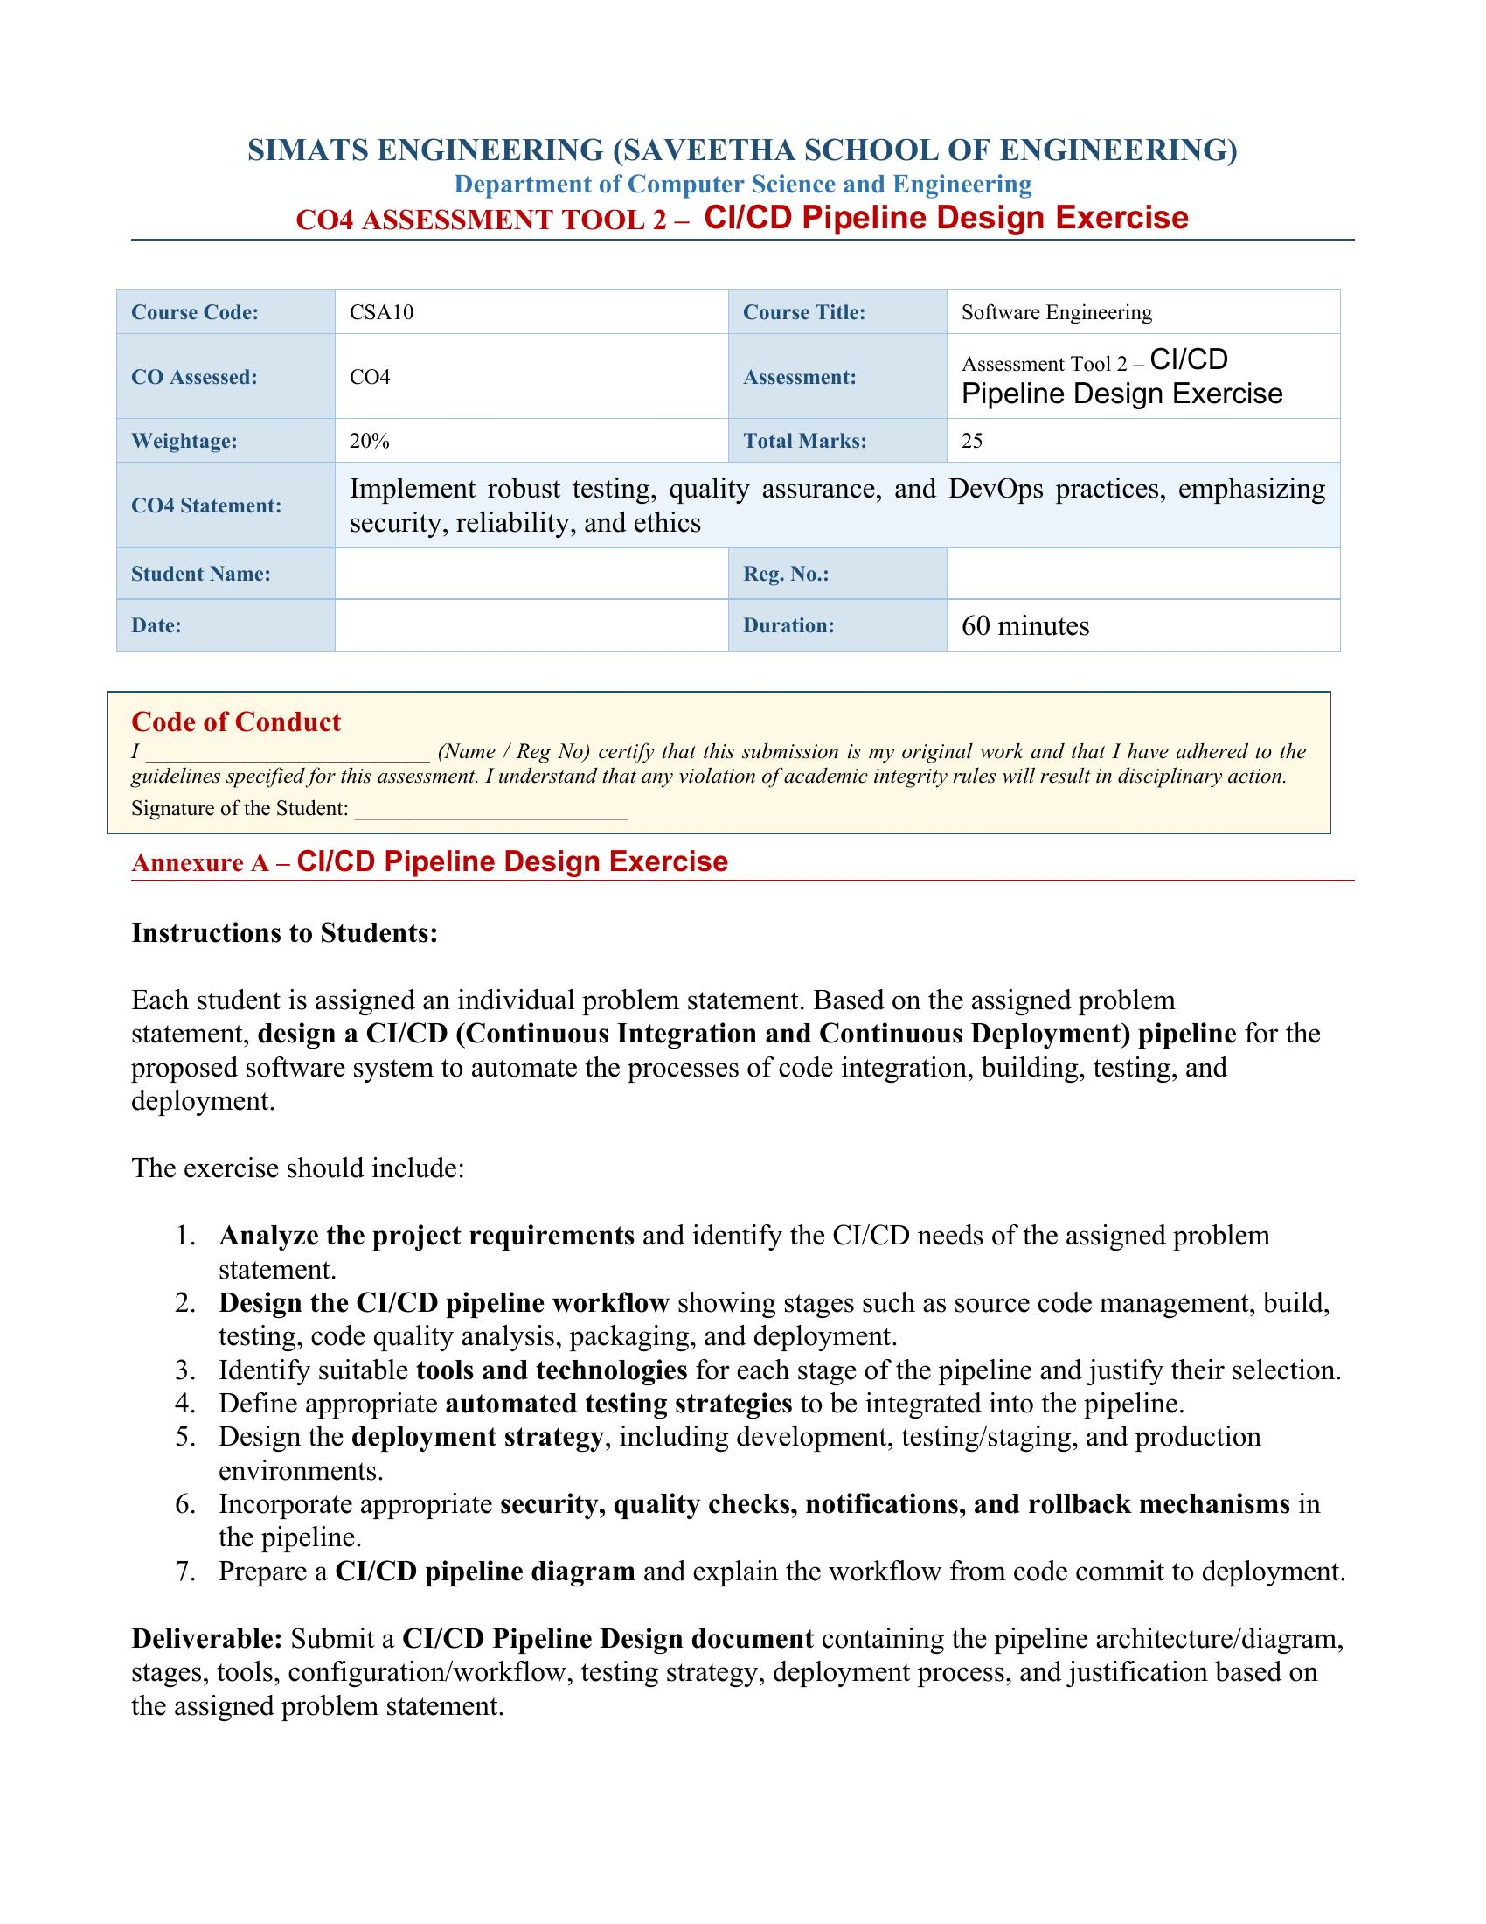

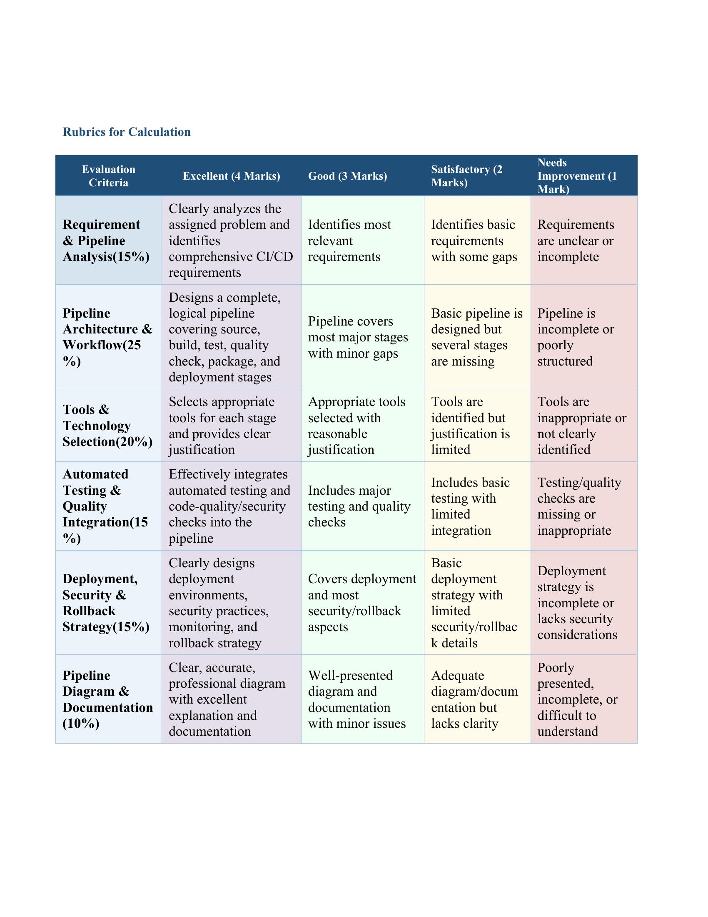

SIMATS ENGINEERING (SAVEETHA SCHOOL OF ENGINEERING)
Department of Computer Science and Engineering
CO4 Assessment Tool 2 – CI/CD Pipeline Design Exercise
CI/CD PIPELINE DESIGN REPORT
Problem Statement 38: Intelligent Smart Port Operations and Cargo Management Platform
Course Code | CSA1013 | Course Title | Software Engineering
CO Assessed | CO4 | Assessment | Assessment Tool 2 – CI/CD Pipeline Design
Student Name | Spandana | Registration Number | 192525160
Faculty In-Charge | Latha | Weightage / Marks | 20% / 25

1. Problem Statement Summary
1.1 Industry Context
Modern seaports manage high volumes of cargo and vessel traffic, requiring efficient logistics coordination and real-time operational monitoring. AI, IoT, RFID, GPS, and cloud technologies enable intelligent cargo tracking, automated scheduling, and predictive analytics, improving port productivity and reducing operational delays.
1.2 Problem Statement
Port authorities often experience operational inefficiencies due to cargo congestion, manual documentation, delayed vessel scheduling, and limited visibility of cargo movement. These challenges increase turnaround time and logistics costs. The Intelligent Smart Port Operations and Cargo Management Platform is required to monitor cargo movement using IoT devices, optimize berth allocation, predict cargo handling delays using AI, automate documentation processes, and provide real-time operational dashboards, while enhancing logistics efficiency and supporting secure, transparent port operations.
1.3 Objectives
- Monitor cargo movement in real time.
- Optimize berth and vessel scheduling.
- Predict cargo handling delays using AI.
- Automate logistics documentation.
- Improve warehouse coordination.
- Generate operational performance reports.
- Enhance cargo security.
- Increase port operational efficiency.

2. Requirement & Pipeline Analysis
Based on the functional requirements (real-time cargo tracking, berth/vessel scheduling, AI-based delay prediction, automated documentation, warehouse coordination, reporting, and security) and non-functional requirements (performance, scalability, reliability, security, availability, auditability) of the Intelligent Smart Port Operations and Cargo Management Platform, the following CI/CD needs were identified:
CI/CD Need | Justification
Frequent, independent module updates | The platform spans cargo tracking, berth allocation, AI prediction, documentation, warehouse, and security modules that are best built as independently deployable microservices, requiring CI/CD to integrate and release changes safely and frequently.
Continuous IoT/AI model integration | IoT sensor firmware updates and periodically retrained AI delay-prediction models must be integrated, tested, and rolled out without disrupting live port operations.
High reliability & near-zero downtime | Port operations run 24/7 (NFR7); the pipeline must support zero/near-zero-downtime deployment strategies (blue-green/canary) and automated rollback on failure.
Strong security & compliance needs | The system handles sensitive cargo, customs, and vessel data (NFR4), so the pipeline must enforce automated security scanning, secrets management, and access control at every stage.
Rapid, safe bug fixes & feature delivery | Operational inefficiencies (congestion, scheduling delays) must be addressed quickly; CI/CD shortens the feedback loop from code commit to production fix.
Consistent multi-environment testing | Berth allocation and AI prediction logic must be validated in staging environments that mirror production before reaching live port operations, minimizing risk to real cargo/vessel scheduling.
Traceable, auditable releases | NFR8 (auditability) requires every deployment and configuration change to be logged, versioned, and traceable back to a specific commit and approver.

3. Pipeline Architecture & Workflow
The CI/CD pipeline for the Intelligent Smart Port Operations and Cargo Management Platform follows a five-phase workflow: Source & Commit, Continuous Integration, Packaging, Continuous Deployment, and Monitoring & Feedback, as illustrated below.
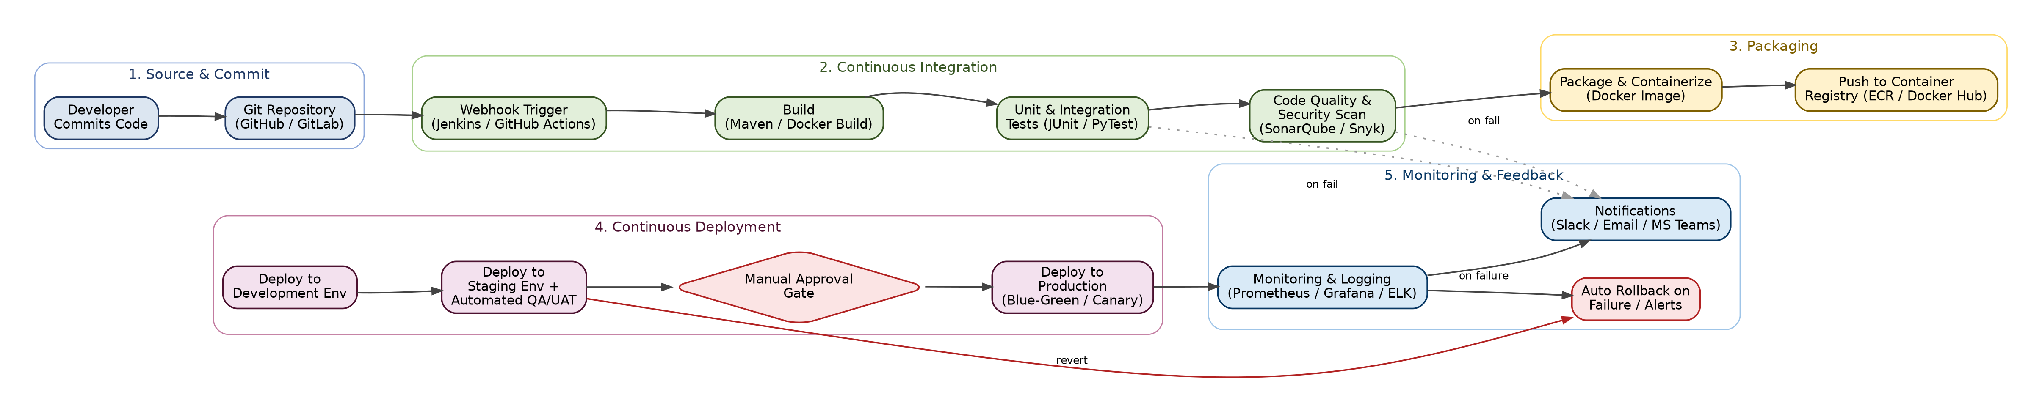
3.1 Pipeline Stages
1. Source Code Management: Developers commit code to feature branches; pull requests are reviewed and merged into the main/develop branch, triggering the pipeline via a webhook.
2. Build: The application (microservices for tracking, berth allocation, AI prediction, documentation, etc.) is compiled and built into deployable artifacts/Docker images.
3. Automated Testing: Unit tests and integration tests run automatically against the build to verify individual module correctness and inter-module communication (e.g., IoT data ingestion to dashboard).
4. Code Quality & Security Analysis: Static code analysis, code-coverage checks, and security/vulnerability scanning are performed to catch defects, code smells, and security issues (e.g., insecure API endpoints, dependency vulnerabilities) before packaging.
5. Packaging: Validated builds are containerized (Docker images) and versioned/tagged, then pushed to a container registry.
6. Deployment - Development: The packaged artifact is automatically deployed to a development environment for early smoke testing.
7. Deployment - Staging/UAT: The build is deployed to a staging environment that mirrors production, where automated regression, performance, and user-acceptance tests run; a manual approval gate follows successful staging validation.
8. Deployment - Production: On approval, the release is deployed to production using a blue-green or canary strategy to minimize risk and downtime to live port operations.
9. Monitoring & Feedback: Post-deployment, the system is continuously monitored (logs, metrics, alerts); notifications are sent to the DevOps team, and automatic rollback is triggered on failure.

4. Tools and Technology Selection
Pipeline Stage | Tool(s) Selected | Justification
Source Code Management | Git + GitHub / GitLab | Industry-standard distributed version control with built-in webhook support, pull-request review workflow, and branch protection for safe collaboration across microservice teams.
CI Orchestration | Jenkins / GitHub Actions | Widely adopted, highly extensible automation servers that trigger and orchestrate the build-test-deploy pipeline on every commit/PR, with rich plugin ecosystems for IoT and cloud integrations.
Build Tool | Maven / Docker Build | Maven manages Java-based service builds and dependencies; Docker builds produce consistent, portable container images across dev, staging, and production.
Unit / Integration Testing | JUnit / PyTest + Postman/Newman | JUnit and PyTest automate unit tests for backend services (Java/Python); Postman/Newman automates API/integration tests for cargo-tracking and berth-allocation endpoints.
Code Quality Analysis | SonarQube | Provides automated static code analysis, code-coverage tracking, and maintainability/reliability ratings, enforcing a quality gate before code proceeds further.
Security Scanning | Snyk / OWASP ZAP / Trivy | Snyk/Trivy scan dependencies and container images for known vulnerabilities; OWASP ZAP performs dynamic security testing on exposed APIs handling cargo/customs data (NFR4).
Containerization & Registry | Docker + Amazon ECR / Docker Hub | Ensures consistent runtime environments across all stages and provides versioned, centrally accessible image storage for deployments.
Deployment / Orchestration | Kubernetes + Helm | Automates scalable, self-healing deployment of microservices across environments and supports blue-green/canary rollout strategies needed for near-zero-downtime (NFR7).
Infrastructure as Code | Terraform | Provisions and version-controls cloud infrastructure (compute, networking, IoT gateways) consistently across dev, staging, and production.
Monitoring & Logging | Prometheus + Grafana + ELK Stack | Provides real-time performance dashboards (aligned with FR9), metrics-based alerting, and centralized log analysis for troubleshooting and audit trails (NFR8).
Notifications | Slack / MS Teams / Email (via webhook) | Sends real-time build, test, and deployment status alerts to the DevOps and port-operations teams for fast issue response.
Secrets Management | HashiCorp Vault / AWS Secrets Manager | Secures API keys, database credentials, and IoT device certificates used across pipeline stages, supporting the platform's security requirements (NFR4).

5. Automated Testing and Quality Integration
A multi-layered automated testing strategy is embedded directly into the pipeline so that defects are caught as early as possible, minimizing the risk of faulty berth-allocation, scheduling, or AI-prediction logic reaching production.
Test Type | Tool(s) | Trigger Point | Purpose
Unit Testing | JUnit / PyTest | Every CI build | Validates individual functions/modules (e.g., berth-allocation logic, delay-prediction calculation) in isolation before integration.
Integration / API Testing | Postman / Newman, REST-assured | Every CI build | Verifies communication between microservices, e.g., IoT tracking service -> dashboard API -> notification service.
Static Code Analysis | SonarQube (quality gate) | Every CI build | Enforces coding standards, detects code smells/duplication, and blocks merges below the defined maintainability threshold.
Security / Dependency Scanning | Snyk, Trivy, OWASP ZAP | Every CI build + nightly | Scans dependencies, container images, and exposed APIs (cargo/customs data endpoints) for known vulnerabilities.
Regression Testing | Selenium / Cypress (automated UI suite) | Staging deployment | Confirms existing dashboard/reporting features still work correctly after new changes.
Performance / Load Testing | Apache JMeter / k6 | Staging deployment | Validates NFR1 (5-second dashboard refresh) and NFR2 (5,000 concurrent cargo units) under simulated peak load.
User Acceptance Testing (UAT) | Manual + automated staging suite | Staging deployment | Port-operations stakeholders validate berth allocation and scheduling workflows before production release.
Smoke Testing | Automated post-deploy health checks | Every environment, post-deploy | Quick automated checks confirm core services (tracking, dashboard, documentation) are healthy immediately after deployment.

A quality gate is enforced after the code-quality and security-scan stage: if code coverage falls below 80%, critical vulnerabilities are detected, or the SonarQube quality gate fails, the pipeline automatically halts and notifies the responsible developer, preventing the build from proceeding to packaging.

6. Deployment, Security and Rollback Strategy
6.1 Deployment Environments
Environment | Deployment Trigger | Validation Performed | Characteristics
Development | Continuous, on every merge to develop branch | Automated unit/integration tests, smoke tests | Sandbox cloud namespace; synthetic/mock IoT data; no access to live vessel/customs systems.
Staging / UAT | On successful CI build + manual trigger | Regression, performance, security, UAT | Mirrors production architecture; anonymized/sanitized cargo data; restricted access to QA and port-operations reviewers.
Production | Manual approval gate after staging sign-off | Automated smoke tests + post-deploy monitoring | Live port environment; blue-green or canary rollout; full RBAC, encrypted data (NFR4), and 24/7 monitoring (NFR7).

6.2 Deployment Strategy
- Blue-Green Deployment for core services (dashboard, berth allocation): a new ("green") version is deployed alongside the live ("blue") version; traffic is switched only after health checks pass, enabling instant rollback by re-pointing traffic to "blue".
- Canary Releases for the AI delay-prediction service: new model versions are rolled out to a small percentage of traffic first, with prediction-accuracy metrics monitored before a full rollout.
- Zero-downtime rolling updates for stateless microservices via Kubernetes, ensuring continuous cargo-tracking availability (NFR7) during deployments.

6.3 Security Practices
- Secrets (API keys, database credentials, IoT certificates) are stored in HashiCorp Vault / AWS Secrets Manager, never hard-coded in the pipeline or repository.
- Role-Based Access Control (RBAC) restricts who can approve production deployments and access sensitive cargo/customs data.
- All data in transit and at rest is encrypted using TLS 1.2+/AES-256, satisfying NFR4.
- Container images are scanned for vulnerabilities (Trivy/Snyk) before being pushed to the registry, and only signed, verified images are permitted to deploy to production.
- All pipeline actions (builds, approvals, deployments) are logged with timestamp and user ID to support auditability (NFR8).

6.4 Rollback Strategy
- Automated health checks and monitoring (Prometheus/Grafana) continuously assess post-deployment service status.
- If error rates, latency, or failed health checks exceed defined thresholds, the pipeline automatically triggers a rollback to the last known-good version (blue environment / previous canary baseline).
- All rollbacks and failures immediately trigger notifications (Slack/MS Teams/Email) to the DevOps and port-operations teams for rapid incident response.
- Database migrations are designed to be backward-compatible so that a service rollback does not break data integrity.

7. Workflow: From Code Commit to Deployment
The following step-by-step walkthrough explains how a code change flows through the CI/CD pipeline shown in Section 3, from initial commit to a monitored production release:
- A developer commits code (e.g., an update to the berth-allocation algorithm) and opens a pull request against the develop branch.
- On merge, a webhook automatically triggers the CI pipeline in Jenkins/GitHub Actions.
- The pipeline builds the affected microservice(s) and produces a build artifact/Docker image.
- Unit and integration tests execute automatically; if any test fails, the pipeline stops and the developer is notified immediately.
- SonarQube performs static code analysis and Snyk/Trivy scan for vulnerabilities; the build must pass the defined quality gate to proceed.
- The validated build is containerized, tagged with a version number, and pushed to the container registry.
- The image is automatically deployed to the Development environment and smoke-tested.
- On success, the image is deployed to the Staging environment, where regression, performance, and UAT are run against production-like conditions.
- A manual approval gate requires sign-off from the release manager/port-operations lead before production deployment.
- Upon approval, the pipeline deploys to Production using a blue-green or canary strategy, minimizing risk to live port operations.
- Post-deployment, monitoring tools track system health in real time; any anomaly triggers an automatic rollback and an alert notification to the DevOps team.

8. Conclusion
This document presents a complete CI/CD pipeline design for the Intelligent Smart Port Operations and Cargo Management Platform, covering requirement analysis, a five-phase pipeline architecture (Source & Commit, Continuous Integration, Packaging, Continuous Deployment, and Monitoring & Feedback), justified tool selection, a multi-layered automated testing and quality-gate strategy, and a deployment approach spanning development, staging, and production environments with blue-green/canary rollout, strong security controls, and automated rollback. Together, these elements ensure the platform can deliver frequent, reliable, and secure updates to cargo tracking, berth allocation, and AI-based delay-prediction services with minimal disruption to live port operations.

