Overview:
This folder contains experimental data and MATLAB scripts used for generating results. In this work we evaluated a rectangular massive MIMO array in outdoor with 48 antenna ports at the base station (BS) and 24 user equipments (UEs). The dataset includes channel measurements and downlink received constellation results for different UE arrangement (some UEs inside and some UEs outside the building). The data is intended for channel analysis, spatial multiplexing evaluation, and modulation performance assessment.
By running main.m file, all the results published in the paper will be generated automatically.

Folder structure:
Rectangular_Outdoor_alternate_UE_arrangement/
│
├── main.m
│
├── channel_data/
│ ├── Expt_1/
│ ├── Expt_2/
│ └── Expt_3/
│
└── dl_received_constellation/
├── Expt_1/
├── Expt_2/
└── Expt_3/

Description of Contents:
1. main.m
- Main MATLAB script for loading and processing channel and constellation data.
- Entry point for analysis.
2. channel_data/
Contains raw channel measurement data.
Subfolders:
- Expt_1/ – CSI matrices recorded while correlation threshold is set to 0.3 and modulation scheme for all UEs is QPSK with user pairing
- Expt_2/ – CSI matrices recorded while correlation threshold is set to 0.3 and modulation scheme for all UEs is QPSK with user pairing and fair scheduling
- Expt_3/ – CSI matrices recorded while correlation threshold is set to 0.3 and modulation scheme for all UEs is QPSK with user pairing, fair scheduling, and low power UEs discarded.
Files in each subfolder:
ch0.bkp, ch1.bkp, ..., ch47.bkp
- Binary channel files for 48 subframes.
- Each .bkp file corresponds to 24x48 CSI matrix for a subframe and also it has paired UE list and number of paired UEs in the same subframe. For example, ‘ch0.bkp’ is a 24x48 CSI matrix for subframe 1.
- Only 2 Physical Resource Block (PRB)s are used per subframe.
- Used for channel analysis such as eigen analysis and sum spectral efficiency.
3. dl_received_constellation/
Contains downlink received symbol data recorded from testbed along with paired UE list, modulation index, and REVM for multiple subframes.
Subfolders:
- Expt_1/ – QPSK (Threshold 0.3) with user pairing
- Expt_2/ – QPSK (Threshold 0.3) with user pairing and fair scheduling
- Expt_3/ – QPSK (Threshold 0.3) with user pairing, fair scheduling, and low power UEs discarded.
Each experiment folder contains:
dat_SFn.bkp – Received data for all paired UEs along with above parameters for subframe n

Appendix:
Reading the Real-time Recorded Data in MATLAB
This file presents a detailed explanation of how the real-time recorded experimental data can be read in MATLAB. In addition, it addresses the key issue of endian mismatch encountered during data reading and outlines the proposed solution to resolve it.
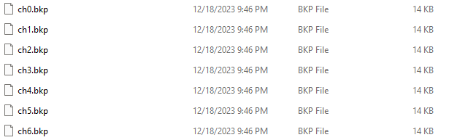
Figure 1: Recorded data format
After conducting the experiments, the recorded measurements were stored as binary files with the extension “.bkp”, as illustrated in Fig. 1. Each “.bkp” file contains raw baseband samples in a compact format suitable for high-throughput recording. This storage format ensures efficient handling of large datasets generated during real-time massive MIMO experiments, while also providing compatibility for subsequent processing in MATLAB.
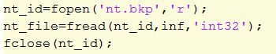
Figure 2: MATLAB code snippet for reading the data
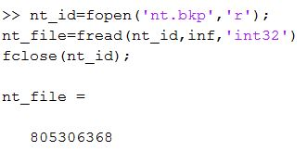
Figure 3: Output of MATLAB code snippet mentioned in Fig. 2
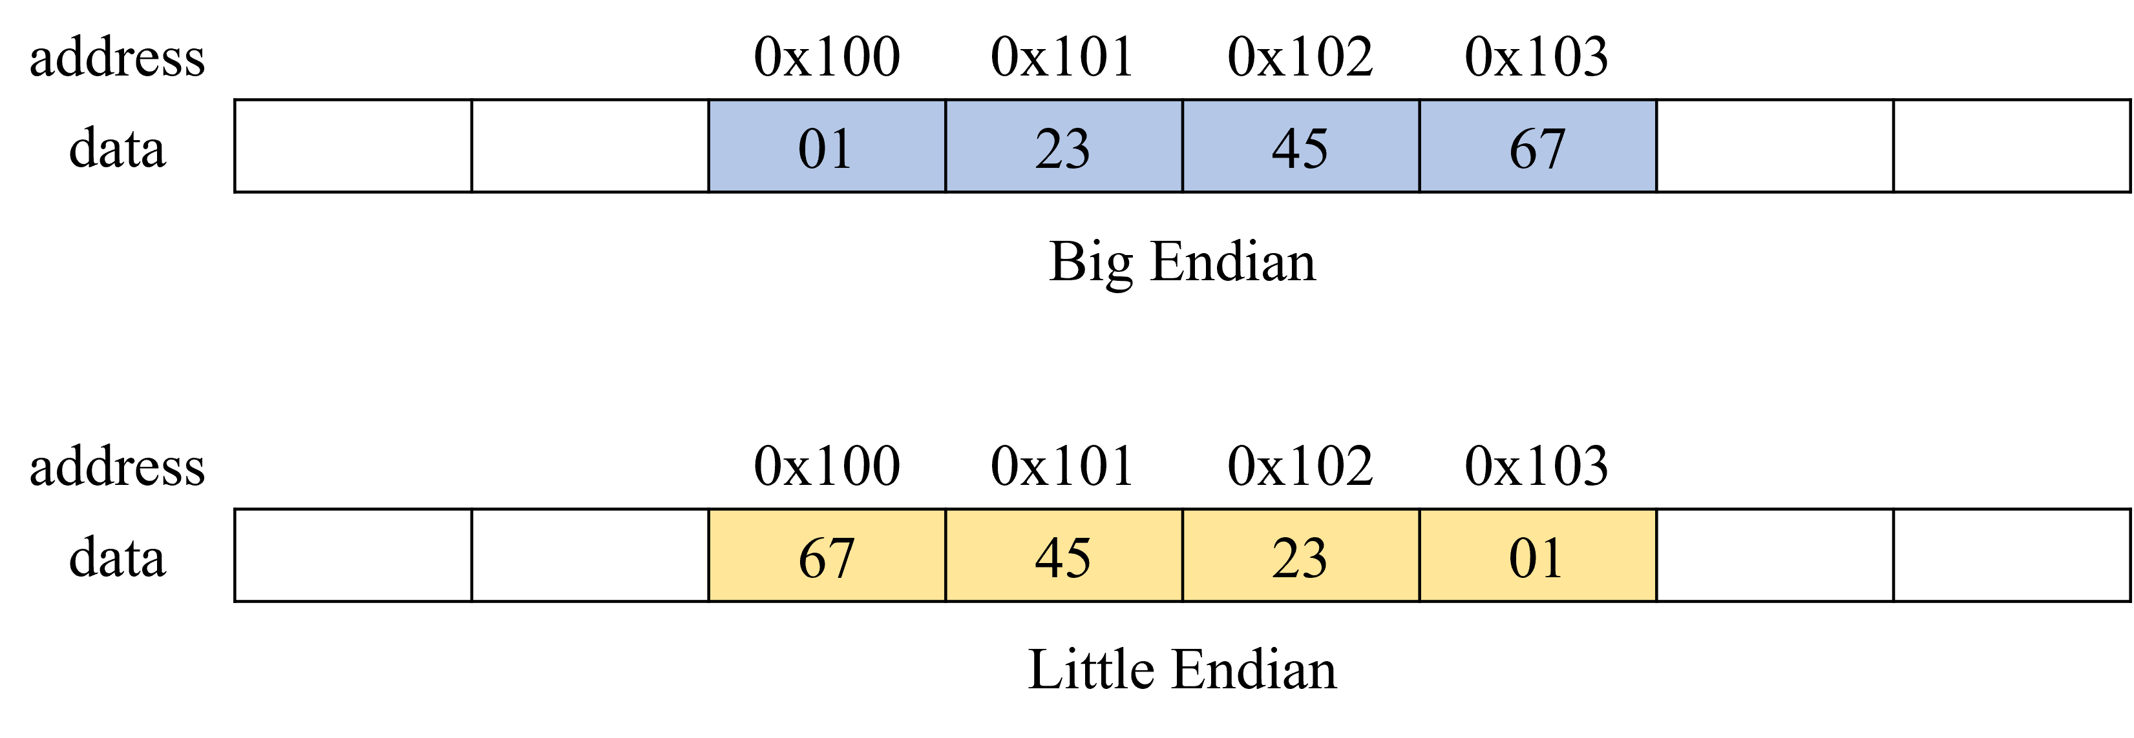
Figure 4: Big and little endian formats for binary files

Problem in Reading Binary Files
As illustrated in Fig. 1, the recorded binary files are stored with the naming convention “filename.bkp”. These files can be accessed in MATLAB using the standard fread (file_id, size, precision) command. For example, consider the file “nt.bkp”, which contains the number of transmit antennas with a value of 48. Normally, this data would be read directly using the fread command, as demonstrated in Fig. 2. However, in this case, the output is a random number instead of the expected value 48, as shown in Fig. 3.
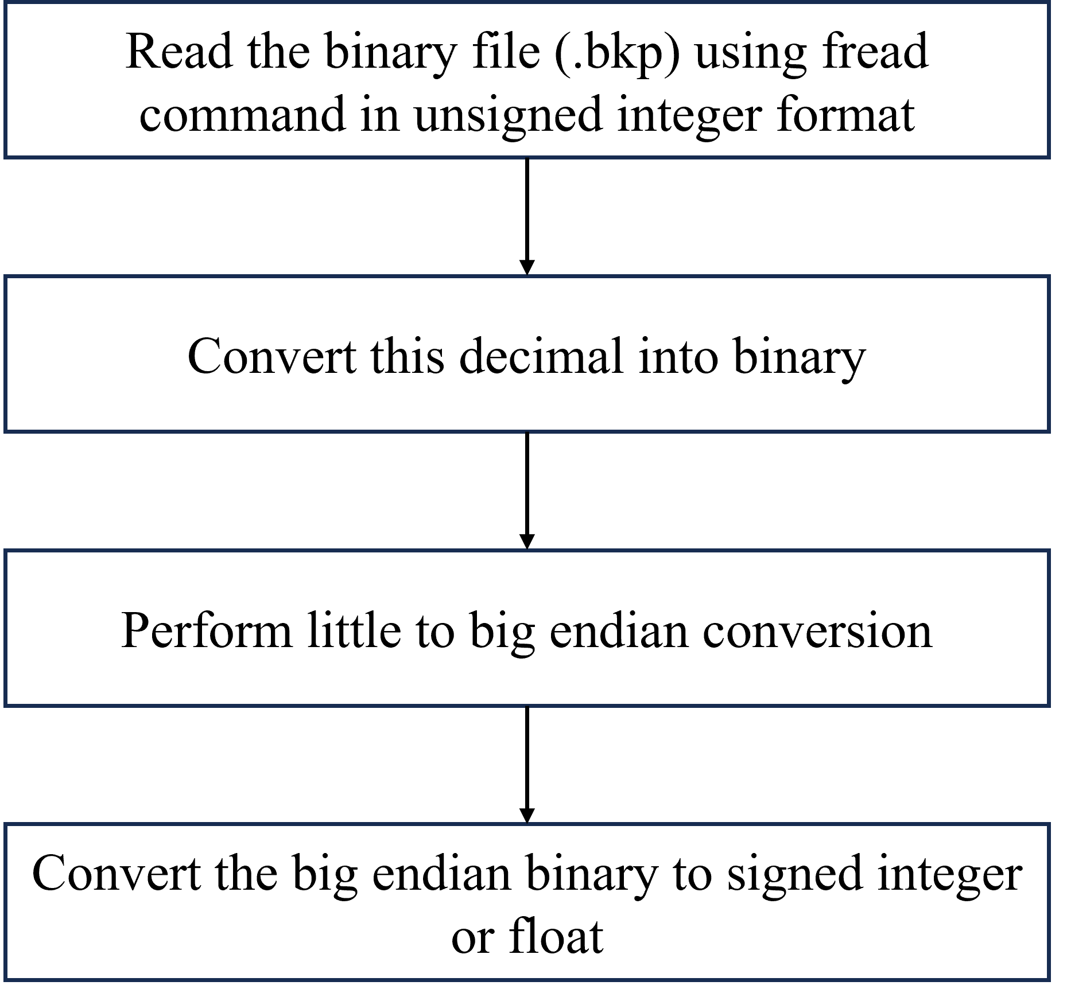
Figure 5: Sequence of steps for reading the data in MATLAB
The root cause of this discrepancy lies in the difference in data storage formats. Specifically, the datasets were recorded in big-endian format, whereas MATLAB by default reads binary files in little-endian format. Endianness refers to the order in which bytes of multibyte data types (e.g., integers, floating-point numbers) are stored in memory. In little-endian format, the least significant byte is stored first, whereas in big-endian format, the most significant byte is stored first [1]. For instance, the hexadecimal number 0x01234567 would be stored as 67 45 23 01 in little-endian format and as 01 23 45 67 in big-endian format. A comparison of big-endian and little-endian storage conventions is illustrated in Fig. 4. This mismatch necessitates a conversion from big-endian to little-endian in order to correctly interpret the recorded experimental data.
Proposed Solution
To overcome the issue of data reading errors in MATLAB, we propose a systematic method for handling the endian mismatch. In the first step, the binary file is read using the fread command in unsigned integer format, which allows the raw data to be captured without any interpretation of sign or precision. Next, this decimal data is converted into its binary representation. Since MATLAB, by default, interprets the data in little-endian format, the resulting binary sequence does not directly match the actual recorded values. To correct this, we explicitly reorder the binary sequence from little-endian to big-endian format, thereby restoring the original ordering used during the experiment. Finally, the reordered binary data is converted back into the appropriate numerical type, such as signed integer or floating-point, depending on the parameter that was recorded in the experiment. An overview of the proposed method is presented in Fig. 5.
Little to Big Endian Conversion
In binary data representation, the most significant byte is regarded as the first byte, followed sequentially by the second, third, and so on. For a 32-bit binary word, this results in four bytes in total. In the little-endian format, the storage order is reversed, such that the fourth byte is stored first, followed by the third, second, and finally the first. To convert this representation into the big-endian format, the bytes are rearranged in their natural order, i.e., from the first to the fourth, instead of from the fourth to the first. This process is illustrated in Fig. 6, while the corresponding MATLAB implementation is provided in Fig. 7 and Fig. 8. This conversion can be generalized for any word length: for an N-byte word, the bytes are reordered from $[B_{N} , B_{N -1}, ..., B_{1}]$ in little-endian to $[B_{1}, B_{2}, ..., B_{N} ]$ in big-endian.
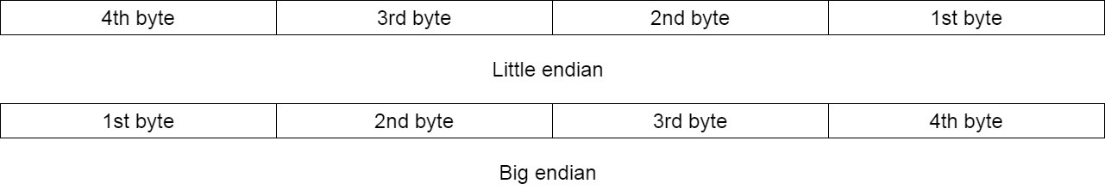
Figure 6: Little to big endian conversion.
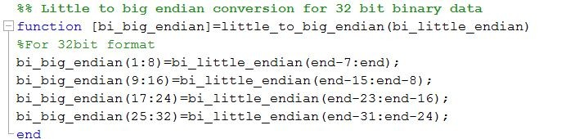
Figure 7: MATLAB implementation of little to big endian conversion for a 32-bit data.
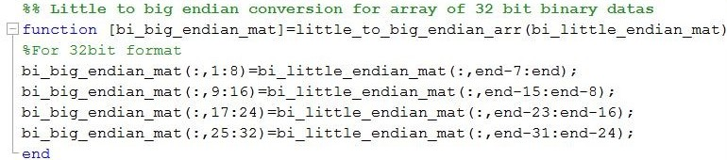
Figure 8: MATLAB implementation of little to big endian conversion for an array of 32-bit data.
Big Endian Binary to Signed Integer
Signed integers in computers and hardware are represented using the 2’s complement method [2]. In this representation, the most significant bit serves as the sign bit: it is 0 for positive numbers and 1 for negative numbers. For positive numbers, the binary value can be directly converted to decimal. For negative numbers, the 2’s complement of the binary value is first computed, then converted to decimal, and finally multiplied by -1 to obtain the corresponding signed integer. Our MATLAB implementation of this conversion process is illustrated in Fig. 9 and Fig. 10.
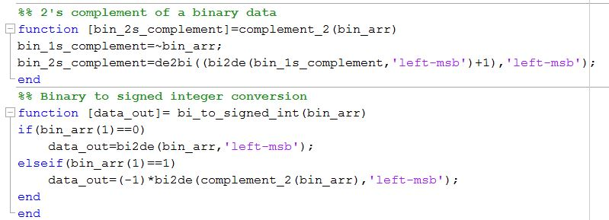
Figure 9: MATLAB implementation of big-endian binary to signed integer conversion for a binary data.
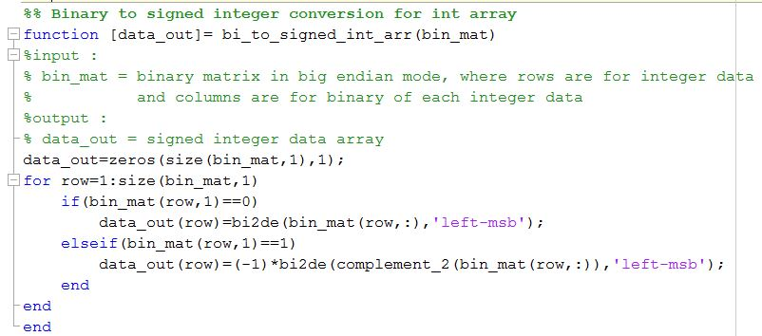
Figure 10: MATLAB implementation of big-endian binary to signed integer conversion for an array of binary data.
Big Endian Binary to 32-bit single-precision float
In IEEE-754 [3, 4] 32-bit single-precision floating-point representation, the most significant bit serves as the sign bit (S), where 0 indicates a positive number and 1 indicates a negative number. The following 8 bits represent the exponent (E), and the remaining 23 bits represent the fraction (F), as illustrated in Fig. 11. In the normalized form, the fraction is represented with an implicit leading 1, i.e., in the form 1.F. The actual exponent is given by E − 127, following the excess−127 (bias−127) scheme. This scheme allows representation of both positive and negative exponents using an 8-bit exponent field, which ranges from 0 to 255, thereby providing an actual exponent range from −127 to 128. Consequently, the value of the floating-point number N is calculated as:
$N = {\left(-1\right)}^{S}×(1.F )× {\left(2\right)}^{(E-127)}$ (1)
Our MATLAB implementation for converting big-endian binary data to 32-bit single-precision floating-point numbers is shown in Fig. 12 and Fig. 13.
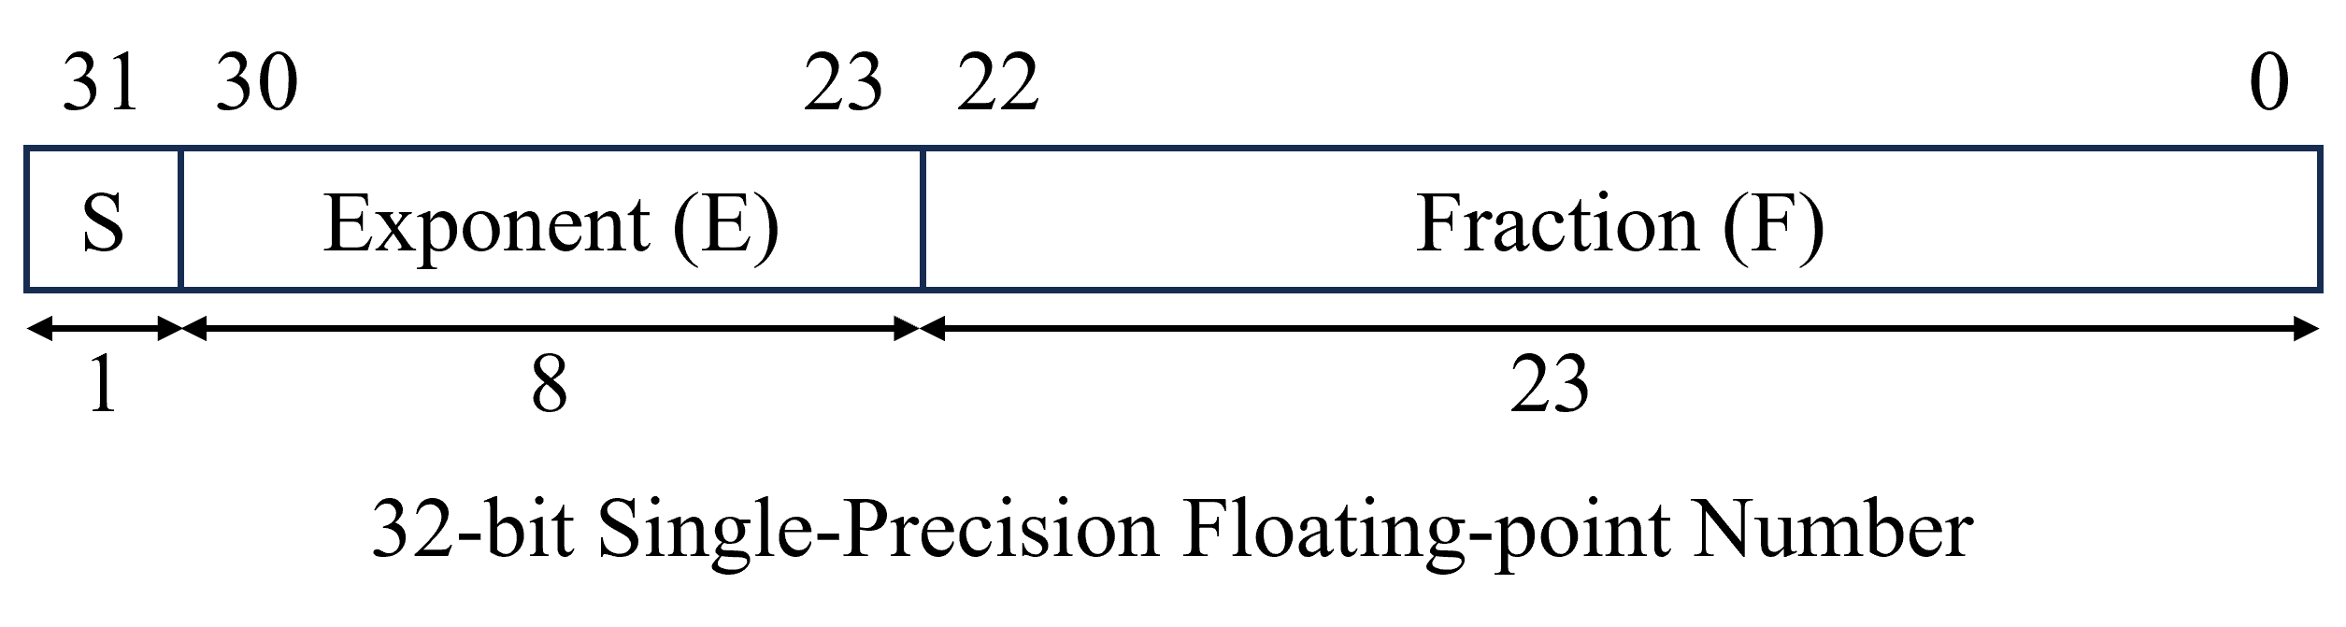
Figure 11: 32-bit single-precision floating-point number
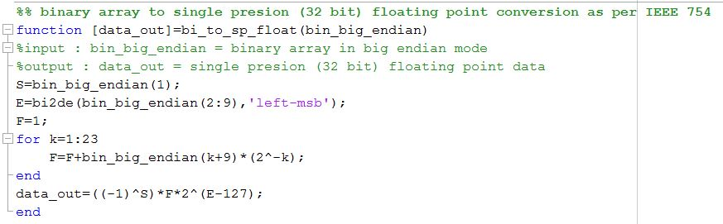
Figure 12: MATLAB implementation of big-endian binary to single-precision floating-point number conversion for a 32-bit binary data
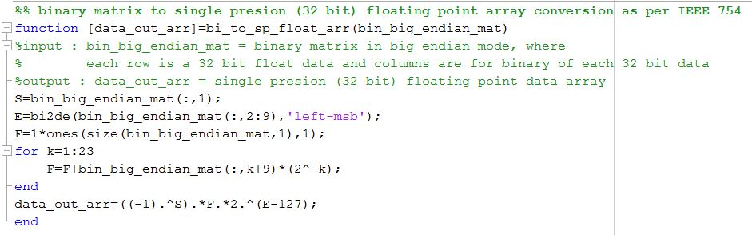
Figure 13: MATLAB implementation of big-endian binary to single-precision floating-point number conversion for an array of 32-bit binary data
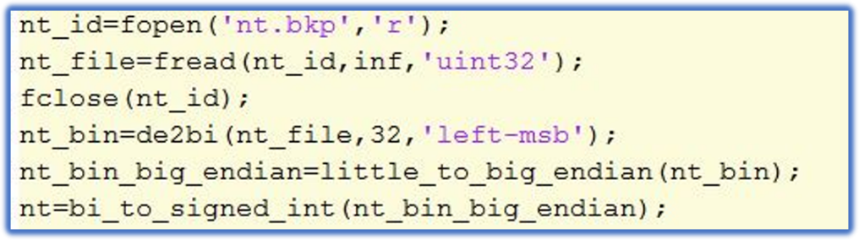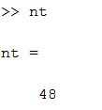
- Code (b) Output
Figure 14: MATLAB code for reading 32-bit signed integer and output
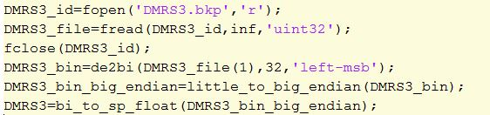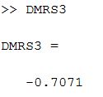
- Code (b) Output
Figure 15: MATLAB code for reading 32-bit single-precision floating-point number and output

MATLAB Implementation of proposed method
The MATLAB implementation of the proposed method, as outlined in Fig. 5, for reading the recorded experimental data in real time is presented in this subsection. The MATLAB code and corresponding output for reading a 32-bit signed integer are shown in Fig. 14a and Fig. 14b, respectively. Similarly, the MATLAB code and output for reading a 32-bit single-precision floating point number are presented in Fig. 15a and Fig. 15b, respectively. The binary files recorded from the experiment are shown in Fig. 6.1. The MATLAB code snippet used to read these files is provided in Fig. 6.16
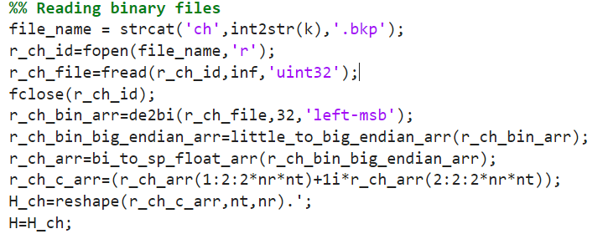
Figure 16: Code for reading real-time recorded data in MATLAB
This step-by-step approach ensures that the recorded experimental data are reconstructed accurately, regardless of the endian mismatch between the recording system and MATLAB’s default file reading mechanism. The method is generic and can be applied to all recorded parameters, including system-level constants and raw signal samples, thereby enabling precise analysis of the experimental dataset.
References:
- Geeksforgeeks, What is Endianness? Big-Endian & Little-Endian, 2008. [Online]. Available: https://www.geeksforgeeks.org/dsa/little-and-big-endian-mystery/.
- Geeksforgeeks, Representation of Negative Binary Numbers, 2008. [Online]. Available: https://www.geeksforgeeks.org/representation-of-negative-binary-numbers/.
- IEEE Standard Board and ANSI, “IEEE standard for binary floating-point arithmetic,” IEEE Std 754-1985, 1985.
- N. T. U. Singapore, A Tutorial on Data Representation Integers, Floating-point Numbers, and Characters. [Online]. Available: https://www3.ntu.edu.sg/home/ehchua/programming/java/datarepresentation.html.

