Customer Segmentation via Unsupervised Learning
PCA + K-Means Clustering on Retail Customer Data
Project 3 — Unsupervised Learning (Customer Segmentation)
Goal: Use distance-based algorithms to discover hidden mathematical groupings in unlabeled retail data.

1. Executive Summary
This project applies fully unsupervised machine learning to a retail dataset of 2,000 customers described by 28 behavioral, demographic, and transactional features — with no pre-existing labels. Principal Component Analysis (PCA) compressed the feature space into 2-3 dimensions, and K-Means clustering was applied on that reduced space. The Elbow Method and Silhouette Score were used together to mathematically justify the number of clusters, rather than guessing. The result is 4 statistically distinct, well-separated customer segments (overall silhouette score of 0.628, indicating strong cluster cohesion and separation), each translated below into an actionable business persona.

2. Methodology

2.1 Data & Preprocessing
The dataset contains 2,000 customers x 28 numeric features spanning demographics (age, income, tenure), purchase behavior (frequency, monetary value, average order value, recency), channel usage (web/store/catalog purchases, app sessions, web visits), engagement (email open rate, social engagement, reviews, wishlist items), service signals (complaints, returns, customer service contacts), and category-level spend (electronics, apparel, grocery, home goods, beauty). All features were standardized (zero mean, unit variance) using StandardScaler before any distance-based computation — this is essential because raw features span wildly different scales (e.g., discount rates of 0-1 vs. monetary totals in the thousands), and without scaling, the largest-magnitude feature would dominate every distance calculation.

2.2 Dimensionality Reduction (PCA)
PCA reduced the 28-dimensional standardized feature space down to 2 and 3 principal components for clustering and visualization. The first 2 components capture 57.5% of total variance (PC1: 36.0%, PC2: 21.5%); the first 3 components capture 65.3%. PC1 is driven primarily by overall purchase volume and value (MonetaryTotal, Frequency, Web/Store Purchases, Loyalty Points) — effectively a 'customer value' axis. PC2 is driven by digital engagement and lifecycle stage (Wishlist Items, Cart Abandon Rate, Web Visits, Tenure, Age) — effectively a 'digital-native vs. established-customer' axis.
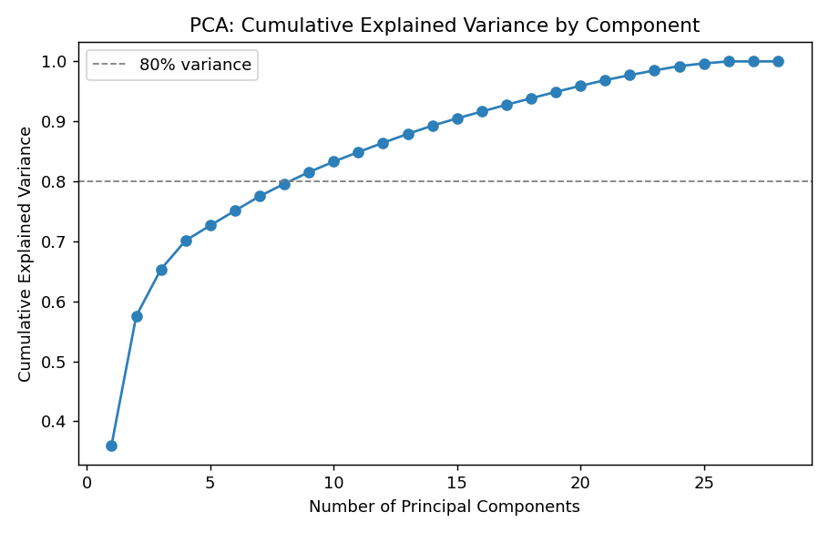
Figure 1 — Cumulative explained variance by principal component.

2.3 Determining Optimal K: Elbow Method + Silhouette Score
Two independent methods were run across k = 2 to 10 to mathematically identify the optimal number of clusters, rather than relying on a visual guess alone:
- Elbow Method: plots within-cluster sum of squares (inertia) vs. k. The rate of improvement slows sharply after k=4, forming the 'elbow'.
- Silhouette Score: measures how well-separated and internally cohesive clusters are (range -1 to 1; higher is better). This is the more rigorous, quantitative signal since the elbow can be visually ambiguous.
Silhouette scores by k: k=2: 0.541 | k=3: 0.593 | k=4: 0.628 (peak) | k=5: 0.611 | k=6: 0.515 | k=7: 0.513 | k=8: 0.522 | k=9: 0.461 | k=10: 0.451.
k=4 produces the maximum silhouette score (0.628) and coincides with the elbow in the inertia curve — both methods agree, giving strong mathematical justification for 4 clusters.
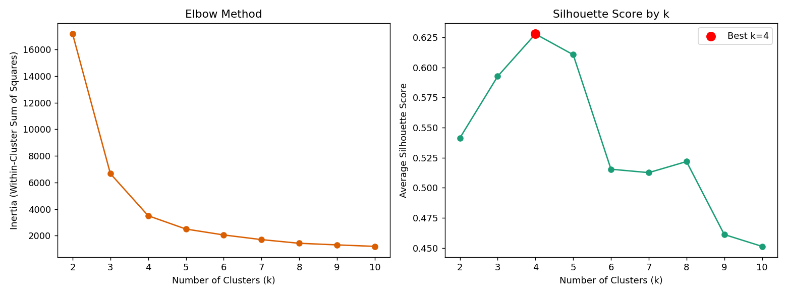
Figure 2 — Elbow Method (left) and Silhouette Score (right) across k=2..10. Both methods point to k=4.
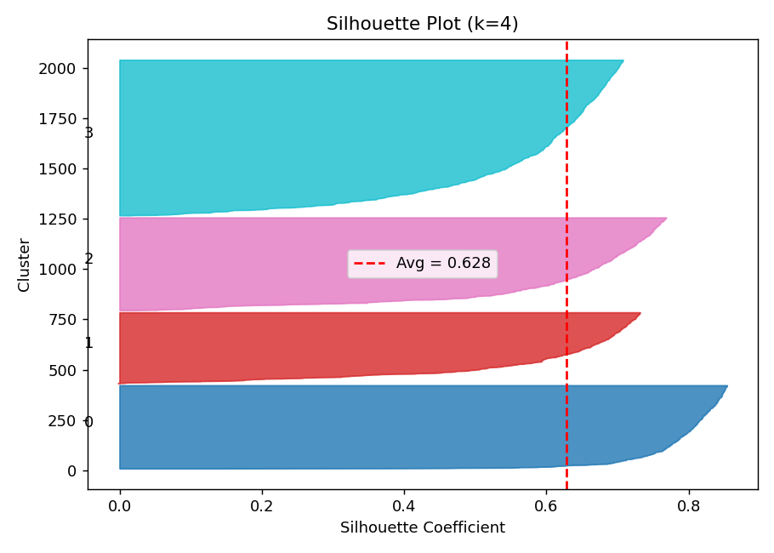
Figure 3 — Per-cluster silhouette diagram at k=4. All four clusters sit at or above the average line (red dashed), confirming healthy, well-separated groupings with no weak/overlapping cluster.

2.4 Final Clustering Result
K-Means was fit with k=4 on the 2D PCA-reduced space (25 random initializations to avoid poor local minima), producing an overall silhouette score of 0.628.
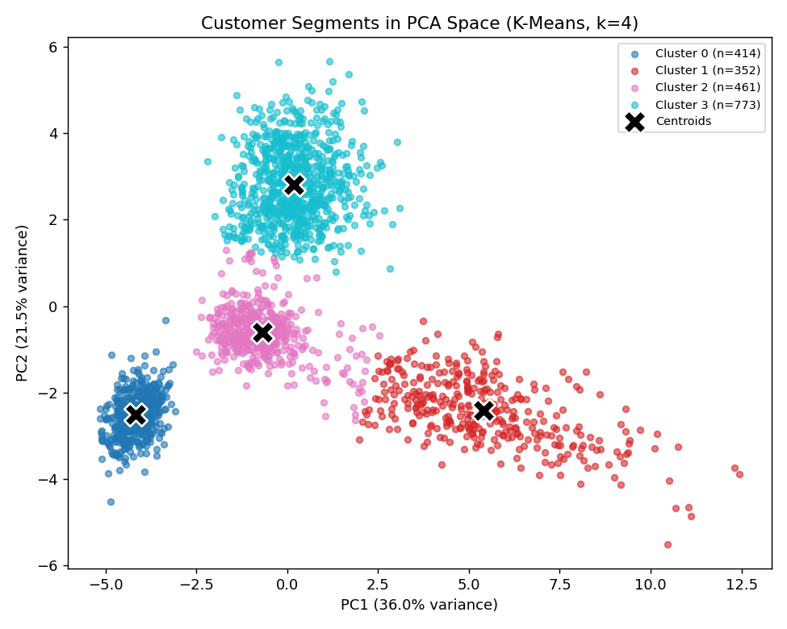
Figure 4 — The four customer segments, visualized in 2D PCA space. Centroids (black X) mark each cluster's mathematical center.
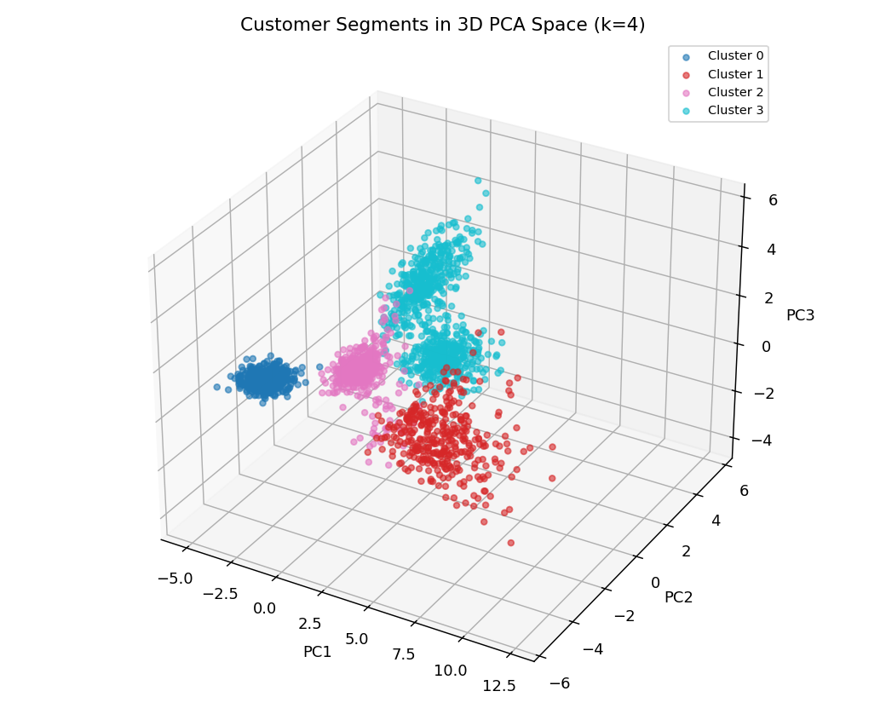
Figure 5 — The same four segments in 3D PCA space (adds the 3rd component, +7.8% variance), confirming separation holds beyond 2 dimensions.
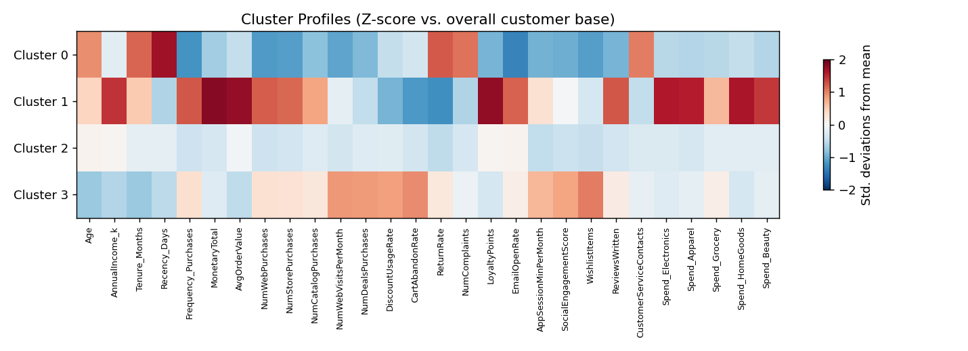
Figure 6 — Standardized (z-score) feature profile per cluster. Red = above-average, blue = below-average. This heatmap is the direct source for the persona descriptions in Section 3.
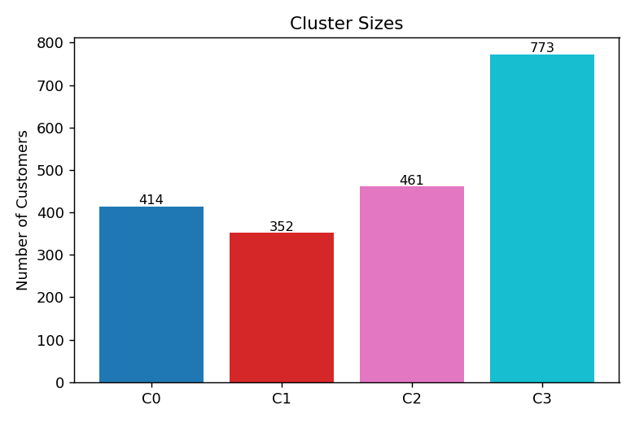
Figure 7 — Customer count per cluster.

3. Business Personas
Each mathematical cluster is translated below into a persona a marketing or CRM team can act on directly — including what makes them distinct and specific recommended actions.

Cluster 3: The Digital Deal-Seekers
38.6% of customers (n=773) — the largest segment
Young (avg. age 32), short tenure (~22 months), extremely active online — highest web visits, app usage (117 min/mo) and social engagement (62.3) of any group — but they hunt for discounts (48% discount usage) and abandon carts nearly twice as often as average (40%).
Metric | Value
Avg. Age | 32.0
Avg. Income | $55.5k
Purchase Frequency | 19.3 / yr
Annual Spend | $857
Discount Usage Rate | 48%
Cart Abandon Rate | 40%
App Session Min/Month | 116.7
Recommended Actions:
- Trigger cart-abandonment email/SMS flows with a time-boxed small discount to convert the 40% abandon rate.
- Gamify the mobile app (points, streaks, referral badges) — this segment already lives there.
- Push flash sales and limited-time bundles via app notifications rather than email (their open rate is average, but app engagement is 3x the base rate).
- Grow lifetime value gradually with a tiered loyalty program rather than one-time discounts, to reduce long-run margin erosion.

Cluster 1: Premium Loyalists (VIPs)
17.6% of customers (n=352) — smallest but most valuable segment
Highest income ($110.9k), highest spend ($4,324/yr — 5x the overall average), highest order values ($149.81), and they buy across every category. Very low return rate (3%) and complaints (0.18), with the highest email engagement (53% open rate).
Metric | Value
Avg. Income | $110.9k
Annual Spend | $4,324
Purchase Frequency | 29.1 / yr
Avg. Order Value | $149.81
Return Rate | 3%
Email Open Rate | 53%
Recency (days since last order) | 8.0
Recommended Actions:
- Protect this segment first — a small % churn here has an outsized revenue impact given ~5x average spend.
- Launch/expand a white-glove loyalty tier: early access to new arrivals, dedicated support line, free premium shipping.
- Use them as a source of testimonials/referral drivers — low complaint rate signals genuine satisfaction.
- Cross-sell rather than discount — they respond to curated recommendations and email, not price cuts.

Cluster 2: Steady Average Shoppers
23.0% of customers (n=461) — the stable middle
A middle-of-the-road segment on almost every metric: moderate income ($72.7k), moderate spend ($742.77/yr), moderate engagement. Nothing about them is extreme — the opportunity is to nudge them toward either the Loyalist or Digital segment before they drift toward the At-Risk group.
Metric | Value
Avg. Age | 40.9
Avg. Income | $72.7k
Annual Spend | $742.77
Purchase Frequency | 11.3 / yr
Discount Usage Rate | 25%
Email Open Rate | 32%
Recency (days) | 31.8
Recommended Actions:
- A/B test personalized product recommendations to lift engagement above the current baseline.
- Offer a loyalty-program enrollment nudge — they're engaged enough to convert but aren't currently in a program.
- Monitor recency trend monthly; a rising recency value here is the earliest warning sign of drift into the At-Risk segment.
- Light-touch win-back content (not heavy discounting) to reinforce brand engagement.

Cluster 0: At-Risk / Dormant Customers
20.7% of customers (n=414) — churn-risk priority
Long-tenured (60 months average — these are OLD customers) but have gone quiet: 139 days since last purchase (vs. 8-32 days for other segments), lowest purchase frequency (3.0/yr), highest return rate (20%) and by far the most complaints (2.06 vs <1 elsewhere). Email open rate has collapsed to 5%.
Metric | Value
Avg. Tenure | 60.2 months
Recency (days since last order) | 139.2
Purchase Frequency | 3.0 / yr
Return Rate | 20%
Avg. Complaints | 2.06
Email Open Rate | 5%
Annual Spend | $145.93
Recommended Actions:
- Launch a win-back campaign via a channel other than email (5% open rate signals email fatigue) — try SMS, direct mail, or retargeting ads.
- Investigate the root cause: this group's elevated complaints + returns suggest a service-quality issue, not just disinterest.
- Offer a genuine save-the-relationship incentive (not a generic coupon) — e.g., a personal outreach or service recovery gesture given their long tenure.
- If no response after 1-2 win-back attempts, suppress from regular marketing sends to protect deliverability/reputation and stop wasting spend.

4. Conclusion & Next Steps
The combination of PCA + K-Means, validated by the Elbow Method and Silhouette Score, uncovered 4 mathematically distinct and business-interpretable customer segments from fully unlabeled data: Digital Deal-Seekers (38.6%), Premium Loyalists (17.6%), Steady Average Shoppers (23.0%), and At-Risk/Dormant Customers (20.7%). These segments differ meaningfully on value, channel behavior, and service signals — differences invisible in the raw 28-column dataset but clear once distance-based unsupervised learning was applied.
Suggested next steps:
- Re-run this pipeline quarterly to track how customers migrate between segments over time (e.g., Steady -> At-Risk drift).
- Feed the Cluster label back into the CRM/marketing platform as a customer attribute to drive segment-specific campaigns.
- Test alternative distance metrics (e.g., cosine distance) or algorithms (DBSCAN, Gaussian Mixture Models) to check cluster stability.
- Deepen the At-Risk segment analysis with a churn-prediction (supervised) follow-up model.

