**Observations:**

* The epoch date is converted to GMT using [epoch-gmt converter](https://www.epochconverter.com/) link and then converted it to local time using python code.
* The below graphs show the comparison of Megasense and Aeroqual data for NO2, CO, and PM.

NO2:

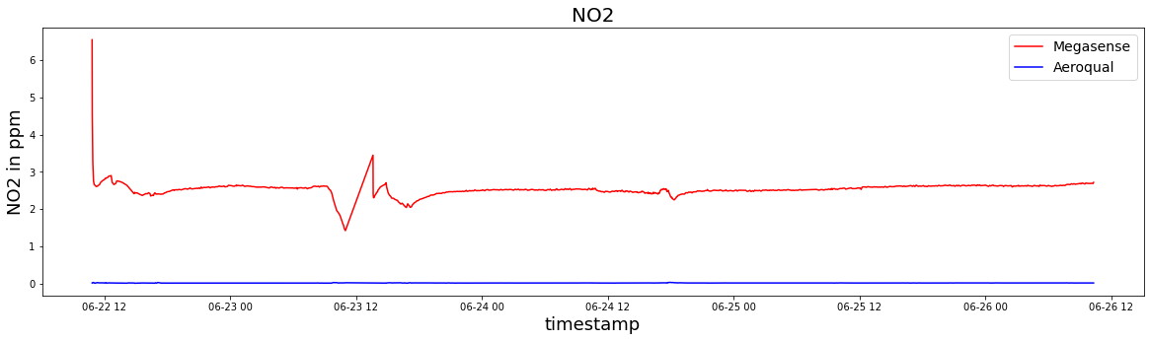

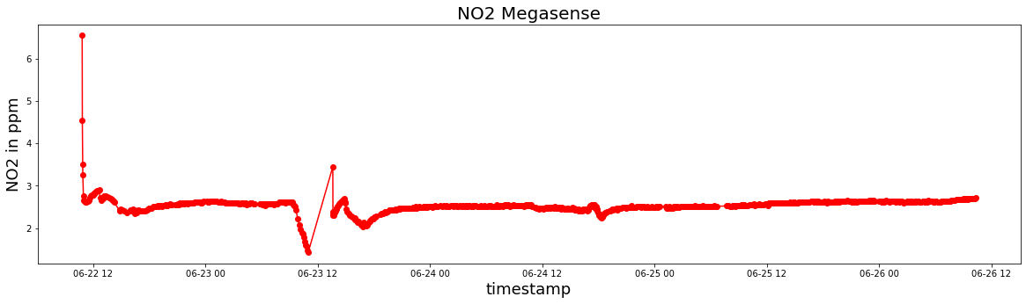

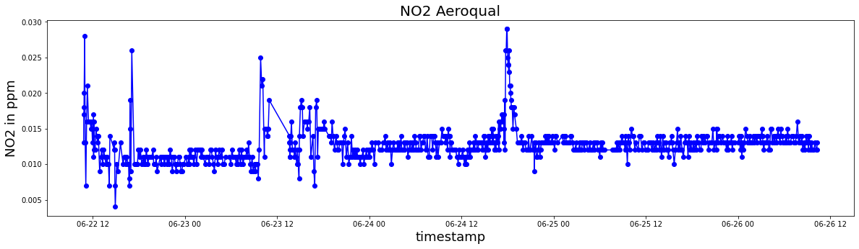

CO:

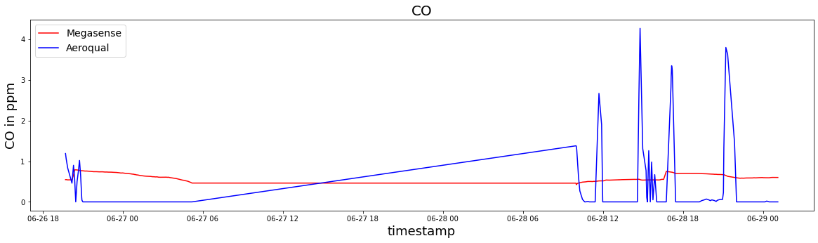

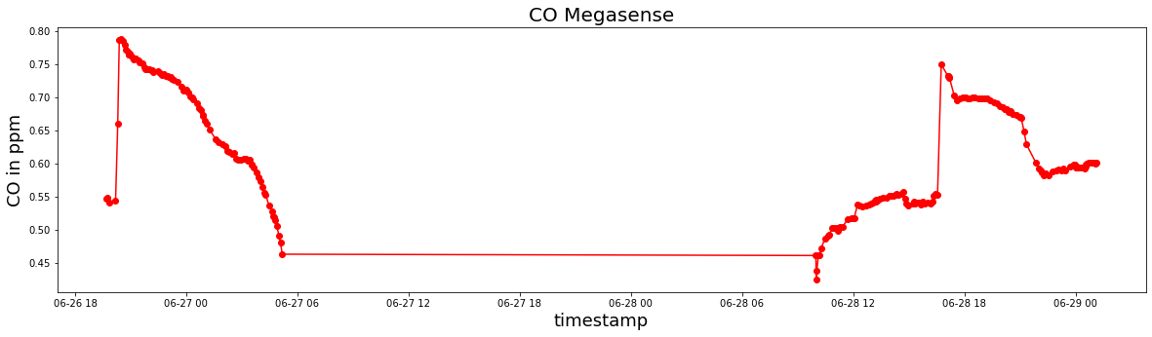

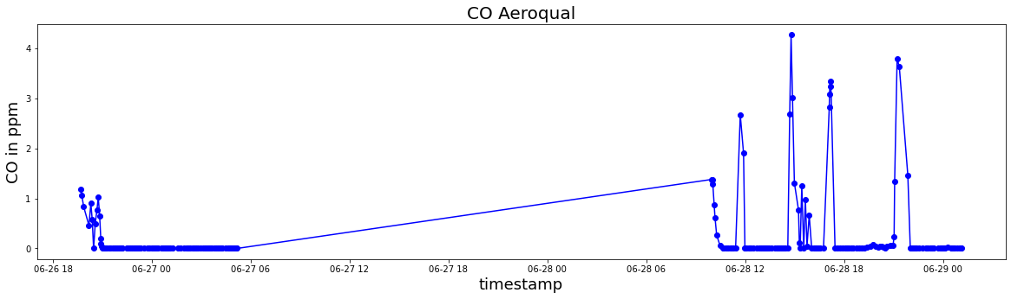

PM:

