Split on X1 First | Split on X2 First
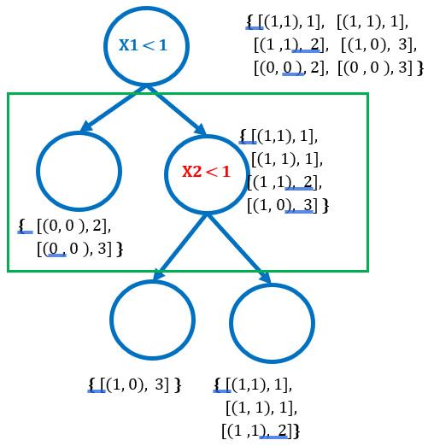 | 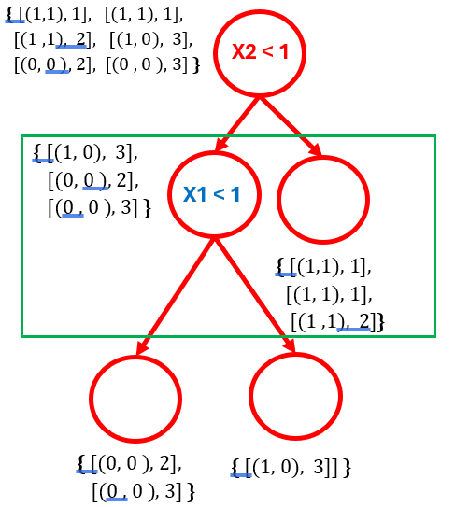

X1 < 1
{ [(1,1), 1], [(1, 1), 1],
[(1 ,1), 2], [(1, 0), 3],
[(0, 0 ), 2], [(0 , 0 ), 3] }

{ [(0, 0 ), 2],
[(0 , 0 ), 3] }

{ [(1,1), 1],
[(1, 1), 1],
[(1 ,1), 2],
[(1, 0), 3] }

{ [(1, 0), 3] }

{ [(1,1), 1],
[(1, 1), 1],
[(1 ,1), 2]}

X2 < 1
X2 < 1
{ [(1,1), 1], [(1, 1), 1],
[(1 ,1), 2], [(1, 0), 3],
[(0, 0 ), 2], [(0 , 0 ), 3] }

{ [(1, 0), 3],
[(0, 0 ), 2],
[(0 , 0 ), 3] }

{ [(1,1), 1],
[(1, 1), 1],
[(1 ,1), 2]}

X1 < 1
{ [(0, 0 ), 2],
[(0 , 0 ), 3] }

{ [(1, 0), 3]] }

X1 < 1
{ [(1,1), 1], [(1, 1), 1],
[(1 ,1), 2], [(1, 0), 3],
[(0, 0 ), 2], [(0 , 0 ), 3] }

{ [(0, 0 ), 2],
[(0 , 0 ), 3] }

{ [(1,1), 1],
[(1, 1), 1],
[(1 ,1), 2],
[(1, 0), 3] }

{ [(1, 0), 3] }

{ [(1,1), 1],
[(1, 1), 1],
[(1 ,1), 2]}

