DimensionalityReduction-1-3.pdf: Slide 14/37

The terms in red and blue rectangle are exactly the same. Is this a typo or am I missing something?
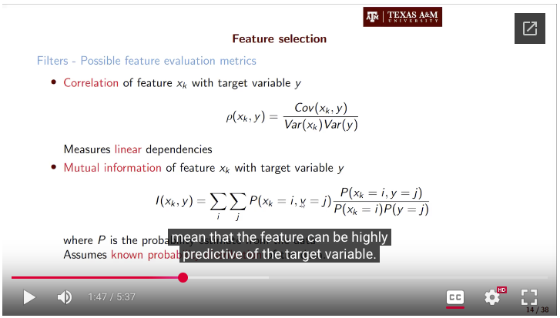

HW-5 1.3
Expected order and the number of return values?

- return_tuple = input_tensor, label_tensor, None
Enter IMDBDataset.__getitem__
IDX = 517, model_type = lstm
input: <class 'torch.Tensor'>, shape: torch.Size([128])
label: <class 'torch.Tensor'>, value: 1
Exit-2 IMDBDataset.__getitem__
[DEBUG] Return types: [<class 'torch.Tensor'>, <class 'torch.Tensor'>, <class 'NoneType'>]

Test Failed: default_collate: batch must contain tensors, numpy arrays, numbers, dicts or lists; found <class 'NoneType'>

- return_tuple = input_tensor, None, label_tensor
Enter IMDBDataset.__getitem__
IDX = 2097, model_type = lstm
input: <class 'torch.Tensor'>, shape: torch.Size([128])
label: <class 'torch.Tensor'>, value: 1
Exit-2 IMDBDataset.__getitem__
[DEBUG] Return types: [<class 'torch.Tensor'>, <class 'NoneType'>, <class 'torch.Tensor'>]

Test Failed: default_collate: batch must contain tensors, numpy arrays, numbers, dicts or lists; found <class 'NoneType'>

- return_tuple = None, input_tensor, label_tensor
Enter IMDBDataset.__getitem__
IDX = 175, model_type = lstm
input: <class 'torch.Tensor'>, shape: torch.Size([128])
label: <class 'torch.Tensor'>, value: 1
Exit-2 IMDBDataset.__getitem__
[DEBUG] Return types: [<class 'NoneType'>, <class 'torch.Tensor'>, <class 'torch.Tensor'>]

Test Failed: default_collate: batch must contain tensors, numpy arrays, numbers, dicts or lists; found <class 'NoneType'>

- return_tuple = None, label_tensor, input_tensor
Enter IMDBDataset.__getitem__
IDX = 263, model_type = lstm
input: <class 'torch.Tensor'>, shape: torch.Size([128])
label: <class 'torch.Tensor'>, value: 1
Exit-2 IMDBDataset.__getitem__
[DEBUG] Return types: [<class 'NoneType'>, <class 'torch.Tensor'>, <class 'torch.Tensor'>]

Test Failed: default_collate: batch must contain tensors, numpy arrays, numbers, dicts or lists; found <class 'NoneType'>

- return_tuple = label_tensor, None, input_tensor
Enter IMDBDataset.__getitem__
IDX = 1059, model_type = lstm
input: <class 'torch.Tensor'>, shape: torch.Size([128])
label: <class 'torch.Tensor'>, value: 0
Exit-2 IMDBDataset.__getitem__
[DEBUG] Return types: [<class 'torch.Tensor'>, <class 'NoneType'>, <class 'torch.Tensor'>]

Test Failed: default_collate: batch must contain tensors, numpy arrays, numbers, dicts or lists; found <class 'NoneType'>

- return_tuple = label_tensor, input_tensor, None
Enter IMDBDataset.__getitem__
IDX = 2339, model_type = lstm
input: <class 'torch.Tensor'>, shape: torch.Size([128])
label: <class 'torch.Tensor'>, value: 0
Exit-2 IMDBDataset.__getitem__
[DEBUG] Return types: [<class 'torch.Tensor'>, <class 'torch.Tensor'>, <class 'NoneType'>]

Test Failed: default_collate: batch must contain tensors, numpy arrays, numbers, dicts or lists; found <class 'NoneType'>

retval = (label_tensor, input_tensor)
DEBUG: Enter IMDBDataset.__getitem__
IDX = 270, model_type = lstm
DEBUG: return types = [<class 'torch.Tensor'>, <class 'torch.Tensor'>]
DEBUG: return len = 2
DEBUG: LeaveIMDBDataset.__getitem__

DEBUG: Enter IMDBDataset.__getitem__
IDX = 181, model_type = lstm
DEBUG: return types = [<class 'torch.Tensor'>, <class 'torch.Tensor'>]
DEBUG: return len = 2
DEBUG: LeaveIMDBDataset.__getitem__

Test Failed: 1205 != 2 : The second element of the batch should be a binary label

