CONSTELLATION DETECTION USING TRIANGLE BASED COMPARISON

LICENSE THESIS

 | Graduate: | Horatiu-Stefan SPANIOL
 | Supervisor: | Conf.Dr.Ing Ion-Augustin GIOSAN

2021

DEAN, |  |  | HEAD OF DEPARTMENT,
Prof. dr. eng. Liviu MICLEA |  | Prof. dr. eng. Rodica POTOLEA

Graduate: Horatiu-Stefan Spaniol

LICENSE THESIS TITLE

- Project proposal: Constellation detection using triangle-based comparison

- Project contents: (enumerate the main component parts) Presentation page, advisor's evaluation, title of chapter 1, title of chapter 2, …, title of chapter n, bibliography, appendices.

- Place of documentation: Example: Technical University of Cluj-Napoca, Computer Science Department

- Consultants:

- Date of issue of the proposal: November 1, 2020

- Date of delivery: July 8, 2021

Graduate: | ____________________________
Supervisor: | ____________________________

Declaraţie pe proprie răspundere privind
autenticitatea lucrării de licenţă

Subsemnatul(a) Horatiu-Stefan Spaniol, legitimat(ă) cu CI seria CJ nr. 483084
CNP 1980427124604, autorul lucrării ____________________________________________________________________________________________________________________________________________________________________________________________elaborată în vederea susţinerii examenului de finalizare a studiilor de licență la Facultatea de Automatică și Calculatoare, Specializarea ________________________________________ din cadrul Universităţii Tehnice din Cluj-Napoca, sesiunea _________________ a anului universitar 2020-2021, declar pe proprie răspundere, că această lucrare este rezultatul propriei activităţi intelectuale, pe baza cercetărilor mele şi pe baza informaţiilor obţinute din surse care au fost citate, în textul lucrării, şi în bibliografie.
Declar, că această lucrare nu conţine porţiuni plagiate, iar sursele bibliografice au fost folosite cu respectarea legislaţiei române şi a convenţiilor internaţionale privind drepturile de autor.
Declar, de asemenea, că această lucrare nu a mai fost prezentată în faţa unei alte comisii de examen de licenţă.
In cazul constatării ulterioare a unor declaraţii false, voi suporta sancţiunile administrative, respectiv, anularea examenului de licenţă.

Data  _____________________ |  | Nume, Prenume  Horatiu-Stefan Spaniol
 |  | Semnătura

De citit înainte (această pagină se va elimina din versiunea finală):

- Cele trei pagini anterioare (foaie de capăt, foaie sumar, declaraţie) se vor lista pe foi separate (nu faţă-verso), fiind incluse în lucrarea listată. Foaia de sumar (a doua) necesită semnătura absolventului, respectiv a coordonatorului. Pe declaraţie se trece data când se predă lucrarea la secretarii de comisie.
- Pe foaia de capăt, se va trece corect titulatura cadrului didactic îndrumător, în engleză (consultaţi pagina de unde aţi descărcat acest document pentru lista cadrelor didactice cu titulaturile lor).
- Documentul curent a fost creat în MS Office 2007. Dacă folosiţi alte versiuni e posibil sa fie mici diferenţe de formatare, care se corectează (textul conţine descrieri privind fonturi, dimensiuni etc.).
- Cuprinsul începe pe pagina nouă, impară (dacă se face listare faţă-verso), prima pagina din capitolul Introducere tot aşa, fiind numerotată cu 1. Pentru actualizarea cuprinsului, click dreapta pe cuprins (zona cuprinsului va apare cu gri), Update field->Update entire table.
- Vizualizaţi (recomandabil şi în timpul editării) acest document după ce activaţi vizualizarea simbolurilor ascunse de formatare (apăsaţi simbolul π din Home/Paragraph).
- Fiecare capitol începe pe pagină nouă, datorită simbolului ascuns Section Break (Next Page) care este deja introdus la capitolul precedent. Dacă ştergeţi din greşeală simbolul, se reintroduce (Page Layout -> Breaks).
- Folosiţi stilurile predefinite (Headings, Figure, Table, Normal, etc.)
- Marginile la pagini nu se modifică (Office 2003 default).
- Respectaţi restul instrucţiunilor din fiecare capitol.

Table of Contents

Chapter 1. Introduction (Heading 1 style) 1
1.1. Project context (Heading 2 style) 1
1.1.1. (Heading 3 style) 1
Chapter 2. Project Objectives 3
Chapter 3. Bibliographic Research 4
Chapter 4. Analysis and Theoretical Foundation 5
Chapter 5. Detailed Design and Implementation 6
Chapter 6. Testing and Validation 7
Chapter 7. User’s manual 8
Chapter 8. Conclusions 9
Bibliography 10
Appendix 1 (only if needed) 11

Introduction

Project context
The night sky has always been fascinating to humans world-wide. Even early humans must have been looking curiously at the sky, wondering about the lights that can be seen all across the landscape. At some point, humans let their imagination define some patterns in the stars observed, and have associated them to animals, objects, mythological creatures and characters. They also realized that some patterns can be seen in only a specific time period throughout the year and from certain locations on the globe, which allowed them to use these patterns even in navigation.
These patterns are called constellations. Nowadays, the International Astronomical Union recognizes 88 different constellations[1][2] on the celestial sphere. Constellations provide an easy entry in the field for people that take a liking towards astronomy because they can be seen with the naked eye and getting to know their backstories and the meaning behind their names is fun. This information can be refreshed every time while person recognizes one of these constellations while star gazing.
An astronomical image represents an image of the night sky. This image could be taken with the camera in a phone, although a higher quality would definitely be obtained by taking a photo with an actual camera directly or through a telescope. An example of an astronomical image can be seen in Figure 1.1
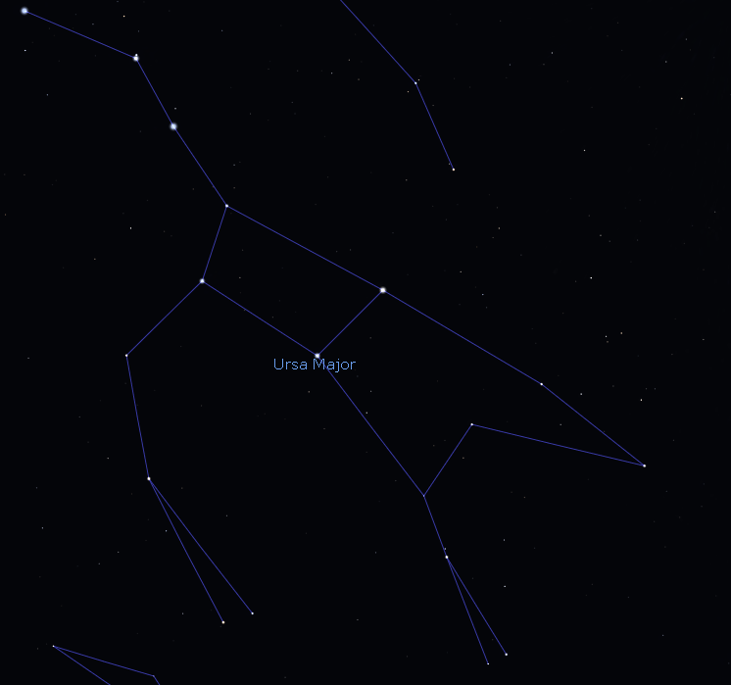

Figure 1.1 Ursa Major constellation as seen in Stellarium
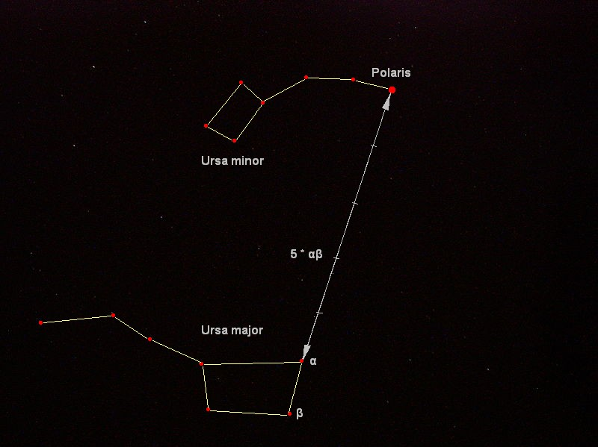
Ursa Major is perhaps one of the most famous constellations, due to being able to be seen throughout the whole year in most of the northern hemisphere.

Figure 1.2 Relation between „Big Dipper” asterism and Ursa Minor constellation
It also contains the very visible “Big Dipper” asterism, which mimics the pattern of the “Little Dipper”, or the Ursa Minor constellation. The latter has also served its purpose in navigation due to its brightest star, Polaris, being the closest star to the north pole, hence named the north pole star.
Constellations are not easy to spot if not for an untrained eye. Even so, the “manual” detection can be difficult due to the fact that the position of the observer on the globe and the time of the year influence the representation that a constellation might form on the celestial sphere. However, what is important to note is that the overall structure remains the same; the positions of the stars stay relatively the same to each other. This statement is not entirely true as stars are constantly moving but the human lifespan is much too short for that movement to become apparent. Such is why I considered that the overall structure remains constant.
Without having an expectation or information about the way the constellation should appear on the night sky, a certain constellation might be present but the observer might not perceive it as such due to the constellation appearing warped in one way or another. It could be in another location that the observer expects, or the observer might misjudge the angle that the constellation would be rotated at the current time of the day, or the observer might misjudge the scale of the constellation.

Project Objectives

Objectives
My project’s purpose is to allow amateur astronomers to recognize constellations in their photographs of the night sky. Astronomy enthusiasts might not even realize that certain constellations are present in their astrophotographs, and this application would automatically bring this aspect into attention. The project does not aim to identify each star in the image as it does not use a star catalogue, but to identify the constellation as a whole.
The application should not make any assumptions about the image such as longitude and latitude on the globe from which the photograph was taken, the precise moment in time when the photograph was taken nor should it receive any additional information about the image. Other information that is not required about the image includes details about the field of view, or lens, focal length of scope or the eyepiece, if the image would be taken through a telescope. These data would only decrease the usability of the application, which is not something I want. However, due to the large number of possible combinations between the aspects mentioned previously, the extremely large number of stars that can appear in an astrophotograph and the fact that the only proposed measure of matching is by geometry in nature, it is expected to obtain false positives.

Specifications
The specifications of the whole project will be divided in either functional or nonfunctional requirements.

Functional Requirements
The application should be a desktop application that takes as input an image provided by the user. This image could be in several formats, such as Windows bitmaps (.bmp, .dib), JPEG files(.jpeg, .jpg, .jpe), Portable Network Graphics (.png) or other widely known image formats. The image could also be of an arbitrary size. The system should be able to read and interpret any type of images described above. It should also be able to create an image of the same size, altered in such a way that the constellation detected is clearly visible and identified by the user of the application.
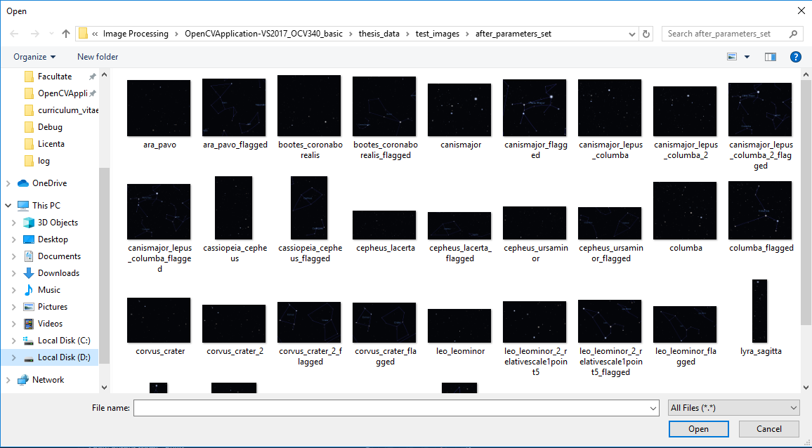
Figure 2.3 Example of a file dialog used to provide the application with an image
The application should be able to convert the image read into a grayscale image, as the primary colors in our domain are black and white.
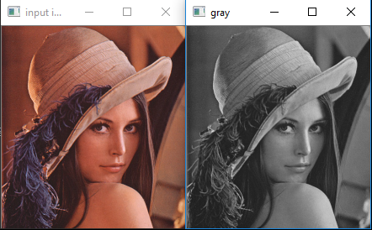
Figure 2.4 Example of image conversion from color to grayscale

Also in the same context, the system should convert the image from an 8-bit grayscale into a 1-bit grayscale, or a binary image, consisting of white points represented by objects, or stars, and black points consisting of the sky which is perceived as background.

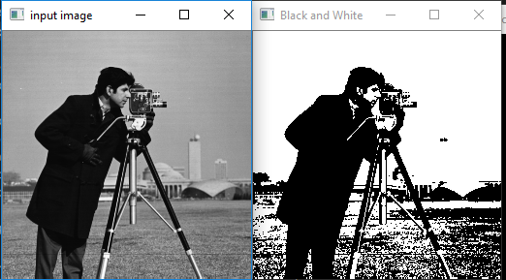
Figure 2.5 Example of image conversion from grayscale to binary

After the process of binarization, the system should be able to begin the process of labeling, which will differentiate stars from each other.
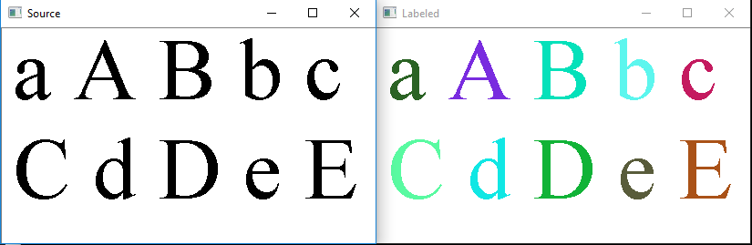
Figure 2.6 Example of binary image labeling

Once the stars can be differentiated, the application should compute the centers of mass and the areas of each star in order to represent them as a single point in the image.

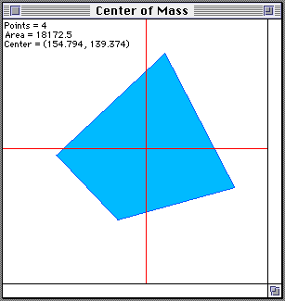
Figure 2.7 Example of area and center of mass of a polygon

When processing the constellation models, the system should be able to generate triangles, compute the lengths of each side of the triangles, normalize the lengths to the smalles one and then store them for later use in detection. When processing images from a user for detection, the system should be able to follow the same process regarding triangle generation and then start the detection process by comparing triangles from constellation models with triangles from the input image and finding similar pairs. Furthermore, the system should be able to match a constellation model in the source image by warping the model based off a pair of similar triangles previously found. The application should be able to filter through detections and provide the most likely detection for said constellation, which should then be drawn on the original source image in order to provide the user the visual aid necessary. Finally, said altered source image should be saved as a separate file with the time stamp of the end of execution.

Nonfunctional Requirements

Performance
The application’s most important nonfunctional requirement is the performance. Since it is intended for amateur enthusiasts of astrology, this application should be able to produce results in the fastest time possible in order to not lose the interest of the user. However, since the system would be running and performing computations on the computer of the user, the performance is dependant on the actual hardware of the computer. More exactly, the application should see performance increases with a better CPU.

Usability
The second most important nonfunctional requirement is the usability. The application should be able to be used with effectiveness and without problems even by a novice computer user. It should provide a familiar way for the user to upload the image and then show the results in a way that is simple to interpret.

Availability
The third most important nonfunctional requirement is the availability. Since this application is ran on the computer of the user, and does not rely on the internet whatsoever, the system is always available for use.

Scalability
The fourth most important nonfunctional requirement is the scalability. The design of the system should allow for easy manipulation in order to modify the existing pipeline process of image manipulation, whether by adding new intermediary or end processes.

Reliability
The fifth most important nonfunctional requirement is the reliability. Ideally, the detection algorithm should be able to produce correct results with little to none false detections. However, due to the nature of the thesis, this is very hard to achieve. The fact that the application does not use any other information regarding constellations other that distances between stars, it is hard to determine when a detection is false. A correct result should be manageable but a highly magnified image of the night sky where a high number of visible stars is present is bound to encumber the performance and reliability of the detection. Due to this high number of stars, coincidences can occur where a pattern of stars appears to look like a certain constellation and the detection algorithm will falsely detect the mentioned constellation. This is possible because the models and the images don’t always match one-to-one, and a certain position variation error should be maintained and allowed for each star.

Bibliographic Research

Introduction
In this section, similar systems and papers will be presented in order to provide justifications for the decisions taken in the development of the application.

Related Work

Evaluation of Star Identification Techniques
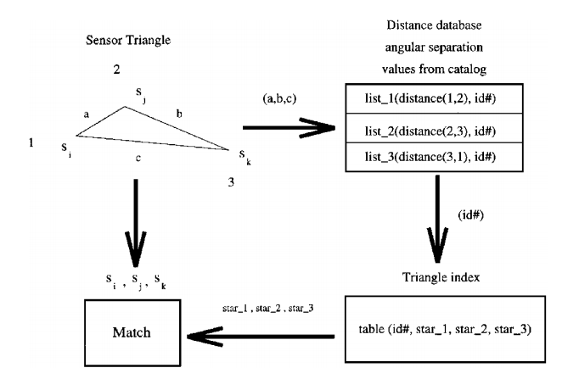
In paper [3] the authors present a detailed evaluation regarding star identification using various algorithms. These algorithms make use of a star catalogue and the paper also discusses the difficulties implied when designing such a system. A star catalogue typically represents stars as vertices in an undirected graph and optionally other features, such as brightness or precomputed distances between stars. The detection problem can be more technically described as finding two isomorph graphs: one belonging to the input image, and one belonging to the star catalogue. Two such algorithms described by the paper are a triangle star identification algorithm and a match group star identification algorithm.
Figure 3.8 Triangle star identification algorithm(taken from [3])

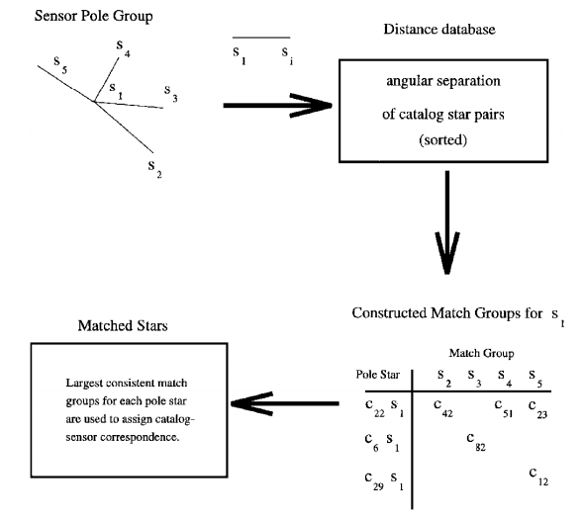
Figure 3.9 Pole star or match group algorithm(taken from [3])

The triangle algorithm compares the lengths of the sides of triangles in order to prove similarity while the pole star algorithm chooses a star and compares the distances of from the selected star to neighbouring stars with distances from the catalogue.
Since a star catalogue is built in order to be used by a specific system, it should be tailored to it; this means that the precomputed distances between stars and the positions of the stars should leave little to no room for variation and the matches should be very strict. In my case, this is hardly possible as the application is intended to be used by amateur enthusiasts that capture photos of the night sky with various devices. Therefore it is necessary to provide the system with a certain room for error.

Lost-In-Space Star Identification Using Planar Triangle Principal Component Analysis
The same concept of the triangle algorithm is also described in paper [4] for use in devices called star sensors. A star tracker, or sensor, is usually mounted on interstellar objects such as satellites in order to determine their orientation in space.

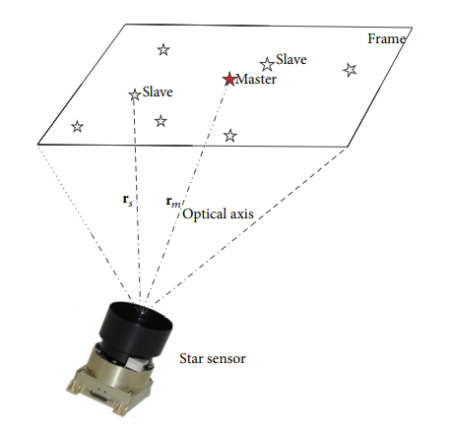

Figure 3.10 Star sensor capturing image(taken from [4])

The mentioned article uses a simulated star sensor with a resolution of 1024x1024 in order to form images as can be seen in the figure above. It also is focused on transposing the stars and subsequentially, the triangles, from a sensor frame in order to use principal component analysis for matching.

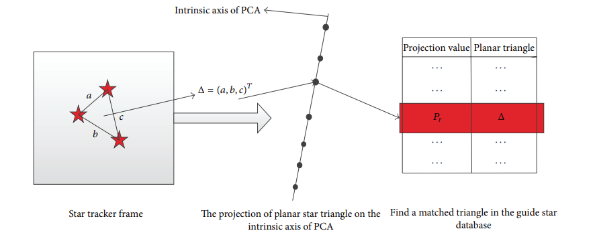
Figure 3.11 Diagram of projection geometry(taken from [4])

The hardest detection is when the system has to rely entirely on the current image data, and is called lost-in-space. This is also the type of detection to be designed an implemented in this thesis, as requiring other information would substantially decrease the usability of the application.

Neural networks
In this section, I shall present a couple articles and papers that use neural networks in order to solve the problem of star identification. While the second article does focus on finding a subset of stars, the first one focuses on single star identification. It is important to note this is not the final goal of my thesis, as I consider single star identification less intriguing to an amateur astronomy enthusiast.

Efficient Star Identification Using a Neural Network
The [5] article also tackles the problem of lost-in-space star identification, however in a different way than previously discussed. The method used to solve this problem is a pattern feature extraction method. The authors report that even with a small and full connected neural network, results can be very promising as long as the feature extraction method is appropriate.
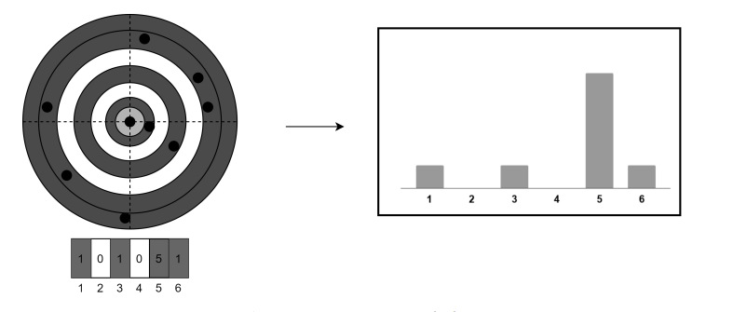
Figure 3.12 Feature extraction method in [5]

The feature extraction presented in this article makes use of a distance distribution of stars from a selected polestar in order to create a histogram. The input of the discussed network is the distribution shown above. In the next figure we can see the proposed network architecture in this paper.

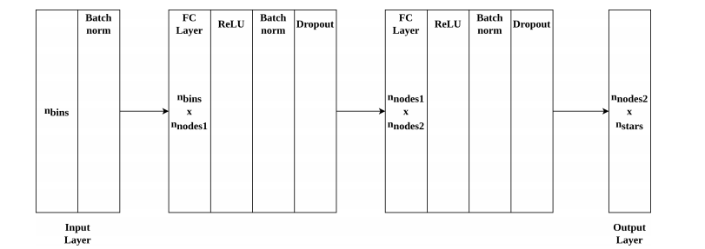
Figure 3.13 Proposed architecture (taken from [5])
This is a general architecture that can be modified and tailored to a specific application environments, as the nnodes1 and nnodes2 variables are determined through experiments and the layer sizes can also be dependant on the application enviroment.

Neural Network approach to star field recognition
The use of hopfield neural networks
What are hopfield neural networks
We can see this paper also uses a star catalog(fig.1 from paper) and the system is fairly the same with what we’ve seen so far
Star field recognition is based on comparison of angular separations between the stars and the magnitude of each star that belongs to the triangle(fig 2 from paper)
The paper reports 50 correct results out of 50 test images, each image containing 5 stars. Tests were also done after inducing some noise the images, to which the system also responded with the same success. Although the number of stars in the image is very low, the authors recommend parallelization in order to achieve better results for a larger number of stars.

Constellation Detection paper

Astrometry.net

Bibliographic research has as an objective the establishment of the references for the project, within the project domain/thematic. While writing this chapter (in general the whole document), the author will consider the knowledge accumulated from several dedicated disciplines in the second semester, 4th year (Project Elaboration Methodology, etc.), and other disciplines that are relevant to the project theme.
Represents about 15% of the paper.
References will be included in the Bibliography section. The reference format must be IEEE, or similar. The introduction of new references in the Bibliography section, and their citation within the document text can be done manually (by obeying the format), but it is less recommended, or by using the tools mentioned in the last paragraphs of this chapter.
In the Bibliography section, there are examples of references to conferences or workshops articles [1], journal articles [2], and books [3]. References to applications or online resources (web pages) must include at least a short relevant description in addition to the link [4], and other information is available (authors, year, etc.). References that contain only the link to the online resource will be placed in the page footer.
Each reference must be cited within the document text, see example below (depending on the project theme, the presentation of a method/application can vary).
In paper [1] the authors present a detection system for moving obstacles based on stereovision and ego motion estimation. The method is … discus the algorithms, data structures, functionality, specific aspects related to the project theme, etc…. Discussion: pros and cons.
In chapter 4 of [3], the similar-to-my-project-theme algorithm is presented, with the following features…
Software and other tools managing bibliography for MS Word 2003, and usage instructions can be found at:
How to use JabRef (BibTeX) with Microsoft Word 2003
Bibtex4Word
BibWord makes it easier to create and manipulate Microsoft Word citation and bibliography styles
For MS Word 2007 and MS Word 2010, the integrated bibliography management system should be used, References, Citations & Bibliography. More information can be found in the online documentation of MS Office.

Analysis and Theoretical Foundation
Together with the next chapter takes about 60% of the whole paper.
The purpose of this chapter is to explain the operating principles of the implemented application.
Here you write about your solution from a theory standpoint – i.e. you explain it and demonstrate its theoretical properties/value, e.g.:
- used or proposed algorithms,
- used protocols,
- abstract models,
- logic explanations/arguments concerning the chosen solution,
- logic and functional structure of the application, etc.
YOU DO NOT write about implementation.
YOU DO NOT copy/paste info on technologies from various sources and others alike, which do not pertain to your project (no fillers, please!).

Detailed Design and Implementation
Together with the previous chapter takes about 60% of the paper.
The purpose of this chapter is to document the developed application such a way that it can be maintained and developed later. A reader should be able (from what you have written here) to identify the main functions of the application.
The chapter should contain (but not limited to):
- a general application sketch/scheme,
- a description of every component implemented, at module level,
- class diagrams, important classes and methods from key classes.

Testing and Validation
About 5% of the paper.

User’s manual
In the installation description section your should detail the hardware and software resources needed for installing and running the application, and a step by step description of how your application can be deployed/installed. An administrator should be able to perform the installation/deployment based on your instructions.
In the user manual section you describe how to use the application from the point of view of a user with no inside technical information; this should be adorned with screen shots and a stepwise explanation of the interaction. Based on user's manual, a person should be able to use your product.

Conclusions
About. 5% of the whole.
In this chapter you present:
- A summary of your contributions/achievements,
- A critical analysis of the results achieved,
- A description of the possibilities of improvements/further development.

Bibliography

[1] E. Delporte, Délimitation scientifique des constellations: (tables et cartes), Cambridge University Press, 1930
[2] I. Ridpath, Star Tales, ISD LLC, 2018, chapter 1, p.4. [Online]. Available: http://www.ianridpath.com/startales/startales1d.html
[3] C. Padgett, K. Kreutz-Delgado, S. Udomkesmalee, Evaluation of Star Identification Techniques, Journal of Guidance, Control and Dynamics, 1997
[4] F. Zhou, T. Ye, Lost-In-Space Star Identification Using Planar Triangle Principal Component Analysis Algorithm, Mathemathical Programs in Engineering, 2015
[5] D. Rijlaarsdam, H. Yous, J. Byrne, D. Oddenino, G. Furano, D. Moloney, Efficient Star Identification Using a Neural Network, Sensors, 2020
[6] M.J. Domeika, E.W. Page, G.A. Tagliarini, Neural network approach to star field recognition, Applications and Science of Artificial Neural Networks, 1995

Appendix 1 (only if needed)
…
Relevant code sections
…
Other relevant info (proofs etc.)
…
Published papers (if any)
etc.

