CONSTELLATION DETECTION USING TRIANGLE-BASED COMPARISON

LICENSE THESIS

 | Graduate: | Horatiu-Stefan SPANIOL
 | Supervisor: | Conf.Dr.Ing Ion-Augustin GIOSAN

2021

DEAN, |  |  | HEAD OF DEPARTMENT,
Prof. dr. eng. Liviu MICLEA |  | Prof. dr. eng. Rodica POTOLEA

Graduate: Horatiu-Stefan Spaniol

LICENSE THESIS TITLE

- Project proposal: Constellation detection using triangle-based comparison

- Project contents: (enumerate the main component parts) Presentation page, advisor's evaluation, title of chapter 1, title of chapter 2, …, title of chapter n, bibliography, appendices.

- Place of documentation: Example: Technical University of Cluj-Napoca, Computer Science Department

- Consultants:

- Date of issue of the proposal: November 1, 2020

- Date of delivery: July 8, 2021

Graduate: | ____________________________
Supervisor: | ____________________________

Declaraţie pe proprie răspundere privind
autenticitatea lucrării de licenţă

Subsemnatul(a) Horatiu-Stefan Spaniol, legitimat(ă) cu CI seria CJ nr. 483084
CNP 1980427124604, autorul lucrării ____________________________________________________________________________________________________________________________________________________________________________________________elaborată în vederea susţinerii examenului de finalizare a studiilor de licență la Facultatea de Automatică și Calculatoare, Specializarea ________________________________________ din cadrul Universităţii Tehnice din Cluj-Napoca, sesiunea _________________ a anului universitar 2020-2021, declar pe proprie răspundere, că această lucrare este rezultatul propriei activităţi intelectuale, pe baza cercetărilor mele şi pe baza informaţiilor obţinute din surse care au fost citate, în textul lucrării, şi în bibliografie.
Declar, că această lucrare nu conţine porţiuni plagiate, iar sursele bibliografice au fost folosite cu respectarea legislaţiei române şi a convenţiilor internaţionale privind drepturile de autor.
Declar, de asemenea, că această lucrare nu a mai fost prezentată în faţa unei alte comisii de examen de licenţă.
In cazul constatării ulterioare a unor declaraţii false, voi suporta sancţiunile administrative, respectiv, anularea examenului de licenţă.

Data  _____________________ |  | Nume, Prenume  Horatiu-Stefan Spaniol
 |  | Semnătura

De citit înainte (această pagină se va elimina din versiunea finală):

- Cele trei pagini anterioare (foaie de capăt, foaie sumar, declaraţie) se vor lista pe foi separate (nu faţă-verso), fiind incluse în lucrarea listată. Foaia de sumar (a doua) necesită semnătura absolventului, respectiv a coordonatorului. Pe declaraţie se trece data când se predă lucrarea la secretarii de comisie.
- Pe foaia de capăt, se va trece corect titulatura cadrului didactic îndrumător, în engleză (consultaţi pagina de unde aţi descărcat acest document pentru lista cadrelor didactice cu titulaturile lor).
- Documentul curent a fost creat în MS Office 2007. Dacă folosiţi alte versiuni e posibil sa fie mici diferenţe de formatare, care se corectează (textul conţine descrieri privind fonturi, dimensiuni etc.).
- Cuprinsul începe pe pagina nouă, impară (dacă se face listare faţă-verso), prima pagina din capitolul Introducere tot aşa, fiind numerotată cu 1. Pentru actualizarea cuprinsului, click dreapta pe cuprins (zona cuprinsului va apare cu gri), Update field->Update entire table.
- Vizualizaţi (recomandabil şi în timpul editării) acest document după ce activaţi vizualizarea simbolurilor ascunse de formatare (apăsaţi simbolul π din Home/Paragraph).
- Fiecare capitol începe pe pagină nouă, datorită simbolului ascuns Section Break (Next Page) care este deja introdus la capitolul precedent. Dacă ştergeţi din greşeală simbolul, se reintroduce (Page Layout -> Breaks).
- Folosiţi stilurile predefinite (Headings, Figure, Table, Normal, etc.)
- Marginile la pagini nu se modifică (Office 2003 default).
- Respectaţi restul instrucţiunilor din fiecare capitol.

Table of Contents

Chapter 1. Introduction (Heading 1 style) 1
1.1. Project context (Heading 2 style) 1
1.1.1. (Heading 3 style) 1
Chapter 2. Project Objectives 3
Chapter 3. Bibliographic Research 4
Chapter 4. Analysis and Theoretical Foundation 5
Chapter 5. Detailed Design and Implementation 6
Chapter 6. Testing and Validation 7
Chapter 7. User’s manual 8
Chapter 8. Conclusions 9
Bibliography 10
Appendix 1 (only if needed) 11

Introduction

Project context
The night sky has always been fascinating to humans world-wide. Even early humans must have been looking curiously at the sky, wondering about the lights that can be seen all across the landscape. At some point, humans let their imagination define some patterns in the stars observed, and have associated them to animals, objects, mythological creatures and characters. They also realized that some patterns can be seen in only a specific time period throughout the year and from certain locations on the globe, which allowed them to use these patterns even in navigation.
These patterns are called constellations. Nowadays, the International Astronomical Union recognizes 88 different constellations[1][2] on the celestial sphere. Constellations provide an easy entry in the field for people that take a liking towards astronomy because they can be seen with the naked eye and getting to know their backstories and the meaning behind their names is fun. This information can be refreshed every time while person recognizes one of these constellations while star gazing.
An astronomical image represents an image of the night sky. This image could be taken with the camera in a phone, although a higher quality would definitely be obtained by taking a photo with an actual camera directly or through a telescope. An example of an astronomical image can be seen in Figure 1.1
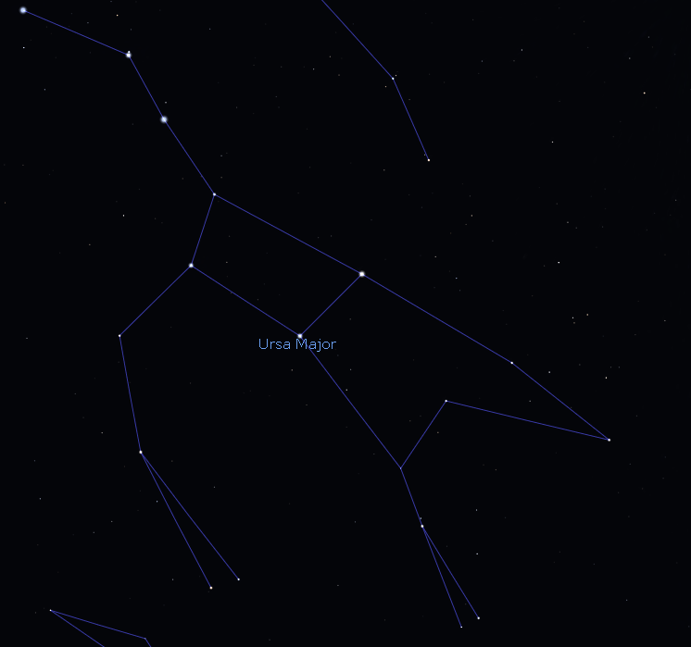

Figure 1.1 Ursa Major constellation as seen in Stellarium
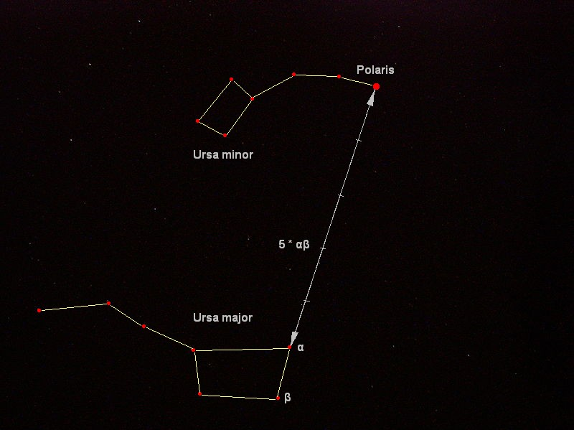
Ursa Major is perhaps one of the most famous constellations, due to being able to be seen throughout the whole year in most of the northern hemisphere.

Figure 1.2 Relation between „Big Dipper” asterism and Ursa Minor constellation

It also contains the very visible “Big Dipper” asterism, which mimics the pattern of the “Little Dipper”, or the Ursa Minor constellation. The latter has also served its purpose in navigation due to its brightest star, Polaris, being the closest star to the north pole, hence named the north pole star.
Constellations are not easy to spot if not for an untrained eye. Even so, the “manual” detection can be difficult due to the fact that the position of the observer on the globe and the time of the year influence the representation that a constellation might form on the celestial sphere. However, what is important to note is that the overall structure remains the same; the positions of the stars stay relatively the same to each other. This statement is not entirely true as stars are constantly moving but the human lifespan is much too short for that movement to become apparent. Such is why I considered that the overall structure remains constant.
Without having an expectation or information about the way the constellation should appear on the night sky, a certain constellation might be present but the observer might not perceive it as such due to the constellation appearing warped in one way or another. It could be in another location that the observer expects, or the observer might misjudge the angle that the constellation would be rotated at the current time of the day, or the observer might misjudge the scale of the constellation.

Project Objectives

Objectives
My project’s purpose is to allow amateur astronomers to recognize constellations in their photographs of the night sky. Astronomy enthusiasts might not even realize that certain constellations are present in their astrophotographs, and this application would automatically bring this aspect into attention. The project does not aim to identify each star in the image as it does not use a star catalogue, but to identify the constellation as a whole.
The application should not make any assumptions about the image such as longitude and latitude on the globe from which the photograph was taken, the precise moment in time when the photograph was taken nor should it receive any additional information about the image. Other information that is not required about the image includes details about the field of view, or lens, focal length of scope or the eyepiece, if the image would be taken through a telescope. These data would only decrease the usability of the application, which is not something I want. However, due to the large number of possible combinations between the aspects mentioned previously, the extremely large number of stars that can appear in an astrophotograph and the fact that the only proposed measure of matching is by geometry in nature, it is expected to obtain false positives.

Specifications
The specifications of the whole project will be divided in either functional or nonfunctional requirements.

Functional Requirements
The application should be a desktop application that takes as input an image provided by the user. This image could be in several formats, such as Windows bitmaps (.bmp, .dib), JPEG files(.jpeg, .jpg, .jpe), Portable Network Graphics (.png) or other widely known image formats. The image could also be of an arbitrary size. The system should be able to read and interpret any type of images described above. It should also be able to create an image of the same size, altered in such a way that the constellation detected is clearly visible and identified by the user of the application.
The application should be able to convert the image read into a grayscale image, as the primary colors in our domain are black and white. Also in the same context, the system should convert the image from an 8-bit grayscale into a 1-bit grayscale, or a binary image, consisting of white points represented by objects, or stars, and black points consisting of the sky which is perceived as background. After the process of binarization, the system should be able to begin the process of labeling, which will differentiate stars from each other. Once the stars can be differentiated, the application should compute the centers of mass and the areas of each star in order to represent them as a single point in the image. When processing the constellation models, the system should be able to generate triangles, compute the lengths of each side of the triangles, normalize the lengths to the smalles one and then store them for later use in detection. When processing images from a user for detection, the system should be able to follow the same process regarding triangle generation and then start the detection process by comparing triangles from constellation models with triangles from the input image and finding similar pairs. Furthermore, the system should be able to match a constellation model in the source image by warping the model based off a pair of similar triangles previously found. The application should be able to filter through detections and provide the most likely detection for said constellation, which should then be drawn on the original source image in order to provide the user the visual aid necessary. Finally, said altered source image should be saved as a separate file with the time stamp of the end of execution.

Nonfunctional Requirements

Bibliographic Research
Bibliographic research has as an objective the establishment of the references for the project, within the project domain/thematic. While writing this chapter (in general the whole document), the author will consider the knowledge accumulated from several dedicated disciplines in the second semester, 4th year (Project Elaboration Methodology, etc.), and other disciplines that are relevant to the project theme.
Represents about 15% of the paper.
References will be included in the Bibliography section. The reference format must be IEEE, or similar. The introduction of new references in the Bibliography section, and their citation within the document text can be done manually (by obeying the format), but it is less recommended, or by using the tools mentioned in the last paragraphs of this chapter.
In the Bibliography section, there are examples of references to conferences or workshops articles [1], journal articles [2], and books [3]. References to applications or online resources (web pages) must include at least a short relevant description in addition to the link [4], and other information is available (authors, year, etc.). References that contain only the link to the online resource will be placed in the page footer.
Each reference must be cited within the document text, see example below (depending on the project theme, the presentation of a method/application can vary).
In paper [1] the authors present a detection system for moving obstacles based on stereovision and ego motion estimation. The method is … discus the algorithms, data structures, functionality, specific aspects related to the project theme, etc…. Discussion: pros and cons.
In chapter 4 of [3], the similar-to-my-project-theme algorithm is presented, with the following features…
Software and other tools managing bibliography for MS Word 2003, and usage instructions can be found at:
How to use JabRef (BibTeX) with Microsoft Word 2003
Bibtex4Word
BibWord makes it easier to create and manipulate Microsoft Word citation and bibliography styles
For MS Word 2007 and MS Word 2010, the integrated bibliography management system should be used, References, Citations & Bibliography. More information can be found in the online documentation of MS Office.

Analysis and Theoretical Foundation
Together with the next chapter takes about 60% of the whole paper.
The purpose of this chapter is to explain the operating principles of the implemented application.
Here you write about your solution from a theory standpoint – i.e. you explain it and demonstrate its theoretical properties/value, e.g.:
- used or proposed algorithms,
- used protocols,
- abstract models,
- logic explanations/arguments concerning the chosen solution,
- logic and functional structure of the application, etc.
YOU DO NOT write about implementation.
YOU DO NOT copy/paste info on technologies from various sources and others alike, which do not pertain to your project (no fillers, please!).

Detailed Design and Implementation
Together with the previous chapter takes about 60% of the paper.
The purpose of this chapter is to document the developed application such a way that it can be maintained and developed later. A reader should be able (from what you have written here) to identify the main functions of the application.
The chapter should contain (but not limited to):
- a general application sketch/scheme,
- a description of every component implemented, at module level,
- class diagrams, important classes and methods from key classes.

Testing and Validation
About 5% of the paper.

User’s manual
In the installation description section your should detail the hardware and software resources needed for installing and running the application, and a step by step description of how your application can be deployed/installed. An administrator should be able to perform the installation/deployment based on your instructions.
In the user manual section you describe how to use the application from the point of view of a user with no inside technical information; this should be adorned with screen shots and a stepwise explanation of the interaction. Based on user's manual, a person should be able to use your product.

Conclusions
About. 5% of the whole.
In this chapter you present:
- A summary of your contributions/achievements,
- A critical analysis of the results achieved,
- A description of the possibilities of improvements/further development.

Bibliography

[1] E. Delporte, Délimitation scientifique des constellations: (tables et cartes), Cambridge University Press, 1930
[2] I. Ridpath, Star Tales, ISD LLC, 2018, chapter 1, p.4. [Online]. Available: http://www.ianridpath.com/startales/startales1d.html

[1] A. Bak, S. Bouchafa, and D. Aubert, "Detection of independently moving objects through stereo vision and ego-motion extraction," in IEEE Intelligent Vehicles Symposium (IV), San Diego, USA, 2010, pp. 863-870.
[2] A. Chambolle and T. Pock, "A First-Order Primal-Dual Algorithm for Convex Problems with Applications to Imaging," Journal of Mathematical Imaging and Vision, vol. 40, pp. 120-145, 2011.
[3] R. C. Gonzalez and R. E. Woods, Digital Image Processing. Second Edition.: Addison-Wesley Longman Publishing Co., Inc., 2001.
[4] Ajax Tutorial, http://www.tutorialspoint.com/ajax/.

Appendix 1 (only if needed)
…
Relevant code sections
…
Other relevant info (proofs etc.)
…
Published papers (if any)
etc.

