CHAPTER THREE

SYSTEM DESIGN AND METHODOLOGY

3.1.0 INTRODUCTION

The process of determining the presence of heart disease is a form of adaptive programming, where the program extracts information from the data provided and optimize the accuracy of it’s output in the discovery of knowledge from the data. The data must be structured for the accurate extraction of knowledge from the data.

In this project, the dataset used is structured in a tabular form, by the pandas library. From the website pandas.pydata.org (2017), “Pandas” is an open source BSD-licenced library providing high performance, easy-to-use data structures and data analysis tools for the Python programming language.

There are many machine learning frameworks used today, one of the very best is the python machine learning framework “Scikit learn”. It has a wide range of basic and advanced machine learning algorithms built in. it has great support (or integration) with the pandas library. The three algorithms used in this project are from the Scikit learn. From the website scikit-learn.org/stable (2017), scikit-learn contains simple and efficient tools for data mining and data analysis, which is accessible to everybody and reusable in various contexts.

3.2.0 REQUIREMENTS SPECIFICATION

The training of machine learning algorithms is a CPU bound process, and therefore can only be carried out by a certain range of hardware. The machine learning program in this project will run on systems that meet the following specifications.

- Operating systems: Microsoft Windows 7 or newer, mac OS, Linux distributions with kernel versions later than 3.0
- Python 2.0 or later.
- Ram of 2GB or above
- Intel Quad Core or AMD A4 or better.

Software requirements include the following:

- Jupyter Notebook.
- Enthought Canopy.
- Web Browser (Google Chrome or any other modern web browser).

All program code were written and tested with Jupyter Notebook running on an Arch Linux distribution and Intel Core i3 processor. Data for this project was gotten from the UCI machine learning repository. According to the website, the database contains 76 attributes, but all published experiments refer to using a subset of 14 of them. In particular, the Cleveland database is the only one that has been used by Machine Learning researchers to this date. The goal field, refers to the presence of heart disease in the patient. It is integer valued from 0 (no presence) to 4.

3.3.0 SYSTEM DESIGN

Over the years, the machine learning workflow has been developed to organize machine learning tasks in an efficient manner, to ensure that no critical steps are missed.(cite)

    - Logical Design

Every machine learning process requires data for training and testing. The quality of the result of a machine learning process is heavily dependent on the data used. Therefore any successful machine learning process must have a reliable and accurate dataset. To achieve this, the machine learning workflow is used. The machine learning workflow, is an orchestrated and repeatable pattern which systematically transforms and processes information to create prediction models.
/////// there are numerous machine learning workflow definition
In using this workflow, work has been purposely organized into defined tasks and the same workflow can be used to develop solutions to different problems. Before we can use data to create solutions, it must be transformed into the format we can use for processing. Statistical computations are typically done with numbers, therefore, the format of data best suitable for machine learning are numerical data.

Finally the product of the workflow is a prediction solution, which must meet the performance criteria we specify. Herein the performance criteria we have specified is a model that best predict the presence of heart disease in an individual.

The machine learning workflow used involves the following steps:(cite)// cite not really needed

- Asking the right question.

Asking the right question involves specifying the goal of a machine learning process and to what degree of accuracy the produced model is considered acceptable. In this project, the goal, as specified in chapter one, is to find the most suitable and accurate predictor model for the detection of presence of heart disease in an individual, given the following test results: age (age), sex (sex), chest pain type (cp), resting blood pressure in mm Hg (trestbps), serum cholestoral in mg/dl (chol), fasting blood sugar greater than 120 mg/dl (fbs), resting electrocardiographic result (restecg), Maximum heart rate achieved (thalach), exercise induced angina (exang), ST depression induced by exercise relative to rest (oldpeak), the slope of the peak exercise ST segment (slope), number of major vessels (0-3) colored by flourosopy (ca) and type of defect (thal).

- Preparing the data:

Generally, data to be used in training a machine learning algorithm, must be normalized to standard formats suitable for learning from. The data gotten from the UCI Machine Learning repository, has some nuances that could alter the quality of result of the machine learning process. Steps were taken to get rid of these nuances, and these steps are forms the overall process of preparing data.

III. Selecting the algorithm:
There are numerous machine algorithms in use today, each one is best suitable for a particular task or application. Some are suitable for supervised learning while others are suitable for unsupervised learning. Some of the algorithms work well with results that are continuous data, while others work well with discrete data. In this project, the result, which is “the presence of heart disease” is either true or false. This is a binary classification data therefore a type of discrete or classified data. The algorithms selected and used here are Gaussian Naive Bayes, Support Vector Machines and Logistic Regression which are all capable of predicting classification data.

IV. Training the model:

After selecting the right algorithm, the data is split into two different proportionate parts. One of them is used for training the algorithm and the other is used for testing the model. The training data and it’s result is passed to the algorithm, it then learns from the data passed to it to create a model based on the data, which will be used to predict similar but unfamiliar data sets.

V. Testing the model:
Testing the model (trained algorithm), involves predicting the result of the test data derived from dividing the data into two parts. Since this test data is new to the algorithm, but the result is known, the prediction made by the model on this test data is compared to the already predetermined results. The outcome of this comparison determines the accuracy of the model.

- Input/Output:
In this project, the main input here is the collected data, which is used to train the model. The data is in the form of a table representing columns that represents the features of an individual and a single column to represent the result of an individual or patient(i.e has Heart disease or Not).
The feature columns includes:
- Age
- Sex
- Cp. (Chest Pain type)
  - Value 1: typical Angina
  - Value 2: atypical angina
  - Value 3: non-anginal pain
  - Value 4: Asymptomatic
- Tresbps: resting blood pressure (in mmHg on admission to the hospital)
- Chol: serum cholesterol in mg/dl
- Fbs: (fasting blood sugar > 120 mg/dl)(1 = true; 0 = false)
- Restecg: resting electrocardiographic results
  - Value 0 : normal
  - Value 1 : Having ST-T wave abnormality
  - Value 2 : Showing probable or definite left ventricular hypertrophy by Este’s criteria
- Thalac : Maximum heart rate achieved.
- Exang: Exercise induced angina (1 = yes, 0 = no)
- Oldpeak: ST depression induced by exercise relative to rest.
- Slope: The slope of the peak exercise ST segment.
  - Value 1: upsloping
  - Value 2: flat
  - Value 3: Downsloping
- Ca: Number of major vessels (0-3) colored by flourosopy
- Thal: 3 = normal; 6 = fixed defect; 7 = reversible defect.

While the result column is the “num” column; it’s values are either 1 or 0, where 1 represent presence of heart disease in the individual, while 0 represents the absence of heart disease in the individual.

Below is a diagram of the first 20(twenty) rows and last 5(five) rows of the raw data used in this project.
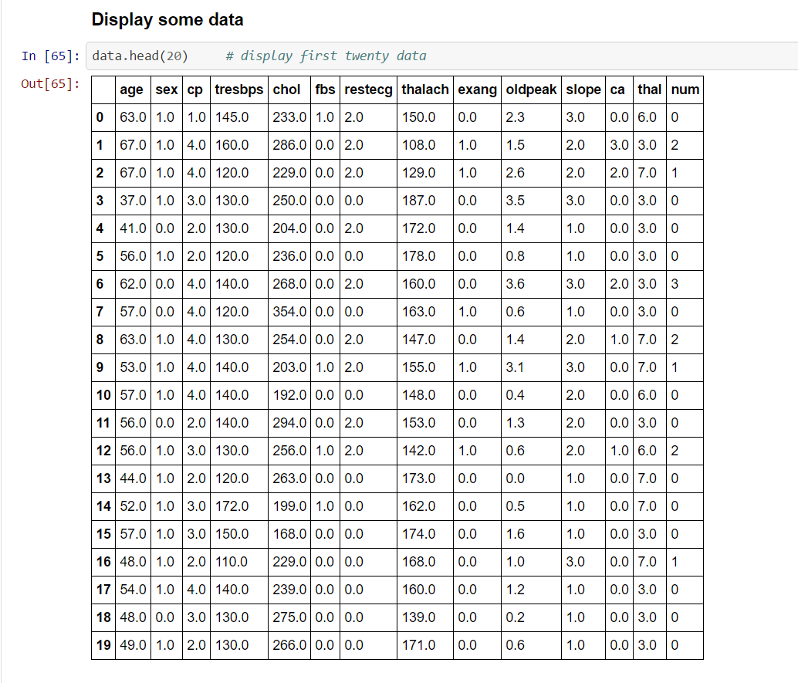

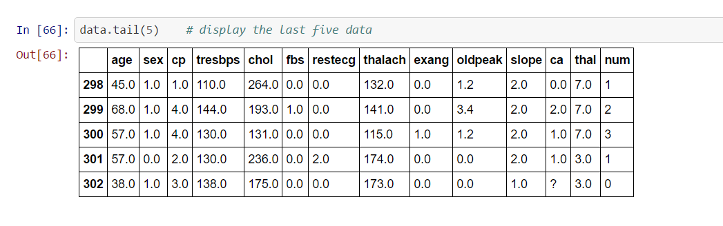

- // the result of the prediction
- // please remember to write a function to loop through the test and predicted list, print them out to compare the data.
- Use case Diagram

3.3.1.1 Use cases:
A typical use case is one where a patient in a hospital is tested and the result of this test is passed to a program that uses the machine learning model to predict the patient’s heart disease status. This is a step forward from expert systems, based on the accuracy of the results.
// draw a diagram.

3.3.1.2 Activity Diagram

LOAD THE DATA INTO THE PROGRAM

CHECK FOR INVALID, NULL OR FALSE POSITIVE VALUES IN THE DATASET

REMOVE THE INVALID DATA IF ANY

Physical Design
Program Specification
Layout of Tables and Database Structure
System Controls
//how the pandas dataframe is structured.

