Question 4)

[Survey – 40 pts] Write a 2~3 pages survey report on a specific 2D-data measurement/detection problem related to automotive engineering (e.g.: lane detection, traffic sign detection, drivable area detection, a B-scan inspection for a manufacturing component, material characterization using microscopy image, et al. It is not limited to camera data. A negative example: ‘Obstacle detection in 2D image’ is not considered to be a specific problem because obstacle is not a specific target).

The grading of this question is based on the contents which the survey covers:

- The importance of this measurement (5);

- The challenges of measuring this target (5);

- Existing solutions of measuring this target (15);

- Existing problems of measuring this target (5);

There will be other grading factors (such as novelty, organization, et al) (10);

\* You are encouraged to include any drawing/table in the report;

\* Attention: use “…” [1] to cite any sentence you literally copied and use … [1] to cite a content you referred to, with reference list in the end;

ANSWER:

1. The importance of this measurement.

Lane Detection is required for various ADAS features and purely autonomous vehicles. The lane detection is a virtual assistant to improve driving safety and reduce traffic accidents. The lane boundaries are detected to avoid collisions and issue warnings if a vehicle passes a lane boundary. It is important to precisely detect the lanes by applying computer vision because at times the lane boundaries are not clearly visible.

* Lane Keep Assist: The lane detection helps the vehicle to avoid drifting out of the lane unintentionally by continuously providing inputs to the steering of the vehicle. Also, it has features to warn the driver in condition of lane departure through audio, visual or vibration signals (seat pulses in the direction of the lane and steering wheels).
* Eliminate illegal parking of vehicles: In certain countries like Korea, a surveillance vehicle is used to collect pictures of illegally parked vehicles for penalizing these incidents and regulation of law and order. This vehicle uses a camera that detects if the vehicle is parked outside the dedicated lane for parking.

1. The challenges in measuring this target.

Despite the perceived simplicity of finding the white markings on a dark road, it can be very difficult to determine the lane markings on different types of roads due to the following reasons.

* 1. The biggest challenge with detecting lanes is that, often the lanes are not clearly visible. This is due to poor road conditions, insufficient quantity of paints used for making the lane boundaries.
  2. Often the environment factors like hail, snow, road potholes filled with water make it difficult to detect the lane lines in such regions
  3. Shadow and other opaque objects: Sometimes there are objects on the road, occlusion by other vehicles ahead of the car or littered objects on the road that cover the lane markings or the shadows from trees or the vehicles that makes it difficult to detect the lanes
  4. Illumination conditions: Inadequate streetlight intensity, nighttime condition, fog makes it challenging to detect lane markings on the road. The sunlight affects the road color during the day compared to dusk or dawn time. The RGB gray value will be nearly 130-170 more and 80-130 with shadow. Approaching headlight or the back light also affects detection.
  5. Different type of lane markings: No governing standard for the geometry of road markings makes it difficult to consider geometry as the only parameter to discriminate the lanes.
  6. The road splitting or merging and the interferences from the roadside objects worsen the detection successfully.

All these challenges make it difficult to discriminate between the road lane from the background in a captured image.

1. Existing solutions of measuring this target.

The erroneous findings will generate wrong steering commands that might jeopardize the vehicle safety. Therefore, a robust and reliable algorithm is the minimum requirement.

* 1. Distortion removal with camera calibration: Most of the vehicle-mounted cameras are wide angle lens in order to obtain an enlarged field of vision and the image distortion changes appeared remarkable. In the actual road scene edge distortion of lanes, vehicles and background is called radial distortion. And if the camera is not parallel to image plane of sensor, image is tilted that makes the scene appear closer than its 3-D world position. This is more disadvantages tangential distortion. The mathematical model of the two distortions are as follows:

 

1. Mathematical model of radial distortion 2. Mathematical model of tangential distortion

The parameters k1, k2, k3, p1, p2 are acquired by camera calibration and using a checkboard calibration plate composed of black and white grids with regular shapes to easily find corner points and observe the correction conveniently. A transformation matrix is created to map the distorted points to the undistorted points and the distortion is removed using coordinate transformation.

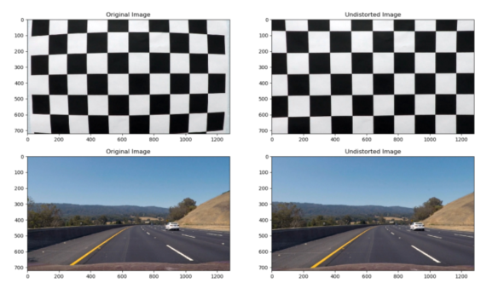

2. The correction of the distorted image

* 1. Edge detection solution by superimposing the threshold of Sobel operator and HSL color space and less computational cost: The Sobel operator performs edge detection of the image from horizontal and vertical directions and sufficiently filters the interference noise with the improved image processing effect. Only Sobel operator has low detection accuracy and rough edges. Therefore, HSL color space where Hue, saturation and lightness can be used. The position of spectral color represented by angle and different color values correspond to different angles. S refers to the degree of color to describe the similarity between the image and the standard. S [min=0 (grayscale image) where H is undefined to max =1, fully saturated]. L indicates the degree of the image color which changes along x axis. The HSL color space better reflects the visual field perception characteristics and each can be processed independently. By binarizing the image, useless interference information can be removed to speed up the operation of the detection algorithm.

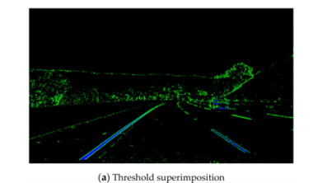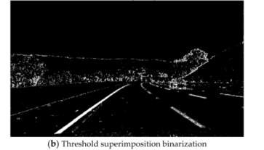

3. Gradient threshold and color threshold superposition.

* 1. ROI Extraction and Inverse perspective Transformation: The effective portion of a frame that is lane accounts for two-third of the area detected is extracted. Using the vanishing point setting extracted from the Hough transform an adaptive ROI can be established to reduce computational cost and time for lane detection.

Also, since the inverse perspective transformation is based on the inverse coordinate transformation from world coordinate to image coordinates, it transforms the perspective image into aerial view and restore the parallel relationship between the lane lines. As compared to the distortion removal, the IPT maps the position points in detected image to the new position points overlooking the perspective to obtain the aerial view of the road image. 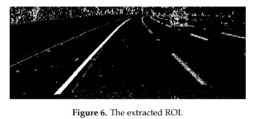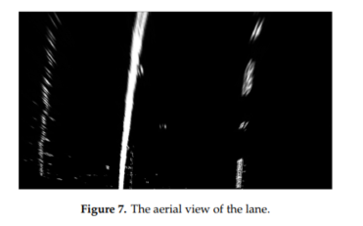

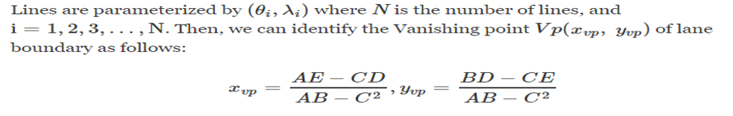

* 1. Mask Operation, B-spline Curve and RANSAC: The road conditions that are susceptible to environment factors and for dynamic driving while maintaining a high recognition rate with high accuracy. The interfering pixels that can cause false detection in the next lane frame can be done by masking the detected necessary image. The mask operation clearly shows the target pixel point by weighting and averaging the pixels around the target pixel that contributes to sharpening the detection image. The actual lane under complicated road conditions tend to vary therefore a third-order B spline curve can be adjusted accordingly for best fit. The RANSAC that is a randomly sampling algorithm that first obtains random points from a large number of observation data points and then the valid points are selected that meet the hypothesis to estimate the corresponding models after optimization through continuous iteration for accurately fitting based on the effective parameters.

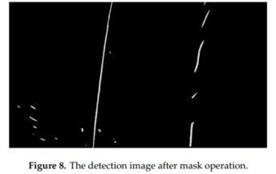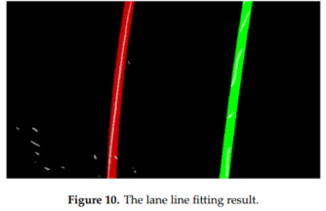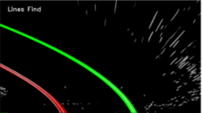

1. Existing problems of measuring this target.
   1. Image Distortion: Although most of the camera lens enable rapid generation of the images, the images get distorted. Image Distortion: Although most of the camera lens enable rapid generation of the images, the images get distorted. The distortion changes the shape and size of the lane, vehicle, and background in the road scene. These changes are not conducive to judging the correct driving direction and determining the exact location of the vehicle. Therefore, it is essential to remove image distortion. The changes are not conducive to judging the correct driving direction and determining the exact location of the vehicle. Therefore, it is essential to remove image distortion.
   2. Edge Detection: The edges of an image and the structure intensity surrounding them contains an essential information about the scene, the edge detection is important step in scene analysis for lane detection. There are certain problems while detection the edges. Firstly, the edge detectors are not robust to changes against the background noise or the noise introduced by the image capturing system. That is, it should not falsely detect edge caused by noises nor it should miss weak actual edges. Secondly, the edge detectors fail to localize the edges correctly. And third, if the brightness in the scene are non-homogenous their boundaries are not indicated by perfectly closed contour. Although many algorithms are robust but single-edge detection operators (Canny, Prewitt, LOG etc.) have many problems including a too-wide detection range, poor anti-noise interference and prolonged calculation time.

<https://ieeexplore.ieee.org/stamp/stamp.jsp?tp=&arnumber=633081>

* 1. ROI extraction: The substantial redundant information such as sky, tress and vehicles remain in the image and also the two lane lines that appear near-wide and far-narrow gradually meet and make it difficult to detect the lane at later stage. This extra information requires unnecessary computation and also increase the time for computation of the subsequent image processing step.
  2. Vanishing point: The closer is the object to the camera the bigger it gets and vice versa. The parallel lines of the lanes merge into a point in the distant field of vision that is known as vanishing point. The distance between the adjacent lanes near the vanishing point decreases gradually that is detrimental to the effective lane detection.