Homework 3 Student Name: __SHAURYA PANTHRI____

AuE 8930: Machine Perception and Intelligence

Instructor: Dr. Bing Li, Clemson University, Department of Automotive Engineering

* Refer to Syllabus for homework grading, submission and plagiarism policies;

* Submission files includes (Due March. 25, 2020 11:59 pm):

* This document file (with answers), and with your program results/visualization;
* A .zip file of source code (and data if any) with names indicating question number;

Note: You can use any 3rd party libraries and built-in functions

Download the Apollo “Lidar Point Cloud Obstacle Detection & Classification” dataset and description (LiDAR_datasets.zip and LiDAR_datasets_description.pdf) from Canvas/File Homework 3 folder: This Lidar dataset is collected from a 3D Velodyne HDL-64E Lidar. You will find the .bin (point cloud) files for each scanning frames. Please pay attention that in the description pdf, it says:

* The point cloud data are stored in the format of binary files.
* The data are arranged in the order of X1, Y1, Z1, I1, X2, Y2, Z2, I2… (Xi, Yi, Zi refer to the spatial 3D coordinates of each point.
* Ii represents the reflectance value of this point and the effective value of the reflectance value is from 0 to 255)
* The data in each dimension are stored as the four-byte float type.

Question 1) [10 pts]

Select a frame (or a few frames) of LiDAR data file, parse the file and visualize the 3D point cloud of this frame, colored by its reflectivity value.

**ANSWER:** I read all the binary files using wild card in the directory and opened the files using fread and fopen function in MATALB. I sliced the x y z and Intensity in different arrays and created a point-cloud object in MATLAB and plot it using pcshow function.

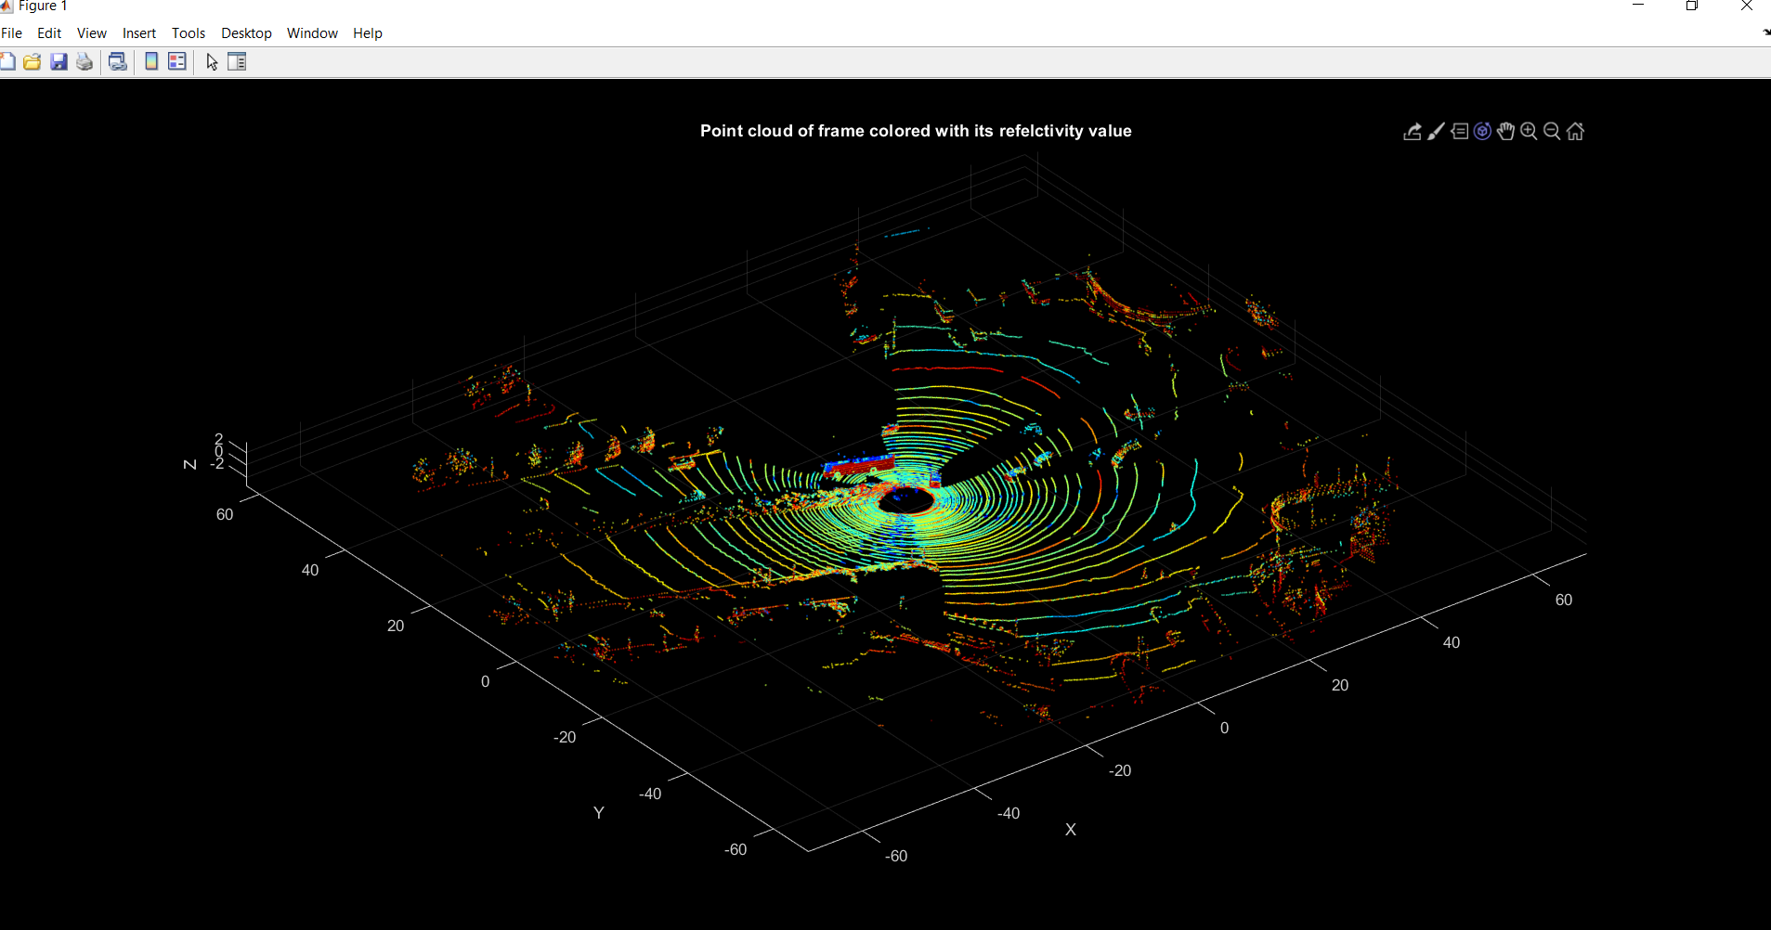

Question 2) [10 pts]

Choose a 3-D resolution granularity, perform voxel filter (or box grid filter) to down-sample all the 3D point cloud points to the 3D voxel space points, and visualize the result points.

ANSWER: After using three different downsampling techniques I used pcdownsample that returns a downsampled point cloud using a non-uniform box grid filter. The maximum number of points were selected as 7 in each grid box.

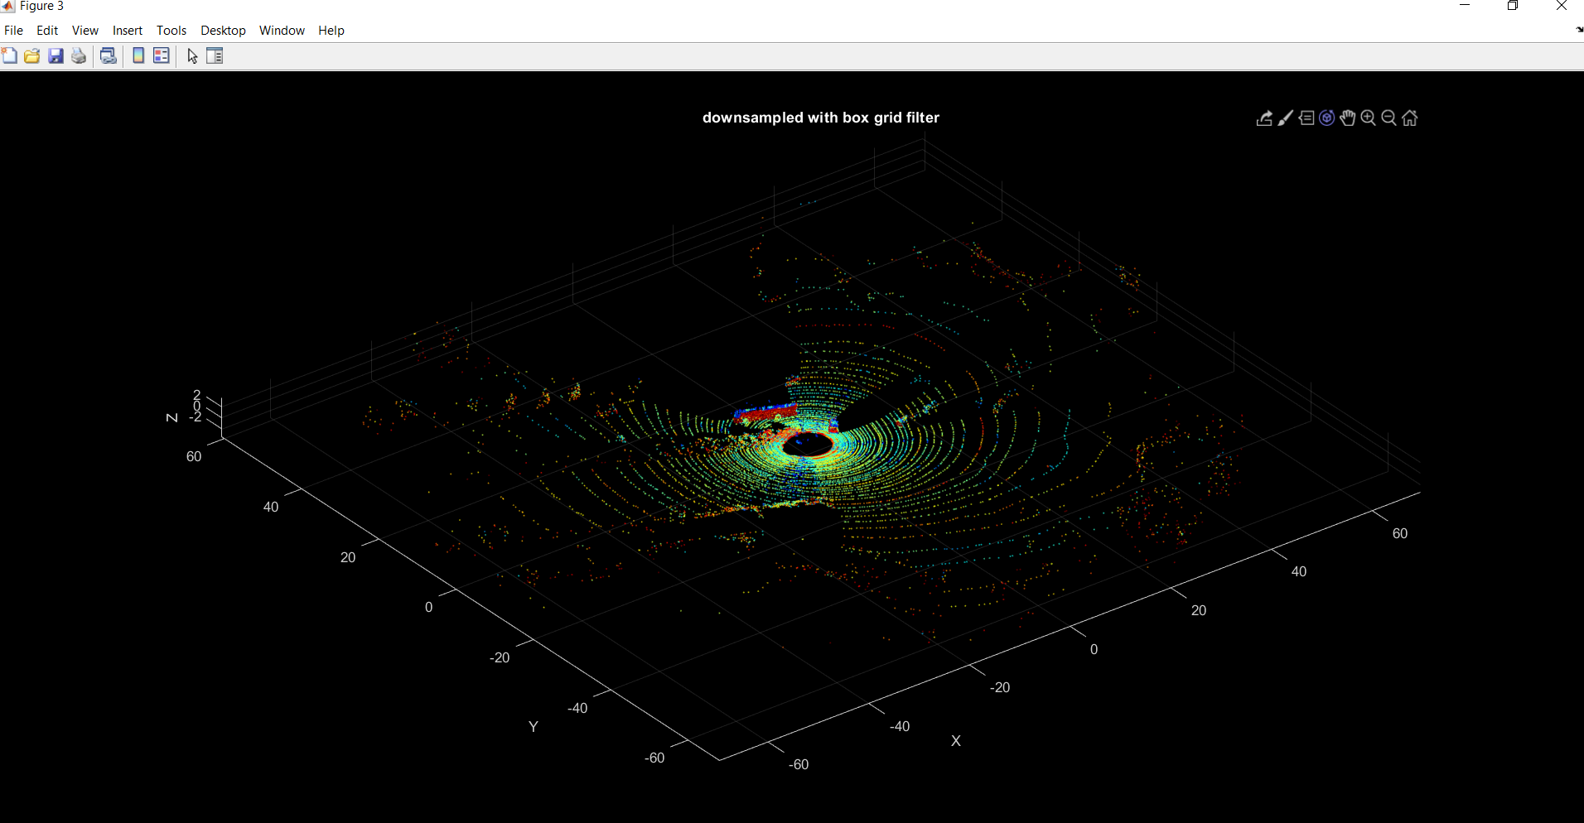

Question 3) [20 pts]

* Apply RANSAC algorithm (or any others you prefer) to the 3D voxel space points to find a ground plane model. Print out your plane model parameter values result, visualize the plane with the points in the 3D (10 pts);
* Analyze the computational time complexity of this algorithm (5 pts).
* Remove all the ground planes points in the 3D voxel space points, visualize all the off-ground points in the 3D (5 pts);

ANSWER:

Model Parameter Values: 0.0255 0.0091 0.9996 1.6198

And Model Normal are: 0.0255434235233523 0.00913565874180085 0.999631968903586

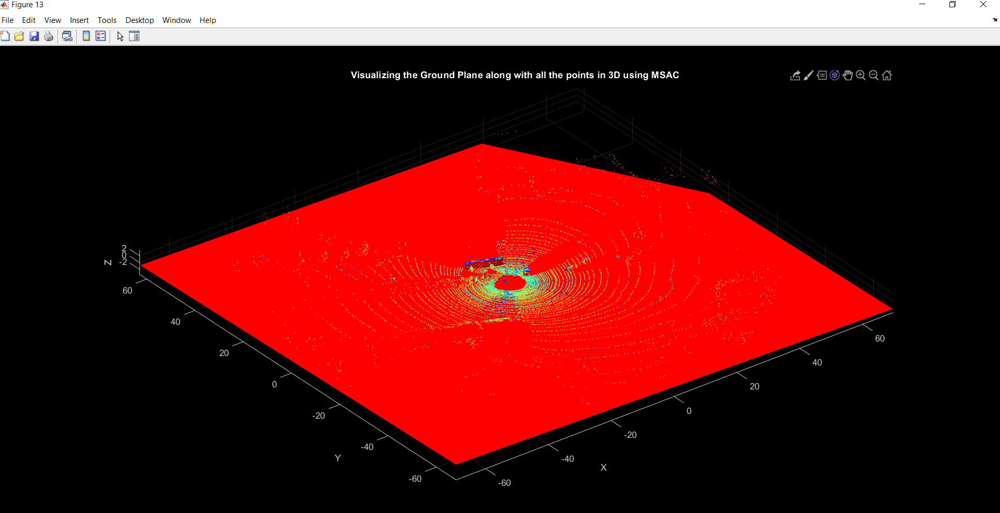

Analyze the computational time complexity of this algorithm

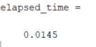

"The time elapsed to run this algorithm is:0.014546"

Remove all the ground planes points in the 3D voxel space points, visualize all the off-ground points in the 3D

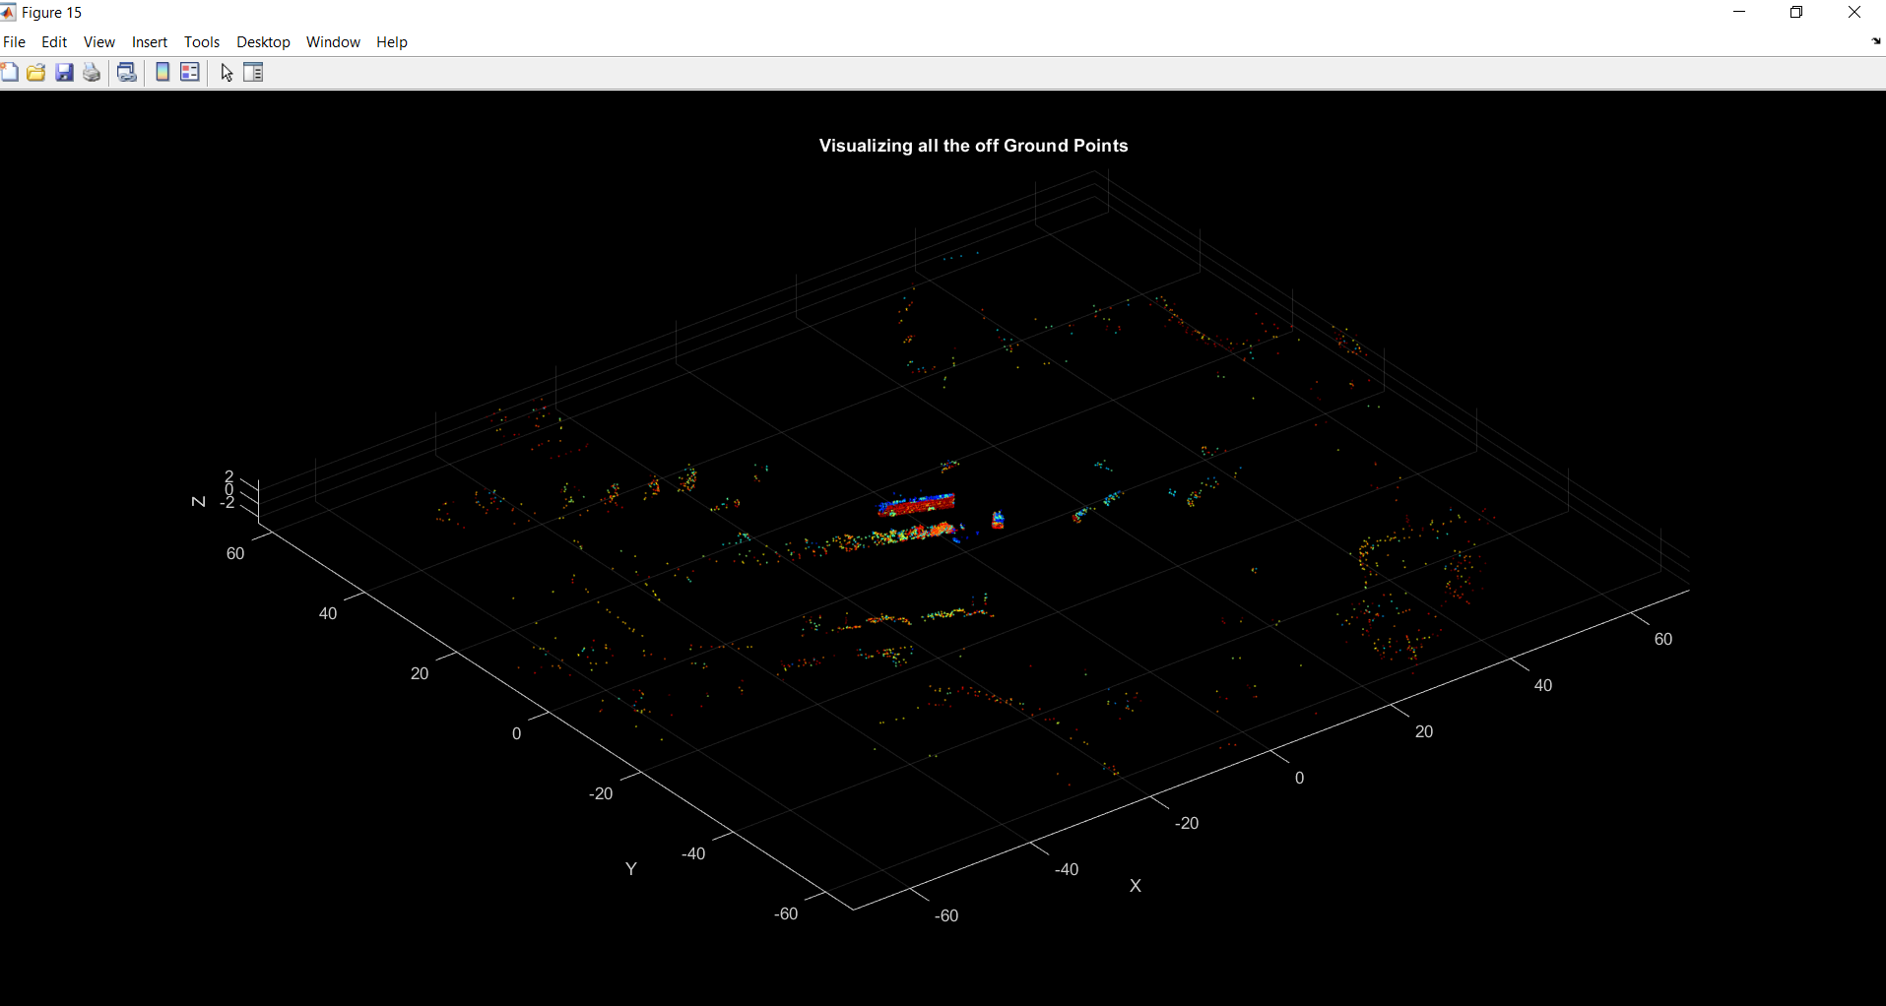

Question 4) [10 pts] 1

Perform a x-y projection to the off-ground points and get a 2D matrix (you decide what is the element value) and visualize the 2D matrix as an image.

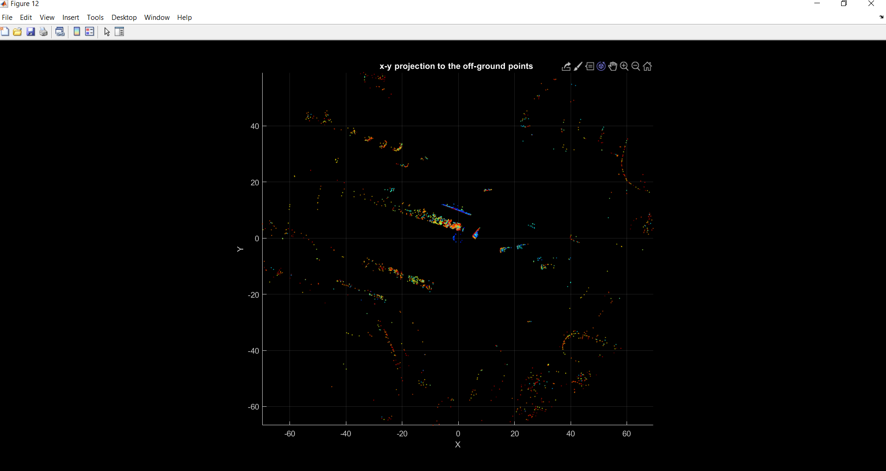

Question 5) [10 pts] 2

* Based on the raw point cloud data (Questions 1), which is in Cartesian Coordinate, represent and visualize all the point cloud in spherical Coordinate (with horizontal and vertical angles and distance to the original) (5 pts).

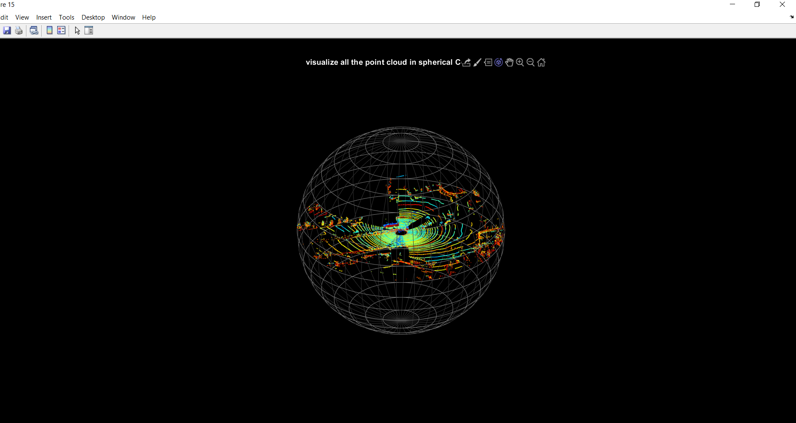

* Finally, generate the projected 2D depth image w.r.t horizontal and vertical angels, with intensity value using the distance. Visualize the 2D depth image (5 pts).

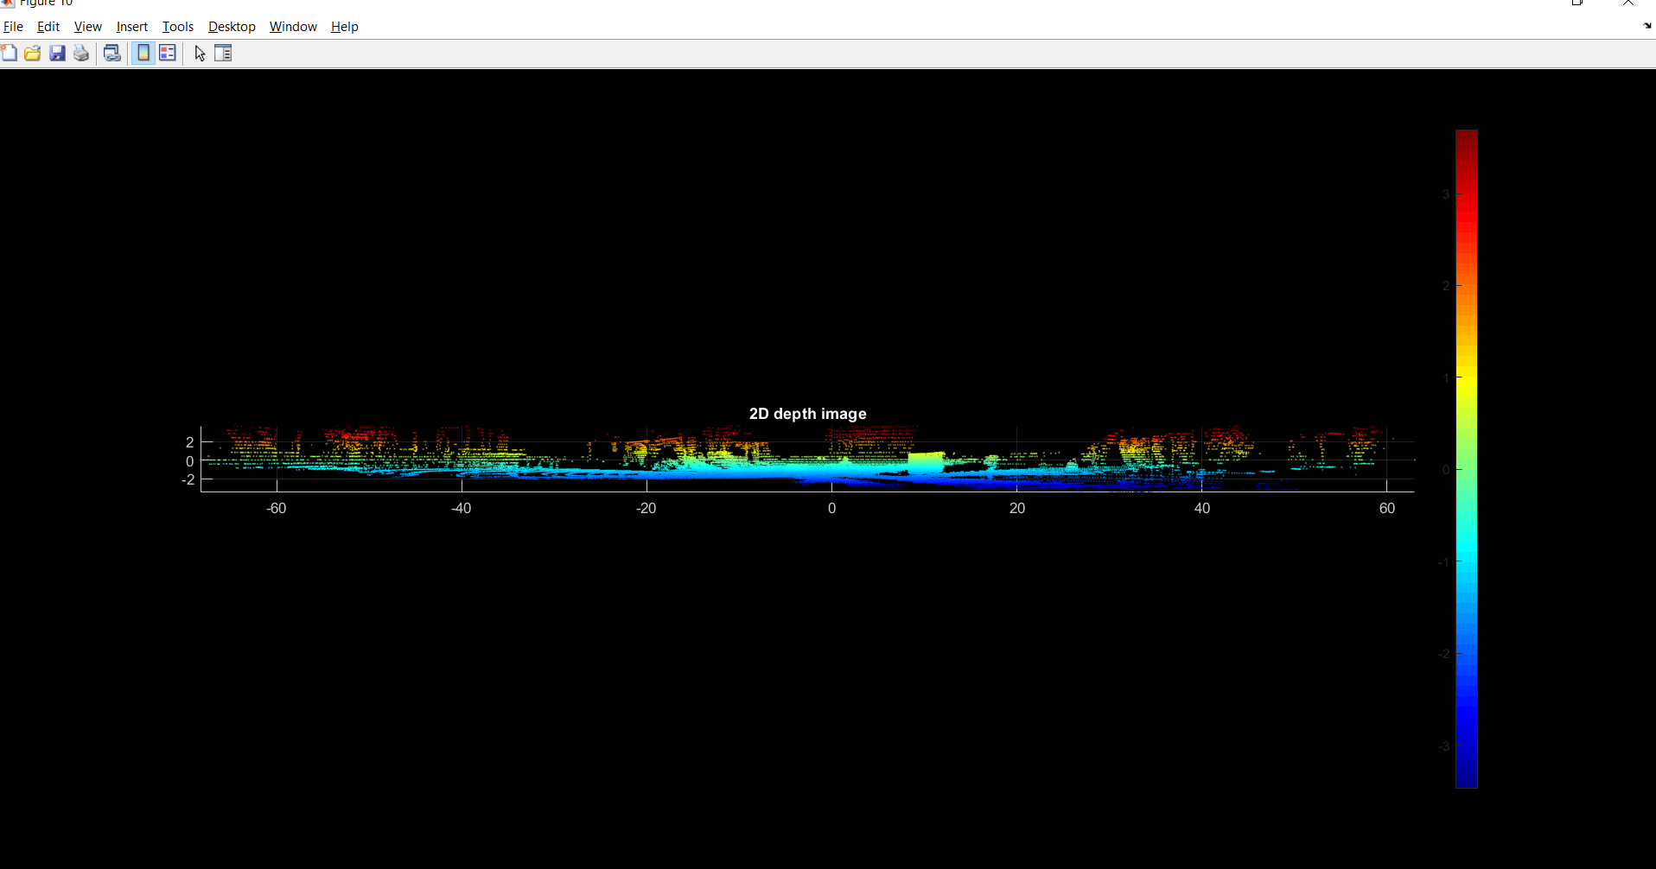

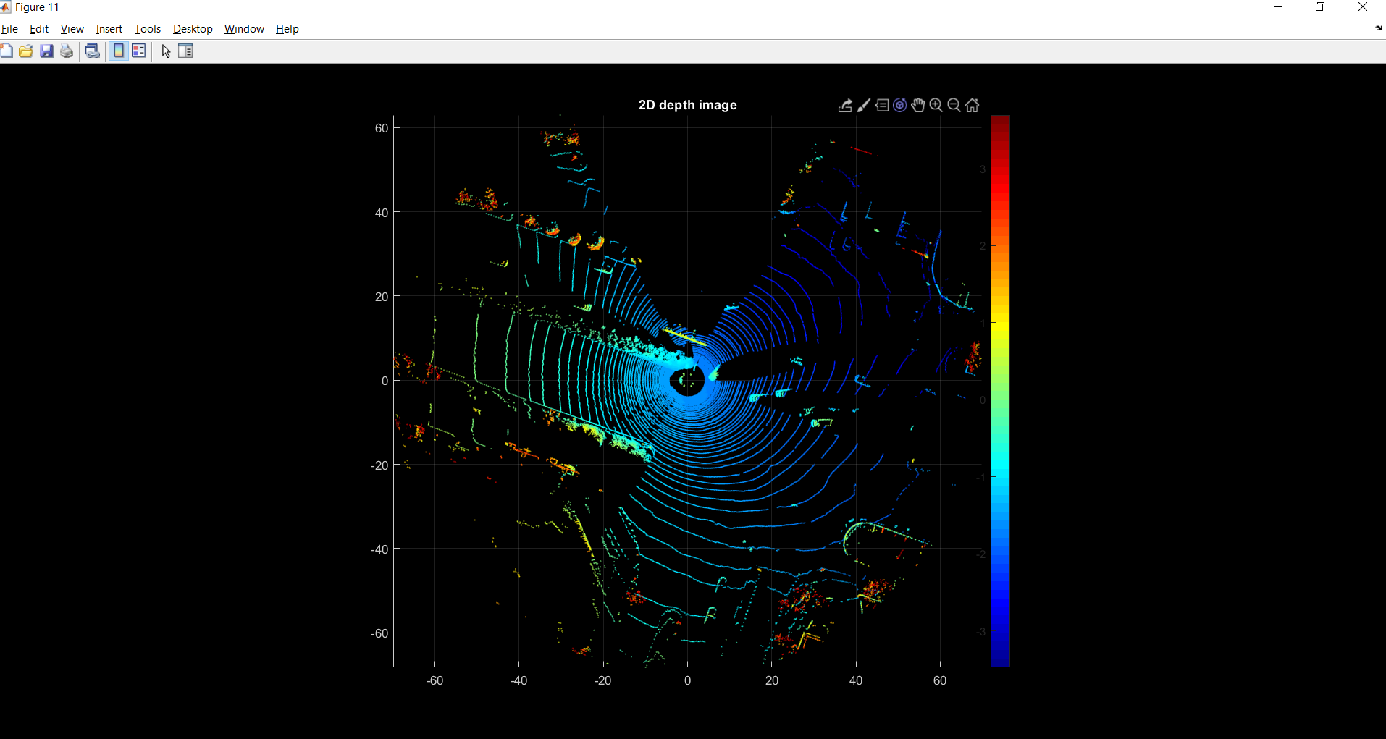

The magnified images of the projections of the 2d Depth images.

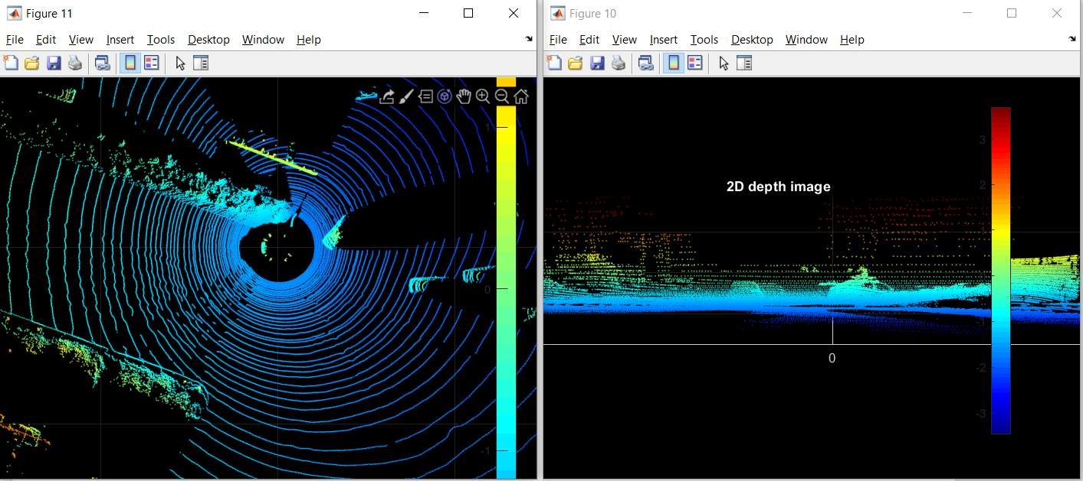

Question 6) [40 pts]

Write 2~3 pages of survey on a 3D data measurement related to vehicles.

The grading of this question is based on the contents which the survey covers:

- The importance of this physical quantity measurement (5);

- The challenges of measuring this physical quantity (5);

- Existing solutions of measuring this physical quantity (15);

- Existing problems of measuring this physical quantity (5);

There will be other grading factors (such as novelty, organization, et al) (10);

* You are encouraged to include any drawing/table in the report.

* Attention: use “…” [1] to cite any sentence you literally copied and use … [1] to cite a content you referred to, with reference list in the end;

**ANSWER: 3D measurement of LIDAR.**

Since the entire automotive industry is looking forward to autonomous vehicles and assisted technologies. The companies are coming with the innovative assisted technologies. The concept of fully autonomous vehicles is impossible without the LIDAR based ADAS systems along with other sensors to take control over the vehicle and manage the speed, steering and therefore supplying a safe driving experience. Lidar is able to sample points extremely quickly — up to 1.5 million data points per second.

**The importance of this measurement:** Lidar answers Where am I? and Where are others?

3D mapping and images of the surrounding: The Lidar sensors continuously rotate and generate the thousands of high-speed laser beams that are continuously emitted in the 360-degree surroundings of the vehicle and are reflected by the objects in the way. With the use of complex machine learning algorithms. The data received through this activity is converted into 3D graphics known as the 3D point cloud or real time map of surrounding. It provides accurate object detection and recognition of 3D shapes and even for longer distances (100-200 meters) with cm accuracy and also the velocity of the objects around. [1]

1. **Differentiating objects:** With the 3D mapping capability the LIDAR data also helps in differentiating between the cars, pedestrians, trees, people, or other objects. It helps to command the brakes to slow or stop the vehicle. When the road ahead is clear, it also allows the vehicle to speed up.
2. **Pre-Scan:** LIDAR can also be used to scan the road surface and this information can be fed to the on-board computer, processed in a fraction of a second, adjusting the individual suspension at each wheel. **(Active Suspension)**
3. It is necessary to find intersections in advance especially when there is **no position or geographic auxiliary information available**. This is done using a LIDAR to classify the intersections ahead so that **motion planning and navigation can be done in advance**.
4. Feed data into various safety systems like **Collision warning and avoidance systems** that generates audio/visual/physical warning signal. Also, helps in **blind spot monitoring**.
5. The measurement is used for driver’s assistance systems for example **lane keeping assistance, lane departure warnings, adaptive cruise control** that assists the drivers and automate certain driving tasks

**The challenges in measuring this target.**

1. **Classification and segmentation problems when objects are close**: This happens due to clustering that is when we need to perform segmentation in detecting which measures belong to same object and clustering them into its corresponding set. Its challenging to avoid constructing segments from measures of various obstacles when distance between the objects is small and thus makes it difficult to distinguish that the measurements are not from same object. For example, a fleet of same cars are tailgating at high speed or parked one behind other.
2. **High computational cost and complexity**: The Lidar used for driving assessment scenario first of all assess the environment in the 360 FOV set data known as point cloud which is organized in layers organized in elliptical patterns with same orientation. The system then analyzes the data to extract the meaningful information such as number of obstacles, vehicles and their velocity and also classify them into different classes. The segmentation and processing require high computational speed and complexity.
3. **Mechanical/ MEMS Lidar Reliability and Robustness:**  The MEMS lidar system uses tiny mirror whose tilt angle varies when applying a stimulus such as voltage. The lidar requires multiple mirrors to move the beam, in multiple dimensions. This arrangement and all mechanical Lidars are not trivial and once installed are prone to shocks and vibrations encountered in moving vehicles. Another problem is that MEMS based systems is that automotive specification start at -40 (deg. C) that is impossible for MEMS device.
4. **Slow refresh rate of spinning Lidar system and Aiming and Alignment Errors:** The refresh rate of the system is limited by how fast the complicated optics can rotate. Approximately 10Hz is the speed of fastest lidar and this hence limits the refresh rate of data stream. For example, a car moving at 60 miles per hour travels 2.93m in 1/10th of the second as the lidar rotates. Therefore, the sensor is blind to changes happening within 2.93m. This means that an object detected 120m away in perfect condition for lidar equates to 4.5 seconds of reaction time for a car moving at 60mph. The beam that are narrow should be closely aligned to tolerances otherwise due to misalignment there are erroneous measurement recorded. An alignment error that is greater than half the bandwidth will place the crosshairs outside the beam.

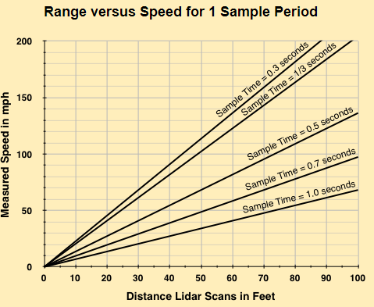 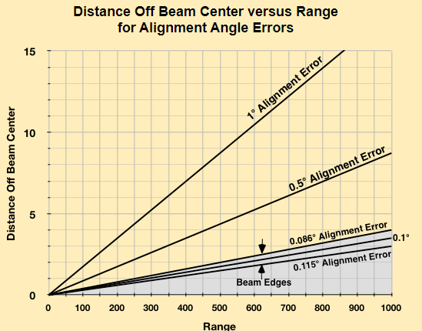

**Existing solutions of measuring this target**

* **Detect Intersections for navigation and path planning** is done advance especially when there is no position or geographic auxiliary information available. A 3D point cloud-based solution for intersection and road segment classification can be done using a beam model for analysis of features by building a grid map and clearing the cells that belong to other vehicles. Then a specified beam model is applied with specified distance to extract feature based on length of distribution of beam from current beam frame that is combined with a trained classifier to solve road type classification problem. That is segment and intersection and also distinct between a +- shaped and a T-shaped intersection. [2]

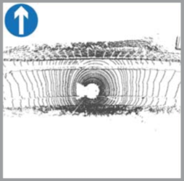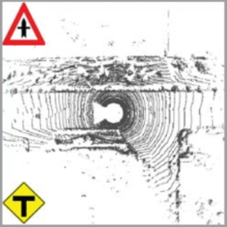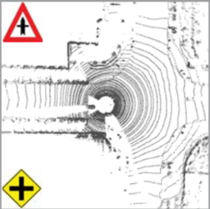

* **New Lidar technology measurement:** The Optical Phased Arrays technology is better than MEMS and flash LIDARs. It is based on PIC (Photonics Integrated Circuits) OPA to steer the beam without moving parts offers low cost at high volume and good performance. Most existing systems use the NIR range (905 nm) because of the compatibility with CMOS technologies. But, in the long term, the SWIR range (1550 nm) will probably experience a high growth because it offers a wider range (200-300 meters) and better performance in bad weather conditions. Currently, one of the major hurdles is the cost of SWIR detectors but new promising technologies like quantum dots detectors are already being developed. [3]
* **Fast Segmentation:** A two-step algorithm that first extracts the ground surface in an iterative fashion using deterministically assigned seed points and then clusters the remaining non-ground points taking advantage of the structure of Lidar point cloud. An iterative deterministic multiple plane fitting technique called the Ground Plane Fitting that is better than the RANSAC for fast extraction of the ground points. The splitting of point cloud into multiple segments initially and fitting a plane to each segment makes it possible to correct the erroneous labelling for ground points. This is followed by a point cloud clustering that is Scanned Line Run for connected components labeling in library images. [4]

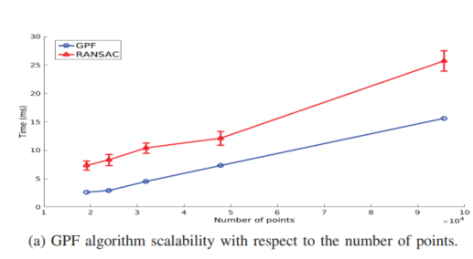 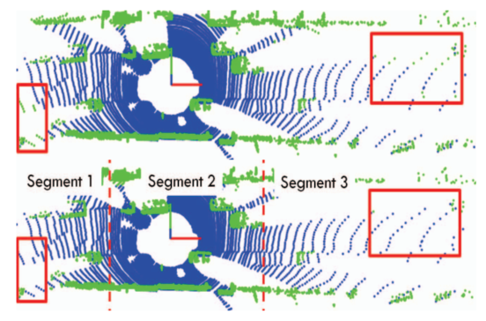

(a) GPF scalability with respect to the points (b)GPF fitting the entire ground plane and GPF for each one of the segments sa

* **Segmentation of objects similar features** that are close to each other a distance-based approach can be used. That is if the objects are closer than certain threshold θ, then they are clustered into the same segment. The adaptive threshold depends on the distance to the object with following formula. **θ = s0 + s1 d(t) + s2 v(t).** The Ramer-Douglas-Peucker Algorithm gives a set of lines for each segment. The model of component line from the first segment that is closest to the second is obtained and used to describe the component lines of second segment that is closest to first. If the model describes the component line with confidence, then two belong to the same object. The positions and the identifiers of each perceived object are stored so that in the next sampling these are associated with the current objects in case they are recognized as the same.

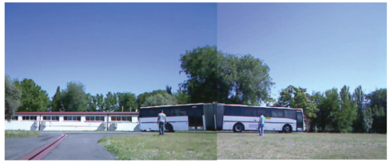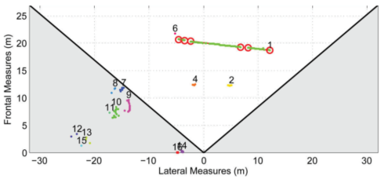 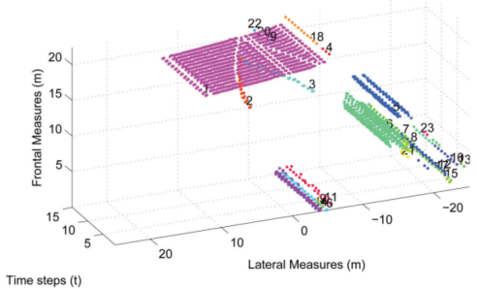

The segmentation divided the bus into 4 components to the occlusion caused by the pedestrians and the next image joins the segments generating a unique cluster of objects. Each sampling is represented as a plane in Z-axis in the bottom right image. As wrongly formed segments are part of distant objects risk of collision is small.

**Existing problems of measuring this target**.

1. Lidar measurements are affected if there is dust or dirt on the Lidar that can be due to bad weather hailstorm also. The opaque particle can affect the translation motion of the beams. Also, Lidar fails to distinguish between a bag and a rock if they are of same intensity in a point cloud. They have shorter operating distance when compared to Radar and complex and computationally costly when compared to cameras or ultrasonic sensors. Also, the beam penetrates the glass of transparent object partially generating scattered point cloud result that might lead to misdetection in some cases.
2. **Size and Cost of the System:** LIDARs mostly are bulky mounted and rotating on the roof of a car. While, new LIDARs have components installed in different portion of the vehicle, still it is way too big or have traded size for performance (resolution and range). They are way too expensive so that it will not be able to meet the automotive industry grade application and a significant design revision is required.
3. **Highly reflective surfaces:** Most materials have rough surfaces on a microscopic level, and scatter light in all directions. A small portion of this scattered light makes its way back to the sensor and is sufficient to generate the distance data. If a surface is very reflective, however, the light is reflected coherently away from the sensor, and the point cloud is incomplete for that area. [5]
4. **Scattering:** The environment and bad weather affects the lidar measurement. The rain, fog and snow also pose issues for the lidar system. The beams go through scattering or some other form of attenuating in the emitted laser pulses. In order to alleviate issues like these high-power laser are used. These are not feasible for low power-sensitive applications or smaller mobile applications.

References:

1. “How Automotive LIDAR works for Autonomous Vehicles,” 11-Dec-2019. [Online]. Available: https://www.einfochips.com/blog/how-lidar-based-adas-work-for-autonomous-vehicles/. [Accessed: 26-Mar-2020].
2. Q. Zhu, L. Chen, Q. Li, M. Li, A. Nüchter and J. Wang, "3D LIDAR point cloud based intersection recognition for autonomous driving," 2012 IEEE Intelligent Vehicles Symposium, Alcala de Henares, 2012, pp. 456-461.
3. R. and M. ltd, “LIDAR technologies for the Automotive Industry: Technology benchmark, Challenges, Market forecasts,” *Research and Markets - Market Research Reports - Welcome*. [Online]. Available: https://www.researchandmarkets.com/research/cvwt57/lidar?w=5. [Accessed: 26-Mar-2020].
4. R. Domínguez, E. Onieva, J. Alonso, J. Villagra and C. González, "LIDAR based perception solution for autonomous vehicles," 2011 11th International Conference on Intelligent Systems Design and Applications, Cordoba, 2011, pp. 790-795.
5. Comet Labs Research Team, “Engineer Explains: Lidar,” *Medium*, 08-Nov-2016. [Online]. Available: https://blog.cometlabs.io/engineer-explains-lidar-748f9ba0c404.

CODE: Question1 to Question5

clc;

clear all;

close all;

bin_files= dir('*.bin'); % Reading all the bin files

open1=fopen(bin_files(1).name); % Opening the first file that is 002_00000000.bin

read1=fread(open1,'float32'); % Reading the values of this file

c=1;

for i=1:4:length(read1);

x(c)=read1(i);

y(c)=read1(i+1);

z(c)=read1(i+2);

I(c)=read1(i+3);

c=c+1;

end

% I=I'

figure()

pt=pointCloud([x(:),y(:),z(:)],'Intensity',I(:)); % ,'Color',[0, 255]

pcshow(pt)

% plot3(x,y,z,'.');

xlabel('X');

ylabel('Y');

zlabel('Z');

%% Question 02

% pt_down=pcdownsample(pt,'random',.50) % pecentage

% pt_down = pcdownsample(pt,'gridAverage',10) % GRid Step (Uniform Grid Average) downsampled point cloud using a box grid filter. The gridStep input specifies the size of a 3-D box.

pt_down = pcdownsample(pt,'nonuniformGridSample',7); %nonuniform box grid filt

figure()

pcshow(pt_down)

title("downsampled")

xlabel('X');

ylabel('Y');

zlabel('Z');

%% Question 03

%[model,inlierIdx] = ransac(data,fitFcn,distFcn,sampleSize,maxDistance)

% [model,inlierIdx] = ransac(data,fitFcn,distFcn,sampleSize,maxDistance)

maxDistance=0.5;

vectorr= [0,0,1];

maxAngularDistance = 3;

tic

[model,inlierIndices,outlierIndices,meanError] = pcfitplane(pt_down,maxDistance,vectorr,maxAngularDistance);

elapsed_time =toc

display("The time elapsed to run this algorithm is:" + elapsed_time)

% figure()

% model.plot;

% title("Ground Plane using MSAC")

% xlabel('X');

% ylabel('Y');

% zlabel('Z');

display(model.Parameters)

% display(model.Values)

hold off

figure()

pcshow(pt_down)

hold on;

model.plot;

title("Visualizing the Ground Plane along with all the points using MSAC with points")

xlabel('X');

ylabel('Y');

zlabel('Z');

hold off;

% Plot the off Ground indices

offgroundplane = select(pt_down,outlierIndices);

figure()

pcshow(offgroundplane)

title("Visualizing all the off Ground Planes")

xlabel('X');

ylabel('Y');

zlabel('Z');

% Plot the on Ground indices

figure()

ongroundplane = select(pt_down,inlierIndices);

pcshow(ongroundplane)

title("Visualizing all the on Ground Planes")

xlabel('X');

ylabel('Y');

zlabel('Z');

%% Question 04

offground=pt_down.Location(outlierIndices,:,:);

% offground=pt_down.Intensity()

offground(:,3)=0;

Intense=pt_down.Intensity(outlierIndices(:,1));

pt_ground=pointCloud([offground(:,1),offground(:,2),offground(:,3)],'Intensity',Intense(:));

% A point cloud object for the projection of off-ground points

figure();

pcshow(pt_ground)

title("x-y projection to the off-ground points ")

xlabel('X');

ylabel('Y');

zlabel('Z');

offground=offground(:,1:2);

figure()

scatter(offground(:,1),offground(:,2),0.11)

title("x-y projection to the off-ground points ")

xlabel('X');

ylabel('Y');

%% QUestion 05

%% cartesian to polar

% [theta(:),rho(:),z1(:)] = cart2pol(x(:),y(:),z(:));

[theta1(:),phi(:),rhoo1(:)] = cart2sph(x(:),y(:),z(:));

% [theta1,phi]=meshgrid(theta1,phi);

figure()

axis equal

% p_cloud=pointCloud([theta1(:),rhoo1(:),phi(:)],'Intensity',I(:))

% pcshow(p_cloud)

% scatter3(theta1,phi,rhoo1,'.');

[x,y,z]=sph2cart(theta1,phi,rhoo1);

plot3(x,y,z,'.','color',0.2*[0 1 0]);

figure()

hold on;

R=max(rhoo1);

latspacing = 10;

lonspacing = 10;

% lines of longitude:

[lon1,lat1] = meshgrid(0:10:360,linspace(-90,90,300));

[x1,y1,z1] = sph2cart(lon1*pi/180,lat1*pi/180,R);

plot3(x1,y1,z1,'-','color',0.2*[1 1 1])

hold on

% lines of latitude:

[lat2,lon2] = meshgrid(0:10:360,linspace(-180,180,300));

[x2,y2,z2] = sph2cart(lon2*pi/180,lat2*pi/180,R);

plot3(x2,y2,z2,'-','color',0.5*[1 1 1])

hold on;

pt1=pointCloud([x(:),y(:),z(:)],'Intensity',I(:));

pcshow(pt1)

axis equal tight off

%% Question 05 part 02 (Depth image)

figure();

pt=pointCloud([x(:),y(:),z(:)],'Intensity',z(:)); % ,'Color',[0, 255]

pcshow(pt);

colorbar();

colorbar('AxisLocation','in');

view(90,0);

title('2D depth image');

figure()

pt=pointCloud([x(:),y(:),z(:)],'Intensity',z(:)); % ,'Color',[0, 255]

pcshow(pt);

colorbar('AxisLocation','in')

view(0,90);

title('2D depth image');