Be a Movie Director

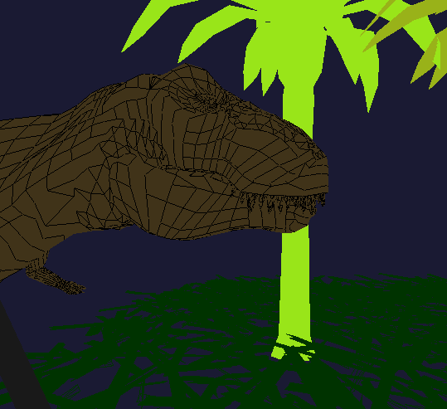

**Description:**

Today you’re going to Hollywood! You will use your knowledge of 3D transformations to help the director get the right camera shots for a scene. You will be implementing various transformations that explore how the camera can be manipulated with OpenGL.

**Your Task:**

* Fill in the public functions for the movie cameras. There is lots of room for creativity in this lab assignment, but there should be at least 5 unique uses of the camera. Here are some examples
  + Orthogonal camera
  + Perspective
  + Different field of views
  + Follow cameras
  + Close up shots
  + Spinning around a point, or moving point

**Files Given:**

main.cpp – Main

movieCamera.cpp and movieCamera.h – Fill in the empty public functions

**Compiling: (On the Mac)**

g++ -Wall -Wextra main.cpp movieCamera.cpp ply.cpp entity.cpp -I/Library/Frameworks/GLUI.framework/Headers/ -framework OpenGL -framework GLUT -framework GLUI -o movie

**Running:**

./movie

**Finished Early?**

* Load more ply objects into the scene
* Add more views into the camera class
* Add a special tessellate function for the ply loader. Then you can call it anytime the camera views models that are close up.
* Draw the viewing volume from the camera when the scene isn’t running.

**Going Further:**

Did you enjoy this in class assignment? The techniques here are very similar to how animation systems, and in-game cinematic cut-scenes are created. Try exploring(i.e. “googling”) the following topics.

* Waypoint systems
* Moving along a path
  + After completing lab 5, you will have some tools to do this.