**Session3 Output**

1. **Task1 :**

**Class name:** acadgild.session3.task1. JavaListing.java

**Input:** HDFS path to list directories and file

**Output:** This will list all the files and directories present in the given input HDFS path

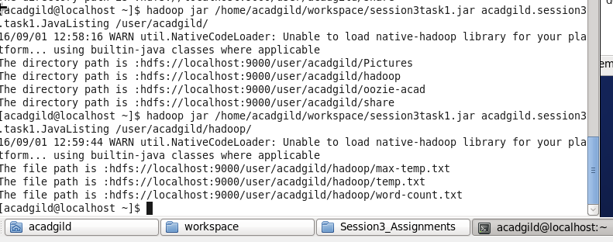

1. **Task2 :**

**Class name:** acadgild.session3.task2. FileListingRecursively.java

**Input:** HDFS path to list directories and file

**Output:** This will list all the files and directories present in the given input HDFS path recursively

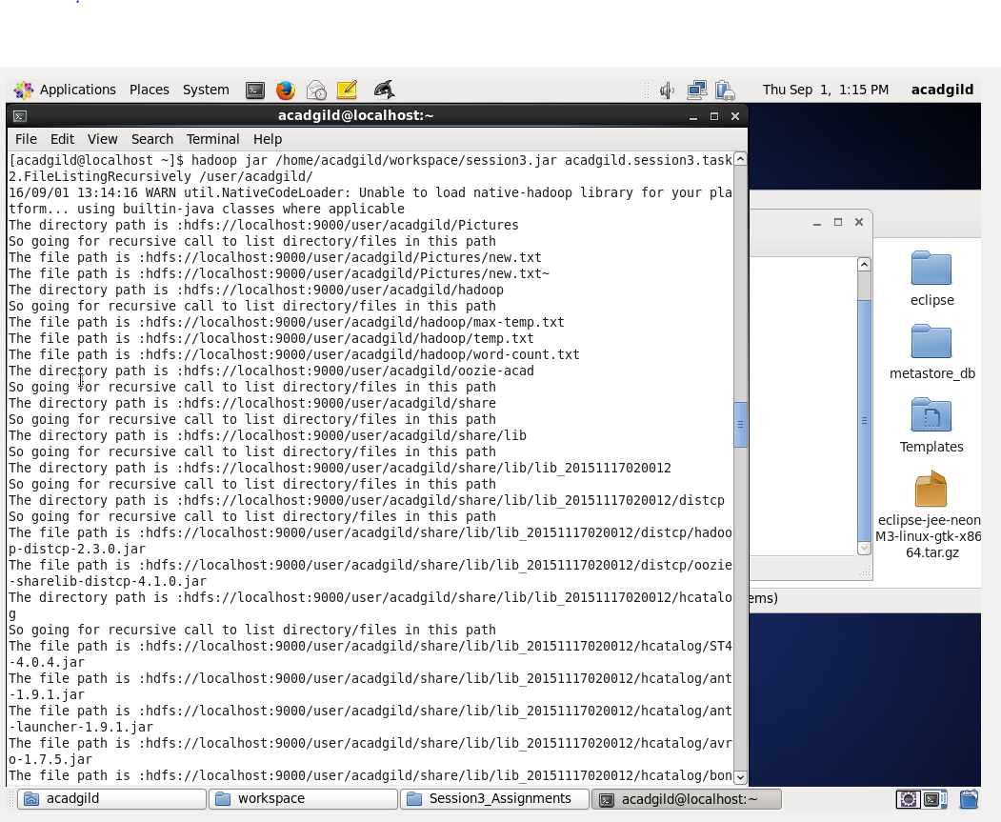

**3.Task3**

**Class name:** acadgild.session3.task3.FileListingRecursivelyForDiffPaths.java

**Input:** MultipleHDFS paths to list directories and file

**Output:** This will list all the files and directories present in the given input HDFS path

