**Session3.2 Assignment Solutions**

1. **Task4:**

**Class name:** acadgild.session3.task4. TimeStampBasedFileListing.java

**Input:** HDFS path, start_timestamp, end_timestamp

**Output:** This will list all the files whose modified time b/w start and end times

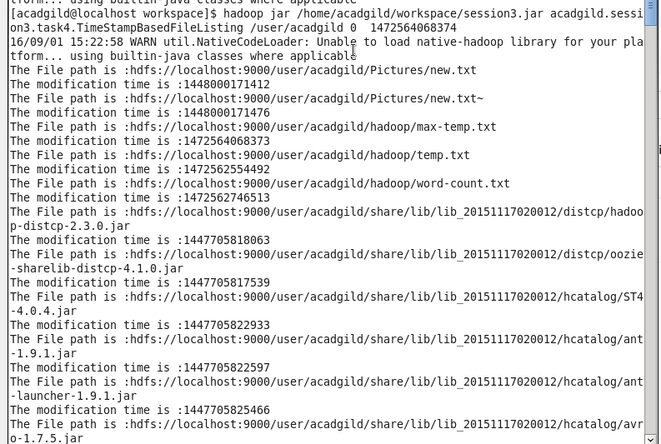

1. **Task5:**

**Class name:** acadgild.session3.task5. FileRead.java

**Input:** HDFS path

**Output:** This will read the content of HDFS file and displays it on the screen

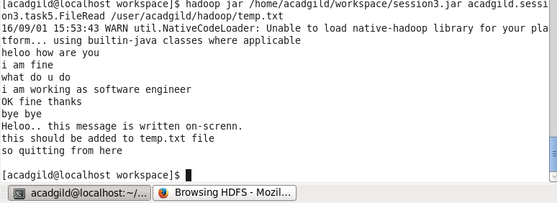

1. **Task6:**

**Class name:** acadgild.session3.task6. FileUpload.java

**Input**: file name **and** HDFS path

**Output:** This will upload/copy the file from local file system to HDFS

