**Task:** Filter Records if product/company name specified as “NA”

**Class:** acadgild.session4.task1.Filter

**Input:**

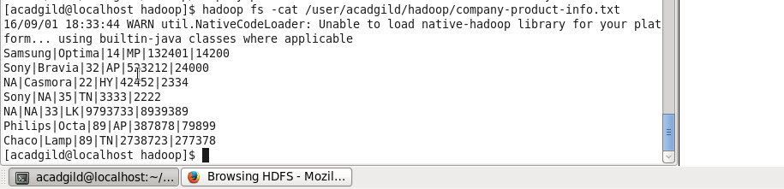

**Running Program:**

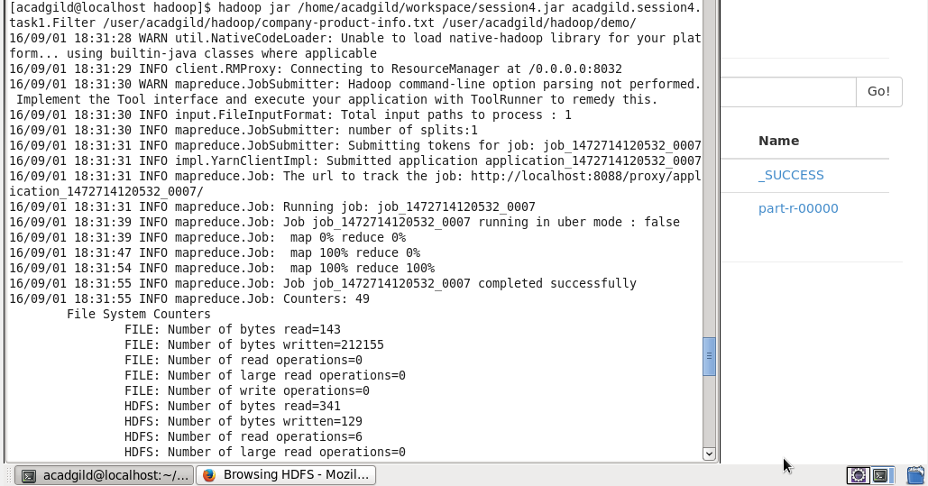

**Output:**

