**Input:**

Company Name|Product Name|Size in inches|State|Pin Code|Price

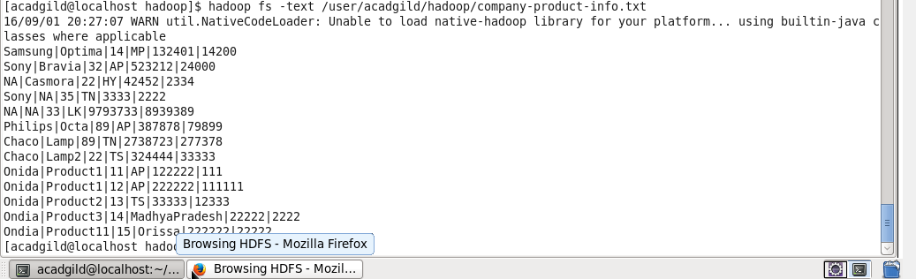

Task2: Map Reduce program to calculate the total units sold for each Company.

Package: acadgild.session4.task2

Driver Class: DriverProg.java

Mapper Class: MapperProg.java

Reducer Claass: ReducerProg.java

**Output:**

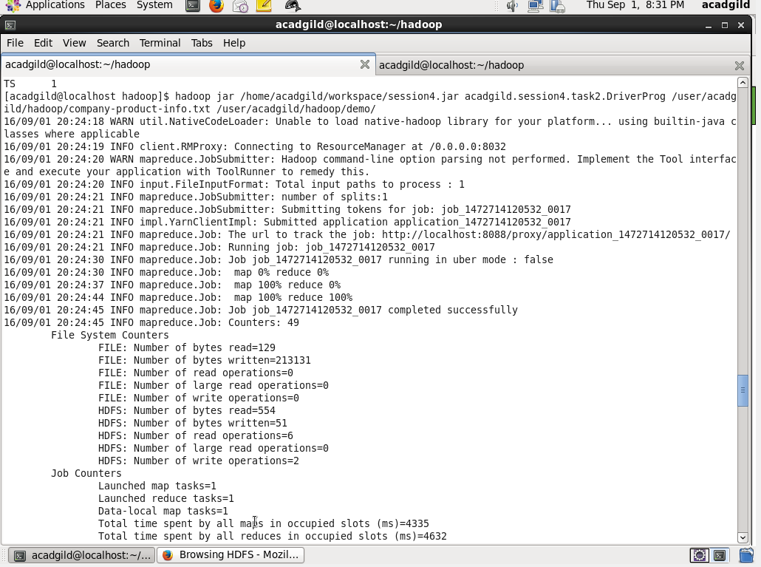

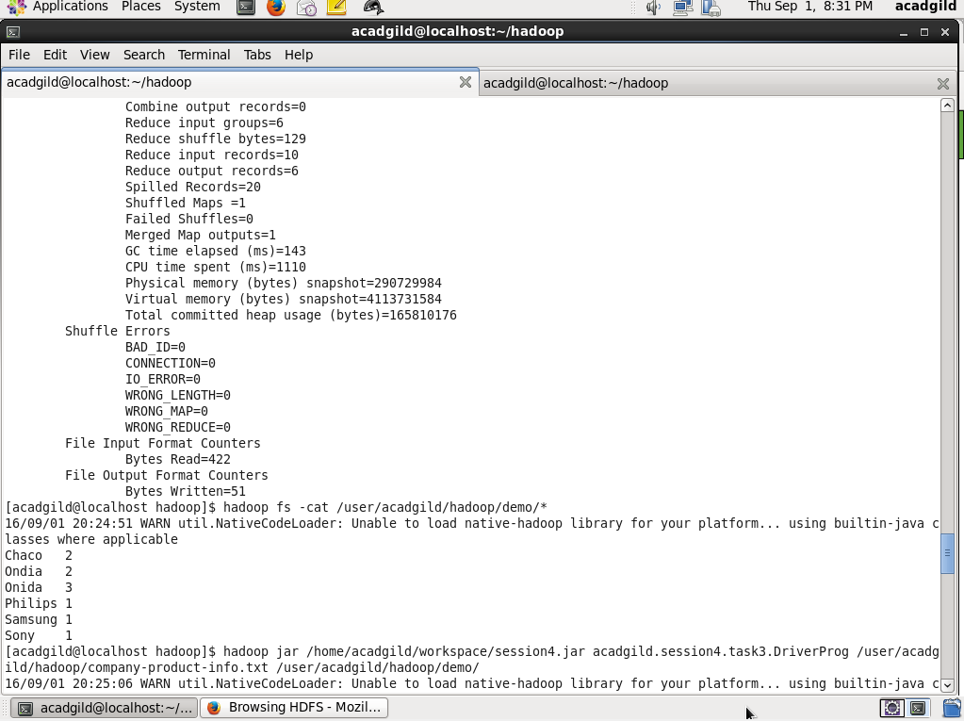

**Task3: Map Reduce program to calculate the total units sold in each state for Onida company.**

Package: acadgild.session4.task3

Driver Class: DriverProg.java

Mapper Class: MapperProg.java

Reducer Claass: ReducerProg.java

**Output:**

