**Input:**

Company Name|Product Name|Size in inches|State|Pin Code|Price

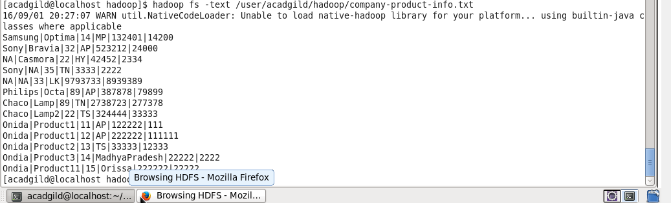

**Task4:** Write a Map Reduce program to modify Task 2 (refer session 4, assignment 2) to use a custom partitioner with 4 reducers.

Make sure that all records whose company name starts with A-F (upper or lower case) should go to 1st reducer,

those starting with G-L to 2nd reducer, those starting with M-R to 3rd reducer and others to 4th reducer..

Package: acadgild.session5.task4

Driver Class: DriverProg.java

Mapper Class: MapperProg.java

Reducer Claass: ReducerProg.java

Partitioner Class: PartitionerProg.java

**Output:**

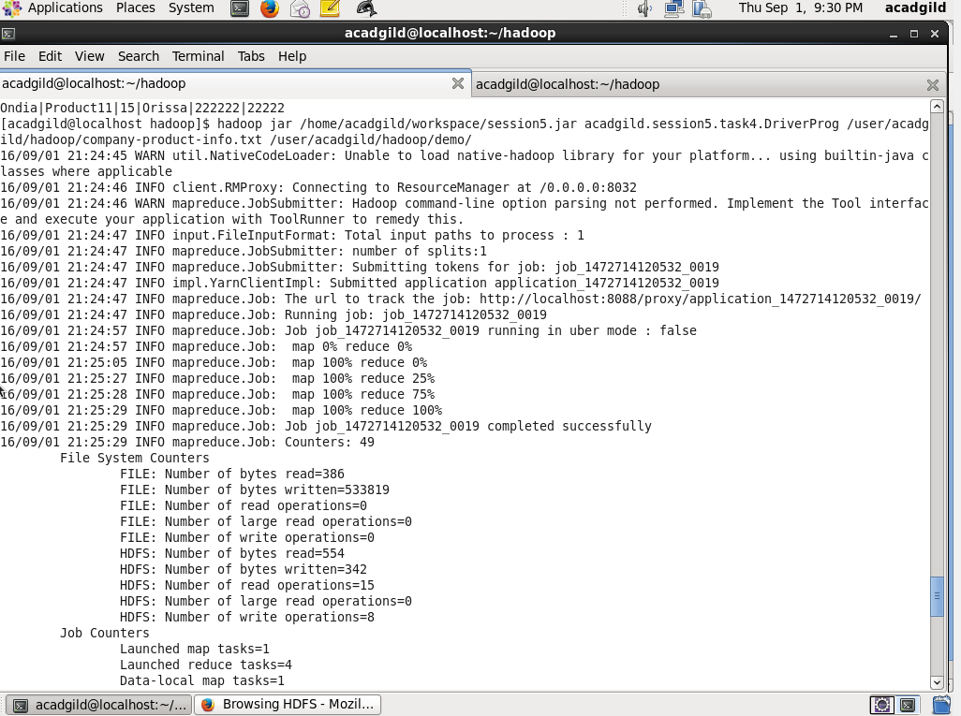

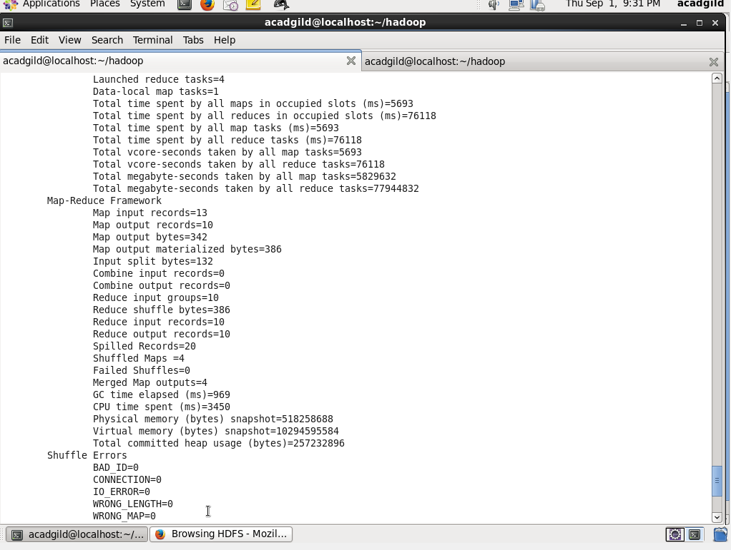

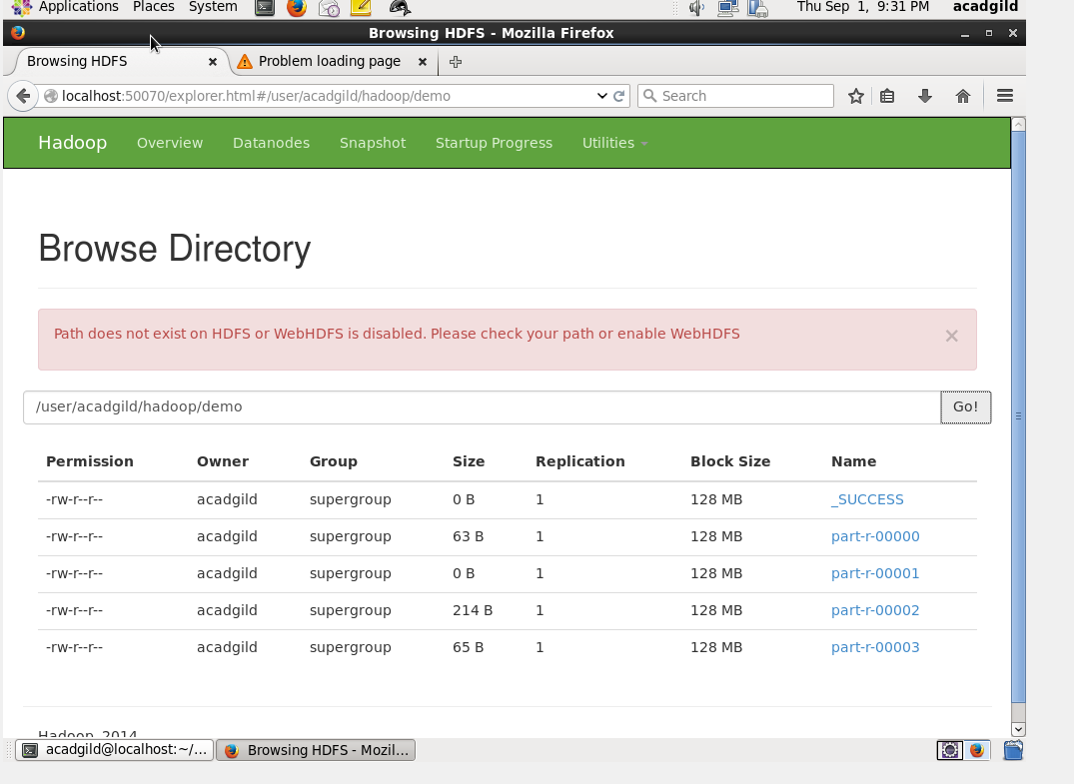

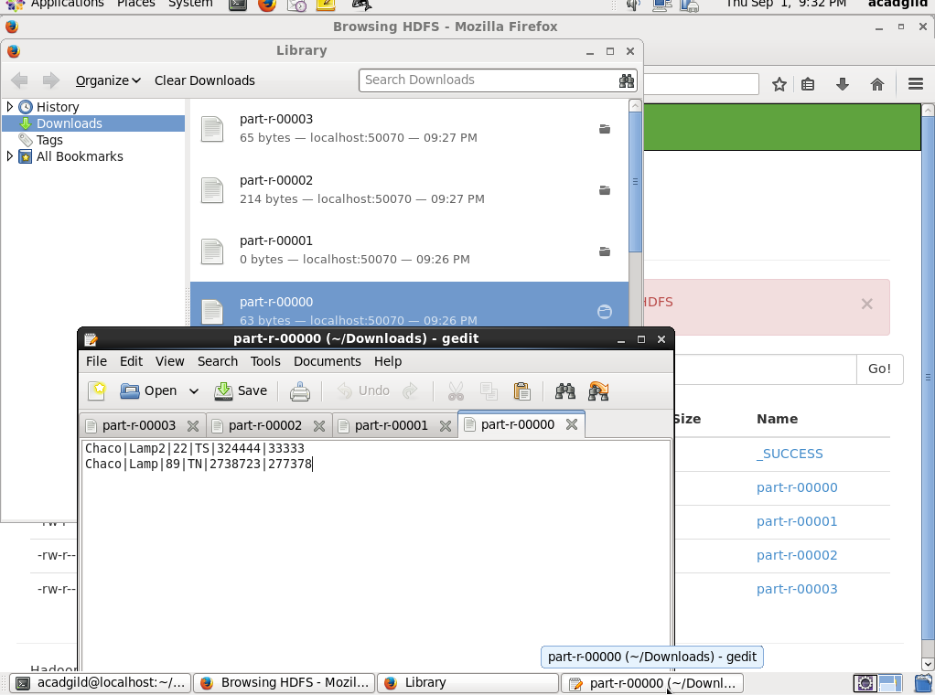

**Task5:** Map Reduce program using combiners to calculate the total units sold for each Company

Package: acadgild.session5.task5

Driver Class: DriverProg.java

Mapper Class: MapperProg.java

Reducer Class: ReducerProg.java

Output:

