**Input:**

Company Name|Product Name|Size in inches|State|Pin Code|Price

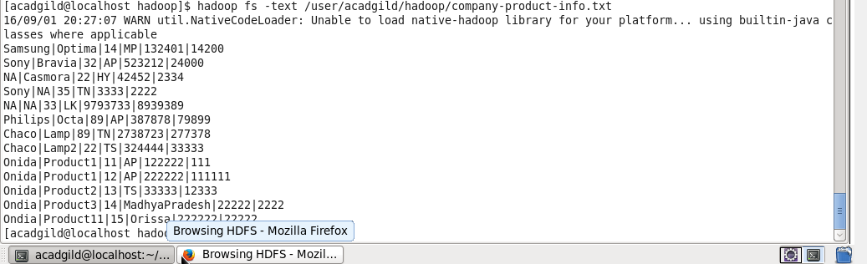

**Task6:** Map Reduce program using combiners to calculate the total units sold in each state for Onida company.

Package: acadgild.session5.task6

Driver Class: DriverProg.java

Mapper Class: MapperProg.java

Reducer Claass: ReducerProg.java

Combiner Class: ReducerProg.java

**Output:**

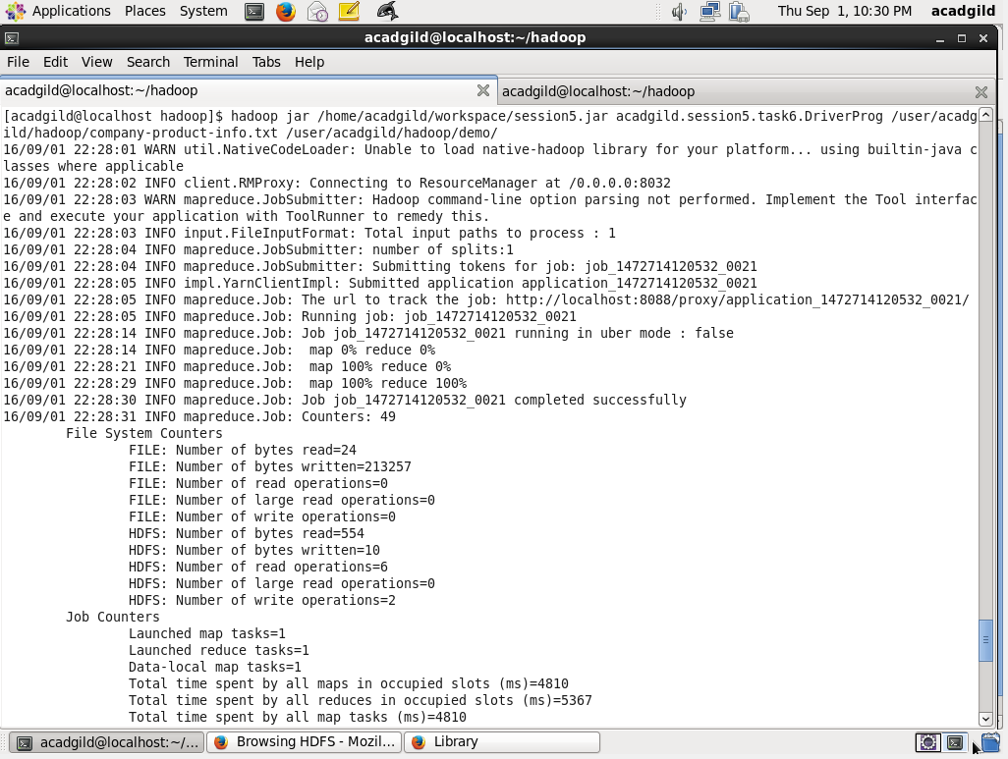

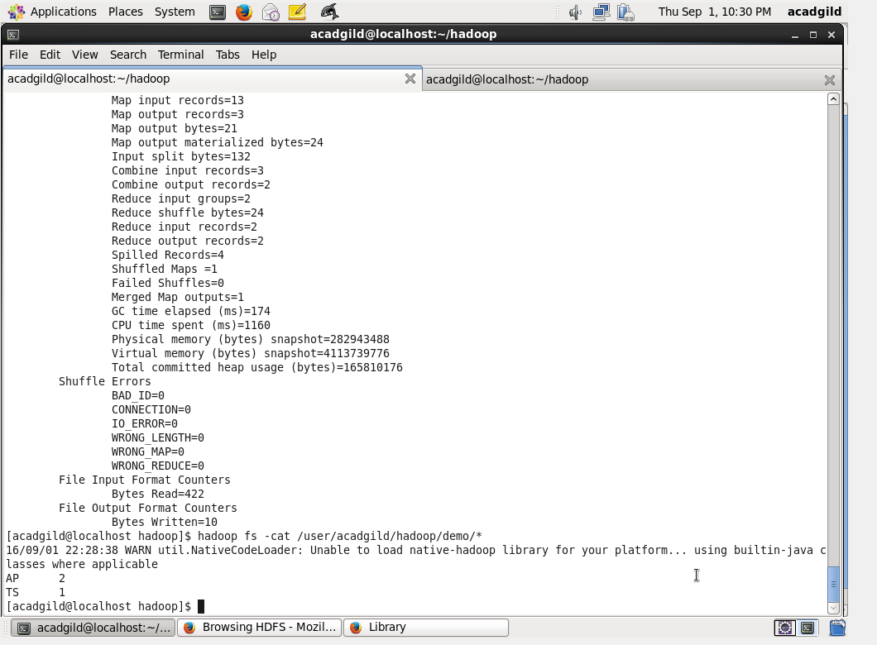

**Task7:** Write a Map Reduce program to view the total sales for each product for every Company corresponding to each size.

Make sure that all records for a single company goes to a single reducer and inside every reducer, keys must be sorted in descending order of the size.

You may write a custom WritableComparable for this purpose.

Package: acadgild.session5.task7

Driver Class: DriverProg.java

Mapper Class: MapperProg.java

Reducer Class: ReducerProg.java

WritableComparable Class : ProductInfo.java

Output:

